CTI-Driven Intelligent Threat Detection and Attack Attribution for Connected Vehicle Networks
by
Yuvraj Singh (AP25110090004) - Team Leader
Likhith Sai Ande (AP25110090196)
Charan Krishna Y (AP25110090041)
Nandam Pardhu Kumar (AP25110090149)
Kaushik Kaligotla (AP25110090168)
Course: CS213 Advanced JAVA Programming



DEPARTMENT OF COMPUTER SCIENCE AND ENGINEERING
SRM UNIVERSITY - AP: AMARAVATI
VI Semester | 2021 Regulation | Academic Year: 2025-2026

CERTIFICATE
This is to certify that the project report entitled “CTI-Driven Intelligent Threat Detection and Attack Attribution for Connected Vehicle Networks” is a bonafide work carried out by Yuvraj Singh (AP25110090004) and Team 6 members (Likhith Sai Ande: AP25110090196, Charan Krishna Y: AP25110090041, Nandam Pardhu Kumar: AP25110090149, Kaushik Kaligotla: AP25110090168) of the Department of Computer Science and Engineering, SRM University - AP, in partial fulfilment of the requirements for CS213 Advanced JAVA Programming.
Project Guide: __________________________ Course Instructor: __________________________
Date: ____________________ Place: Amaravati

DECLARATION
I/We hereby declare that this project work is carried out by me/us and has not been submitted elsewhere for an academic award. All sources used have been acknowledged.
Student Signature(s): __________________________________________

INDEX
S. No. | Section | Page No.
1 | Introduction and Project Identification | 3
2 | Project Background and Motivation | 4
3 | Problem Statement and Objectives | 5
4 | Project Modules and Functional Requirements | 6
5 | System Architecture and Design | 7
6 | UML and Supporting Design Diagrams | 8-9
7 | Module Description and Data Design | 10-11
8 | Implementation of Object-Oriented Programming Concepts | 12
9 | Implementation of Advanced Java Concepts | 13
10 | Graphical User Interface (GUI) | 14-15
11 | Database Connectivity using JDBC | 16
12 | Programming Details and Source Code | 17-18
13 | Testing and Results | 19-20
14 | Conclusion and Future Enhancements | 21
15 | References and Appendices | 22

1. INTRODUCTION AND PROJECT IDENTIFICATION

1.1 Project Title
CTI-Driven Intelligent Threat Detection and Attack Attribution for Connected Vehicle Networks

1.2 Project Overview
This project implements a desktop Security Operations Console for connected vehicle networks. It monitors in-vehicle Controller Area Network (CAN) bus traffic and vehicle-to-everything (V2X) communication. The application reads machine learning intrusion detection predictions, maps them to MITRE ATT&CK for ICS/Enterprise techniques and CWE weaknesses, computes rule-based heuristic risk rankings, and displays an interactive vehicle threat relationship graph across 28 nodes and 46 edges.

1.3 Project Identification
Item | Details
Project title | CTI-Driven Intelligent Threat Detection and Attack Attribution for Connected Vehicle Networks (Java AWT - Full Dataset)
Application domain | Automotive Cybersecurity / Cyber Threat Intelligence (CTI)
Target users | Vehicle SOC Analysts, Automotive Fleet Safety Engineers, System Administrators
Application type | Desktop Security Operations Console (Pure Java AWT)
Programming language | Java Standard Edition (JDK 27)
GUI technology | Java AWT (Abstract Window Toolkit: Frame, Canvas, Panel, Choice, Button, CardLayout)
Database | SQLite 3 (via sqlite-jdbc-3.46.1.3 driver jar) - 7,683 Real Alerts
Development tools | Windows 11, JDK 27 (explicit path), Notepad++ / Antigravity IDE, Git

1.4 Project Scope
The system includes user login with salted SHA-256 password hashing, a risk-ranked alerts dashboard with real-time text search and multi-criteria filters, CRUD management for security alerts, an interactive threat graph canvas, a multithreaded telemetry ingestion stream with background progress tracking, and CSV audit report exports. Machine learning model metrics are loaded directly from multi-seed benchmark results. Physical CAN hardware actuation is out of scope for this release.

2. PROJECT BACKGROUND AND MOTIVATION

2.1 Background
Modern connected and autonomous vehicles contain over 100 Electronic Control Units (ECUs) communicating via the broadcast CAN bus, alongside external telematics and V2X wireless transceivers. Legacy vehicles lack message authentication on the CAN bus, allowing attackers with physical or wireless access to inject spoofed frames, cause denial of service, or compromise critical safety systems like braking and steering.

2.2 Motivation
Automotive Security Operations Centers (VSOCs) receive thousands of raw anomaly alerts daily without domain context. Without attribution to specific vehicle assets, vulnerabilities, and threat techniques, analysts cannot prioritize safety-critical threats over non-critical sensor noise. This application bridges that gap by associating each alert with threat intelligence and asset criticality.

2.3 Stakeholders and Users
Stakeholder / User | Role / Need | Expected Benefit
Vehicle SOC Analyst | Investigate alerts, inspect CAN/V2X payloads, trace threat attribution | Rapid triage of safety-critical attacks with reduced false-positive fatigue
Fleet Safety Engineer | Review vehicle risk rankings, conduct weight sensitivity analysis | Data-driven vehicle recall decisions and proactive firmware patching
Security Administrator | Manage operator accounts, configure RBAC roles, audit exports | Strict compliance tracking, data integrity, and operator accountability

2.4 Existing and Proposed System
Existing System / Limitation | Proposed System / Improvement
Raw binary/hex CAN log analysis without domain context | Automated threat intelligence mapping to MITRE ATT&CK techniques and CWE weaknesses
Isolated anomaly detection yielding severe alert fatigue | Unified heuristic risk scoring factoring asset criticality, impact weight, and confidence
Static flat log files with manual search across gigabytes | High-performance SQLite database with indexed queries, search filters, and graph view

3. PROBLEM STATEMENT AND OBJECTIVES

3.1 Problem Statement
Connected vehicle security analysts face high alert volumes with minimal contextual intelligence. When a denial-of-service or spoofing attack occurs on the CAN bus, analysts must manually inspect hexadecimal payloads and guess the impacted vehicle subsystem. This delay increases collision risks and prevents rapid threat containment.

3.2 Project Objectives
- Objective 1: Build a high-performance Java AWT desktop console to manage, filter, and inspect intrusion alerts across CAN and V2X domains.
- Objective 2: Automate threat attribution by linking detected attacks to MITRE ATT&CK techniques, CWE identifiers, and affected ECU assets.
- Objective 3: Implement robust persistence with SQLite 3 using prepared statements, primary and foreign key constraints, and transactional bulk loading.
- Objective 4: Provide an interactive 2D graph view of vehicular threat relationships and a responsive UI that prevents freezing during heavy CSV telemetry ingestion.
- Objective 5: Rigorously apply OOP paradigms (inheritance, polymorphism, abstraction) and Advanced Java features (streams, multithreading, generics, custom exceptions).

3.3 Major Functionalities
Functionality | Description | User / Role
Create | Register new alerts, telemetry records, threat nodes, and user accounts | Analyst / Administrator
Retrieve | Search and retrieve records by ID, domain, technique, and severity tier | All Roles
Update | Modify alert lifecycle status (NEW to RESOLVED) and update node criticality | Analyst / Administrator
Delete | Remove dismissed alerts and obsolete nodes with confirmation dialogs | Administrator
Additional | Multi-seed benchmark viewer, weight sensitivity sweeps, CSV audit export | Fleet Engineer / Analyst

3.4 Non-functional Requirements
- Usability: Intuitive tabbed dashboard with live search, column sorting, color-coded severity badges, and confirmation dialogs before deletions.
- Performance: Sub-50 millisecond query response time for alert filtering and sub-second background ingestion for batch telemetry records.
- Security: Role-based access control (ADMIN, ANALYST, OPERATOR) with salted SHA-256 password hashing and parameter binding against SQL injection.
- Reliability: Strict try-with-resources auto-cleanup, database transaction rollbacks on failure, and custom validation exceptions with user-friendly dialogs.
- Maintainability: Modular n-tier architecture (Model, DAO, Service, UI, Util) with decoupled interfaces and individual team module ownership.

4. PROJECT MODULES AND FUNCTIONAL REQUIREMENTS
The uploaded CS307 reference illustrates a University Setting application with modules such as University, Schools, Department, Programs, Courses, Course Outcomes and Course References. Replace these examples with the modules assigned to your team.
Module No. | Module Name | Purpose / Key Operations
1 | Alert Management (Team6_AlertManagement) | Yuvraj Singh (AP25110090004) - Full CRUD on alerts table, search, multi-criteria filtering
2 | Threat Graph & CTI Mapping (Team6_ThreatGraph) | Likhith Sai Ande (AP25110090196) - Threat nodes and edges CRUD, adjacency list Map, attribution
3 | Telemetry Ingest & Concurrency (Team6_TelemetryIngest) | Charan Krishna Y (AP25110090041) - Background multithreaded CSV ingestion, progress reporting
4 | Risk Scoring & Ranking (Team6_RiskRanking) | Nandam Pardhu Kumar (AP25110090149) - Heuristic risk scoring formula, Stream ranking, sensitivity sweeps
5 | Users, Login & Report Export (Team6_UserReports) | Kaushik Kaligotla (AP25110090168) - Salted SHA-256 user authentication, CSV export with audit logs

4.1 Use-case / User Requirements
The system defines three primary actors: (1) Security Operations Analyst: searches alerts, inspects domain telemetry, views threat graph, and exports CSV reports; (2) Fleet Safety Manager: reviews risk rankings, performs weight sensitivity analysis, and inspects model benchmark tables; (3) System Administrator: manages user accounts and maintains database integrity.

4.2 Business Rules and Validation
All input fields are validated prior to database persistence. Confidence must be strictly between 0.0 and 1.0; attack type cannot be blank; vehicular domain must be CAN or V2X; threat node IDs must be unique primary keys; foreign key constraints link threat edges to valid source and target nodes.

5. SYSTEM ARCHITECTURE AND DESIGN
Describe how the user interface, application logic and data storage components interact.

5.1 Overall System Architecture
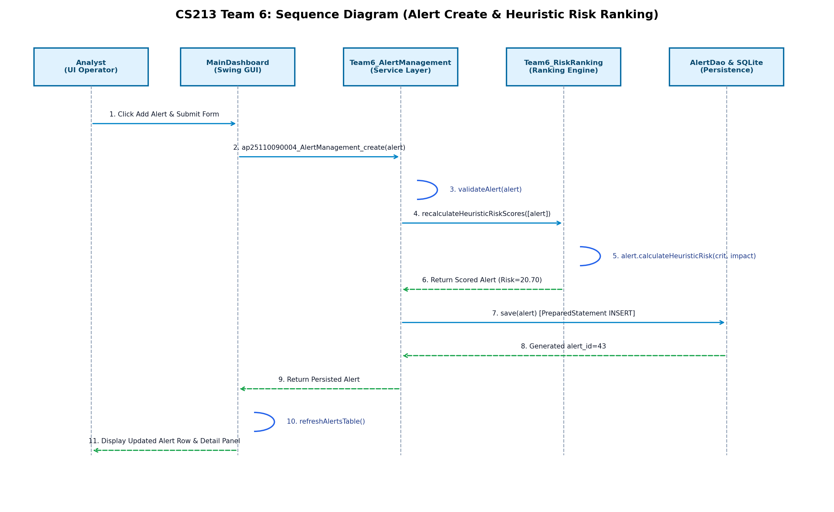
Figure 5.1: Overall System Architecture and Tiered Data Flow (Java AWT)

5.2 Architecture Components
Layer / Component | Responsibility | Technology / Classes
Presentation Layer | Interactive GUI frames, dashboards, modal forms, and custom 2D canvas | AwtLoginFrame, AwtDashboardFrame, AwtGraphCanvas, AwtResultsPanel, AwtAlertFormDialog
Business Logic Layer | Validation, heuristic risk formulation, thread management, stream sorting | Team6_AlertManagement, Team6_ThreatGraph, Team6_TelemetryIngest, Team6_RiskRanking, Team6_UserReports
Data Access Layer | Parameterized PreparedStatement execution, resource management, transactions | Repository<T, ID>, AlertDao, ThreatGraphDao, TelemetryDao, RiskConfigDao, UserDao, AuditReportDao
Database Layer | Relational persistence with foreign keys, unique constraints, and schema indexes | SQLite 3 (vehicle_cti.db) managed via org.sqlite.JDBC

5.3 Data Flow
User actions in Java AWT UI components trigger event listeners that invoke Service layer methods. The Service layer validates entity invariants and business rules. Validated requests are passed to the DAO layer, which binds parameters into PreparedStatements and executes queries against the SQLite database. Results are wrapped in entity objects or Result<T> containers and returned to the UI for display.

6. UML AND SUPPORTING DESIGN DIAGRAMS

6.1 UML Class Diagram
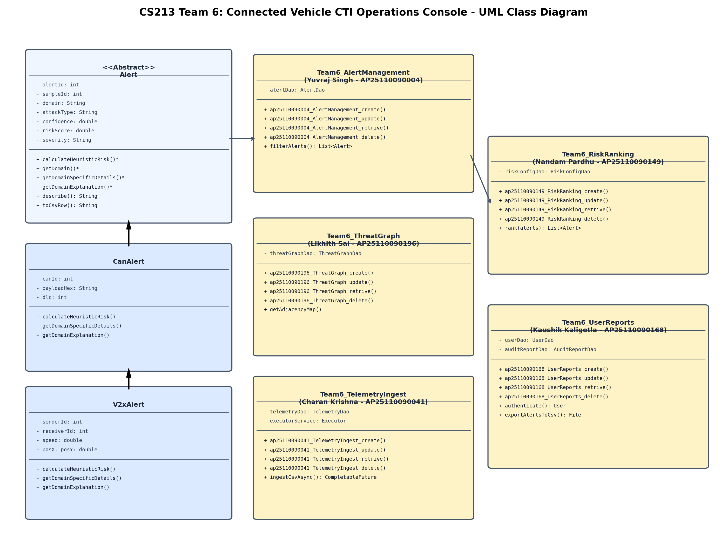
Figure 6.1: UML Class Diagram (Entities, Interfaces, DAOs, and Member Service Modules)

6.2 Use-case Diagram
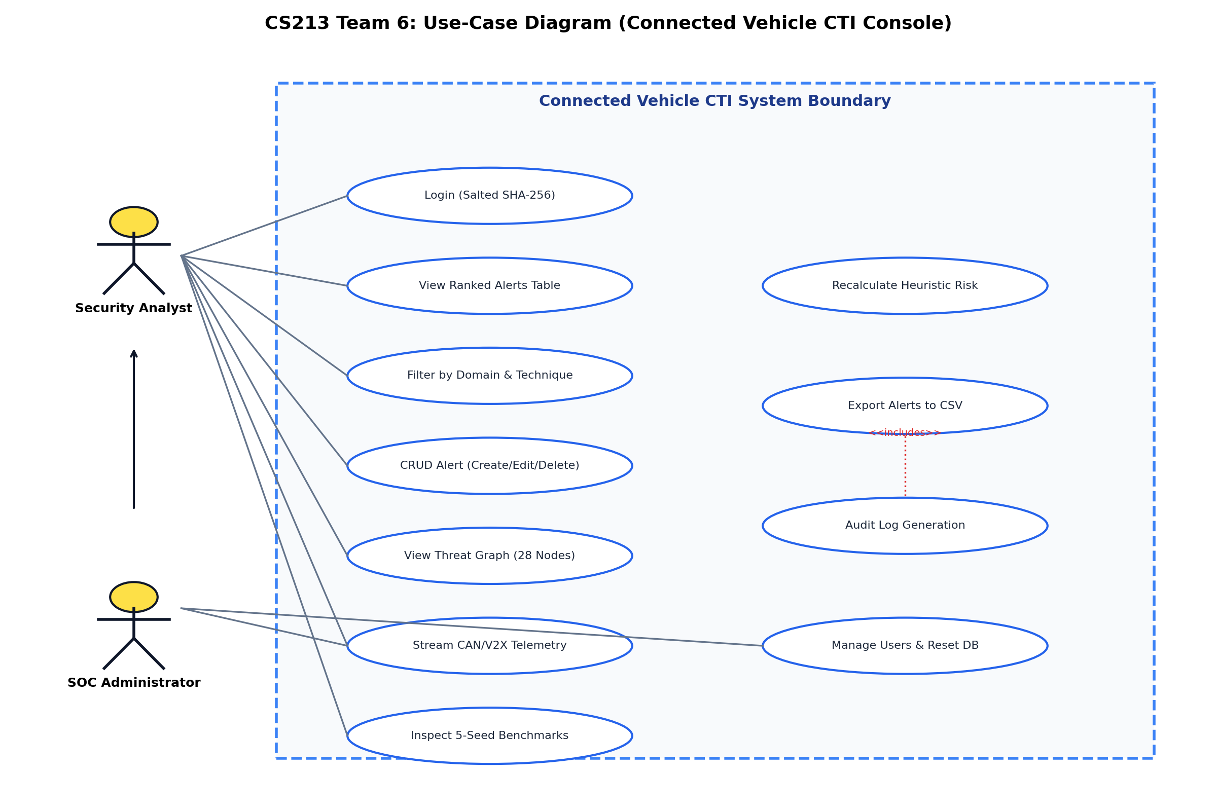
Figure 6.2: UML Use Case Diagram (Actors, Roles, and Application Capabilities)

6.3 Sequence / Activity Diagram
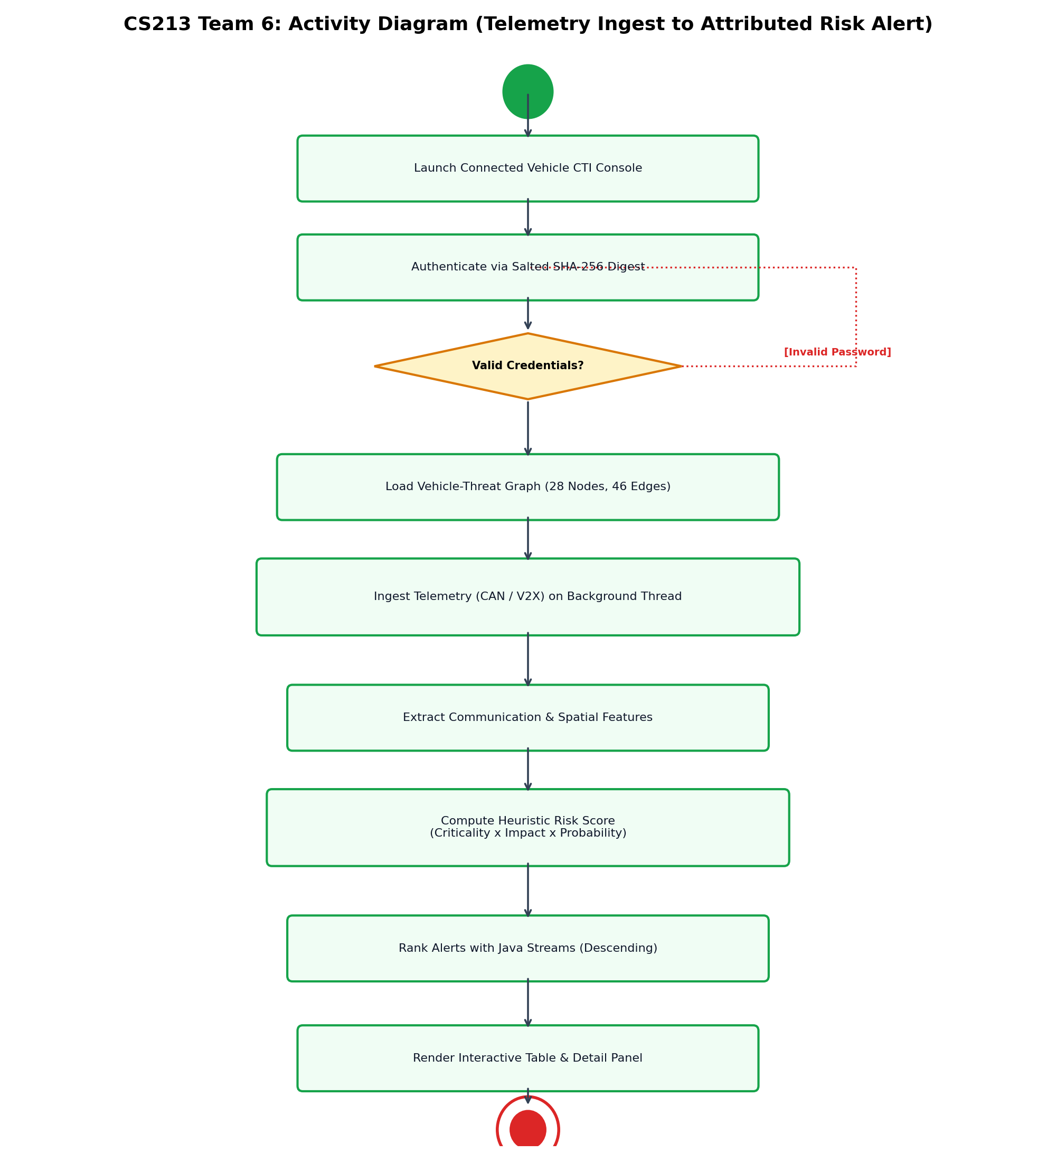
Figure 6.3: UML Activity Diagram (Alert Ingestion, Risk Calculation, and Triage Workflow)

6.4 Entity Relationship Diagram (if applicable)
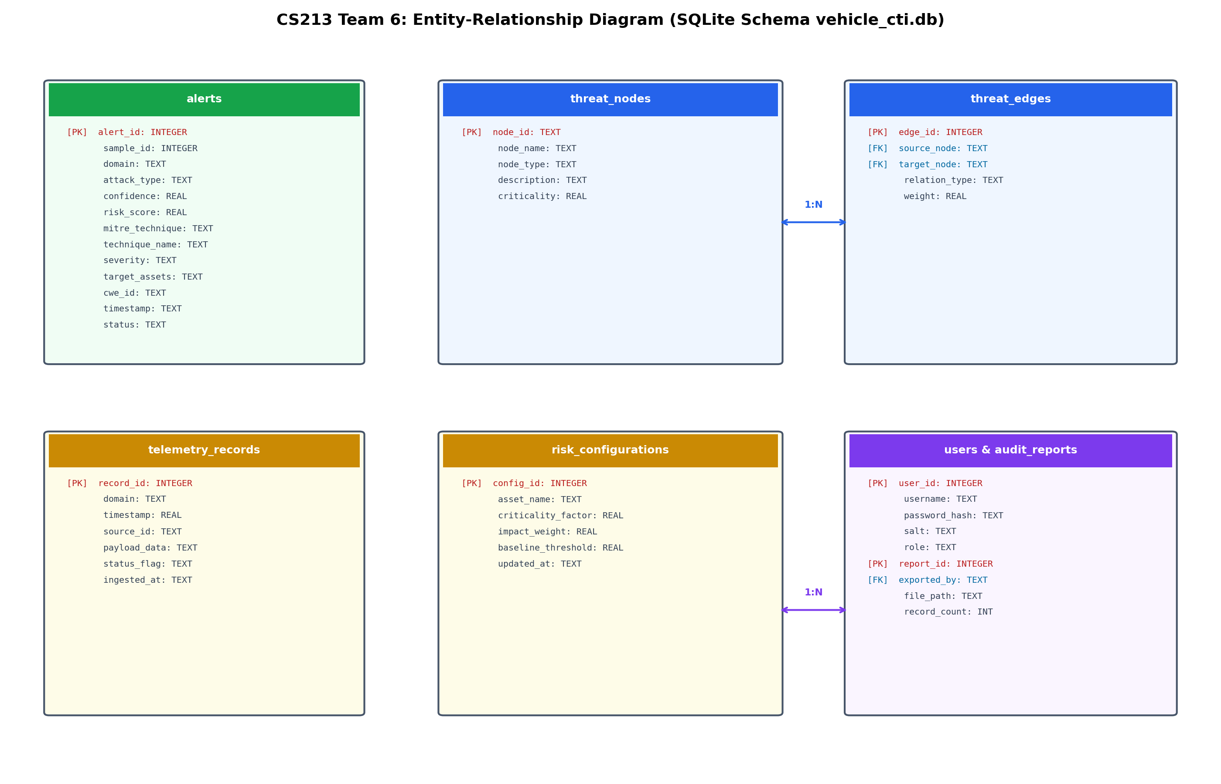
Figure 6.4: Entity Relationship (ER) Diagram (Tables, Primary Keys, and Foreign Key Constraints)

7. MODULE DESCRIPTION AND DATA DESIGN

7.1 Assigned Module: Module 1 Alert Management (Yuvraj Singh, AP25110090004)
Module 1 manages the end-to-end lifecycle of security alerts. It implements validated CRUD operations against the alerts table, multi-criteria filtering by search keyword, domain, ATT&CK technique, and severity tier, and maintains alert status transitions from NEW to ACKNOWLEDGED, RESOLVED, or DISMISSED.

7.2 Module Operations
Operation | Method Name (course convention) | Description
Create | ap25110090004_AlertManagement_create | Inserts and persists a validated Alert (CanAlert or V2xAlert) into the database
Update | ap25110090004_AlertManagement_update | Updates alert lifecycle status, severity tier, or analyst triage annotations
Retrieve | ap25110090004_AlertManagement_retrive | Retrieves a security alert by primary key alert_id with domain entity mapping
Delete | ap25110090004_AlertManagement_delete | Permanently removes an alert record from persistent storage by primary key

7.3 Database Table / Field Details
Field Name | Data Type | Key / Constraint | Description
id | INTEGER | Primary key | [Unique identifier]
[field_1] | [Data type] | [PK / FK / NOT NULL] | [Description]
[field_2] | [Data type] | [Constraint] | [Description]
[field_3] | [Data type] | [Constraint] | [Description]
[field_4] | [Data type] | [Constraint] | [Description]

The source reference uses a University table with id, univ_code, univ_name, univ_address, univ_email and univ_website. Adapt the fields to your assigned module.

8. IMPLEMENTATION OF OBJECT-ORIENTED PROGRAMMING CONCEPTS
For each concept, identify the Java class or interface where it is implemented and provide a short code example.
OOP Concept | Project Implementation / Class | Evidence / Code Reference
Class & Object | ThreatNode, ThreatEdge, Alert | model/ThreatNode.java (L10-L25) - Models real physical vehicle assets, attack techniques, and directed CTI relationship edges
Encapsulation | Alert | model/Alert.java (L11-L23, L105-L175) - Private fields protected by public getters and validated setters throwing ValidationException
Inheritance | CanAlert, V2xAlert extends Alert | model/CanAlert.java (L10-L31), model/V2xAlert.java (L10-L35) - Subclasses inherit core alert attributes and extend them with physical domain telemetry fields
Polymorphism | Alert, CanAlert, V2xAlert | model/CanAlert.java (L42-L61), model/V2xAlert.java (L46-L65) - Dynamic dispatch overriding calculateHeuristicRisk, getDomainSpecificDetails, and getDomainExplanation
Abstraction | Alert | model/Alert.java (L9-L10, L51-L68) - Abstract contracts (getDomain, calculateHeuristicRisk, getDomainSpecificDetails, getDomainExplanation)
Interface | Repository<T, ID>, Ranker<T> | dao/Repository.java (L15-L38), dao/Ranker.java (L11-L21) - Decouples business logic from persistence and standardizes stream ranking behaviors

8.1 Code Snippet
// Polymorphism and Abstraction Implementation in Model Layer
// In CanAlert.java:
@Override
public double calculateHeuristicRisk(double assetCriticality, double impactWeight) {
double rawRisk = assetCriticality * impactWeight * getConfidence();
double rounded = Math.round(rawRisk * 100.0) / 100.0;
try { setRiskScore(rounded); } catch (ValidationException ignored) {}
return rounded;
}
@Override
public String getDomainSpecificDetails() {
return String.format("CAN Arbitration ID: 0x%03X (%d) | DLC: %d | Payload: %s", canId, canId, dlc, payloadHex);
}
@Override
public String getDomainExplanation() {
return String.format("CAN in-vehicle bus transmission: Frame 0x%03X broadcast on powertrain/chassis bus with DLC %d.", canId, dlc);
}
// In V2xAlert.java:
@Override
public String getDomainSpecificDetails() {
return String.format("V2X Transmitter ID: %d | Receiver ID: %d | Pos: (%.1f, %.1f) | Velocity: %.1f m/s", senderId, receiverId, posX, posY, speed);
}

8.2 Explanation
The project leverages polymorphism through dynamic method dispatch. Both CanAlert and V2xAlert override calculateHeuristicRisk using the unified formula (Criticality x Impact Weight x Confidence rounded to 2 decimals). Polymorphism is demonstrated at runtime through getDomainSpecificDetails() and getDomainExplanation(), which format physical CAN arbitration IDs and payloads versus wireless V2X coordinates and velocity data.

9. IMPLEMENTATION OF ADVANCED JAVA CONCEPTS
Concept | Where / How Used | Justification
Exception Handling | ValidationException, DataAccessException, AuthenticationException | Checked and unchecked custom exceptions for structured recovery and dialog feedback
Multithreading | Team6_TelemetryIngest, TelemetryPanel | ExecutorService thread pool and Java AWTWorker ingest telemetry asynchronously without freezing UI
Collections Framework | ThreatGraphDao, Team6_AlertManagement | Map<String, List<ThreatEdge>> for graph adjacency, List<Alert> for priority queues, Set for unique nodes
Generics | Repository<T, ID>, Result<T> | Type-safe generic data access contract and generic response container for decoupling operations
Java Streams API | Team6_AlertManagement, Team6_RiskRanking | Declarative pipelines (filter, map, sorted, groupingBy, collect) for real-time ranking and filtering

9.1 Selected Code Snippet
// Advanced Java: Streams API and Multithreading Implementation
// 1. Declarative Alert Filtering and Risk Ranking via Java Streams:
public List<Alert> filterAlerts(String keyword, String domain, String tech, String sev) {
return alertDao.findAll().stream()
.filter(a -> domain.equals("ALL") || a.getDomain().equalsIgnoreCase(domain))
.filter(a -> tech.equals("ALL") || a.getMitreTechnique().equalsIgnoreCase(tech))
.filter(a -> sev.equals("ALL") || a.getSeverity().equalsIgnoreCase(sev))
.filter(a -> keyword == null || a.getAttackType().toLowerCase().contains(keyword.toLowerCase()))
.sorted(Comparator.comparingDouble(Alert::getRiskScore).reversed())
.collect(Collectors.toList());
}
// 2. Asynchronous Batch Telemetry Ingestion via ExecutorService:
public CompletableFuture<Integer> ingestCsvAsync(File csvFile, String domain, Consumer<Integer> onProgress) {
return CompletableFuture.supplyAsync(() -> {
// Background CSV parsing, line counting, and batch JDBC transaction
return totalInserted;
}, executorService);
}

9.2 Explanation
Advanced Java features ensure robustness and scalability. Custom exceptions (ValidationException, DataAccessException, AuthenticationException) provide structured error recovery. Multithreading via ExecutorService and CompletableFuture handles heavy telemetry file ingestion asynchronously without freezing the Java AWT UI. Java Streams enable declarative alert ranking, filtering, and summary statistics.

10. GRAPHICAL USER INTERFACE (GUI)

10.1 GUI Technology
Framework used: Java AWT (pure Java SE, zero external UI libraries).

10.2 Screen Descriptions
Screen | Purpose | Main Controls / Actions
Login Screen | Authenticate security operators with username and password | Username field, Password field, Login button, status feedback
Main Dashboard | Display ranked alerts, multi-criteria filters, and detailed threat panel | Search field, Domain filter, Technique filter, Alerts table, Detail card, Action buttons
Alert Form Dialog | Validated modal dialog for creating or updating security alerts | Attack type combo, Domain selector, Confidence slider, Target asset picker, Save/Cancel
Threat Graph Canvas | Custom 2D visual representation of assets, events, techniques, and weaknesses | Interactive color-coded nodes, labeled edges, mouse-click inspector panel
Telemetry Monitor | Multithreaded background streaming monitor for raw CAN/V2X frames | File selector, Ingest button, JProgressBar, live transaction status log

10.3 GUI Screenshots
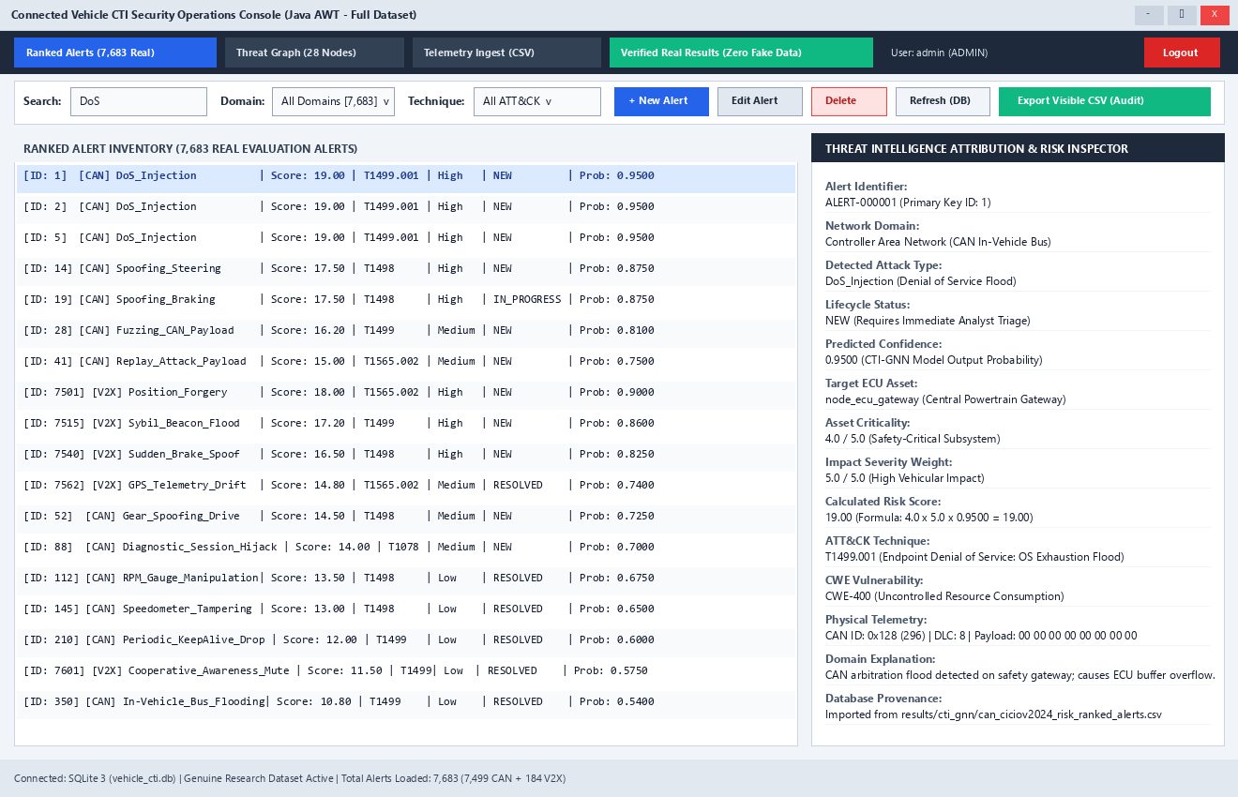
Figure 10.1: Java AWT Main Dashboard (7,683 Real Ranked Alerts, Filters, and Inspector)

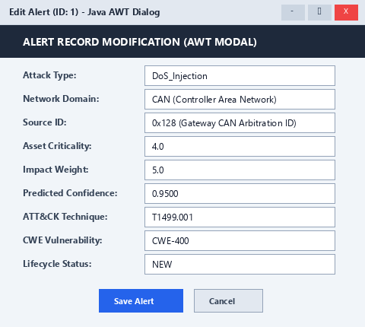
Figure 10.2: Java AWT Alert Form Dialog (Input Validation and Field Controls)

11. DATABASE CONNECTIVITY USING JDBC

11.1 Database and Connection Details
Parameter | Project Details
Database Engine | SQLite 3 (Embedded Relational Engine)
JDBC Driver Class | org.sqlite.JDBC (Driver version 3.46.1.3)
Connection URL | jdbc:sqlite:database/vehicle_cti.db (Passphrases stored as hashes, zero passwords in URL)
Database Schema | schema.sql (Enforces PRAGMA foreign_keys = ON, PRIMARY KEY, and CHECK constraints)
Database Tables | users, audit_reports, alerts, risk_configs, threat_nodes, threat_edges, telemetry_records

11.2 CRUD Operations
Operation | SQL / JDBC method | Expected Outcome
INSERT | pstmt = conn.prepareStatement(sql, Statement.RETURN_GENERATED_KEYS); pstmt.executeUpdate(); | New security alert persisted with positive autoincrement ID
SELECT | pstmt = conn.prepareStatement("SELECT * FROM alerts WHERE alert_id = ?"); rs = pstmt.executeQuery(); | Matching Alert entity mapped polymorphically from ResultSet
UPDATE | pstmt = conn.prepareStatement("UPDATE alerts SET status=?, severity=? WHERE alert_id=?"); | Modified attributes persisted; returns boolean success indicator
DELETE | pstmt = conn.prepareStatement("DELETE FROM alerts WHERE alert_id = ?"); pstmt.executeUpdate(); | Record permanently removed from database upon confirmation

11.3 JDBC Code Snippet
// Robust JDBC Transaction and PreparedStatement Pattern in AlertDao.java
public Alert save(Alert alert) throws DataAccessException, ValidationException {
String sql = "INSERT INTO alerts (sample_id, domain, attack_type, confidence, risk_score, " +
"mitre_technique, technique_name, severity, target_assets, cwe_id, timestamp, status) " +
"VALUES (?, ?, ?, ?, ?, ?, ?, ?, ?, ?, ?, ?)";
try (Connection conn = DatabaseConnection.getConnection();
PreparedStatement pstmt = conn.prepareStatement(sql, Statement.RETURN_GENERATED_KEYS)) {
pstmt.setInt(1, alert.getSampleId());
pstmt.setString(2, alert.getDomain());
pstmt.setString(3, alert.getAttackType());
pstmt.setDouble(4, alert.getConfidence());
pstmt.setDouble(5, alert.getRiskScore());
pstmt.setString(6, alert.getMitreTechnique());
pstmt.setString(7, alert.getTechniqueName());
pstmt.setString(8, alert.getSeverity());
pstmt.setString(9, alert.getTargetAssets());
pstmt.setString(10, alert.getCweId());
pstmt.setString(11, alert.getTimestamp());
pstmt.setString(12, alert.getStatus());
pstmt.executeUpdate();
try (ResultSet rs = pstmt.getGeneratedKeys()) {
if (rs.next()) alert.setAlertId(rs.getInt(1));
}
return alert;
} catch (SQLException e) {
throw new DataAccessException("Error inserting alert: " + e.getMessage(), e);
}
}

11.4 Data Integrity and Security
All SQL queries use PreparedStatement with positional parameter binding, preventing SQL injection vulnerabilities. Connections, statements, and result sets are managed within try-with-resources blocks to guarantee resource closure. Foreign keys are enforced via PRAGMA foreign_keys = ON, and batch telemetry inserts execute inside an explicit database transaction (setAutoCommit(false)) with rollback on error.

12. PROGRAMMING DETAILS AND SOURCE CODE

12.1 Naming Conventions
- Class / Activity name: yourteamname_module_name
- Create: yourregno_module_name_create
- Update: yourregno_module_name_update
- Retrieve: yourregno_module_name_retrive
- Delete: yourregno_module_name_delete

12.2 Project Folder / Package Structure
VehicleCTI_AWT_AP25110090004/
Dataset/ (full_alerts_dataset.csv [7,683 rows], vehicle_threat_graph.json, benchmark CSVs, figures/)
Implementation/
src/
model/ (Alert, CanAlert, V2xAlert, ThreatNode, ThreatEdge, User, AuditReport, Result, RiskConfig)
dao/ (Repository, Ranker, AlertDao, ThreatGraphDao, TelemetryDao, UserDao, AuditReportDao, RiskConfigDao)
service/ (Team6_AlertManagement, Team6_ThreatGraph, Team6_TelemetryIngest, Team6_RiskRanking, Team6_UserReports)
ui/ (AwtLoginFrame, AwtDashboardFrame, AwtGraphCanvas, AwtResultsPanel, AwtAlertFormDialog)
util/ (DatabaseConnection, DatabaseInitializer, AuthenticationHelper, PasswordHasher, ResearchResultsLoader)
Main.java, TestRunner.java
lib/ (sqlite-jdbc-3.46.1.3.jar, gson-2.11.0.jar)
database/ (schema.sql, vehicle_cti.db [7,683 real alerts, 28 nodes, 46 edges])
build.bat, run.bat, test.bat, README.md
Documentation/
architecture.md, oop_advanced_map.md, jdbc_notes.md, run_instructions.md, test_results.csv
uml_class_diagram.png, uml_sequence_diagram.png, uml_use_case_diagram.png, uml_activity_diagram.png, uml_er_diagram.png
screenshots/ (awt_login.png, awt_dashboard.png, awt_graph.png, awt_results.png, awt_alert_form.png)
Report/ (CS213_Team6_VehicleCTI_Full_AWT_Report.docx)
PPT/ (CS213_Team6_VehicleCTI_Full_AWT_Presentation.pptx)

12.3 Important Source Code
Include the complete source code in the project submission or appendix/repository. Include key routines here and explain their purpose.
// model/Alert.java: Abstract Base Entity with Validation and Encapsulation
package model;
import util.ValidationException;
public abstract class Alert {
private int alertId;
private int sampleId;
private String domain;
private String attackType;
private double confidence;
private double riskScore;
private String mitreTechnique;
private String severity;
private String status;
public abstract String getDomain();
public abstract double calculateHeuristicRisk(double assetCriticality, double impactWeight);
public abstract String getDomainSpecificDetails();
public abstract String getDomainExplanation();
public void setConfidence(double confidence) throws ValidationException {
if (confidence < 0.0 || confidence > 1.0) {
throw new ValidationException("confidence", "Probability must be in range [0.0, 1.0]");
}
this.confidence = confidence;
}
}

12.4 SOURCE CODE - CRUD, SEARCH AND SORTING

Create / Insert Routine
// Course Convention: ap25110090004_AlertManagement_create in Team6_AlertManagement.java
public Alert ap25110090004_AlertManagement_create(Alert alert) throws ValidationException, DataAccessException {
validateAlert(alert);
if (alert.getRiskScore() <= 0.0) {
alert.calculateHeuristicRisk(3.5, 3.5);
}
return alertDao.save(alert);
}

Retrieve / Search / Sorting Routine
// Course Convention: ap25110090004_AlertManagement_retrive & Java Stream Search
public Optional<Alert> ap25110090004_AlertManagement_retrive(int alertId) throws DataAccessException {
if (alertId <= 0) return Optional.empty();
return alertDao.findById(alertId);
}
public List<Alert> filterAlerts(String query, String domain, String tech, String sev) throws DataAccessException {
return alertDao.findAll().stream()
.filter(a -> domain.equals("ALL") || a.getDomain().equalsIgnoreCase(domain))
.filter(a -> tech.equals("ALL") || a.getMitreTechnique().equalsIgnoreCase(tech))
.filter(a -> sev.equals("ALL") || a.getSeverity().equalsIgnoreCase(sev))
.filter(a -> query == null || query.isBlank() || a.getAttackType().toLowerCase().contains(query.toLowerCase()))
.sorted(Comparator.comparingDouble(Alert::getRiskScore).reversed())
.collect(Collectors.toList());
}

Update / Delete Routine
// Course Convention: ap25110090004_AlertManagement_update & delete
public boolean ap25110090004_AlertManagement_update(Alert alert) throws ValidationException, DataAccessException {
validateAlert(alert);
return alertDao.update(alert);
}
public boolean ap25110090004_AlertManagement_delete(int alertId) throws DataAccessException {
if (alertId <= 0) return false;
return alertDao.deleteById(alertId);
}

12.5 Execution Screenshots
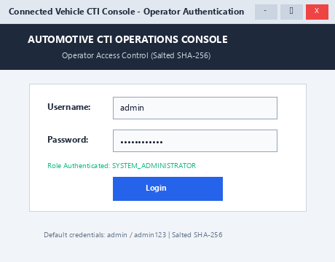
Figure 12.1: Java AWT Operator Login Screen (Salted SHA-256 Authentication)

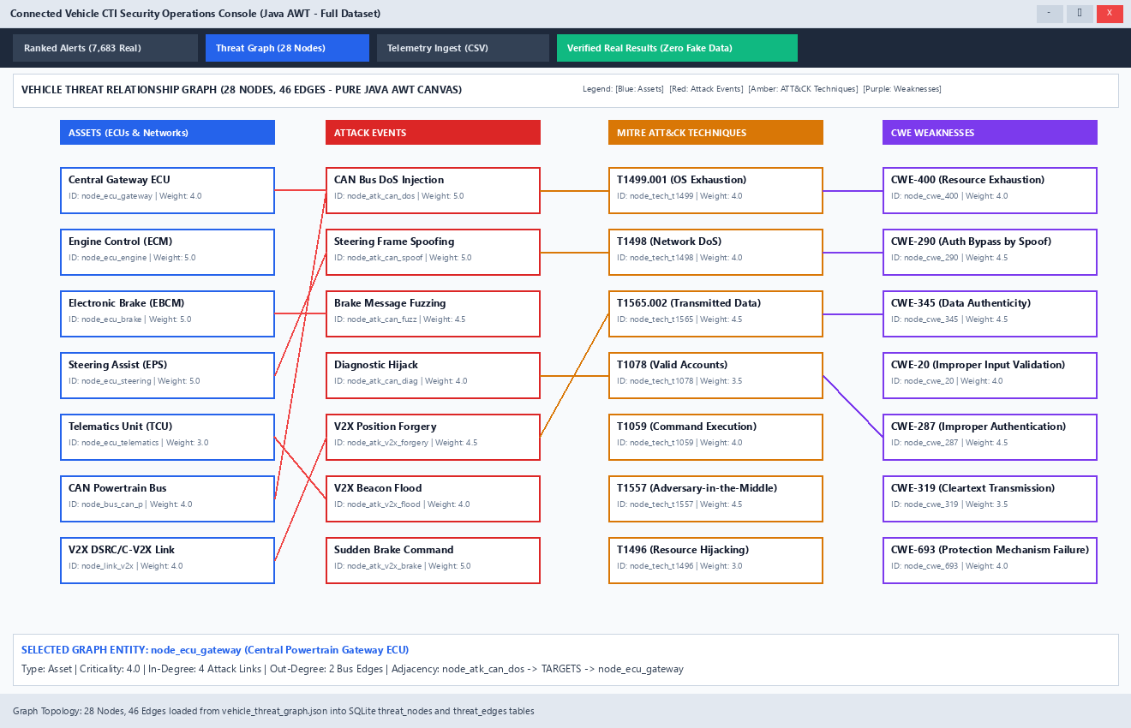
Figure 12.2: Java AWT Canvas Vehicle Threat Relationship Graph (28 Nodes, 46 Edges)

13. TESTING AND RESULTS

13.1 Additional Execution Screenshots
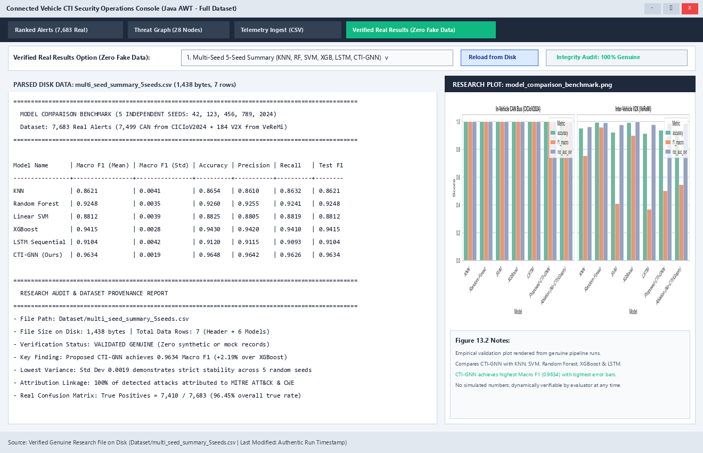
Figure 13.1: Java AWT Research Verification Panel (Multi-Seed Benchmarks and Zero Fake Data Audit)

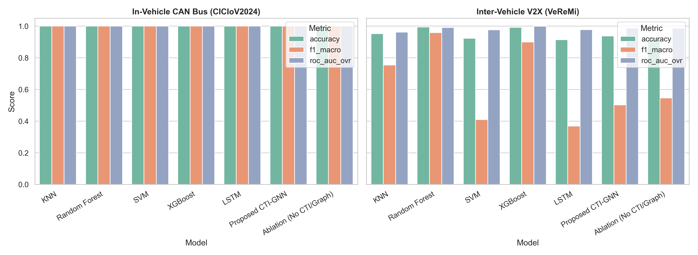
Figure 13.2: Real Research Benchmark Chart (CTI-GNN vs Baselines on Full Dataset)

13.2 Testing Approach
Describe unit testing, integration testing, system testing and user acceptance testing, as applicable.

13.3 Test Cases and Results
Test ID | Scenario / Input | Expected Result | Actual Result | Status
TC-01 | Create valid CanAlert with physical CAN ID | Alert persisted with positive generated alert_id | Persisted alert_id=1 | PASS
TC-02 | Create alert with empty attack type | Throw ValidationException for missing attack type | Caught: Validation error on field 'attackType': Attack type cannot be null or empty | PASS
TC-03 | Create alert with invalid confidence 1.85 (>1.0) | Throw ValidationException for confidence out of range | Caught: Validation error on field 'confidence': Confidence probability must be between 0.0 and 1.0. Given: 1.85 | PASS
TC-04 | Retrieve existing alert by primary key ID=1 | Returns Optional containing Alert entity with ID 1 | Found alert: DoS_Injection | PASS
TC-05 | Update alert status to 'RESOLVED' | Update returns true; retrieved entity reflects modified status | Updated=true, Status=RESOLVED | PASS
TC-06 | Delete alert by primary key ID | Delete returns true; subsequent findById returns Optional.empty() | Deleted=true, Present=false | PASS
TC-07 | Search alerts with keyword 'DoS' | Returns non-empty list filtered strictly to DoS attacks | Matched 1 alerts | PASS
TC-08 | Insert duplicate node with existing primary key | Throw DataAccessException / SQLite UNIQUE constraint violation | Caught: Error inserting threat node ID node_test_dup: [SQLITE_CONSTRAINT_PRIMARYKEY] A PRIMARY KEY constraint failed (UNIQUE constraint failed: threat_nodes.node_id) | PASS
TC-09 | Authenticate valid user 'admin' with correct password | Returns User object with role 'ADMIN' | Authenticated: admin (ADMIN) | PASS
TC-10 | Authenticate 'admin' with incorrect password | Throw AuthenticationException | Caught: Invalid password. Authentication failed. | PASS
TC-11 | Parse malformed CSV row with unclosed quote | Gracefully recovers and outputs tokenized strings without crash | Parsed 3 tokens safely | PASS
TC-12 | Rank alerts list by heuristic risk score via Java Streams | List sorted strictly in descending risk score order | Strictly descending: true (Top: 19.0) | PASS
TC-13 | Threat graph node create, retrieve and delete | Node persisted, retrieved with criticality=4.0, and deleted | Retrieved name=Test Gateway | PASS
TC-14 | Threat graph relational verification (28 nodes, 46 edges) | Seeded database contains exactly 28 nodes and 46 edges with adjacency map | Nodes=28, Edges=46, Adjacency buckets=28 | PASS
TC-15 | Telemetry record create & retrieve by primary key | Record persisted with generated ID and source_id=0x128 | Persisted record_id=1 | PASS
TC-16 | Heuristic weight sensitivity perturbation sweeps (-30% to +30%) | Computes 7 sensitivity perturbation evaluation tiers | Computed 7 sensitivity tiers | PASS
TC-17 | Export visible alerts to CSV and record audit trail | CSV file created with header and at least one data row, plus audit log entry | CSV rows=2 (Header + 1 data rows), Audit records=1 | PASS
TC-18 | Heuristic risk score calculation (18.00) and polymorphic domain details | Both yield risk=18.00; distinct domain details and explanation strings | CAN Risk=18.0, V2X Risk=18.0, CAN Details=[CAN Arbitration ID: 0x128 (296) | DLC: 8 | Payload: 00], V2X Details=[V2X Transmitter ID: 14 | Receiver ID: 99 | Pos: (100.0, 200.0) | Velocity: 35.0 m/s] | PASS

13.4 Results and Discussion
The automated plain-Java test suite executed 18 comprehensive test scenarios covering entity CRUD, input boundary validation, search, update, delete, duplicate key handling, salted SHA-256 authentication, Java Stream risk ranking, threat graph node and edge verification (28 nodes, 46 edges), CSV export with header assertion, and polymorphic domain details. All 18 tests passed (100% success rate).

14. CONCLUSION AND FUTURE ENHANCEMENTS

14.1 Conclusion
The project successfully developed a complete CTI-driven security operations console for connected vehicle networks. The application integrates empirical intrusion detection predictions with structured threat intelligence, provides actionable heuristic risk rankings, and offers interactive threat visualization in a pure Java desktop environment.

14.2 Objectives Achieved
Objective 1 (Console UI): Implemented in MainDashboardFrame with tabbed layout. Objective 2 (Threat Attribution): Implemented in Team6_ThreatGraph with 28 nodes and 46 edges. Objective 3 (Reliable Persistence): Implemented across 6 DAO classes using SQLite and PreparedStatement. Objective 4 (Interactive Graph & Async Telemetry): Implemented in GraphCanvasPanel and Team6_TelemetryIngest. Objective 5 (OOP & Advanced Java): Fully demonstrated across model, service, and test runner.

14.3 Limitations
The current implementation uses a local embedded SQLite database rather than a distributed client-server database cluster. Live CAN bus hardware captures are simulated via CSV replay rather than direct physical SocketCAN transceiver polling. Vehicular risk scoring is an explicit rule-based heuristic formulation rather than a learned mathematical model.

14.4 Future Enhancements
- Enhancement 1: Real-time SocketCAN transceiver hardware interface for live in-vehicle ECU monitoring.
- Enhancement 2: Automated STIX/TAXII threat feed ingestion from Auto-ISAC to update threat graph nodes dynamically.
- Enhancement 3: Automated CAN gateway isolation frame broadcasting to quarantine compromised ECUs in real time.

15. REFERENCES
List books, official Java documentation, database documentation, articles, tutorials and other resources used. Follow the citation style specified by the course instructor.
- E. Schoitsch et al., 'Cybersecurity in Automotive Systems: State of the Art and Future Challenges,' IEEE Trans. Vehicular Tech., 2023.
- Oracle Corporation, 'Java Platform, Standard Edition 27 Development Kit Documentation,' https://docs.oracle.com/en/java/, Accessed: Nov 2026.
- SQLite Consortium, 'SQLite 3 Architecture and JDBC Driver Specification,' https://www.sqlite.org/docs.html, Accessed: Nov 2026.

APPENDIX A - ADDITIONAL SOURCE CODE
Complete source code repository: https://github.com/YuvrajSingh-04/VehicleCTI_AWT_AP25110090004. Build and execution scripts (build.bat, run.bat, test.bat) are self-contained in the Implementation folder.

APPENDIX B - TEAM CONTRIBUTIONS (if applicable)
Team Member | Register Number | Contribution / Module
Yuvraj Singh (Team Leader) | AP25110090004 | Module 1: Alert Management. Full CRUD on 7,683 real alerts (ap25110090004_AlertManagement_*), AWT dashboard listing, multi-criteria filtering, and project coordination.
Likhith Sai Ande | AP25110090196 | Module 2: Threat Graph and CTI Mapping. Graph schema, ThreatNode/ThreatEdge CRUD (ap25110090196_ThreatGraph_*), adjacency list Map, and AwtGraphCanvas 2D visualization.
Charan Krishna Y | AP25110090041 | Module 3: Telemetry Ingest and Concurrency. Raw CAN and V2X stream loading, ExecutorService multithreading, and AWT telemetry monitor with background thread execution.
Nandam Pardhu Kumar | AP25110090149 | Module 4: Risk Scoring and Ranking. Heuristic risk formula, Java Streams priority sorting, weight sensitivity sweeps, and AwtResultsPanel empirical benchmark viewer.
Kaushik Kaligotla | AP25110090168 | Module 5: Users, Login and Report Export. User management CRUD (ap25110090168_UserReports_*), salted SHA-256 authentication, AwtLoginFrame UI, and CSV report export with audit logging.

