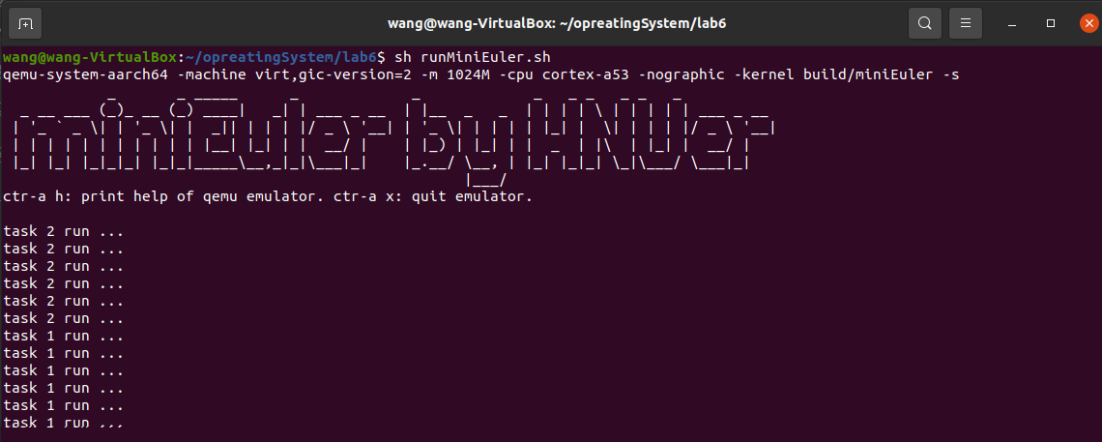

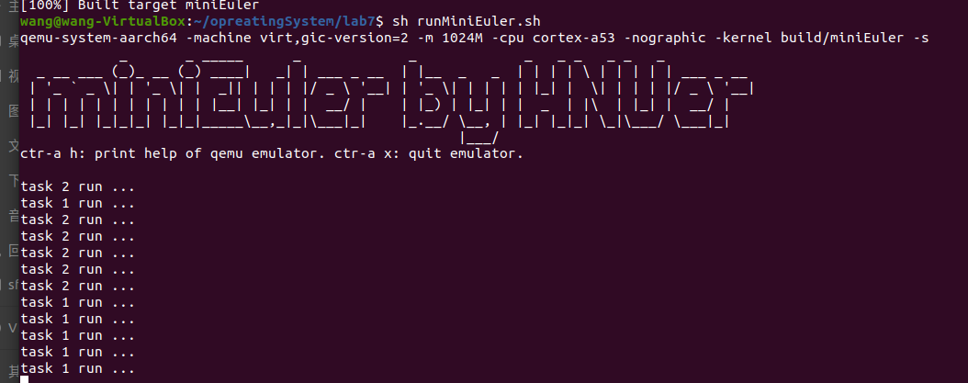

OS_SEC_L0_TEXT void OsHwiDispatch( U32 excType, struct ExcRegInfo *excRegs) //src/arch/cpu/armv8/common/hwi/prt_hwi.c

{

// 中断确认，相当于OsHwiNumGet()

U32 value = OsGicIntAcknowledge();

U32 irq_num = value & 0x1ff;

U32 core_num = value & 0xe00;

OsHwiHandleActive(irq_num);

// 清除中断，相当于 OsHwiClear(hwiNum);

OsGicIntClear(irq_num|core_num);

uintptr_t intSave = OsIntLock();

struct TagTskCb *taskCb = RUNNING_TASK;

// 降低当前任务优先级（若优先级低于最低允许值）

if (taskCb != NULL) {

if (taskCb->priority <= OS_TSK_PRIORITY_LOWEST) {

taskCb->priority += 1;

OsTskSchedule(); // 触发任务调度

}

}

OsIntRestore(intSave); // 恢复中断状态

}

