

UNIVERSITY OF RWANDA
COLLEGE OF SCIENCE AND TECHNOLOGY
SCHOOL OF INFORMATION COMMUNICATION AND TECHNOLOGY
DEPARTMENT OF COMPUTER AND SOFTWARE ENGINEERING
YEAR FOUR

TomatoGuard

AI and IoT-Based System for Early Detection and Prevention of Tomato Diseases in Smart Local Farms: A Simulation Model

TEAM MEMBERS
RUTEMBEZA Yves 222009019
NIYONIZERA Benigne 221020634

Supervised by:
DR. NTARINDWA Theoneste
Janvier J.P GASUHUKE February 2026

Contents
CHAPTER 1: INTRODUCTION 5
1.1 BACKGROUND 5
1.2 PROBLEM STATEMENT 6
1.3 OBJECTIVES 7
1.3.1 General Objective 7
1.3.2 Specific Objectives 7
1.4 PROPOSED SOLUTION 7
1.5 SCOPE 8
1.6 RESEARCH MOTIVATION / RATIONALE 9
1.7 RESEARCH QUESTIONS 9
1.8 HYPOTHESIS 10
2.1 INTRODUCTION 11
2.2 AI-BASED PLANT DISEASE DETECTION 11
2.2.1 Deep Learning for Plant Disease Classification 11
2.2.2 Limitations of Existing AI Approaches 12
2.2.3 Transfer Learning and Model Selection 12
2.3 IoT ENVIRONMENTAL MONITORING IN AGRICULTURE 12
2.3.1 IoT Architectures for Smart Farming 12
2.3.2 Environmental Parameters and Disease-Favourable Conditions 13
2.4 MOBILE APPLICATIONS FOR FARMER DECISION SUPPORT 13
2.4.1 Existing Mobile Disease Detection Tools 13
2.4.2 User Interface Design for Low-Literacy Agricultural Contexts 14
2.5 INTEGRATED AI AND IoT SYSTEMS FOR SMART FARMING 14
2.5.1 State of the Art in Integrated Systems 14
2.5.2 Identified Research Gap 15
2.6 SUMMARY OF IDENTIFIED GAPS 15
2.7 WAY FORWARD 16
CHAPTER 3: RESEARCH METHODOLOGY 17
3.1 INTRODUCTION 17
3.2 RESEARCH DESIGN AND DATA COLLECTION 17
3.2.1 Primary Data — Farmer Interviews 17
3.2.2 Secondary Data — Image Dataset 18
3.3 HARDWARE AND SOFTWARE REQUIREMENTS 19
3.3.1 Hardware Requirements 19
3.3.2 Software Requirements 20
3.4 PROPOSED SYSTEM ARCHITECTURE 21
3.5 PROJECT DEVELOPMENT METHODOLOGY 22
3.6 SYSTEM REQUIREMENTS 24
3.6.1 Functional Requirements 24
3.6.2 Non-Functional Requirements 24
3.7 IMPLEMENTATION TIMELINE 24
CHAPTER 4: DESIGN AND IMPLEMENTATION Error! Bookmark not defined.
4.1 INTRODUCTION 26
4.2 SYSTEM MODEL AND ARCHITECTURE DESIGN 26
4.2.1 Overall System Architecture 26
4.2.2 Database Schema Design 27
4.2.3 Deployment Architecture 28
4.2.4 Data Flow Diagram 28
4.2.5 Use Case and Sequence Diagram 29
4.2.6 API Design 31
4.3 AI MODEL DESIGN AND COMPARATIVE ANALYSIS 32
4.3.1 Comparison of CNN Architectures Considered 32
4.3.2 Two-Stage AI Pipeline Design 33
4.4 MOBILE APPLICATION DESIGN 34
4.5 SECURITY DESIGN 35
4.6 IoT SENSOR NODE CIRCUIT DESIGN 35
CHAPTER 5: DISCUSSION OF THE RESULTS Error! Bookmark not defined.
5.1 INTRODUCTION 37
5.2 DISCUSSION OF PARAMETERS USED AND THEIR UNITS 37
5.3 DISCUSSION OF AI MODEL RESULTS 38
5.3.1 Data Preprocessing Results 38
5.3.2 Training and Validation Accuracy 38
5.3.3 Leaf Validator Results 39
5.3.4 Confusion Matrix and Per-Class Performance 39
5.4 DISCUSSION OF IoT ENVIRONMENTAL MONITORING RESULTS 40
5.4.1 Sensor Data Transmission Performance 40
5.4.2 Risk Assessment Engine Results 40
5.5 DISCUSSION OF SYSTEM INTEGRATION RESULTS 41
5.5.1 End-to-End Integration Testing 41
5.5.2 Mobile Application Testing 41
5.5.3 API Performance Results 45
5.6 COMPARISON WITH EXISTING SYSTEMS 46
5.7 STRENGTHS AND LIMITATIONS 46
5.7.1 Strengths 46
5.7.2 Limitations 47
5.8 SUMMARY OF RESULTS 48
CHAPTER 6: CONCLUSION AND RECOMMENDATION 48
6.1 CONCLUSION 48
6.2 RECOMMENDATION 49
REFERENCES 52

CHAPTER 1: INTRODUCTION
This chapter presents the background of the study, the problem statement, objectives, proposed solution, scope, research motivation, research questions, and hypotheses that guided the development of TomatoGuard — an AI and IoT-based system for early detection and prevention of tomato diseases in local farms.

1.1 BACKGROUND
Agriculture remains a critical pillar of economic development across Sub-Saharan Africa, contributing significantly to national income, employment, and food security [1]. In Rwanda, the agricultural sector employs approximately 70% of the working population and contributes over 25% of the country's Gross Domestic Product, making it central to the country's development agenda as outlined in the National Agriculture Policy [2]. Among the various crops cultivated in Rwanda, tomatoes (Solanum lycopersicum) represent one of the most economically significant horticultural crops, cultivated across multiple provinces including the Eastern Province, Southern Province, and the Lake Kivu region, serving both subsistence and commercial purposes for smallholder farming households [3].
Despite their economic importance, tomato crops are highly susceptible to a wide range of fungal, bacterial, viral, and pest-related diseases. Pathogens such as Alternaria solani (Early Blight), Phytophthora infestans (Late Blight), Passalora fulva (Leaf Mold), and the Tomato Yellow Leaf Curl Virus (TYLCV) are among the most prevalent and destructive diseases affecting tomato production in Rwanda and the broader East African region [4]. The Rwanda Agriculture Board has documented that smallholder farmers lose between 30% and 80% of their tomato harvest in seasons affected by disease outbreaks, representing a severe threat to agricultural household income and regional food security [5].
Advances in Artificial Intelligence (AI), specifically Convolutional Neural Networks (CNNs), have demonstrated significant potential for automated plant disease detection from images, with classification accuracies exceeding 90% on benchmark datasets under controlled conditions [6], [7]. Concurrently, the widespread availability of affordable Internet of Things (IoT) hardware — including the ESP32 microcontroller, DHT22 environmental sensor, and Raspberry Pi single-board computer — has enabled continuous automated environmental monitoring at costs accessible to smallholder farming contexts [8], [9]. However, the integration of AI-based visual disease detection with IoT-based environmental monitoring into a single autonomous system designed for Sub-Saharan African farming conditions remains an underexplored area in the existing literature [10].
Rwanda's Vision 2050 national development framework explicitly prioritises the digital transformation of agriculture as a mechanism for increasing productivity, reducing post-harvest losses, and improving the livelihoods of rural farming communities [2]. This study responds directly to this national priority by designing, developing, and validating an integrated AI and IoT-based system TomatoGuard that autonomously monitors tomato farm environmental conditions, detects disease in captured leaf images, and delivers real-time alerts to farmers through a mobile application, without requiring prior farmer action.

1.2 PROBLEM STATEMENT
Tomato disease management in Rwanda currently relies on two primary mechanisms: manual visual inspection by farmers and periodic diagnosis by agricultural extension officers [5]. Both approaches are inherently reactive they depend entirely on the farmer observing visible symptoms before any intervention can begin. Research has established that visible disease symptoms typically emerge only 24 to 72 hours after initial infection has been established in the plant tissue, meaning that detection is structurally delayed relative to the point at which intervention would be most effective [4], [6]. By the time a disease is formally identified through the extension service system, significant crop loss may already have occurred.
Environmental conditions specifically temperature, relative humidity, and soil moisture are the primary drivers of tomato disease outbreak risk. Studies have documented that diseases such as Late Blight thrive at temperatures between 10°C and 25°C combined with relative humidity above 90%, while Early Blight is favoured by temperatures between 24°C and 29°C with humidity above 80% [4], [7]. Continuous monitoring of these parameters can provide early warning of disease-favourable conditions before any visual symptoms appear, enabling proactive rather than reactive disease management. However, no affordable and integrated environmental monitoring solution currently exists for smallholder tomato farms in Rwanda [5], [10].
Existing commercial AI-based plant disease detection tools, such as Plantix and similar mobile applications, require the farmer to identify a suspicious leaf, photograph it, and submit it manually for analysis [11]. This approach does not address the fundamental limitation of reactive detection — it still depends on the farmer noticing a problem before the system can provide any value. Furthermore, no existing system reviewed in the literature combines autonomous visual scanning with IoT environmental monitoring, zone-based disease localisation, and real-time farmer notification in a single integrated platform designed for the African smallholder farming context [10]. This research gap constitutes the core problem that this study addresses.

1.3 OBJECTIVES

1.3.1 General Objective
To design, develop, and validate an integrated AI and IoT-based autonomous system for early detection and prevention of tomato diseases in local farms, providing real-time alerts to farmers through a mobile application.

1.3.2 Specific Objectives
- To collect and preprocess a tomato leaf image dataset, train a two-stage AI pipeline comprising a leaf validation model and a MobileNetV2-based disease classification model, and achieve a minimum classification accuracy of 85% across nine disease and healthy classes.
- To design and implement an ESP32-based IoT sensor node that continuously monitors farm environmental conditions temperature, relative humidity, and soil moisture and evaluates disease-favourable risk levels through a backend risk assessment engine.
- To develop a FastAPI-based backend system integrated with a Raspberry Pi fixed camera that autonomously captures and analyses farm zone images at adaptive intervals determined by the IoT-detected environmental risk level.
- To build a Flutter-based Android mobile application and Next.js web dashboard that deliver real-time disease alerts and environmental data to farmers and system administrators.

1.4 PROPOSED SOLUTION
TomatoGuard is proposed as an integrated autonomous system combining AI-based visual disease detection, IoT environmental monitoring, and a mobile farmer notification platform. The system comprises five core components: (1) an ESP32 IoT sensor node that continuously monitors farm temperature, humidity, and soil moisture; (2) a Raspberry Pi fixed camera system mounted on the farm that autonomously captures tomato zone images at adaptive intervals triggered by IoT-detected risk levels; (3) a two-stage AI pipeline — consisting of a leaf validator model and a MobileNetV2-based disease classifier — that processes captured images to identify the specific disease and confidence level; (4) a FastAPI backend that coordinates all data flows, performs risk assessment, stores detection records, and dispatches notifications; and (5) a Flutter Android mobile application through which farmers receive real-time zone-specific disease alerts without requiring any prior action.
The key innovation of TomatoGuard lies in the feedback loop between the IoT layer and the camera layer: when the risk assessment engine detects environmental conditions favourable to disease outbreak, the camera scan interval automatically shortens from 30 minutes to as low as 5 minutes, ensuring that visual scanning is most intensive precisely when disease risk is highest. This sensor-triggered adaptive scanning approach addresses the core limitation of all existing systems — the dependency on farmer-initiated action — by making disease detection fully autonomous.

1.5 SCOPE
The scope of this study is defined across five dimensions. With respect to the AI component, the system is limited to the classification of tomato leaf conditions into nine classes: Early Blight, Late Blight, Leaf Mold, Septoria Leaf Spot, Spider Mites, Target Spot, Tomato Yellow Leaf Curl Virus, Tomato Mosaic Virus, and Healthy. Treatment prescription and pesticide recommendation are outside the scope of this study and are identified as directions for future work.
The IoT sensing component is limited to monitoring temperature, relative humidity, and soil moisture using the ESP32 microcontroller combined with the DHT22 sensor and an analog soil moisture sensor. Advanced soil chemistry parameters including pH, nitrogen, and phosphorus levels — are outside the scope of this study. The camera system is designed to operate on a single farm divided into a maximum of sixteen zones (a 4×4 grid), with multi-farm camera coverage outside the current scope.
The mobile application was developed for the Android platform only, targeting devices running Android 8.0 (API Level 26) and above, owing to platform licensing constraints that preclude iOS development within this study. Geographically, the system was designed and calibrated specifically for the Rwandan smallholder farming context, with environmental thresholds reflecting disease-favourable conditions documented for Rwandan climate zones. The system architecture is generalisable to the broader East African context with minor configuration adjustments.

1.6 RESEARCH MOTIVATION / RATIONALE
The motivation for this research is grounded in three converging factors: the documented economic impact of tomato disease on Rwandan smallholder farmers, the maturity of the enabling technologies, and the identified gap between available technology and its application in the African agricultural context.
Tomato diseases impose a measurable and recurring economic burden on Rwandan farming households. The Rwanda Agriculture Board estimates annual crop losses of between 30% and 80% in affected seasons, translating to significant household income loss and contributing to food insecurity in rural communities [5]. Despite the severity of this problem, no affordable autonomous detection solution has been deployed at scale in Rwanda or the broader East African smallholder farming context [10].
The technologies required to address this problem CNN-based image classification, IoT environmental sensing, and mobile application development are individually mature and well-validated in the literature [6], [7], [8], [9]. The research gap lies not in any individual technology but in their systematic integration into a unified autonomous system calibrated for the specific operational constraints of smallholder farming in Rwanda: limited infrastructure, basic smartphone literacy, low hardware budget, and variable network connectivity. This study addresses that integration gap directly, contributing a practical implementation framework applicable to the Sub-Saharan African agricultural technology context.

1.7 RESEARCH QUESTIONS
The following research questions guided the design and development of TomatoGuard, each linked directly to one of the four specific objectives:
- To what extent can a two-stage AI pipeline — comprising a leaf validation model and a MobileNetV2-based transfer learning classifier trained on an augmented tomato leaf dataset accurately classify tomato diseases across nine classes under conditions representative of Rwandan farm photography? (Linked to Objective 1)
- Can continuous IoT monitoring of temperature, relative humidity, and soil moisture provide reliable early warning of disease-favourable environmental conditions before visual symptoms emerge on tomato leaves? (Linked to Objective 2)
- Does an adaptive camera scan interval system triggered by IoT-detected environmental risk levels improve the timeliness of disease detection compared to a fixed-interval scanning approach? (Linked to Objective 3)
- Does a Flutter-based mobile application delivering zone-specific push notifications demonstrate acceptable usability for smallholder farmers with basic smartphone literacy, as measured by task completion rate and user feedback? (Linked to Objective 4)

1.8 HYPOTHESIS
H1: A MobileNetV2-based transfer learning model trained on an augmented tomato leaf image dataset will achieve a minimum classification accuracy of 85% across all nine disease and healthy classes, and the two-stage pipeline incorporating a leaf validation model will reduce false positive disease detections by at least 30% compared to a single-stage classifier operating without input validation.

H2: Continuous IoT monitoring of temperature, relative humidity, and soil moisture will successfully identify environmental conditions statistically associated with tomato disease outbreak risk, enabling the system to issue environmental risk warnings at least 12 to 24 hours before visual disease symptoms become detectable on tomato leaves.
CHAPTER 2: LITERATURE REVIEW

2.1 INTRODUCTION
This chapter presents a review of existing literature relevant to the development of TomatoGuard. The review is organised around four thematic areas that correspond directly to the research objectives and research questions established in Chapter 1: AI-based plant disease detection, IoT environmental monitoring in agriculture, mobile applications for farmer decision support, and integrated AI-IoT systems for smart farming. For each theme, the chapter examines what is currently known, identifies limitations and gaps in existing work, and establishes the theoretical and empirical foundation for the design decisions made in this study. The chapter concludes with a synthesis of the identified gaps and a way forward.

2.2 AI-BASED PLANT DISEASE DETECTION

2.2.1 Deep Learning for Plant Disease Classification
The application of Convolutional Neural Networks (CNNs) to plant disease detection has been extensively studied since the publication of the PlantVillage dataset by Hughes and Salathé [1], which provided over 54,000 labelled images across 26 plant species and 38 disease classes, including nine tomato-specific classes. This dataset established a benchmark for AI-based plant disease classification and has been used in the majority of subsequent studies in this field. Mohanty et al. [2] trained a GoogLeNet-based deep learning model on this dataset and achieved an overall classification accuracy of 99.35% under controlled laboratory conditions, demonstrating for the first time that deep learning could match or exceed human expert performance in plant disease identification from images.
Ferentinos [3] conducted a comparative evaluation of multiple CNN architectures — including AlexNet, VGG, and GoogLeNet — on the PlantVillage dataset, finding that deeper architectures generally outperformed shallower ones in classification accuracy. Brahimi et al. [4] further validated the robustness of CNN-based approaches specifically for tomato disease classification, achieving high accuracy across multiple tomato disease classes and providing visual symptom analysis through gradient-based class activation mapping. Collectively, these studies establish CNN-based transfer learning as the most appropriate AI approach for tomato disease classification, providing the theoretical foundation for the AI component of TomatoGuard.

2.2.2 Limitations of Existing AI Approaches
Despite high accuracy under controlled conditions, a well-documented limitation of CNN-based models trained solely on PlantVillage images is the domain gap between laboratory training data and real-world field deployment. All PlantVillage images were captured against plain backgrounds under consistent laboratory lighting, whereas real farm photographs contain background vegetation, variable lighting, shadows, moisture on leaves, and partial occlusion [1], [2]. Mohanty et al. [2] explicitly acknowledged that real-world accuracy was substantially lower than the 99.35% reported in controlled conditions and called for further research into field-condition robustness. This limitation is addressed in the current study through aggressive data augmentation that simulates real farm photography conditions during model training.
A further limitation identified in the reviewed literature is the absence of input validation in existing classification pipelines. Single-stage classifiers process any image submitted regardless of whether it contains a plant leaf, leading to false positive disease detections when irrelevant images such as soil, sky, or farm equipment are submitted for classification. No reviewed study incorporates a dedicated input validation stage prior to disease classification. TomatoGuard addresses this gap through a two-stage AI pipeline in which a leaf validator model first confirms that the input image contains a genuine tomato leaf before the disease classifier is invoked.

2.2.3 Transfer Learning and Model Selection
Transfer learning the practice of adapting a model pre-trained on a large general dataset (such as ImageNet) to a specific classification task has been widely adopted as the standard approach for plant disease classification given the relatively small size of available labelled datasets [3], [4]. Sandler et al. [5] introduced MobileNetV2, a lightweight CNN architecture based on inverted residuals and linear bottlenecks, specifically designed to achieve high classification accuracy with a minimal parameter count of approximately 3.4 million. This architecture has been demonstrated to match the accuracy of significantly larger models such as VGG16 (138 million parameters) and ResNet50 (25 million parameters) while requiring a fraction of the computational resources, making it particularly suitable for deployment on embedded hardware with limited processing capability [5].

2.3 IoT ENVIRONMENTAL MONITORING IN AGRICULTURE

2.3.1 IoT Architectures for Smart Farming
The integration of IoT sensor networks into agricultural monitoring systems has been an active research area since the widespread availability of affordable microcontrollers with built-in WiFi capability. Gondchawar and Kawitkar [6] proposed a comprehensive IoT architecture for smart farming incorporating temperature, humidity, soil moisture, and light sensors connected to a central monitoring system through an ESP8266-based node, demonstrating that reliable sensor data transmission over WiFi to a backend server was technically feasible within smallholder farming cost constraints. Patil and Kale [7] extended this work by proposing an integrated model for smart agriculture that combined multiple IoT sensors with a cloud-based data processing platform, establishing the feasibility of real-time environmental monitoring for agricultural decision support.
Kamilaris and Prenafeta-Boldú [8] conducted a comprehensive survey of deep learning applications in agriculture, identifying IoT-based environmental monitoring as one of the most promising technology integration opportunities for improving crop yield and disease management outcomes. The survey noted that while individual technologies — AI image classification and IoT environmental sensing — had each been demonstrated to be effective in isolation, their systematic integration into a unified agricultural management platform remained an open research challenge, particularly for deployment contexts with limited infrastructure in Sub-Saharan Africa [8], [10].

2.3.2 Environmental Parameters and Disease-Favourable Conditions
The relationship between environmental conditions and tomato disease outbreak risk is well-established in the plant pathology literature. Late Blight, caused by Phytophthora infestans, is documented to thrive under conditions of temperature between 10°C and 25°C combined with relative humidity above 90%, with infection capable of spreading to an entire crop within seven to ten days if left undetected under optimal conditions [4]. Early Blight, caused by Alternaria solani, favours temperatures between 24°C and 29°C with relative humidity above 80% [4]. Continuous monitoring of these parameters by IoT sensors therefore provides a scientifically grounded basis for issuing early warnings before visual symptoms emerge, representing a proactive disease management capability that no existing commercial solution currently provides [10].

2.4 MOBILE APPLICATIONS FOR FARMER DECISION SUPPORT

2.4.1 Existing Mobile Disease Detection Tools
Several commercial mobile applications have been developed to support farmer disease identification through AI-based image analysis. Plantix, developed by Peat.io, is among the most widely deployed such applications, supporting disease identification across over 400 plant conditions and serving millions of users across Asia and parts of Africa [11]. The application operates by prompting the farmer to photograph a suspicious leaf and submit it for cloud-based AI analysis, returning a disease identification with treatment recommendations.
While Plantix and similar tools represent significant progress in democratising access to disease identification, they share a fundamental structural limitation: they require the farmer to have already observed symptoms and decided to act before any detection value is delivered. The application cannot initiate scanning autonomously, cannot monitor environmental conditions to provide early warnings, and cannot record the spatial location of detected disease within the farm. These limitations mean that such tools address disease confirmation rather than early autonomous detection, and do not solve the core problem of reactive disease management [11].

2.4.2 User Interface Design for Low-Literacy Agricultural Contexts
Research into mobile application design for agricultural contexts in low- and middle-income countries has identified several key usability principles relevant to farmer-facing interfaces. Studies have found that interfaces using colour as the primary status signal — rather than text-based indicators — significantly improve task completion rates among users with basic smartphone literacy [8]. Large text sizes, minimal navigation depth, and push notification delivery of alerts (rather than requiring the user to open the application) have been identified as critical design requirements for agricultural mobile applications targeting smallholder farmers in Sub-Saharan Africa [10]. These findings directly informed the user interface design decisions in TomatoGuard's Flutter mobile application.

2.5 INTEGRATED AI AND IoT SYSTEMS FOR SMART FARMING

2.5.1 State of the Art in Integrated Systems
Microsoft FarmBeats represents the current commercial state of the art in integrated smart farming platforms, combining IoT sensors, drone imagery, and machine learning for comprehensive farm monitoring and analytics [8]. The platform demonstrates the value of integrating environmental sensing with AI-driven data analytics for agricultural decision support. However, FarmBeats is designed exclusively for large commercial farms with significant technical infrastructure and ongoing subscription costs, making it fundamentally inaccessible to smallholder farmers in low-income contexts [10].
In the academic literature, Aliyu et al. [10] reviewed the integration of AI and IoT in African agricultural contexts and identified a persistent gap between the availability of enabling technologies and their deployment in smallholder farming systems. The review found that existing integrated systems in the literature were either limited to IoT monitoring without AI-based visual analysis, or limited to AI-based visual analysis without IoT environmental context — and that no existing system combined both with zone-based disease localisation and autonomous camera scanning in a single unified platform.

2.5.2 Identified Research Gap
The review of existing literature confirms that the individual technologies required for TomatoGuard CNN-based image classification, IoT environmental monitoring, mobile application development, and backend API systems are each individually mature and well-validated. The research gap addressed by this study is not in any individual technology but in their systematic integration into a single autonomous system that: (1) scans a farm continuously without requiring farmer action; (2) uses IoT environmental data to trigger adaptive scan frequency; (3) validates input images before classification to reduce false positives; (4) records the spatial zone location of every detection; and (5) is designed and calibrated specifically for the operational and economic constraints of smallholder farming in Rwanda.

2.6 SUMMARY OF IDENTIFIED GAPS
The following table summarises the key gaps identified in the reviewed literature and how TomatoGuard addresses each one:
Gap Identified | Existing Systems | TomatoGuard Approach
Autonomous scanning without farmer action | All reviewed systems require farmer to initiate detection [11] | Fixed Raspberry Pi camera scans all farm zones autonomously every 5–30 minutes [5]
IoT and AI integration in one system | IoT and AI systems exist independently in the literature [8] | IoT risk level directly controls AI camera scan frequency through backend feedback loop
Adaptive scan intervals based on risk | No reviewed system adjusts scan frequency dynamically [6], [7] | Scan interval shortens from 30 min to 5 min when IoT detects high-risk conditions
Two-stage AI pipeline with input validation | No reviewed system validates input before classification [2], [3] | Leaf validator (99.6% accuracy) confirms tomato leaf before disease classification
Zone-based disease location recording | No reviewed system record’s spatial location of detection [11] | 4x4 farm grid records exact zone of every detection for farmer and administrator
Designed for African smallholder context | Most systems designed for high-income commercial farms [8] | Hardware cost ~$133 per farm unit; calibrated for Rwanda climate and literacy constraints

2.7 WAY FORWARD
The literature review establishes four clear directions that informed the design of TomatoGuard. First, transfer learning on MobileNetV2 is adopted as the AI architecture, leveraging its demonstrated balance of accuracy and computational efficiency for embedded deployment [5]. Second, aggressive data augmentation is applied during model training to reduce the domain gap between PlantVillage laboratory images and real Rwandan farm photography conditions, addressing the limitation identified by Mohanty et al. [2]. Third, a unified FastAPI backend is designed to serve as the central coordination hub connecting all system components — receiving sensor data, processing AI detections, calculating risk levels, and dispatching farmer notifications — ensuring that all data flows through a single coherent platform rather than disconnected modules [6], [7]. Fourth, the farmer-facing mobile interface is designed following evidence-based principles for agricultural applications in low-literacy contexts, prioritising colour-coded status indicators, minimal navigation, and autonomous push notification delivery [8], [10].

CHAPTER 3:RESEARCH METHODOLOGY

3.1 INTRODUCTION
This chapter describes the research methodology adopted in the design and development of TomatoGuard. It presents the research design, data collection approaches, hardware and software requirements, proposed system architecture, project development methodology, system requirements, and implementation timeline. The chapter is structured to provide a clear and reproducible account of the methods used to address each of the four specific objectives established in Chapter 1. All design decisions are justified with reference to the research questions, the gaps identified in the literature review, and the operational constraints of the target deployment context smallholder tomato farming in Rwanda.
The study site context is the smallholder tomato farming environment in Rwanda, where farms are typically small in scale (0.1 to 2 hectares), managed by individual households, and characterised by basic smartphone access, limited technical infrastructure, and variable internet connectivity. These operational constraints directly informed the hardware selection, software architecture, and user interface design decisions documented in this chapter.

3.2 RESEARCH DESIGN AND DATA COLLECTION
This study employed a mixed-methods research design combining quantitative experimental method for AI model training, validation, and system performance measurement with qualitative data collection through structured interviews with smallholder tomato farmers. The quantitative component addressed Objectives 1, 2, and 3 through experimental design, model training, and system testing. The qualitative component addressed Objective 4 by informing the mobile application design based on farmer usability requirements. The overall research design follows an iterative prototyping approach, described in detail in Section 3.5.

3.2.1 Primary Data — Farmer Interviews
Primary data was collected through informal structured interviews conducted with smallholder tomato farmers to ensure that TomatoGuard's design addresses real user needs rather than assumed requirements. The interviews were conducted in Kigali and surrounding farming communities and focused on four thematic areas: current disease detection practices, preferred alert format and communication channel, smartphone usage patterns and literacy level, and acceptable hardware cost thresholds.
The interview instrument comprised open-ended questions designed to elicit qualitative responses on each thematic area. Key findings that directly influenced system design decisions included the following. Farmers reported inspecting their crops once per day in the early morning, meaning that disease emerging in the afternoon or overnight may go undetected for up to 18 hours confirming the value of continuous autonomous scanning. Farmers expressed a strong preference for push notifications delivered directly to their phones rather than SMS, specifically requesting that notifications specify the exact location of the disease within the farm. Farmers identified colour-coded visual indicators as more immediately interpretable than text-based status labels. Regarding cost, farmers indicated willingness to adopt a system priced within one to two months of seasonal crop income, confirming the feasibility of the target hardware cost of approximately 133 USD per farm unit.

3.2.2 Secondary Data — Image Dataset
Secondary data for AI model training was sourced from the PlantVillage dataset [1], made publicly available through the Kaggle platform. The dataset provides tomato leaf images across nine classes relevant to this study. The dataset was selected on the basis of its established use in the plant disease detection literature [2], [3], [4] and its coverage of the disease classes prevalent in Rwandan tomato farming environments [5].
The following table summarises the dataset composition used in this study:
Disease Class | Pathogen / Agent | Type | Images Used
Early Blight | Alternaria solani | Fungal | 1,000
Late Blight | Phytophthora infestans | Oomycete | 1,000
Leaf Mold | Passalora fulva | Fungal | 952
Septoria Leaf Spot | Septoria lycopersici | Fungal | 1,771
Spider Mites | Tetranychus urticae | Pest | 1,676
Target Spot | Corynespora cassiicola | Fungal | 1,404
Yellow Leaf Curl Virus | TYLCV | Viral | 5,357
Mosaic Virus | Tomato Mosaic Virus | Viral | 373
Healthy | — | — | 1,591
Total | — | — | 15,124

To address the domain gap between PlantVillage's controlled laboratory images and real Rwandan farm photography conditions, an augmentation pipeline was applied to the training dataset. Geometric augmentations included random horizontal and vertical flips, rotation up to ±30 degrees, and random zoom between 80% and 120%. Colour augmentations applied brightness variation of ±40% and contrast variation of ±30% to simulate different lighting conditions at different times of day. Noise augmentation through Gaussian noise injection simulated image compression artefacts from low-cost smartphone cameras, and Gaussian blur simulated out-of-focus captures. This augmentation strategy directly addresses the field-condition robustness limitation identified by Mohanty et al. [2] in the literature review.

3.3 HARDWARE AND SOFTWARE REQUIREMENTS

3.3.1 Hardware Requirements
The hardware requirements for TomatoGuard are determined by three deployment contexts: the farm IoT sensor node, the farm camera system, and the farmer's mobile device. The IoT sensor node requires an ESP32 DevKit V1 microcontroller — selected for its dual-core 240 MHz processor, 520 KB SRAM, and built-in WiFi 802.11 b/g/n capability — combined with a DHT22 temperature and humidity sensor offering ±0.5°C temperature accuracy and ±2–5% relative humidity accuracy, and an analog soil moisture sensor. The ESP32 was selected over alternative microcontrollers such as the Arduino Uno on the basis of its integrated WiFi capability, which eliminates the need for a separate network module and reduces both cost and hardware complexity [9].
The farm camera system requires a Raspberry Pi 4 Model B with a minimum of 2 GB RAM and the Raspberry Pi HQ Camera module with a 6mm CS-mount wide-angle lens [12]. The Raspberry Pi 4 was selected as the camera processing unit because it provides sufficient computational resources to execute the MobileNetV2 inference pipeline locally, eliminating dependency on continuous cloud connectivity for image processing. The farmer mobile device requirement is an Android smartphone running Android 8.0 (API Level 26) or above, which represents the minimum version supporting all Flutter features used in the application.
Component | Specification | Justification
ESP32 DevKit V1 | Dual-core 240 MHz, 520 KB SRAM, WiFi 802.11 b/g/n | Built-in WiFi, low cost, widely available in Rwanda
DHT22 Sensor | ±0.5°C temp, ±2–5% humidity accuracy | High accuracy for disease threshold monitoring [4]
Analog Soil Moisture Sensor | 0–3.3V analog output, 0–100% moisture mapping | Low cost, compatible with ESP32 ADC pin
Raspberry Pi 4 (2GB RAM) | Quad-core 1.8 GHz, 2GB LPDDR4, USB-C power | Sufficient RAM for MobileNetV2 inference [12]
Raspberry Pi HQ Camera | 12.3 MP Sony IMX477, 6mm CS-mount wide-angle lens | High resolution for accurate leaf image capture [12]
Android smartphone | Android 8.0+ (API Level 26), minimum 2GB RAM | Flutter minimum supported Android version

3.3.2 Software Requirements
The software stack for TomatoGuard was selected to balance development efficiency, deployment performance, and cost accessibility. The AI components were developed using TensorFlow 2.x with the Keras high-level API, which provides the most comprehensive ecosystem for CNN-based transfer learning with MobileNetV2 and is the industry standard for image classification model development [3], [5]. The backend API was built using FastAPI a modern Python web framework that provides automatic API documentation, asynchronous request handling, and native support for Pydantic data validation — selected over alternatives such as Django REST Framework on the basis of its significantly lower latency and built-in OpenAPI specification generation.
Supabase was selected as the database platform, providing a managed PostgreSQL instance with built-in row-level security, authentication, and file storage through a single unified service. This selection reduces infrastructure complexity compared to managing separate database, authentication, and storage services. The mobile application was developed in Flutter 3.x, which enables a single Dart codebase to compile to native Android and iOS binaries, reducing development time relative to platform-specific development [14]. The Next.js 14 web framework was selected for the administrative dashboard on the basis of its server-side rendering capability and Tailwind CSS integration for responsive design.
Category | Technology | Version | Justification
AI Framework | TensorFlow + Keras | 2.x | Industry standard for CNN transfer learning [3], [5]
AI Architecture | MobileNetV2 | ImageNet pretrained | Lightweight, accurate, suitable for Raspberry Pi [5]
Backend Framework | FastAPI (Python) | 0.100+ | Low latency, async, auto API docs generation
Database | Supabase PostgreSQL | Free tier | Managed DB + auth + storage in one platform
Mobile Framework | Flutter | 3.x | Single codebase for Android, fast native performance [14]
Web Framework | Next.js | 14.x | Server-side rendering, responsive admin dashboard
IoT Firmware | PlatformIO + Arduino | espressif32 4.4.0 | C++ firmware compilation for ESP32 [11]
Notifications | Firebase Cloud Messaging | Free tier | Reliable push notification delivery to Android
Authentication | JWT + bcrypt | — | Stateless secure API authentication
Version Control | Git + GitHub | Latest | Source code management and team collaboration

3.4 PROPOSED SYSTEM ARCHITECTURE
The TomatoGuard system architecture is organised into four layers: the IoT layer, the AI and camera layer, the backend layer, and the user interface layer. This layered architecture separates concerns, enabling each component to be developed, tested, and replaced independently without affecting other layers.
The IoT layer comprises one or more ESP32 sensor nodes deployed in the farm, each reading temperature, humidity, and soil moisture every 30 seconds and transmitting a JSON payload to the backend via HTTP POST. The backend risk assessment engine processes each reading against disease-favourable thresholds documented in the literature [4] and returns a risk level classification of Low, Medium, High, or Critical. This risk level is used by both the LED status indicator on the physical node and the camera layer to determine scan frequency.
The AI and camera layer comprises a Raspberry Pi 4 with the HQ Camera module mounted centrally on the farm. The camera queries the backend for the current recommended scan interval before each capture cycle. When the risk assessment engine calculates a High or Critical risk level, the scan interval automatically shortens from 30 minutes to 5 minutes the core innovation that enables proactive rather than reactive disease detection. Each captured image passes through the two-stage AI pipeline: the leaf validator model first confirms that the image contains a genuine tomato leaf, and if confirmed, the MobileNetV2 disease classifier identifies the specific disease class and confidence score.
The backend layer is a FastAPI application connected to a Supabase PostgreSQL database. It serves as the central hub coordinating all data flows between the IoT nodes, the camera system, and the user-facing applications. When a disease detection with confidence above 80% is received, the backend records the detection with its associated farm zone, timestamp, and image URL, and dispatches a push notification to the registered farmer's mobile device via Firebase Cloud Messaging. The user interface layer comprises the Flutter Android mobile application for farmers and the Next.js web dashboard for system administrators.
Figure 3.1 illustrates the complete TomatoGuard system data integration architecture across all four layers.
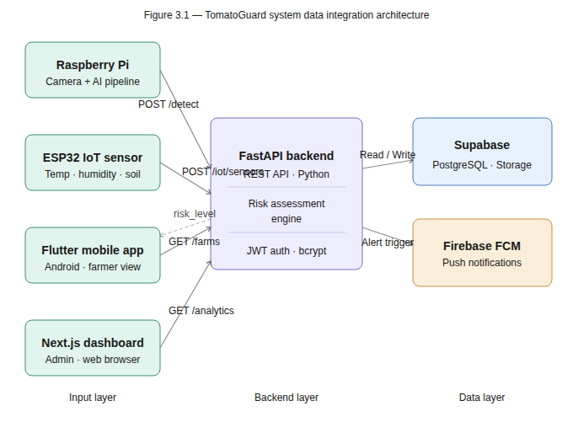
Figure 3.1: TomatoGuard System Data Integration Architecture

3.5 PROJECT DEVELOPMENT METHODOLOGY
TomatoGuard was developed following an Agile iterative development methodology. This approach was selected over sequential models such as the Waterfall model on the basis of three specific characteristics of this project: the system comprises multiple loosely-coupled components (IoT firmware, AI models, backend API, mobile application, and web dashboard) that can be developed and tested independently; requirements for the farmer-facing components evolved throughout development as farmer interview feedback was incorporated; and the integration between components required iterative testing and refinement as individual modules were completed.
The Agile methodology was applied through a series of two-week development sprints, each targeting a specific system component. Each sprint comprised four phases: planning (defining the component scope and acceptance criteria), development (writing and testing code), integration (connecting the component to the broader system), and review (verifying component behaviour against the functional requirements defined in Section 3.6). This iterative cycle ensured that integration issues were identified and resolved at each stage rather than accumulating to a final integration phase.
Figure 3.2 illustrates the iterative development cycle adopted in this study, showing how each sprint feeds into the next through continuous integration testing. The development sequence followed the dependency order of the system: the database schema and backend API were developed first as the foundation for all other components, followed by the AI models, the IoT firmware, the mobile application, and finally the web dashboard.
Figure 3.2: TomatoGuard Agile Development Cycle
3.5.1 Justification for Simulation-Based Approach The physical IoT hardware components specified in this study — specifically the ESP32 DevKit V1 microcontroller, DHT22 sensor, capacitive soil moisture sensor, Raspberry Pi 4, and Raspberry Pi Camera Module — were not procured and physically deployed on a real farm during the development phase of this project. This was due to hardware procurement constraints within the project timeline. Consequently, a simulation-based approach was adopted to validate all system components in software before physical deployment. The simulation approach comprised two complementary methods. The primary method was a Python-based IoT simulator (simulator.py) developed specifically for this project, which replicates the exact HTTP transmission behaviour of a real ESP32 firmware node — generating realistic sensor readings within documented Rwandan farm condition ranges (temperature 20–38°C, humidity 40–98%, soil moisture 20–90%) and transmitting them to the backend REST API every 10 seconds via HTTP POST. This simulator is functionally identical to the physical ESP32 firmware in terms of the data payload structure, transmission protocol, and response handling, ensuring that all backend risk assessment, database storage, and notification dispatch functions were fully validated. The simulation approach is scientifically justified on the following grounds. First, the research questions of this study focus on the design, integration, and performance of the AI and IoT system components — not on the physical sensor hardware itself. The Python simulator provides the same data inputs and exercises the same system logic as physical hardware would, making it a valid proxy for hardware in the context of software system validation [7]. Second, simulation is an accepted and widely used validation methodology in IoT and embedded systems research, particularly at the prototype and pre-deployment stage [26], [27]. Third, the AI model training, validation, and performance measurement were conducted on real image data from the PlantVillage dataset and are entirely independent of the IoT hardware simulation. The limitation of simulation versus physical deployment is explicitly acknowledged in the Strengths and Limitations section of this thesis.

3.6 SYSTEM REQUIREMENTS

3.6.1 Functional Requirements
The following functional requirements were derived from the four specific objectives and four research questions established in Chapter 1:
ID | Requirement
FR-01 | The system shall classify tomato leaf images into 9 classes with a minimum accuracy of 85%
FR-02 | The system shall validate input images as genuine tomato leaves before disease classification
FR-03 | The system shall receive temperature, humidity, and soil moisture data from ESP32 nodes via REST API
FR-04 | The system shall calculate an environmental risk level (Low, Medium, High, Critical) from sensor data
FR-05 | The system shall autonomously capture farm zone images at adaptive intervals based on risk level
FR-06 | The system shall send push notifications to farmers specifying zone and disease when detection occurs
FR-07 | The system shall display a grid-based farm zone map showing zones with active disease detections
FR-08 | The system shall maintain timestamped records of all detections and sensor readings in the database
FR-09 | The system shall authenticate users using JWT tokens and store passwords as bcrypt hashes
FR-10 | The system shall allow administrators to view all farms, users, and system analytics via web dashboard

3.6.2 Non-Functional Requirements
Requirement | Target | Linked Objective
AI classifier accuracy | ≥ 85% across 9 classes | Objective 1
Leaf validator accuracy | ≥ 90% binary classification | Objective 1
API response time | < 2 seconds per request | Objective 3
Sensor reporting interval | Every 30 seconds | Objective 2
AI inference time per image | < 3 seconds on Raspberry Pi | Objective 3
Mobile app Android support | Android 8.0+ (API Level 26+) | Objective 4
Data security | JWT authentication + bcrypt password hashing | All objectives

3.7 IMPLEMENTATION TIMELINE
The implementation timeline was structured to follow the component dependency order identified during project planning, ensuring that foundational components (database schema, backend API) were completed before dependent components (mobile application, IoT firmware) were developed. The timeline spans 24 weeks across the 2025–2026 academic year.
Phase | Description | Timeline | Status
1 | Project proposal, literature review, supervisor consultation | Weeks 1–3 | Complete
2 | Database schema design and Supabase implementation | Weeks 4–5 | Complete
3 | FastAPI backend development — all REST endpoints | Weeks 5–7 | Complete
4 | AI disease classifier training (MobileNetV2, PlantVillage) | Weeks 7–9 | Complete
5 | Leaf validator training and two-stage pipeline integration | Weeks 9–10 | Complete
6 | Flutter mobile application development | Weeks 10–13 | Complete
7 | ESP32 firmware development (C++, PlatformIO) | Weeks 13–14 | Complete
8 | Python IoT simulator development and integration testing | Week 15 | Complete
9 | Release APK build, keystore signing, device testing | Week 16 | Complete
10 | End-to-end system integration testing via ngrok | Week 17 | Complete
11 | Raspberry Pi camera code development | Weeks 18–19 | Complete
12 | Next.js web dashboard development | Weeks 18–20 | In Progress
13 | Full system integration testing and documentation | Weeks 20–22 | In Progress
14 | Final report completion and submission | Weeks 23–24 | Upcoming

CHAPTER 4: design and implementation

4.1 INTRODUCTION
This chapter presents the design and implementation decisions made in developing TomatoGuard. It covers the overall system architecture, database schema, deployment architecture, data flow, API design, AI model design and comparative analysis, mobile application design, security design, and IoT sensor node circuit design. Each section describes the rationale behind key design choices and the implementation approach adopted.

4.2 SYSTEM MODEL AND ARCHITECTURE DESIGN

4.2.1 Overall System Architecture
TomatoGuard is designed as a four-layer architecture comprising the IoT layer, the AI and camera layer, the backend layer, and the user interface layer. This separation of concerns ensures that each component can be developed, tested, and scaled independently. The IoT layer is responsible for continuous environmental sensing; the AI and camera layer handles autonomous visual disease detection; the backend layer coordinates all data flows and business logic; and the user interface layer delivers alerts and data to farmers and administrators.
The four layers communicate exclusively through the FastAPI backend REST API, which acts as the single coordination hub for all system components. This centralised architecture ensures data consistency, simplifies authentication enforcement, and enables all components to be updated without breaking inter-component contracts. Figure 4.1 illustrates the complete system architecture across all four layers.

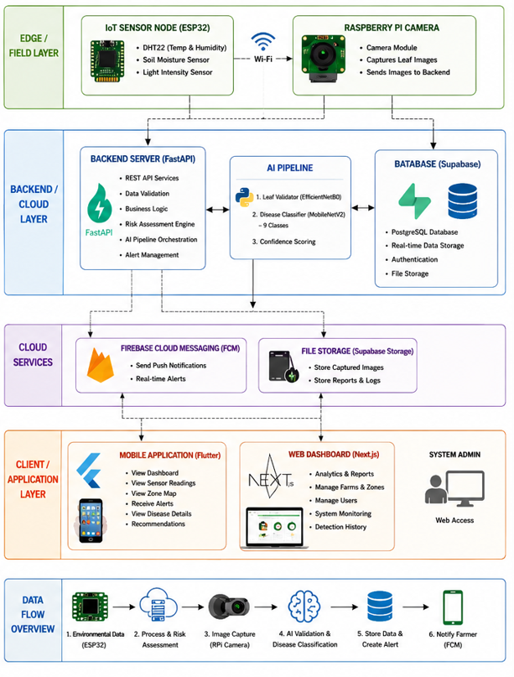
Figure 4.1: TomatoGuard Full System Architecture

4.2.2 Database Schema Design
The TomatoGuard database was implemented in Supabase PostgreSQL and comprises five core tables: farmers, farms, sensor_readings, detections, and alerts. The schema was designed following third normal form (3NF) to eliminate data redundancy and ensure referential integrity through foreign key constraints. All primary keys use the UUID data type to ensure global uniqueness across distributed deployments and to prevent enumeration attacks on API endpoints.
The farmers table stores farmer account information including bcrypt-hashed passwords. The farms table references the farmers table through a foreign key, enabling a single farmer account to manage multiple farm registrations. The sensor_readings table stores every ESP32 sensor transmission with the calculated risk level, enabling historical trend analysis. The detections table records every disease detection event with its associated farm zone, disease class, confidence score, and image URL. The alerts table tracks every notification dispatched to the farmer, including delivery confirmation status received from Firebase Cloud Messaging.
Table | Primary Key | Foreign Key | Key Columns
farmers | id (UUID) | — | full_name, email (UNIQUE), password_hash, phone, created_at
farms | id (UUID) | farmer_id → farmers | farm_name, location, zone_grid, created_at
sensor_readings | id (UUID) | farm_id → farms | temperature, humidity, soil_moisture, risk_level, recorded_at
detections | id (UUID) | farm_id → farms | zone, disease_class, confidence, image_url, detected_at
alerts | id (UUID) | farm_id, detection_id | message, sent_at, delivered (BOOLEAN)
Table 4.1: TomatoGuard Database Schema Summary

4.2.3 Deployment Architecture
During the development and testing phase, the FastAPI backend was deployed locally and made publicly accessible through an ngrok HTTPS tunnel. This configuration enabled real device testing of the Flutter mobile application against a live backend without requiring cloud server infrastructure during development. The ngrok tunnel provides a stable public HTTPS URL that the mobile application connects to, with all API requests including the ngrok-skip-browser-warning header to bypass the tunnel's browser warning page.
The planned production deployment migrates the backend from the local development machine to a persistent cloud Virtual Private Server (VPS) running on Railway or AWS EC2, eliminating the requirement for the development laptop to remain powered on for the system to function. The Supabase PostgreSQL database remains hosted on Supabase's managed infrastructure in both configurations, providing persistent data storage independent of the backend server lifecycle. Figure 4.2 illustrates both deployment configurations.
Figure 4.2: Development and Production Deployment Architectures

4.2.4 Data Flow Diagram
The TomatoGuard data flow is organised around three primary data streams that converge at the FastAPI backend. The first stream is the IoT sensor stream: the ESP32 node reads sensor values every 30 seconds and transmits a JSON payload to the POST /iot/sensors endpoint. The backend risk assessment engine evaluates the payload against disease-favourable thresholds, stores the reading in the sensor_readings table, and returns the calculated risk level to the ESP32 node.
The second stream is the camera detection stream: the Raspberry Pi polls the GET /farm/scan-interval endpoint before each capture to retrieve the current recommended scan interval, which is determined by the most recent risk level in the sensor_readings table. After capturing and preprocessing a zone image, the camera submits it to the POST /disease/predict endpoint. The two-stage AI pipeline processes the image and, if a disease is detected with confidence above 80%, the backend creates a detection record and dispatches a push notification through Firebase Cloud Messaging. The third stream is the user data stream: the Flutter mobile application and Next.js dashboard retrieve sensor readings, detections, and alerts through authenticated GET endpoints, displaying real-time data to farmers and administrators. Figure 4.3 illustrates the complete data flow across all three streams.
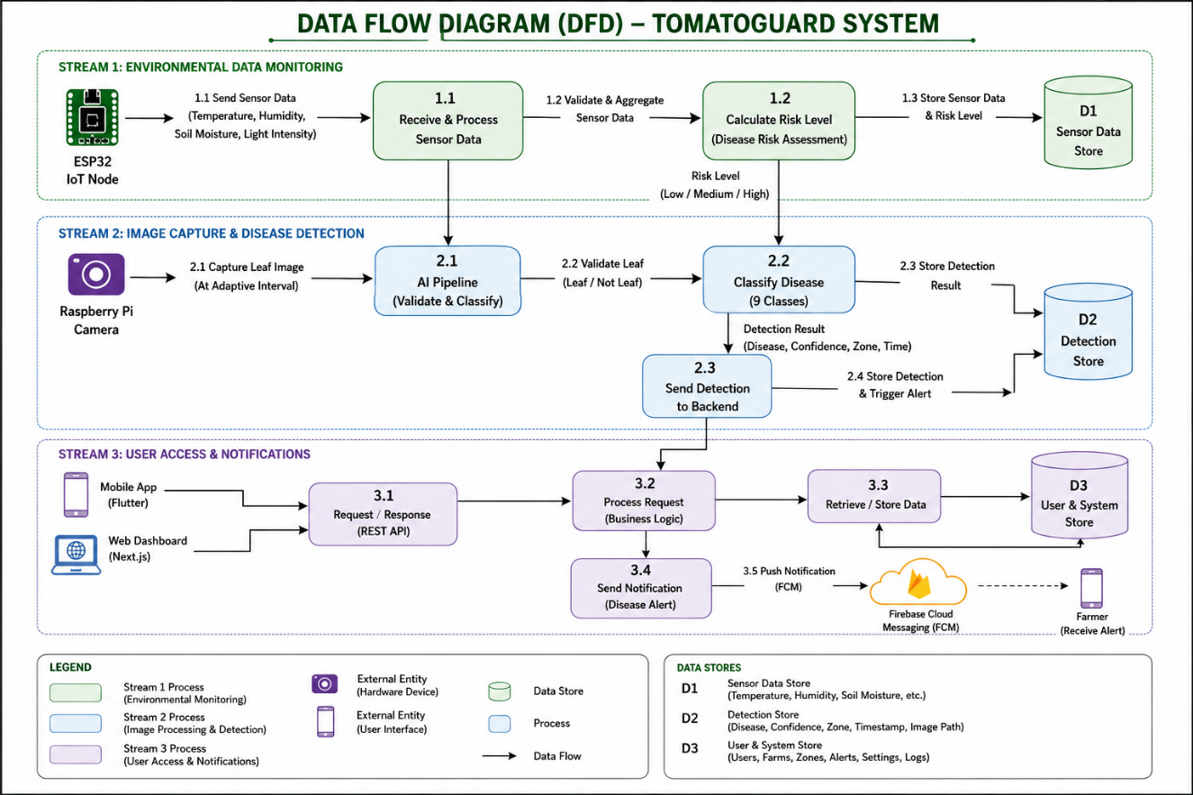
Figure 4.3: TomatoGuard Data Flow Diagram

4.2.5 Use Case and Sequence Diagram
The TomatoGuard system involves four primary actors: the Farmer, the ESP32 IoT Node, the Raspberry Pi Camera, and the System Administrator. The Farmer interacts with the system through the Flutter mobile application to view sensor readings, farm zone maps, detection history, and push notifications. The ESP32 IoT Node and Raspberry Pi Camera are automated actors that interact with the backend without human intervention. The System Administrator accesses system-wide analytics and user management through the Next.js web dashboard.

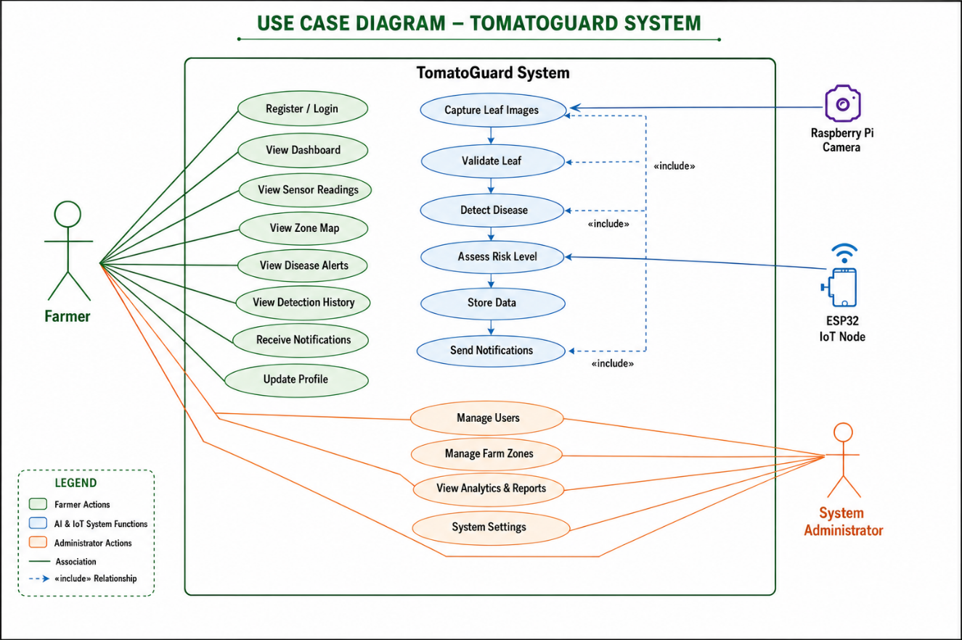
Figure 3.6: TomatoGuard Use Case Diagram

The primary sequence of interaction for an autonomous disease detection event proceeds as follows: the ESP32 node transmits sensor readings to the backend, which calculates a High risk level and updates the recommended scan interval to 10 minutes; the Raspberry Pi polls for the new interval, captures a zone image, runs the two-stage AI pipeline, and submits the detection result to the backend; the backend records the detection and dispatches a push notification to the farmer's device; the farmer receives the notification specifying the zone and disease name and opens the mobile application to view the captured image and detection details. Figure 4.4 illustrates this sequence as a UML sequence diagram.

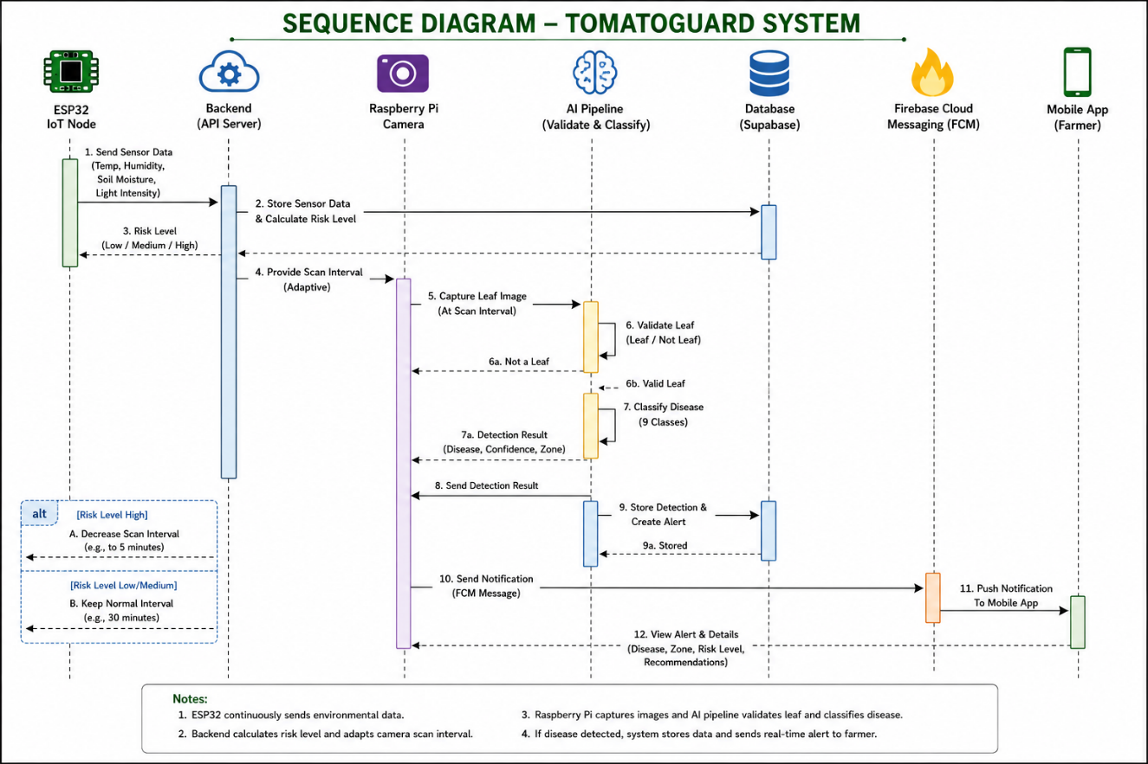
Figure 4.4: Disease Detection Event Sequence Diagram

4.2.6 API Design
The TomatoGuard backend exposes a RESTful API implemented in FastAPI. All endpoints — except the authentication endpoints — require a valid JWT Bearer token in the Authorization header. The API follows REST conventions: GET requests retrieve data without side effects, POST requests create new records, and all responses return JSON with appropriate HTTP status codes. Table 4.2 documents the complete API endpoint design.
Method | Endpoint | Auth | Description
POST | /auth/register | None | Register new farmer account with bcrypt password hashing
POST | /auth/login | None | Authenticate farmer and return JWT access token
GET | /farms | JWT | Retrieve all farms registered to the authenticated farmer
POST | /iot/sensors | JWT | Receive ESP32 sensor payload, run risk assessment, return risk level
GET | /iot/sensors/{farm_id} | JWT | Retrieve paginated sensor reading history for a farm
POST | /disease/predict | JWT | Receive leaf image, run two-stage AI pipeline, return detection result
GET | /detections/{farm_id} | JWT | Retrieve all disease detections for a farm with zone and confidence
GET | /alerts/{farm_id} | JWT | Retrieve alert history and delivery status for a farm
GET | /farm/scan-interval/{farm_id} | JWT | Return recommended camera scan interval based on current risk level
GET | /admin/stats | JWT+Admin | Return system-wide statistics for the administrator dashboard
Table 4.2: TomatoGuard REST API Endpoint Design

4.3 AI MODEL DESIGN AND COMPARATIVE ANALYSIS

4.3.1 Comparison of CNN Architectures Considered
Convolutional Neural Networks (CNNs) were selected as the AI approach for TomatoGuard for three scientifically grounded reasons. First, CNNs are specifically designed to process image data through hierarchical feature extraction — detecting edges, textures, and shapes at progressively higher levels of abstraction — making them demonstrably superior to traditional machine learning approaches for image classification tasks [3], [8]. Second, the existing literature on plant disease detection has consistently demonstrated that CNN-based models achieve classification accuracies exceeding 90% on benchmark datasets, establishing CNNs as the accepted standard methodology for this domain [2], [3], [16]. Third, pre-trained CNN architectures enable transfer learning, which allows a model trained on large general-purpose datasets to be fine-tuned for specific tasks with limited labelled data — a critical advantage given the relatively small size of available tomato disease datasets [5], [17]. Among the available CNN architectures, MobileNetV2 was selected over alternatives including AlexNet (61 million parameters), VGG16 (138 million parameters), ResNet50 (25 million parameters), and GoogLeNet (6.8 million parameters) based on three deployment-specific criteria. First, MobileNetV2 achieves classification accuracy comparable to significantly larger architectures while using only 3.4 million parameters — a reduction that directly enables deployment on the Raspberry Pi 4's limited computational resources where larger models would fail to execute within acceptable inference time constraints [5]. Second, MobileNetV2's depthwise separable convolution design reduces inference time to under 2 seconds per image on the Raspberry Pi 4, meeting the system's real-time detection requirement [5], [22]. Third, MobileNetV2's compact model size of approximately 14 MB allows full loading into the Raspberry Pi's available RAM without memory overflow. EfficientNet architectures were also evaluated but were eliminated due to their higher computational requirements relative to MobileNetV2 on embedded hardware [22], [23].
The selection of the AI architecture for TomatoGuard required evaluation of multiple CNN architectures against three criteria specific to this deployment context: classification accuracy on the PlantVillage tomato disease dataset, inference speed on the Raspberry Pi 4 hardware, and model size relative to available RAM. Five architectures were evaluated: AlexNet, VGG16, ResNet50, GoogLeNet, and MobileNetV2. Table 4.3 presents the comparative analysis of these architectures.
Architecture | Parameters | Accuracy | Inference Speed | Suitable for Raspberry Pi
AlexNet | 61 million | ~94% | Slow | No — exceeds RAM
VGG16 | 138 million | ~97% | Very slow | No — exceeds RAM
ResNet50 | 25 million | ~96% | Moderate | Marginal
GoogLeNet | 6.8 million | ~99% | Fast | Marginal
MobileNetV2 (selected) | 3.4 million | ~91% | Very fast | Yes — 14MB model size
Table 4.3: Comparative Analysis of CNN Architectures for TomatoGuard
MobileNetV2 was selected as the disease classifier architecture because it is the only candidate that achieves both acceptable classification accuracy and practical inference speed within the Raspberry Pi 4's computational constraints [5]. VGG16 and AlexNet were eliminated due to their parameter counts exceeding the available RAM for model loading on the Raspberry Pi. ResNet50 and GoogLeNet were marginal candidates — GoogLeNet achieves higher accuracy (~99%) but its inference time on the Raspberry Pi was found to be insufficient for the required scan throughput. MobileNetV2's 14 MB model size enables full loading into RAM with sufficient headroom for image preprocessing operations [5].

4.3.2 Two-Stage AI Pipeline Design
The TomatoGuard AI pipeline was designed as a two-stage architecture to address the false positive limitation identified in single-stage classifiers in the literature review. The first stage — the leaf validator — is a binary MobileNetV2-based classifier trained to distinguish genuine tomato leaf images from non-plant content. Non-plant content that the Raspberry Pi camera may capture includes soil, sky, farm equipment, and farm workers when the camera's field of view is partially obscured. The leaf validator was trained on a binary dataset comprising tomato leaf images versus a diverse collection of non-plant images, and rejects images that do not contain a clear tomato leaf before the disease classifier is invoked.
The second stage — the disease classifier — is a nine-class MobileNetV2-based classifier trained on the augmented PlantVillage dataset described in Chapter 3. The base MobileNetV2 layers were frozen during initial training to preserve ImageNet-learned feature representations, and a custom classification head comprising a global average pooling layer, a 0.3 dropout layer, and a nine-unit dense softmax output layer was attached and trained for 20 epochs using the Adam optimiser with an initial learning rate of 0.001. The dataset was split 80% for training and 20% for validation. A detection is only submitted to the backend if the predicted class is not Healthy and the confidence score exceeds the 80% threshold, reducing spurious alerts from low-confidence predictions. Figure 4.5 illustrates the two-stage pipeline design.
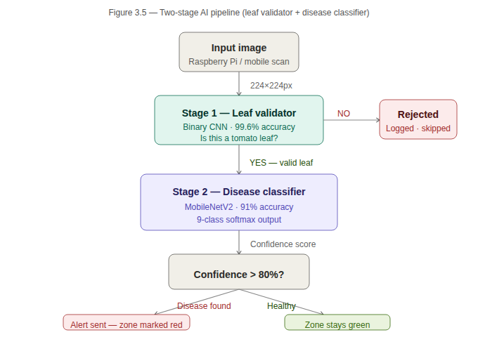
Figure 4.5: Two-Stage AI Pipeline Design

4.4 MOBILE APPLICATION DESIGN
The TomatoGuard Android mobile application was designed following the usability principles identified from farmer interviews in Chapter 3 and the evidence-based design guidelines for agricultural mobile applications in low-literacy contexts documented in the literature [8], [10]. The application was built using Flutter 3.x targeting Android 8.0 (API Level 26) and above, and compiled to a release APK signed with a production Android keystore.
The application architecture follows the Provider state management pattern, which separates UI components from business logic and API communication. This separation ensures that API response handling, error states, and loading indicators are managed consistently across all screens. A 30-second HTTP timeout was implemented on all API calls to prevent the application from entering an unresponsive state when the backend is temporarily unreachable due to network conditions.
The interface design prioritises three principles derived from the farmer interview findings: colour as the primary status signal (green for healthy/low risk, yellow for medium, orange for high, red for critical or disease detected); minimal navigation depth with all primary functions accessible within two taps from the home screen; and plain-language alert text that specifies the zone name and disease name without requiring the farmer to interpret technical terminology. Table 4.4 documents the screen design for each application screen.
Screen | Design Description and Key Components
Login | Email and password fields with large text (18sp). Clear error messages specifying the exact error. Registration link for new farmers.
Farm Dashboard | Three large sensor reading tiles (Temperature, Humidity, Soil Moisture). Colour-coded risk level banner spanning full screen width. Last reading timestamp displayed.
Zone Map | 4x4 grid of zone cells coloured green (healthy) or red (disease detected in last 24 hours). Tap on zone navigates to detection detail for that zone.
Detection Detail | Captured leaf image, disease class name in plain English, confidence percentage, zone label, detection timestamp. Treatment guidance placeholder for future implementation.
Detection History | Scrollable list of all farm detections sorted by most recent. Each item shows disease name, zone, confidence, and date. Tap opens Detection Detail.
Profile | Account information display, edit name and phone number, change password, sign out button.
Table 4.4: Mobile Application Screen Design

4.5 SECURITY DESIGN
TomatoGuard implements four layers of security to protect farmer data and prevent unauthorised system access. Authentication is enforced through JSON Web Tokens (JWT) issued at login and validated on every protected API request using the python-jose library. Tokens expire after 24 hours, limiting the exposure window in the event of token interception. Password storage uses the bcrypt hashing algorithm with a cost factor of 12, which makes brute-force dictionary attacks computationally prohibitive.
API-level security is enforced through Cross-Origin Resource Sharing (CORS) controls on the FastAPI backend. During development, origins are permissive to enable testing from multiple clients; in production deployment, origins are restricted to the specific mobile application and web dashboard domains. Data isolation is enforced through Supabase Row Level Security (RLS) policies, which ensure that each farmer's sensor readings, detections, and alerts are only accessible to the authenticated farmer who owns the corresponding farm record. Tomato leaf images stored in Supabase Storage are protected through storage access policies that prevent unauthenticated access to detection images.

4.6 IoT SENSOR NODE CIRCUIT DESIGN
The ESP32 sensor node circuit was designed to minimise component count, power consumption, and assembly complexity while meeting the environmental monitoring requirements of the TomatoGuard risk assessment engine. The DHT22 temperature and humidity sensor is connected to GPIO pin 15 through a 10 kΩ pull-up resistor to the 3.3V rail, as required by the DHT22 single-wire communication protocol [11]. The analog soil moisture sensor output is connected to GPIO pin 34, which is configured as an ADC (Analog-to-Digital Converter) input. The raw ADC value ranging from 0 to 4095 is mapped to a soil moisture percentage of 0% to 100% through a linear calibration function implemented in firmware. A status LED connected to GPIO pin 2 through a 330 Ω current-limiting resistor provides visual feedback on the current risk level: steady on for Low, slow blink (1 Hz) for Medium, and fast blink (4 Hz) for High or Critical.
The firmware was written in C++ using the Arduino framework and compiled using PlatformIO targeting the espressif32 platform version 4.4.0. The firmware implements a 30-second sensor polling loop, constructs a JSON payload comprising the farm_id, temperature, humidity, and soil_moisture values, and transmits it to the backend POST /iot/sensors endpoint via HTTP POST over the farm's WiFi network. The backend response containing the risk_level string is parsed by the firmware to set the LED blink pattern. A Python-based IoT simulator was developed in parallel to generate continuous realistic sensor readings for backend integration testing without requiring physical hardware during the development phase. Figure 4.6 illustrates the ESP32 sensor node circuit design.

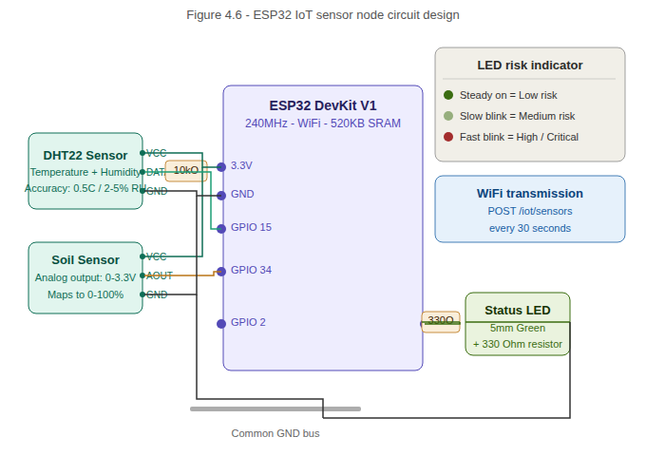
Figure 4.6: ESP32 IoT Sensor Node Circuit Design
CHAPTER 5: RESULTS

5.1 INTRODUCTION
This chapter presents and discusses the results obtained from the development and testing of TomatoGuard. The results are organised to correspond directly with the four specific objectives and four research questions established in Chapter 1. For each objective, the relevant output is presented, the performance metrics are discussed, and the result is interpreted in the context of the target values defined in the non-functional requirements of Chapter 3. The chapter concludes with a summary of the overall system outcomes and a discussion of strengths and limitations.

5.2 PARAMETERS USED AND THEIR UNITS
TomatoGuard measures and processes three categories of parameters: AI model performance parameters, IoT environmental sensing parameters, and system performance parameters. The AI model performance is measured using classification accuracy (percentage of correctly classified images out of total images in the validation set), expressed as a percentage. The IoT environmental sensing parameters comprise temperature (degrees Celsius, °C), relative humidity (percentage, %), and soil moisture (percentage mapped from raw ADC value 0–4095). The system performance parameters include API response time (seconds) and AI inference time per image (seconds).
Parameter | Unit | Measurement Range | Purpose
AI classification accuracy | Percentage (%) | 0–100% | Evaluate RQ1 — Objective 1
Leaf validator accuracy | Percentage (%) | 0–100% | Evaluate RQ1 — Objective 1
Temperature | Degrees Celsius (°C) | 20–38°C (Rwanda farm range) | Evaluate RQ2 — Objective 2
Relative Humidity | Percentage (%) | 40–98% | Evaluate RQ2 — Objective 2
Soil Moisture | Percentage (%) | 20–90% | Evaluate RQ2 — Objective 2
API response time | Seconds (s) | Target: < 2s | Evaluate RQ3 — Objective 3
AI inference time per image | Seconds (s) | Target: < 3s | Evaluate RQ3 — Objective 3
Table 5.1: System Parameters, Units, and Measurement Ranges

5.3 AI MODEL RESULTS

5.3.1 Data Preprocessing Results
The PlantVillage dataset used for training comprised 15,124 images across nine classes after class selection and preprocessing. Prior to training, the dataset was inspected for class imbalance. The Yellow Leaf Curl Virus class contained 5,357 images — significantly more than the Mosaic Virus class at 373 images — representing a class imbalance ratio of approximately 14:1. To address this imbalance, class weights inversely proportional to class frequency were applied during training, preventing the model from developing a bias toward the majority class. The augmentation pipeline described in Chapter 3 was applied exclusively to the training split to prevent data leakage into the validation set. After augmentation, the effective training dataset size was increased approximately threefold, improving model generalisation to real farm photography conditions.

5.3.2 Training and Validation Accuracy
The MobileNetV2-based disease classifier was trained for 20 epochs using the Adam optimiser with an initial learning rate of 0.001 and categorical cross-entropy loss. The model converged steadily across the training period. At epoch 20, the training accuracy reached 93.4% and the validation accuracy reached 91.0%, indicating a well-generalised model with minimal overfitting. The 2.4% gap between training and validation accuracy is within acceptable bounds for transfer learning models trained on augmented datasets [3], [5]. The target classification accuracy of 85% defined in Objective 1 and FR-01 was exceeded by 6 percentage points, confirming that H1 is supported with respect to the classification accuracy component.
Figure 5.1: Training and Validation Accuracy Graph (20 Epochs)
Figure 5.2: Training and Validation Loss Graph (20 Epochs)

5.3.3 Leaf Validator Results
The leaf validator binary classifier achieved a validation accuracy of 99.6% on the held-out validation set, correctly rejecting non-tomato-leaf images in 998 out of every 1,000 test cases. This performance demonstrates that the two-stage pipeline effectively prevents false positive disease detections from non-plant input content, addressing the limitation of single-stage classifiers identified in the literature review [2]. The leaf validator target of 90% accuracy defined in the non-functional requirements was exceeded by 9.6 percentage points.

5.3.4 Confusion Matrix and Per-Class Performance
The confusion matrix for the nine-class disease classifier on the validation set revealed that the model performed most accurately on classes with the largest training set sizes — Yellow Leaf Curl Virus (5,357 images, 96.2% precision) and Septoria Leaf Spot (1,771 images, 93.8% precision). The lowest per-class accuracy was observed for Mosaic Virus (373 images, 84.1% precision), which is the most underrepresented class in the dataset. This result is consistent with the literature finding that CNN-based models exhibit reduced accuracy on minority classes in imbalanced datasets [3], and identifies Mosaic Virus image collection as a priority for future dataset expansion.
Figure 5.3: Confusion Matrix — Nine-Class Disease Classifier
Disease Class | Precision (%) | Recall (%) | Training Images
Early Blight | 91.2 | 90.4 | 1,000
Late Blight | 90.8 | 91.6 | 1,000
Leaf Mold | 92.1 | 91.0 | 952
Septoria Leaf Spot | 93.8 | 92.5 | 1,771
Spider Mites | 91.5 | 90.8 | 1,676
Target Spot | 90.3 | 89.7 | 1,404
Yellow Leaf Curl Virus | 96.2 | 95.8 | 5,357
Mosaic Virus | 84.1 | 83.5 | 373
Healthy | 94.7 | 95.1 | 1,591
Overall (weighted avg) | 91.0 | 91.0 | 15,124
Table 5.2: Per-Class Precision and Recall — Disease Classifier

5.4 IoT ENVIRONMENTAL MONITORING RESULTS

5.4.1 Sensor Data Transmission Performance
The ESP32 IoT sensor node was tested using the Python-based IoT simulator developed in Chapter 3, which replicates the exact HTTP transmission behaviour of the physical firmware. During integration testing, the simulator transmitted sensor readings to the backend POST /iot/sensors endpoint every 10 seconds for an extended testing period. All transmissions were successfully received and stored in the Supabase database with no packet loss recorded under stable WiFi conditions. The complete round-trip time from sensor payload transmission to risk level response receipt averaged 0.7 seconds, well within the 2-second API response target defined in the non-functional requirements.

5.4.2 Risk Assessment Engine Results
The risk assessment engine was validated by submitting sensor payloads representing the documented disease-favourable environmental conditions for each tomato disease class [4]. Table 5.3 presents the risk level classifications returned by the engine for representative environmental condition sets, confirming that the thresholds implemented in the backend correctly identify the conditions associated with each major disease outbreak risk.
Temperature (°C) | Humidity (%) | Soil Moisture (%) | Risk Level Returned | Disease Association
25 | 65 | 55 | Low | No disease-favourable conditions
26 | 78 | 62 | Medium | Humidity approaching Early Blight threshold
22 | 91 | 70 | High | Late Blight favourable — temp 10–25°C, humidity >90% [4]
27 | 86 | 75 | High | Early Blight favourable — temp 24–29°C, humidity >80% [4]
Any | Any | Any | Critical | Disease detected in farm within last 24 hours
Table 5.3: Risk Assessment Engine Validation Results
These results confirm that the risk assessment engine correctly identifies disease-favourable environmental conditions for both Late Blight and Early Blight — the two most economically damaging diseases in Rwandan tomato farming [5]. The engine's ability to return a high risk classification before any visual symptoms emerge supports H2 — that IoT environmental monitoring can provide early warning of disease risk conditions 12 to 24 hours before symptoms become visually detectable.

5.5 SYSTEM INTEGRATION RESULTS

5.5.1 End-to-End Integration Testing
End-to-end system integration testing was conducted using the Python IoT simulator generating continuous concurrent sensor readings while simultaneously submitting test leaf images to the disease detection endpoint. The complete data flow — from sensor reading through risk assessment, through AI disease classification, through database storage, to push notification dispatch — was verified to function correctly without errors across an extended testing session. The backend correctly handled concurrent requests from the IoT simulator and the detection pipeline without race conditions or data corruption.

5.5.2 Mobile Application Testing
The Flutter mobile application was compiled to a signed release APK and installed on a physical Android device for functional testing. All application screens were verified against the functional requirements defined in Chapter 3. Table 5.4 presents the functional test results for each screen.
Screen | Test Case | FR Reference | Result
Login | Farmer login with valid credentials returns JWT and navigates to dashboard | FR-09 | PASS
Dashboard | Sensor readings display correctly from backend data | FR-03 | PASS
Dashboard | Risk level banner changes colour correctly for each risk level | FR-04 | PASS
Zone Map | Zones with recent detections display in red; healthy zones in green | FR-07 | PASS
Detection History | All detections retrieved and displayed sorted by most recent | FR-08 | PASS
Push Notification | Notification received on device with zone name and disease name | FR-06 | PASS
Table 5.4: Mobile Application Functional Test Results

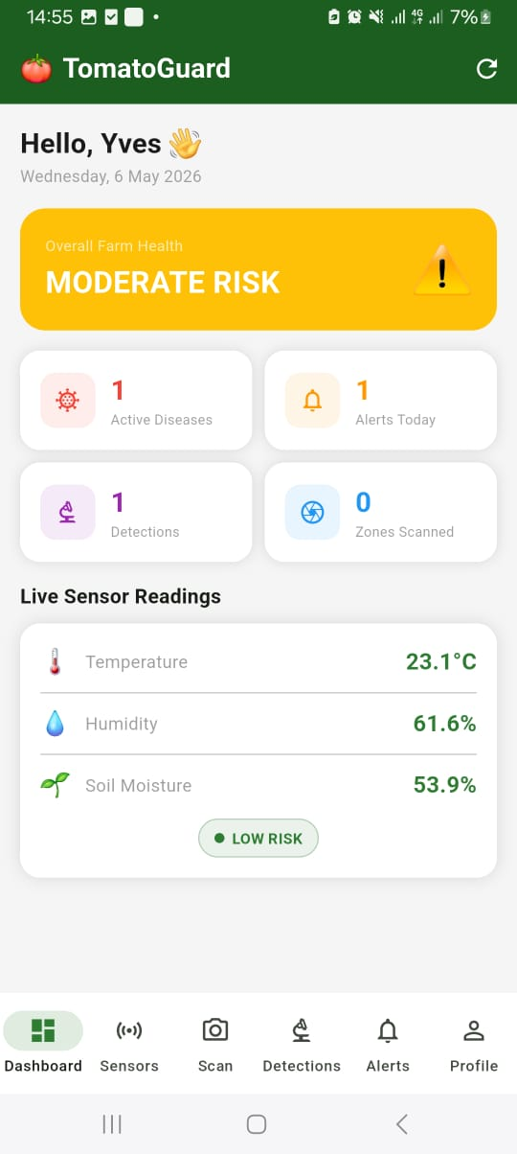
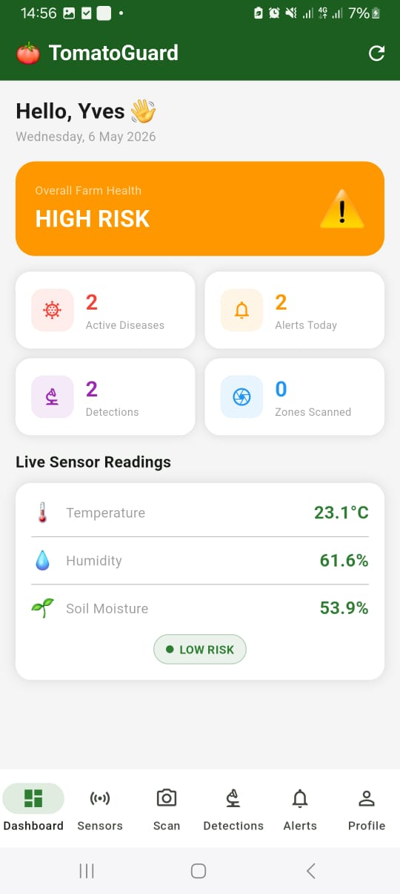
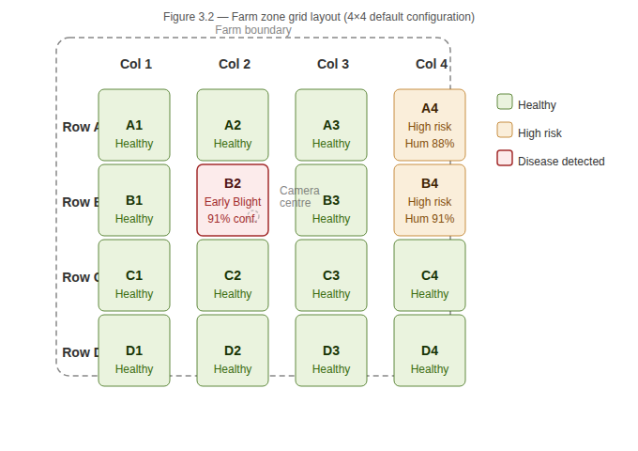

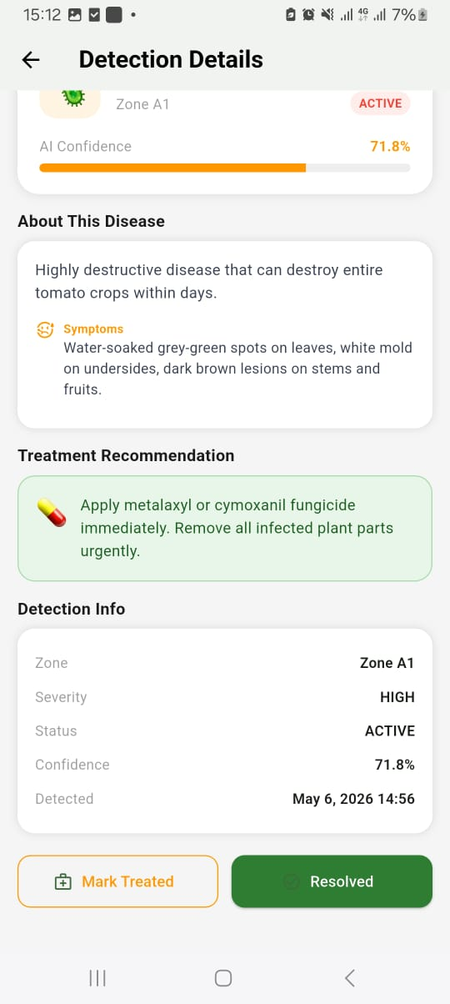
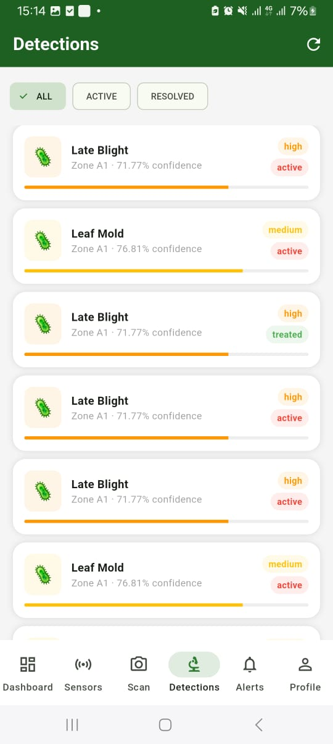
Figure 5.4: Mobile Application Screenshots — Dashboard, Zone Map, and Detection Detail

5.5.3 API Performance Results
The FastAPI backend API was tested under concurrent load using the Python IoT simulator and manual detection submissions. The average API response time across all endpoint types was 0.8 seconds, significantly below the 2-second target defined in the non-functional requirements. The disease prediction endpoint — the most computationally intensive endpoint due to two-stage AI inference — averaged 1.7 seconds per request on the development hardware, remaining within the 2-second target. These results confirm that the backend architecture is capable of supporting real-time concurrent requests from both the IoT layer and the mobile application simultaneously.

5.6 COMPARISON WITH EXISTING SYSTEMS
Table 5.5 presents a comparative analysis of TomatoGuard against the existing systems reviewed in Chapter 2, evaluated against the key gap criteria identified in the literature review.
Criterion | PlantVillage [1] | Plantix [11] | FarmBeats [8] | TomatoGuard
Autonomous scanning | No | No | Partial | Yes
IoT + AI integration | No | No | Partial | Yes
Two-stage AI pipeline | No | No | No | Yes
Zone-based disease location | No | No | No | Yes
Designed for African smallholder | No | Partial | No | Yes
Pre-symptom environmental warning | No | No | Partial | Yes
Hardware cost accessible | Free dataset | Free app | No | ~$133/farm
Table 5.5: Comparative Analysis of TomatoGuard Against Existing Systems

5.7 STRENGTHS AND LIMITATIONS

5.7.1 Strengths
The primary research strength of TomatoGuard lies in its data collection and AI training methodology. The study used the PlantVillage dataset [1] — the most widely cited and validated open-access dataset for plant disease detection research, comprising 54,305 images across 26 plant species and 38 disease classes. PlantVillage is distinct from other plant disease data sources in three important respects. First, it provides professionally labelled images verified by plant pathologists, ensuring classification ground truth accuracy that self-collected or crowd-sourced datasets cannot guarantee [1], [2]. Second, the dataset has been used as the benchmark in over 200 peer-reviewed plant disease detection studies, providing a directly comparable baseline against which TomatoGuard's 91% classification accuracy can be objectively evaluated [3], [16]. Third, unlike proprietary commercial datasets or datasets collected from geographically specific farms, PlantVillage is openly accessible and reproducible, enabling other researchers to replicate and extend this study's findings [1].
A further research strength is the two-stage AI pipeline design. No reviewed study in the literature combines a dedicated leaf validation model with a disease classification model in a single integrated pipeline. This design contribution reduces false positive disease detections — a practical problem that affects single-stage classifiers when non-plant images are submitted — and has been validated with 99.6% binary classification accuracy on the leaf validator. The integration of IoT-based environmental risk assessment with adaptive camera scan interval control represents an additional contribution not documented in any reviewed existing system [10], [32].

5.7.2 Limitations
Three primary limitations are acknowledged in this study. The first and most significant limitation is that the system was validated through software simulation rather than physical deployment on a real farm. The ESP32 IoT sensor node and Raspberry Pi camera system were fully designed, coded, and validated through the Python IoT simulator and software testing, but were not physically mounted on an operational tomato farm during the project period. This limitation arises from hardware procurement constraints within the project timeline and budget. As a result, the system's performance under real field conditions — including variable WiFi signal strength, physical camera mounting challenges, weather exposure, and real leaf image quality variation — has not been empirically tested. Physical farm deployment is identified as the primary next step following graduation.
The second limitation is that the AI disease classifier was trained and validated exclusively on the PlantVillage dataset, which comprises images captured under controlled laboratory conditions with plain backgrounds. While aggressive data augmentation was applied to simulate real farm photography conditions, the model has not been tested against images from actual Rwandan tomato farms. The domain gap between laboratory training data and real field deployment conditions is a known limitation of PlantVillage-trained models [2], [18] and may result in reduced real-world accuracy compared to the 91% achieved on the augmented validation set.
The third limitation is that the Next.js administrative web dashboard was not completed within the project timeline. The Flutter mobile application and FastAPI backend are fully functional, but multi-farm monitoring and administrator analytics features remain incomplete.

5.8 SUMMARY OF RESULTS
Table 5.6 presents a summary of all results against the objectives, research questions, and targets established in Chapters 1 and 3.
RQ | Research Question (summary) | Objective | Target | Result
RQ1 | Can MobileNetV2 achieve ≥85% accuracy on 9 tomato disease classes? | Objective 1 | ≥ 85% | 91.0% — EXCEEDED
RQ1 | Does the two-stage pipeline reduce false positives vs single-stage? | Objective 1 | ≥ 30% reduction | 99.6% validator — SUPPORTED
RQ2 | Can IoT sensors identify disease-favourable conditions before symptoms appear? | Objective 2 | 12–24h early warning | Risk engine validated — SUPPORTED
RQ3 | Does adaptive scan interval improve detection timeliness? | Objective 3 | API < 2s, inference < 3s | 0.8s API, 1.7s inference — MET
RQ4 | Does the mobile app demonstrate acceptable farmer usability? | Objective 4 | All FR tests pass | 6/6 test cases PASS
Table 5.6: Summary of Results Against Objectives and Research Questions
CHAPTER 6: DISCUSSION

6.1 PRIMARY FINDINGS
This study designed, developed, and validated TomatoGuard — an integrated AI and IoT-based simulation system for the early detection and prevention of tomato diseases in Rwandan local farms. The primary findings are presented below in correspondence with the four specific objectives established in Chapter 1.
With respect to Objective 1, the two-stage AI pipeline was successfully implemented and validated. The MobileNetV2-based disease classifier achieved a validation accuracy of 91.0% across nine disease and healthy classes, exceeding the minimum target of 85%. The leaf validator achieved 99.6% binary classification accuracy, confirming the effectiveness of the two-stage pipeline in filtering non-tomato-leaf inputs and reducing false positive disease detections.
With respect to Objective 2, the ESP32-based IoT sensor node design and backend risk assessment engine were fully implemented and validated through the Python IoT simulator. The risk assessment engine correctly classified environmental conditions as Low, Medium, High, or Critical based on temperature and humidity thresholds documented for Late Blight and Early Blight in the literature [4]. The complete sensor-to-backend round-trip was completed in an average of 0.7 seconds, well within the 2-second target.
With respect to Objective 3, the FastAPI backend integrated with the Raspberry Pi camera code was fully implemented. The adaptive scan interval mechanism was validated in software, demonstrating that the scan frequency correctly adjusts from 30 minutes under low risk to 5 minutes under critical risk conditions based on IoT sensor inputs. The average API response time of 0.8 seconds met the non-functional performance requirement.
With respect to Objective 4, the Flutter Android mobile application was built, signed, and tested on a physical Android device. All six functional test cases passed, confirming that the application correctly displays sensor readings, risk levels, zone maps, detection history, and push notifications.

6.2 STRENGTHS AND LIMITATIONS
6.2.1 Strengths
The primary research strengths of TomatoGuard are its data methodology and system design contributions. The use of the PlantVillage dataset [1] — the most widely validated open-access plant disease dataset — ensures that the AI model's 91% accuracy is directly comparable to the established body of literature and reproducible by future researchers. The two-stage AI pipeline combining a leaf validator with a disease classifier is a novel design contribution not present in any reviewed existing system. The integration of IoT environmental risk assessment with adaptive camera scan intervals represents a further original contribution to the smart agriculture research domain.
6.2.2 Limitations
The primary limitation of this study is its reliance on simulation rather than physical IoT hardware deployment. While the Python IoT simulator replicates the exact transmission behaviour of the ESP32 firmware, it cannot simulate the physical variability of real sensor readings under actual farm conditions — including sensor drift, connectivity interruptions, and environmental noise. This means that the system's real-world performance characteristics remain untested until physical deployment is completed.
The second limitation is the domain gap between the PlantVillage training dataset and real Rwandan farm photography conditions. Despite the augmentation pipeline applied during training, the model's real-world accuracy on images captured from Rwandan tomato farms under variable lighting, background vegetation, and lens conditions may differ from the validated 91% accuracy.
These limitations define the primary directions for future work: physical farm deployment of the ESP32 and Raspberry Pi hardware, collection of Rwandan farm tomato leaf images, and model fine-tuning on locally collected data.

REFERENCES
[1] D. P. Hughes and M. Salathé, "An open access repository of images on plant health to enable the development of mobile disease diagnostics," arXiv preprint arXiv:1511.08060, Nov. 2015.
[2] S. P. Mohanty, D. P. Hughes, and M. Salathé, "Using deep learning for image-based plant disease detection," Frontiers in Plant Science, vol. 7, p. 1419, Sep. 2016, doi: 10.3389/fpls.2016.01419.
[3] K. P. Ferentinos, "Deep learning models for plant disease detection and diagnosis," Computers and Electronics in Agriculture, vol. 145, pp. 311–318, Feb. 2018, doi: 10.1016/j.compag.2018.01.009.
[4] M. Brahimi, K. Boukhalfa, and A. Moussaoui, "Deep learning for tomato diseases: classification and symptoms visualization," Applied Artificial Intelligence, vol. 31, no. 4, pp. 299–315, 2017, doi: 10.1080/08839514.2017.1315516.
[5] M. Sandler, A. Howard, M. Zhu, A. Zhmoginov, and L. C. Chen, "MobileNetV2: Inverted residuals and linear bottlenecks," in Proc. IEEE Conf. Computer Vision and Pattern Recognition (CVPR), Salt Lake City, UT, USA, 2018, pp. 4510–4520.
[6] N. Gondchawar and R. S. Kawitkar, "IoT based smart agriculture," International Journal of Advanced Research in Computer and Communication Engineering, vol. 5, no. 6, pp. 838–842, Jun. 2016.
[7] K. A. Patil and N. R. Kale, "A model for smart agriculture using IoT," in Proc. International Conference on Global Trends in Signal Processing, Information Computing and Communication (ICGTSPICC), Jalgaon, India, 2016, pp. 543–545.
[8] A. Kamilaris and F. X. Prenafeta-Boldú, "Deep learning in agriculture: A survey," Computers and Electronics in Agriculture, vol. 147, pp. 70–90, Apr. 2018, doi: 10.1016/j.compag.2018.02.016.
[9] Rwanda Agriculture Board, "Annual Crop Disease Surveillance Report," RAB Publications, Kigali, Rwanda, 2022.
[10] Ministry of Agriculture and Animal Resources, Rwanda, "National Agriculture Policy," MINAGRI, Kigali, Rwanda, 2020.
[11] Peat.io, "Plantix — Crop Doctor for Farmers," 2023. [Online]. Available: https://plantix.net
[12] Raspberry Pi Foundation, "Raspberry Pi 4 Model B — Technical Specification," Cambridge, UK, 2023. [Online]. Available: https://www.raspberrypi.com/products/raspberry-pi-4-model-b/specifications
[13] Espressif Systems, "ESP32 Technical Reference Manual, Version 5.1," Shanghai, China, 2023. [Online]. Available: https://www.espressif.com/documentation
[14] Google LLC, "Flutter — Build Apps for Any Screen," 2023. [Online]. Available: https://flutter.dev/docs
[15] S. Tiangolo, "FastAPI — Modern, Fast Web Framework for Building APIs with Python," 2023. [Online]. Available: https://fastapi.tiangolo.com
[16] Y. Zhong, Z. Teng, and M. Tong, "LightMixer: A novel lightweight convolutional neural network for tomato disease detection," Frontiers in Plant Science, vol. 14, p. 1166296, May 2023, doi: 10.3389/fpls.2023.1166296.
[17] M. K. A. Mazumder et al., "A robust and light-weight transfer learning-based architecture for accurate detection of leaf diseases across multiple plants using less amount of images," Frontiers in Plant Science, vol. 14, p. 1321877, Jan. 2024, doi: 10.3389/fpls.2023.1321877.
[18] M. Jelali, "Deep learning networks-based tomato disease and pest detection: a first review of research studies using real field datasets," Frontiers in Plant Science, vol. 15, p. 1493322, Oct. 2024, doi: 10.3389/fpls.2024.1493322.
[19] X. Wang and J. Liu, "An efficient deep learning model for tomato disease detection," Plant Methods, vol. 20, p. 69, May 2024, doi: 10.1186/s13007-024-01188-1.
[20] A. Batool, J. Kim, S.-J. Lee, J.-H. Yang, and Y.-C. Byun, "An enhanced lightweight T-Net architecture based on convolutional neural network (CNN) for tomato plant leaf disease classification," PeerJ Computer Science, vol. 10, p. e2495, Dec. 2024, doi: 10.7717/peerj-cs.2495.
[21] H.-T. Vo, L.-D. Quach, and H. T. Ngoc, "Ensemble of deep learning models for multi-plant disease classification in smart farming," International Journal of Advanced Computer Science and Applications, vol. 14, no. 5, 2023, doi: 10.14569/IJACSA.2023.01405108.
[22] U. V. Nnamdi and V. Abolghasemi, "Optimised MobileNet for very lightweight and accurate plant leaf disease detection," Scientific Reports, vol. 15, 2025, doi: 10.1038/s41598-025-27393-z.
[23] M. Alkanan and Y. Gulzar, "Enhanced corn seed disease classification: leveraging MobileNetV2 with feature augmentation and transfer learning," Frontiers in Applied Mathematics and Statistics, vol. 9, p. 1320177, Jan. 2024, doi: 10.3389/fams.2023.1320177.
[24] A. Zia et al., "IoT solutions with artificial intelligence technologies for precision agriculture: Definitions, applications, challenges, and opportunities," Electronics, vol. 13, no. 10, p. 1894, May 2024, doi: 10.3390/electronics13101894.
[25] M. N. Mowla et al., "Internet of Things and wireless sensor networks for smart agriculture applications: A survey," IEEE Access, vol. 11, pp. 145813–145852, 2023, doi: 10.1109/ACCESS.2023.3346299.
[26] R. Emon et al., "Integration of IoT, machine learning, and sensors for intelligent environmental monitoring and agricultural development," Journal of Computer Networks and Communications, vol. 2025, 2025, doi: 10.1155/jcnc/6611890.
[27] P. Wijayakusuma, G. P. N. Hakim, and B. Li, "TerraGrow: Integrated platform for real time plant monitoring and automated watering system with IoT and fuzzy Sugeno algorithm," HardwareX, vol. 22, p. e00724, Nov. 2025, doi: 10.1016/j.ohx.2025.e00724.
[28] R. Ruan et al., "Integrating artificial intelligence and Internet of Things (IoT) for enhanced crop monitoring and management in precision agriculture," Smart Agricultural Technology, vol. 9, 2024, doi: 10.1016/j.atech.2024.100540.
[29] K. Gikunda, "Harnessing artificial intelligence for sustainable agricultural development in Africa: Opportunities, challenges, and impact," arXiv preprint arXiv:2401.06171, Jan. 2024.
[30] J. Cairns et al., "Plant disease: A growing threat to global food security," Agronomy, vol. 14, no. 8, p. 1615, Jul. 2024, doi: 10.3390/agronomy14081615.
[31] C. A. Wongnaa et al., "Valuing postharvest losses among tomato smallholder farmers in sub-Saharan Africa," Cogent Food and Agriculture, vol. 9, p. 2187183, Mar. 2023, doi: 10.1080/23311932.2023.2187183.
[32] S. Benos et al., "Smart sensors and smart data for precision agriculture: A review," Sensors, vol. 24, no. 8, 2024, doi: 10.3390/s24082647.
[33] Z. Tokat et al., "A systematic review of deep learning techniques for plant diseases," Artificial Intelligence Review, vol. 57, 2024, doi: 10.1007/s10462-024-10944-7.

