Assignment 4: Becoming an Independent Data Scientist

1. Region and Domain:

Beijing, Shanghai, Guangzhou, People’s Republic of China

Geographical issues: Air Quality (PM2.5 density)

1. Research Question:

During the past five years (2012-2016), how the air quality changes in three major China cities -- Beijing, Shanghai and Guangzhou.

1. Data resource:

Beijing: <http://www.stateair.net/web/historical/1/1.html>

Shanghai: <http://www.stateair.net/web/historical/1/4.html>

Guangzhou: <http://www.stateair.net/web/historical/1/3.html>

1. Image:

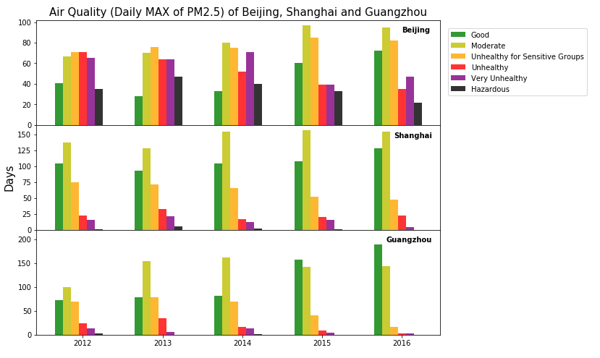

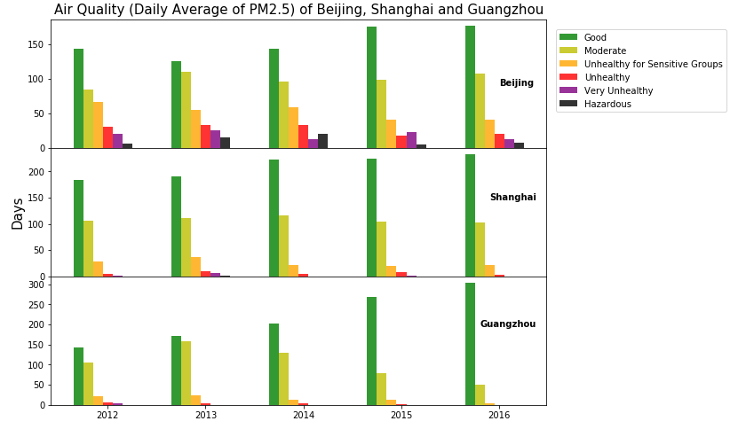

1. Discussion

In order to study the changes of PM2.5 density during the past 5 years (2012-2016), I downloaded the air quality data of three major china cities from Department of State website. The data contains the hourly PM2.5 density value from 2012 to 2016. I use the daily maximum value and the average value between 9:00am and 9:00pm of each day as the measurements. Each day is classified by Air Quality Index (AQI). The AQI is defined as follows:

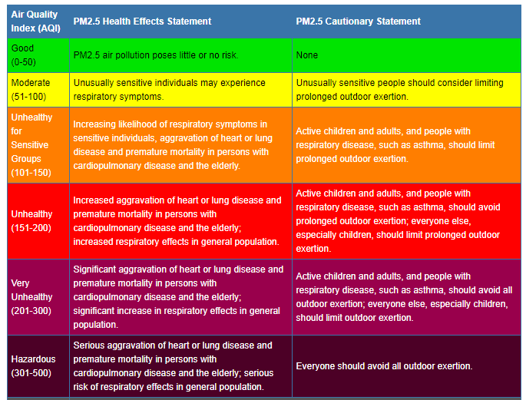

I compute the number of days with different AQI and generate two figures for each measurement. From these figures, we can see that Beijing, the biggest city in northern China, faces more severe air pollution than Shanghai and Guangzhou, which locate in the middle and the south of China, respectively. But all three cities have air pollution problem. Shanghai is a city near sea, where polluted air easily to disperse. However, it still experienced long period of ‘moderate’ days (over 100 days). From the figures, we also can find that the ‘good’ days of three cities increased in 2015 and 2016. In Beijing, the number of ‘Unhealthy’, ‘Very Unhealthy’ and ‘Hazardous’ days decreased. Based on the daily average value, the number of ‘good’ days of both Shanghai and Guangzhou were more than 200 days.