On the basis of the evaluation model based on entropy weight method mentioned above, we get the combinations of text-based measures and ratings-based measures, with the ignored influence of helpful votes.

We have chosen one product for each category as a sample to show how we determine whether a product potentially successful or failing.

The historical composite score of microwave is shown below：

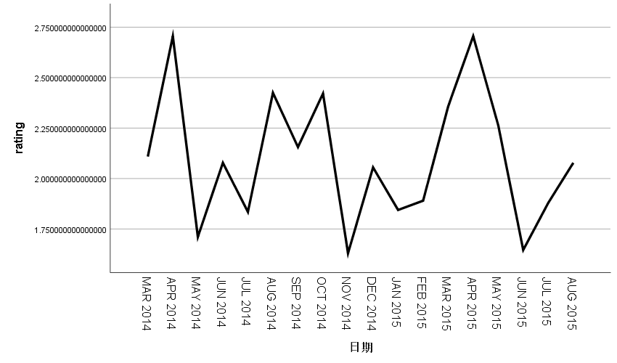

We use the expert model for prediction, which will provide a model with minimum error based on the known sequence data.

The most suitable model in the model description table is the simple seasonal model.

The stable R-square obtained by model fitting test is 0.908, which shows that the model is highly correlated. Both ACF and PACF are within their respective ranges, with no significant difference from 0. The test passed.

|  |  |
| --- | --- |
| statistical matching | AVG |
|
| stable R2 | 0.908 |
| R2 | 0.813 |
| RMSE | 0.147 |
| MAPE | 4.888 |
| MaxAPE | 14.943 |
| MAE | 0.099 |
| MaxAE | 0.297 |
| BIC | -3.512 |

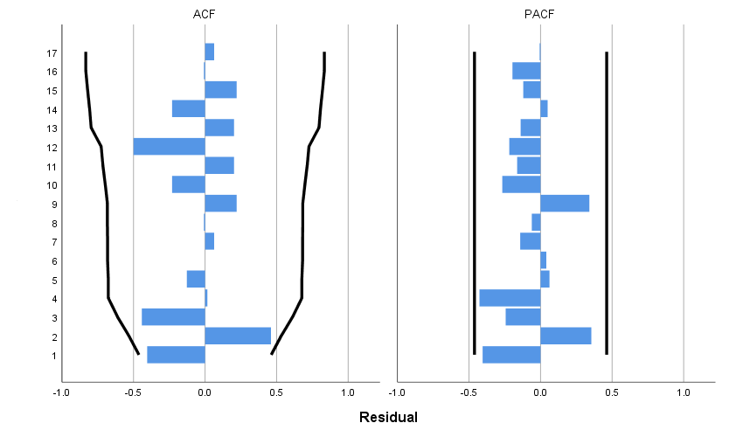

To solve data quality problems for time series analysis and decision-making, a predictionbased sliding window prediction algorithm was proposed. The method first split given product’s time series into subsequences so as to build a forecasting model to predict future values, and then the predicted value is also assumed to be known value, to continue to predict the future data.

First, we used nearly two years of data to predict the trend of products in the next four months. Then, the previous monthly data were used to predict where the product would go in the next three months. The predicted results are as follows:

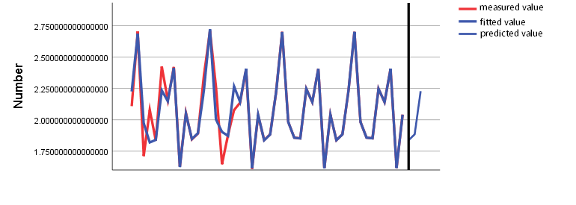

It can be seen from the figure that the time sequence diagrams of real data and fitted data coincide well, which indicates that the simple seasonal model has a better fitting effect on the original data. We do a seasonal breakdown of the data.

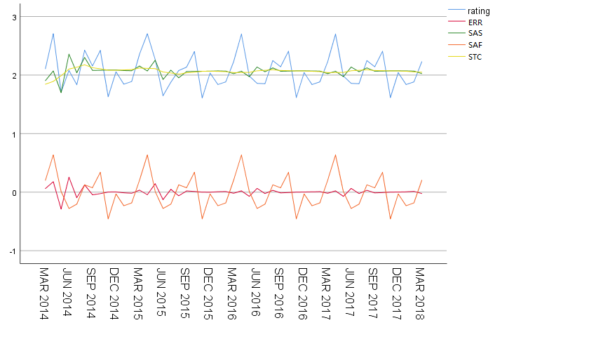

|  |  |
| --- | --- |
| **Seasonal factor** | |
| Name: | rating |
| cycle | Seasonal factor |
| 1 | 0.202886503616550 |
| 2 | 0.635392891679713 |
| 3 | 0.010326788519055 |
| 4 | -0.278963673215924 |
| 5 | -0.204705249341441 |
| 6 | 0.124851080845626 |
| 7 | 0.075438649012786 |
| 8 | 0.338933294328234 |
| 9 | -0.456152812465383 |
| 10 | -0.031461649503738 |
| 11 | -0.232407556089949 |
| 12 | -0.184138267385530 |

The seasonal factor in the first and the three quarters was positive, while the seasonal factor in the second and the fourth quarters was negative, which indicating that the average score of the product in the first and the third quarters was higher than that in the second and the fourth quarters.Seasonal decomposition is to separate the seasonal curve and observe the overall trend of the product.As you can see from the chart above, the product's rating has not been on the rise for a long time, so we don't consider it a success.

In the same way, we evaluate the hair dryer and the pacifier. The Hair-dryer is no more on the rise than the microwave, but the rising trend of pacifier is obvious. So we can say that this pacifier is successful.

