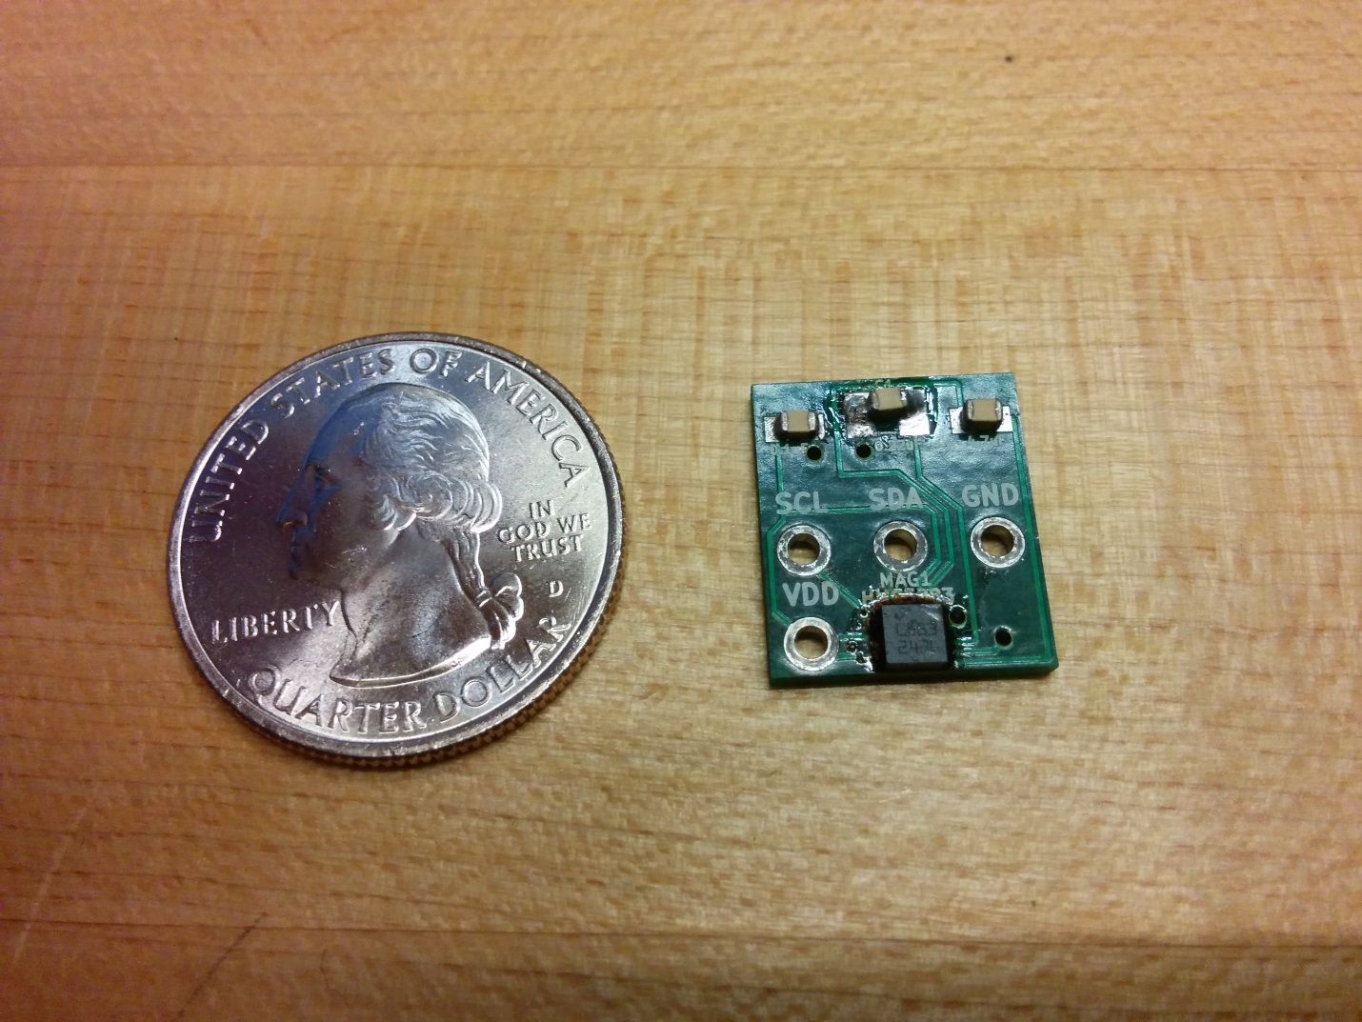

C2: 0.1uF

C1: 0.47uF

C3: 0.22uF

Field name: MAG1 (HMC5883L)

HMC5883L: Moisture sensitive

**MAG1:**

Component: HMC5883

Type: moisture sensitive, magnetic field sensor

Component mounting: make sure the dot matches with dot on the silk screen

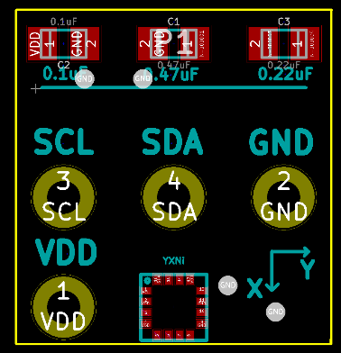

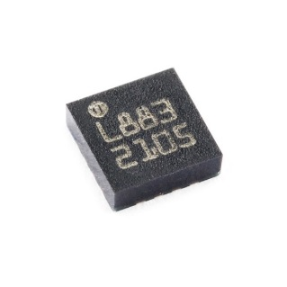

**Solder consideration:**

Use 63/37 solder which doesn’t contain any nickel or iron.

**C1/C2/C3:**

Polarity: no polarity required