# 1.初始化参数

1.请求配置参数

send:

{"param":{"module":"wl"},"call":" Send_REQUEST_CONFIG "," callId ":"1"}

recive:

暂时默认client接收一定成功

**MASTER_IP**:主中继IP地址,如下图红框内数值

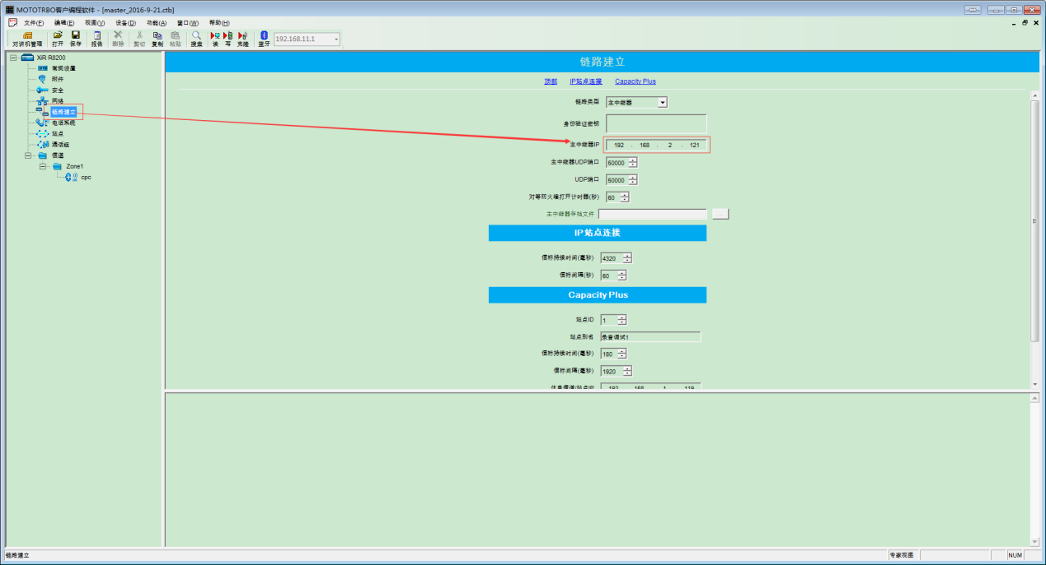

**MASTER_PORT**:主中继端口,如下图红框内数值

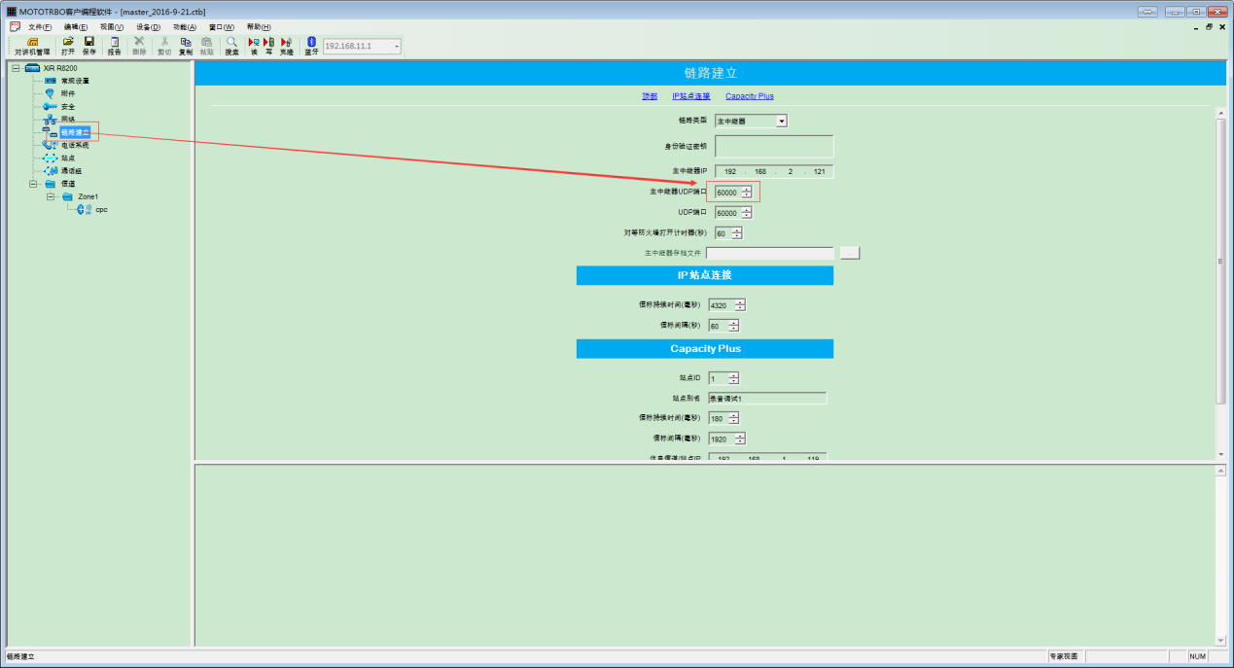

**LOCAL_PEER_ID**:本机PEER ID(唯一,不可重复)

**LOCAL_RADIO_ID**:本机RADIO ID(唯一,不可重复)

**RECORD_TYPE**:当前录音模式(IPSC,CPC,LCP)

**DEFAULT_GROUP**:调度所在的默认组

**DONGLE_PORT**:dongle对应的端口

**HUNG_TIME**:通话挂起时间，如下图红框内数值最大者

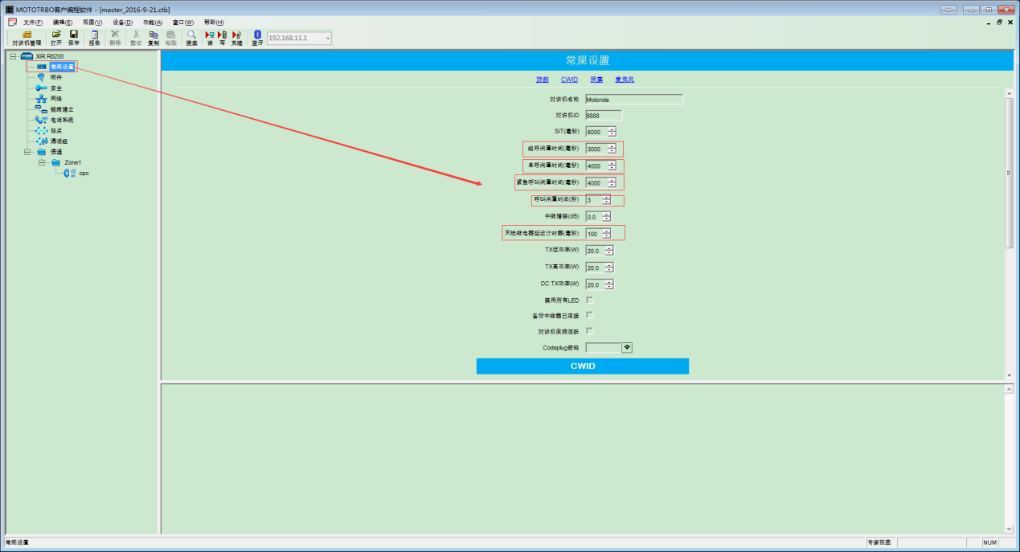

**MASTER_HEART_TIME**:主中继心跳包时间(数值位置如PEER_HEART_TIME)

**PEER_HEART_TIME**:非主中继心跳包时间,如下图红框内数值

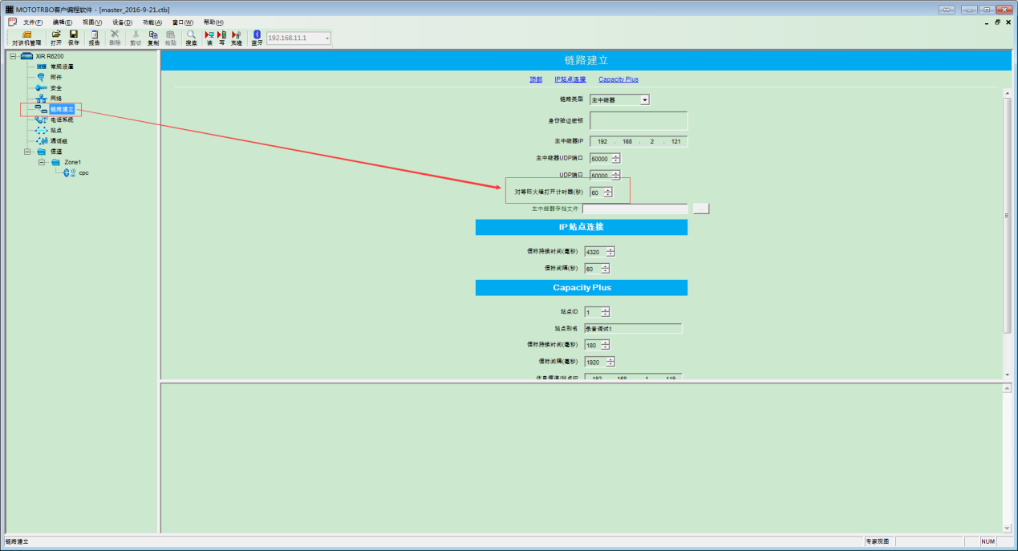

**DEFAULT_SLOT**:IPSC下请求通话时将首选的信道

2.配置参数

recive:

{call":"config","param":{"module":"wl",""MASTER_IP":"192.168.2.121","MASTER_PORT":"50000","LOCAL_PEER_ID":"120","LOCAL_RADIO_ID":"5","RECORD_TYPE":"CPC","DEFAULT_GROUP":"9","DONGLE_PORT":"8","HUNG_TIME":"4000","MASTER_HEART_TIME":"600000","PEER_HEART_TIME":"600000","DEFAULT_SLOT":"1"}," callId ":"1"}

备注(DEFAULT_SLOT):1表示信道1，2表示信道2

response:

{"param":{"module":" wl "}," callId ":"1","status":"0"}

备注(status):0表示成功，非0表示失败

# 2.功能接口

1.请求通话

recive:

{"call":"initialCall","param":{"module":"wl","tartgetId":"9","callType":"79"},"callId":"1"}

备注(callType):79表示组呼,80表示个呼,83表示全呼(全呼时ID为255)

response:

{"param":{"module":" wl "}," callId ":"1","status":"0"}

备注(status):0表示成功,非0表示失败

2.停止通话

recive:

{"param":{"module":" wl "},"call":"stopCall"," callId ":"1"}

response:

{"param":{"module":" wl "}," callId ":"1","status":"0"}

备注(status):0表示成功,非0表示失败

3.上报通话状态

send:

{"call":"Send_CARE_CALL_STATUS","callId":"1","param":{"module":"wl","callType":"79","srcId":"6","tgtId":"9","status":"4"}}

备注(callType):79表示组呼,80表示个呼,83表示全呼(全呼时ID为255)

备注(status):4表示未播放且在后台，5表示开始播放，6表示播放结束,7表示未播放且在后台结束

recive:

暂时默认client接收一定成功

4.设置当前播放组

recive:

{"call":"setPlayCallOfCare","param":{"module":"wl","callType":"79","srcId":"6","tgtId":"9"}," callId ":"1"}

备注(callType):79表示组呼,80表示个呼,83表示全呼(全呼时ID为255)

response：

{"param":{"module":" wl "}," callId ":"1","status":"0"}

备注(status):0表示成功,非0表示失败