Hyperparameter Optimization of a Fixed Pi Agent Harness
  - EP6203 Project Team
  - Nanyang Technological University | 30 October 2026

Abstract
We study hyperparameter optimization over supported configuration interfaces of a fixed Pi Agent harness on a reproducible SkillsBench 1.1 subset. A 27-point space combines reasoning level, context reserve and recent-token retention. We implement Interaction-Guided Block Search (IGBS) and compare it with an untuned default, random search and standard SMAC Bayesian optimization under equal search allocation caps. The recorded campaign ended with 139 validation attempts and 12 held-out attempts; 136 of these 151 observations have valid measurement. All four configurations were frozen before testing. IGBS selected a configuration with 5/8 validation successes, but BO selected identical settings and observed 3/8, so the difference does not establish algorithm superiority. The real IGBS run reached only initialization screening. A separate controlled synthetic test completed adaptive routing and verified strong-signal weighting and conservative fallback (Appendix B). Three of eight held-out tasks ended per method, leaving final pass@1 and the full generalization gap unavailable. Ended observations record USD 20.4248448 in usage-based estimates and USD 17 in unknown-request reserves. The study provides an auditable evaluation pipeline, exploratory parameter and cost analyses, and verified failure cases, while identifying measurement completeness and evaluation noise as limits on the conclusions.
Keywords: hyperparameter optimization; agent harness; Bayesian optimization; interaction analysis; SkillsBench.

1 Introduction
Agent harnesses expose runtime controls that can change task completion and resource use without changing the underlying model. This project treats their supported configuration interfaces as a finite hyperparameter optimization problem. The harness implementation, model, task environments and verifiers remain fixed while configurations are selected using validation outcomes. The selected configurations are then evaluated on a separate held-out task panel [7].
Our question is whether a small-budget search over reasoning and context-management settings can identify a useful configuration and how its observed improvement relates to one-time search expense and subsequent runtime expense. We develop IGBS, a policy that uses local matched parameter contrasts to choose between pair, single-parameter and global moves. Its implemented adaptive mechanism must be distinguished from the stages actually reached during the recorded run.
The campaign stopped at 12:03:07 UTC+8 on 30 October 2026 after an infrastructure error. We report the completed validation panels, partial independent test observations and accounting exceptions explicitly. The results support a study of configuration behavior and measurement challenges, but do not establish a final optimizer ranking. Real-campaign claims refer to this fixed evidence cutoff [4–6].

2 Related Work
Random search is a natural baseline for evaluating adaptive hyperparameter optimization. Bergstra and Bengio [1] show its effectiveness relative to grid and manual search in their learning-system experiments. We use seeded sampling without replacement from the finite 27-point domain; their empirical findings do not imply a performance advantage on our agent tasks.
SMAC3 provides a modular Bayesian optimization framework with surrogate models, acquisition rules and configuration-space support [2]. We use the pinned SMAC implementation as the required standard BO baseline. IGBS instead uses directly observed task-paired contrasts and an interpretable proposal schedule. BO can also model parameter interactions, so the contribution of IGBS is its particular routing policy rather than the general idea of considering interactions.
Hutter, Hoos and Leyton-Brown [3] use functional ANOVA to decompose predicted performance variation into parameter effects and interactions. Our observed local contrasts are more restricted: they compare matched settings on the validation tasks and do not estimate global fANOVA importance. The small sample and incomplete mechanism activation motivate exploratory sensitivity analysis rather than a causal ranking of parameters.

3 Experimental Setup
The objective is to improve a fixed agent harness through supported configuration interfaces. Pi Agent was selected because it exposes the three settings below, permits source and runtime pinning, and can be evaluated through task-native execution. The optimizer does not rewrite the harness, prompts, or tools. [5]
SkillsBench 1.1 was selected for its Skills-based tasks and native verifiers, allowing the configured agent to be assessed in the intended task environment. All methods use one with-skill condition and the project’s predeclared eight-task validation and eight-task held-out subsets.
OpenAI gpt-5.4-mini was available through the project account and adopted as a fixed model under the $60 total budget. Holding it constant isolates the declared harness settings. This was an availability and budget decision; no cross-model experiment establishes that it is superior to alternative models.
Table 1. Exposed configuration parameters and declared domains.
Exposed parameter | Declared values | Role
defaultThinkingLevel | low, medium, high | Requested reasoning level
compaction.reserveTokens | 16384, 360000, 375000 | Context reserve governing the compaction threshold
compaction.keepRecentTokens | 4000, 10000, 20000 | Recent-token retention during compaction

The search space contains 27 configurations. The native Default is medium reasoning, 16384 reserve tokens, and 20000 recent tokens. Correctly written settings do not show that compaction occurred; runtime mechanism evidence is reported separately in Section 6.

Validation and test separation
The project declares eight validation tasks and a separate eight-task held-out panel. This is a reproducible project subset, not a full evaluation of SkillsBench or a claim that the benchmark supplies this exact split. Test outcomes must not guide configuration selection.
Table 2. The eight predeclared validation task identifiers.
Validation task IDs | Validation task IDs
financial-modeling-qa | powerlifting-coef-calc
llm-prefix-cache-replay | bike-rebalance
3d-scan-calc | crystallographic-wyckoff-position-analysis
mario-coin-counting | dapt-intrusion-detection

Native execution and reproducibility
A single controller runs attempts sequentially with task-native dependencies, Skills, time limits, official verifiers, and cleanup. The protocol records source pins, a runtime image digest, the task roster, search and evaluation seeds, budget limits, and source hashes. The provider-side random seed is not controlled, so an evaluation seed does not guarantee deterministic model output.
Public source hashes and aggregate audit records accompany this paper; raw attempt records remain in the local evidence archive. This supports inspection of the recorded run; fresh-machine reproduction and provider invoice reconciliation were not performed. [4–6]

4 Optimization Methods

Baselines and Measurement Policy
Table 3. Configuration generation methods used in the comparison.
Method | Configuration generation and observed scope
Default | One native default configuration with no tuning.
Random | Seeded uniform sampling without replacement from the same 27-point space.
BO | Standard SMAC 2.4.0 Bayesian optimization, with three initial design candidates and subsequent optimizer proposals.
IGBS | Student-developed Interaction-Guided Block Search using local matched contrasts and conservative block selection.

Default provides an untuned reference. Random tests whether systematic adaptation improves on sampling, while standard BO supplies a surrogate-based baseline. IGBS supplies the student-developed method. All three search methods receive the same exposed configuration space, candidate-count ceiling, and dollar cap; their realized spending differs. The detailed IGBS procedure and its actual execution boundary follow in Section 4.
Random shuffles the finite grid with a fixed seed and draws without replacement. BO encodes the three domains as ordinal variables in ConfigSpace and uses the pinned SMAC HyperparameterOptimizationFacade in sequential ask–tell mode. Three initial-design candidates precede subsequent proposals. Each covered panel returns objective loss 1 minus its operational score and task duration; SMAC’s cost field means objective loss, while dollar accounting is maintained separately. The optimizer’s deterministic scenario flag does not control provider randomness. Repeated BO proposals are rejected rather than silently replaced.

Failure handling and score definition
Table 4. Outcome treatment under the revised operational policy.
Observation | Treatment in this continuation
Valid measurement and reward 1 | One operational success.
Valid measurement and reward below 1 | A measured failure; retain partial reward separately.
Executed attempt with incomplete measurement | Retain raw reward, error, known usage, and unknown-cost reserve; apply an explicit zero selection penalty.
Task not yet executed or settled | Missing. Do not replace it with zero or score a partial panel.

A candidate receives an operational score only after all eight tasks have been attempted. Its score is the number of valid successes divided by eight. A fully measurement-valid panel additionally has a reported validation pass fraction. A panel containing exceptions is not relabeled as fully valid.
This is a separately recorded revision after the earlier formal run stopped on incomplete accounting. It preserves the earlier evidence and counts its costs once. Completion of the original frozen formal protocol is not claimed. Tied operational scores are resolved by committed panel cost, elapsed task time, and configuration ID. [5]

Interaction Guided Block Search
Interaction-Guided Block Search uses observed local contrasts to choose which exposed parameters to change together. The source code defines the following policy. BO can also represent interactions; the contribution is this specific interpretable routing policy. [8]

Seven point screening and matched contrasts
A seeded initialization stream chooses one nondefault alternative for each parameter. The seven screening points are Default, the three individual changes, and the three corresponding pair changes. They provide observed edges and two-by-two rectangles around a fixed background; they do not exhaust the 27-point space.
An edge contrast subtracts each task’s baseline success from success after one parameter changes. A pair contrast is joint-change success minus each single-change success plus baseline success. Contrasts require all relevant configurations and the same validation tasks. Missing corners remain unknown. Adaptive analysis uses the incumbent’s settings for parameters outside the block and only that method’s own completed history.

Bootstrap uncertainty and stability weights
The analyzer averages task-paired contrasts and resamples validation groups with replacement 2,000 times. Its uncertainty radius is the 95th percentile of the absolute difference between a bootstrap estimate and the observed mean contrast. Stability is the fraction of leave-one-group estimates that retain the original sign and an absolute magnitude above 0.025.
A contrast receives the positive part of its absolute mean minus the uncertainty radius minus 0.05. Its weight is forced to zero with fewer than eight groups or leave-one-group stability below 0.8. A parameter block’s weight is the root-mean-square of its identified contrast weights; no identified contrast means zero weight. These are routing heuristics, not significance tests. Cost contrasts are auxiliary diagnostics and remain unknown when required costs are missing.

Adaptive proposals and conservative fallback
After seven observed screening panels, proposals cycle through pair, single-parameter, and global moves. A local move considers unseen configurations differing from the incumbent in exactly the selected block. Positive block weights select a highest-weight eligible block, with uniform tie-breaking, then a uniform candidate within it. If all eligible weights are zero, the block is chosen uniformly. A scheduled global move, or absence of eligible local neighbors, draws uniformly from all unseen configurations. Repeated configurations are rejected.
Under this continuation, full-coverage operational outcomes, including declared exception penalties, enter the method’s private history without relabeling measurement validity. At the validation cutoff, five screening panels were fully covered and the sixth remained partial. Every logged IGBS action was screen: no eighth candidate or adaptive proposal had been executed. These real-task results cannot validate interaction-guided routing; Appendix B separately tests its implementation on controlled synthetic inputs. [4–5, 8]

5 Experimental Results

Validation Coverage and Frozen Configurations
Table 5 summarizes the observed validation coverage. The stopped run contains 139 ended validation attempts, followed by 12 ended held-out attempts; three historical BO attempts are reused once within these counts. Across both stages, 136 ended attempts have valid measurement and 15 retain accounting exceptions [4, 6].
Table 5. Validation coverage and measurement completeness by method.
Method | Validation ended | Measurement valid | Full candidates | Fully valid candidates
Default | 8 | 7 | 1 | 0
Random | 44 | 40 | 5 | 3
BO | 44 | 41 | 5 | 4
IGBS | 43 | 37 | 5 | 1

Table 6. Frozen validation selections. Valid-only fractions are descriptive and do not replace the fixed-denominator selection metric.
Method and candidate | Thinking | Reserve | Recent | Operational | Valid only
Default  default-000 | medium | 16384 | 20000 | 3/8 | 3/7
Random  random-001 | low | 16384 | 10000 | 2/8 | 2/8
BO  bo-002 | medium | 16384 | 4000 | 3/8 | 3/8
IGBS  igbs-003 | medium | 16384 | 4000 | 5/8 | 5/8

Operational scores use the fixed eight-task denominator and explicit exception penalties. The valid-only column excludes invalid measurements and is descriptive; its denominator differs for Default. It must not replace the declared selection metric. Random, BO and IGBS each have fully valid selected panels; Default does not. [4]
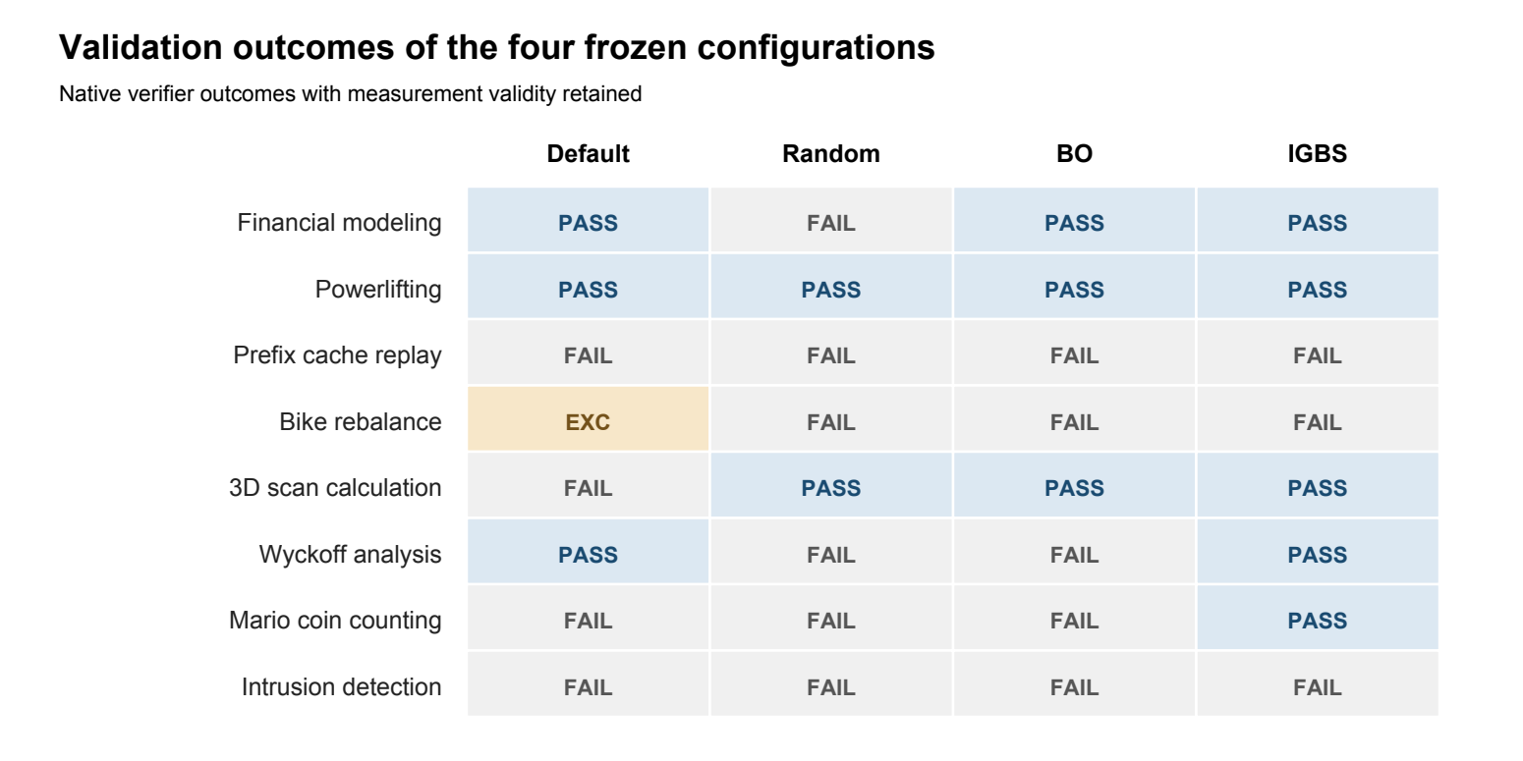
Figure 1. Native validation outcomes for the frozen selections. EXC remains an accounting exception, distinct from a measured task failure.
BO and IGBS selected the identical medium / 16384 / 4000 configuration. Separate executions differed on Wyckoff analysis and Mario coin counting, giving 3/8 and 5/8. No completed compaction was recorded in either selected panel. Thus the gap cannot be attributed to a different discovered configuration, adaptive IGBS routing, or a demonstrated keepRecentTokens effect.
Each search method proposed six candidates, covered five fully, and left its sixth incomplete: Random 4/8, BO 4/8 and IGBS 3/8 tasks. Partial candidates have no operational score and cannot win. The declared ten-candidate maximum was not reached. Selection was finalized from observed validation evidence, and no further search used test outcomes.

Incumbent Curves Under Comparable Budgets
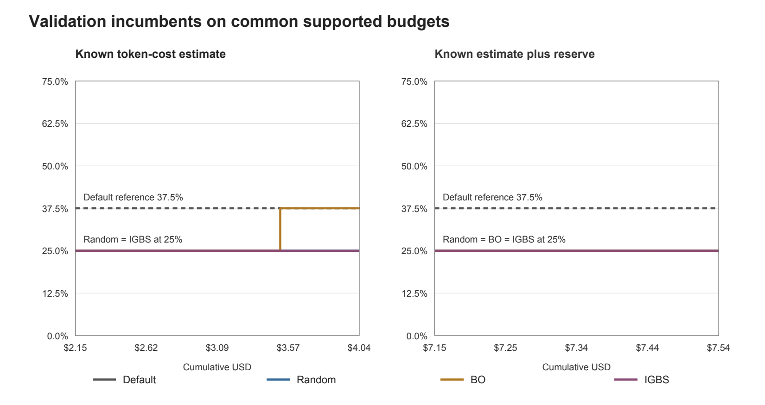
Figure 2. Step curves use only fully covered validation candidates. Left: known token-cost estimates. Right: accounting commitment including reserves. Both show only the observed budget interval shared by Random, BO and IGBS; Default is a fixed baseline reference.
The shared support is $2.1515–$4.0376 on recorded known cost and $7.1515–$7.5359 on commitment. Each interval begins when all three search methods have a first scored panel and ends at the smallest last fully covered panel cost. No scores are extrapolated beyond observed support. Exact points are provided in aggregate-tables/common-budget-curves.csv.
The axes answer different questions. Known cost omits unresolved request charges, while commitment includes a conservative reservation rather than a measured bill. Equal declared caps therefore do not establish equal actual spending. The narrow commitment overlap and unresolved costs prevent a robust equal-invoice-cost ranking.
At the right boundary of the shared known-cost interval, the available incumbents are Random 2/8, BO 3/8 and IGBS 2/8; Default remains 3/8. IGBS’s later 5/8 point lies outside that interval. On the shared commitment interval, all three search incumbents remain 2/8. This differs from comparing each method at its own final expenditure.
All search methods were allocated a $16 cap and ten-candidate ceiling. Default was one untuned configuration under a $3 cap, and held-out evaluation had a separate $9 cap. Partial-panel costs remain in the spending ledger even though those panels add no scored point. These curves include the revised operational penalties; they do not certify completion of the original protocol.

Partial Heldout Evaluation
The selection artifact records all four winners at 11:14:04. Independent evaluation then used the same model, native task environment and official verifier, with one primary attempt per dispatched task. At 12:03 the controller had stopped: only the first three tasks had ended for each method. [4–6]
Table 7. Partial held-out coverage. Ended-subset fractions are not final eight-task pass@1.
Method | Ended of 8 | Valid | Valid passes | Operational on ended | Valid only
Default | 3/8 | 2 | 2 | 2/3 | 2/2
Random | 3/8 | 3 | 1 | 1/3 | 1/3
BO | 3/8 | 3 | 2 | 2/3 | 2/3
IGBS | 3/8 | 3 | 3 | 3/3 | 3/3

The two rightmost columns describe the ended subset. Default’s 2/3 includes one explicit accounting-exception penalty; its valid-only 2/2 excludes that exception. Neither denominator equals the planned test size. Final pass@1 and the full validation-to-test generalization gap remain unavailable.
Table 8. Outcomes on the three held-out tasks that ended for each method. EXC denotes an accounting exception.
Heldout task | Default | Random | BO | IGBS
econ-detrending-correlation | PASS | FAIL | FAIL | PASS
fix-erlang-ssh-cve | EXC | PASS | PASS | PASS
jax-computing-basics | PASS | FAIL | PASS | PASS

Unresolved and unexecuted coverage
organize-messy-files was dispatched as heldout-default-003 at 11:52:58 but has no ended ledger row. The controller stopped at 12:03:07 with controller_error_FileNotFoundError. Independent artifact review found a raw not_dispatched record with zero model calls and zero recorded cost, no provider-setup marker or request journal, and verified cleanup. BenchFlow recorded a timeout of about 600 seconds. The task remains scientifically unresolved because no verified benchmark result entered the ledger; clearing current_attempt does not establish success or failure.
The remaining five planned tasks per method are organize-messy-files, pptx-reference-formatting, python-scala-translation, syzkaller-ppdev-syzlang and travel-planning. Of these 20 method–task evaluations, one is unresolved and 19 were not dispatched. Missing evaluations are not converted to zero or imputed from other methods.

What the partial test can show
On the common three-task subset, IGBS passed all three, BO passed two and Random one; Default has two valid passes and one exception. These outcomes are useful task-level observations. The small, ordered prefix and incomplete cost evidence do not support a final generalization claim. BO and IGBS again differ on an identical configuration, reinforcing the need to separate run variation from parameter effects.

Search Cost and Selected Runtime Cost
Table 9. Recorded stage costs, unknown-request reserves and allocation caps in USD.
Stage | Known estimate USD | Unknown reserve USD | Recorded commitment USD | Cap USD
Default | 1.088507 | 1.00 | 2.088507 | 3
Random | 5.999979 | 4.00 | 9.999979 | 16
BO | 4.178511 | 5.00 | 9.178511 | 16
IGBS | 8.429647 | 6.00 | 14.429647 | 16
Heldout ended | 0.728200 | 1.00 | 1.728200 | 9
Recorded total | 20.424845 | 17.00 | 37.424845 | 60

Known costs are estimates derived from provider-reported token usage under the frozen price rules, including cached-input treatment. They are not provider invoices. The 15 ended measurement exceptions contain 17 unresolved requests; each carries the declared $1 holdback. Raw partial usage is retained and unknown portions are not priced at zero.
The recorded $22.57515520 difference from the $60 cap is arithmetic headroom, not verified available credit or a reconciled invoice. The unresolved fourth Default dispatch has a raw not_dispatched record, zero model calls and zero recorded cost; the audit found no additional inventoried provider exposure. It remains outside ended outcome counts. Historical BO evidence and cost are reused once, without duplicating payment or counting reuse as a new experiment.

Cost of executing frozen configurations
Table 10. Selected-configuration runtime cost on three ended held-out tasks per method.
Method | 3 ended heldout task estimates | Reserve | Valid passes | Known USD per ended task
Default | $0.059882 | $1.00 | 2 | $0.019961
Random | $0.187349 | $0.00 | 1 | $0.062449
BO | $0.308955 | $0.00 | 2 | $0.102985
IGBS | $0.172014 | $0.00 | 3 | $0.057338

The averages describe only the three ended tasks. Default is not fully metered, so its low known estimate is not a confirmed efficiency advantage. Among fully metered three-task subsets, IGBS recorded $0.1720, Random $0.1873 and BO $0.3090, but the samples are too small to support a stable deployment cost ranking.
One-time search estimates are separate from the cost of running a selected configuration on new tasks. A defensible break-even analysis requires complete held-out accuracy and comparable settled runtime costs. Those inputs are missing, so the report does not invent a deployment volume at which search pays for itself.

6 Parameter Sensitivity

Reasoning level comparison
Table 11. Exploratory reasoning-level comparison at fixed compaction settings.
Candidate | Thinking | Validation passes | Panel estimate | Sum of task wall time
bo-002 | medium | 3/8 | $1.0629 | 32.22 minutes
bo-003 | low | 2/8 | $0.2538 | 12.06 minutes

Both panels hold reserveTokens at 16384 and keepRecentTokens at 4000 and have valid measurement on all eight tasks. Medium produced one additional pass at approximately 4.19 times the estimated cost. This is an exploratory matched-setting comparison, not a causal estimate: each setting was evaluated once and provider randomness was uncontrolled.

Compaction and inactive settings
Execution attestations confirm the applied model/settings and requested reasoning effort for all 151 ended attempts. This does not supply missing raw model or usage evidence for the 17 unresolved requests. Runtime evidence records six completed compactions across five attempts, of which three are measurement-valid and two are invalid. Every selected validation task and every ended held-out task recorded zero completed compactions. This distinguishes global mechanism activity from the settings of the chosen configurations. [6]
The four selected validation panels contain no completed compaction event. Configuring keepRecentTokens therefore does not show that its retention mechanism was exercised in those evaluations. The IGBS screening comparison from 20000 to 4000 recent tokens changed the operational score from 2/8 to 5/8, but neither panel compacted and the former includes one exception. A direct retention benefit is not established.
random-000 and random-001 hold low reasoning and 10000 recent tokens constant while changing reserveTokens from 360000 to 16384. Both score 2/8 with valid measurement and no completed compaction. Their $0.4206 versus $0.2490 estimates are descriptive cost observations, not proven savings from the compaction mechanism.

Interaction claims and experimental reach
IGBS’s source supports matched local interaction analysis and conservative routing, but its seventh screening panel and adaptive eighth proposal were not reached in the real campaign. The separate synthetic validation in Appendix B verifies routing behavior, without establishing real-task efficacy. Missing contrast corners are unknown. No measured benefit of adaptive block selection, harmful interaction, or stable parameter importance ranking is claimed.
BO and IGBS selected the same settings yet differed in validation and on the held-out economic task. This variation is direct evidence that settings alone do not determine observed outcomes. Future evaluation should prioritize complete measurement, matched active-mechanism contrasts, repeated seeds and full test coverage before attributing differences to the optimizer.
The assignment asks which parameters most influence success or cost. Reasoning level has the clearest measured tradeoff in this run, while compaction parameters lack an exercised selected-panel mechanism. That is a statement about the present evidence, not a global ranking of parameter importance. [6–8]

7 Failure Analysis
Table 12. Representative validation outcome differences for the frozen configurations.
Validation task | Default | IGBS selection | BO selection
3D scan calculation | FAIL | PASS | PASS
Mario coin counting | FAIL | PASS | FAIL
Wyckoff analysis | PASS | PASS | FAIL
Bike rebalance | EXC | FAIL | FAIL

3D scan and Mario provide the requested direction in which the selected IGBS configuration passes and Default fails. Wyckoff provides the reverse for BO: Default passes while BO receives raw reward 0.82, below the pass threshold. There is no valid Default-pass/IGBS-fail case in the selected validation panels; that category remains empty rather than borrowing BO’s failure.
In the shared held-out subset, Default passes econ-detrending-correlation while Random and BO fail. The selected IGBS execution passes. These are independent task-level contrasts after freezing, but no complete test panel exists. Bike rebalance and Default’s Erlang held-out case retain accounting exceptions and are not presented as fully verified failure comparisons.

Verified Trajectory Cases

Economic filtering and numerical tolerance
On econ-detrending-correlation, the Random trajectory successfully opened the spreadsheets, constructed real logged series, and wrote an answer, so the failure was not an output-file or format failure. Its final computation used hpfilter(...)[1] for both series, whereas the passing Default computation unpacked cycle, trend and correlated cycle. Random submitted 0.99250; the native verifier expected 0.68885 within 0.001, and three of four tests passed. BO used the cycle component but selected only rows explicitly containing '2024:' when constructing its annual value; it submitted 0.68986 and missed the same tolerance by an absolute difference of 0.00101. The passing Default trajectory averaged the three available quarterly rows and submitted 0.68885. These recorded implementation differences explain concrete numerical failure modes; a single run does not establish that thinking level caused them. [9]

JAX recurrence orientation and verification
On jax-computing-basics, Random produced all required files with valid shapes and no duplicate task IDs, but the native allclose test failed specifically on scan_rnn (four of five tests passed). Its recorded recurrence used tanh(x @ Wx + h @ Wh + b). BO initially used the same orientation, inspected numerical differences, compared transposed alternatives, and then edited the recurrence to tanh(x @ Wx.T + h @ Wh.T + b). After rerunning its solver, all five native tests passed. The observable distinction is an actual correction and verification loop in this attempt, not a general causal claim about BO. [9]

Environment timeout before provider setup
The unresolved organize-messy-files attempt is a separate environment-stage event. Its worker returned normally (exit code 0; interrupted=false), cleanup was verified, and the provider-setup-started marker, request journal, callbacks, and seal were absent. The source writes that marker at entry to ensure_litellm_runtime, before starting the provider runtime. The native result reported timeout with 600.4 seconds total, zero tool calls and unavailable provider usage; the normalized result therefore records not_dispatched and zero model calls. There is no inventoried additional provider exposure to add to the known estimate, but there is no heldout outcome either. The controller logged only controller_error_FileNotFoundError, without identifying a filename. We keep this attempt unresolved and retain all existing $17 unknown-call holdbacks. [9]
These examples identify actions and verifier discrepancies actually present in the inspected records. They do not establish a general effect of reasoning level, prove that the optimizer caused a repair, or turn the unresolved environment attempt into a measured task failure.

8 Discussion and Limitations
The controller’s FileNotFoundError is recorded separately from benchmark task failure. The final dispatched task remains unresolved and is excluded from ended counts and reported pass fractions. There was no automatic restart or fabricated result used to complete the table.
Repeated selection on eight validation tasks creates selection bias. One search seed, uncontrolled model randomness, partial sixth candidates, unequal realized costs, accounting exceptions and only three ended held-out tasks per method limit inference. Overfitting and harmful interactions are hypotheses, not established explanations for the observed differences.
The common-budget curves distinguish known usage-price estimates from commitment including reserves. They cannot establish an equal-invoice-cost ranking while provider charges remain unresolved. Likewise, the three-task held-out prefix cannot replace the predeclared eight-task denominator. The original strict protocol, full held-out pass@1 and generalization gap remain incomplete [4–6].
A further limitation concerns empirical efficacy. IGBS completed only five real-task screening panels and part of a sixth, so its adaptive phase was not executed on SkillsBench. A separate controlled synthetic experiment completed the adaptive cycle and verified weighting, fallback and pair-blind ablation behavior (Appendix B). Artificial groups and a signal deliberately aligned with the screening design do not establish real-task performance gains. Repeated measurements and completed independent test coverage remain necessary.

9 Conclusion
We implemented a reproducible configuration-only HPO pipeline for Pi Agent and compared Default, Random, SMAC BO and IGBS on the same declared space. The recorded study provides frozen validation selections, cost curves on common observed support, exploratory sensitivity results and verified failure cases. BO and IGBS selected identical settings yet obtained different outcomes, and IGBS did not reach its adaptive phase in the real campaign. The added controlled synthetic study verifies the adaptive implementation: strong interactions receive positive pair weight, while absent or uncertain signals trigger uniform fallback. This evidence supports mechanism correctness, not optimizer superiority. Combined with incomplete held-out coverage and unresolved accounting, these observations preclude a final superiority or generalization claim. The main result is an inspectable partial study and a clear account of the evidence still required.

References
[1] J. Bergstra and Y. Bengio. Random Search for Hyper-Parameter Optimization. Journal of Machine Learning Research, 13:281–305, 2012. https://www.jmlr.org/papers/v13/bergstra12a.html
[2] M. Lindauer, K. Eggensperger, M. Feurer, A. Biedenkapp, D. Deng, C. Benjamins, T. Ruhkopf, R. Sass, and F. Hutter. SMAC3: A Versatile Bayesian Optimization Package for Hyperparameter Optimization. Journal of Machine Learning Research, 23(54):1–9, 2022. https://www.jmlr.org/papers/v23/21-0888.html
[3] F. Hutter, H. Hoos, and K. Leyton-Brown. An Efficient Approach for Assessing Hyperparameter Importance. Proceedings of the 31st International Conference on Machine Learning, PMLR 32(1):754–762, 2014. https://proceedings.mlr.press/v32/hutter14.html
[4] EP6203 Project Team. Recorded campaign aggregates at 12:03 UTC+8, 30 October 2026. Supplementary repository: results/final-20261030-1203/aggregate-tables/ and figure-input.json. These files report validation, partial held-out coverage, operational outcomes and cost arithmetic.
[5] EP6203 Project Team. Experiment configuration and frozen provenance, 30 October 2026. Supplementary repository: results/final-20261030-1203/experiment-config.json and source-provenance.json; selected parameters are in aggregate-tables/frozen-winners.json.
[6] EP6203 Project Team. Independent evidence audit, 30 October 2026. Supplementary repository: results/final-20261030-1203/audit.json and aggregate-tables/. The audit records checks of 160 protocol source hashes and 1,267 frozen evidence hashes. Raw private records are retained locally.
[7] B. An. Group Project 3 Harness Hyperparameter Optimization. NTU course assignment brief, 2026. Problem description, evaluation and deliverables. The instructor document is cited but not redistributed.
[8] EP6203 Project Team. HPO implementation and operational continuation. Supplementary repository: hpo/methods.py, hpo/interaction_search.py, hpo/contrasts.py and scripts/restart_20261029/deadline_run.py. Source-level design is distinguished from observed execution.
[9] EP6203 Project Team. Verified trajectory case summaries, 30 October 2026. Supplementary repository: results/final-20261030-1203/trajectory-report-paragraphs.json and aggregate-tables/trajectory-cases.json. Summaries include relative references to locally retained evidence.

Appendix A Requirements and Reproducibility
Table 13. Course requirement coverage and remaining evidence gaps.
Instructor requirement | Evidence supplied | Completion boundary
Fixed harness and exposed space | Pi and 27-point supported settings grid | Implementation kept fixed during evaluation
Developed method and three baselines | Default, Random, SMAC BO and IGBS source and native runs | Real run: screening only. Synthetic routing verified in Appendix B.
Equal-budget incumbent curves | Known-cost and commitment curves on common support | Equal caps; actual invoice-cost ranking unavailable
Final test pass@1 and generalization gap | Frozen selections and 3 ended tasks per method | Full 8-task pass@1 and gap unavailable
Search versus runtime cost | Separate stage and selected-runtime tables | Unknown reserves and unresolved dispatch remain
Parameter sensitivity | Matched reasoning and compaction settings | Exploratory; selected panels did not compact
Bidirectional failure comparison | Positive IGBS cases and reverse BO/Random cases | No Default-pass/IGBS-fail case observed
Reproducible GitHub codebase | Source, protocol, split and evidence index | Repository delivery is separate from run completeness

The submission repository contains the HPO implementation, pinned configuration and dependency files, portable aggregate data, the presentation and this paper in Word and PDF form. The requirement checklist in docs/submission_requirements.md distinguishes implemented software, available evidence and incomplete final evaluation requirements. Packaging does not complete missing experiments.
For an offline package integrity check, run python -B scripts/verify_release_package.py from the repository root. The reproduction guide is docs/reproduction.md. The script results/final-20261030-1203/reproduce_figures.py regenerates the two figures from public aggregate inputs. reports/source/build_paper.py rebuilds the editable paper from paper-content.json and those figures; python-docx is required. These checks and report builds make no model calls.
A native benchmark rerun additionally requires the pinned upstream sources, task environments, local credentials and a separately declared budget. The dated controller is preserved as historical execution code and must not be relaunched against the stopped campaign. Raw trajectories and request logs remain in the original local workspace; public source hashes establish file identity, not availability of missing observations or reconciled provider charges.

Appendix B Controlled Synthetic Mechanism Validation
We executed the unchanged IGBS implementation on three declared synthetic objectives with a matched pair-blind ablation. Each of the six runs used seed 31, eight artificial task groups and ten unique configuration panels: seven screening proposals, followed by pair, single and global proposals. This produced 60 complete panels and 480 synthetic evaluations. The local algorithm run took 0.262 seconds, excluding plotting and packaging; it made zero model calls and incurred USD 0 in paid API costs.
The 27-point space uses reasoning levels low/medium/high, reserveTokens 16384/360000/375000, and keepRecentTokens 4000/10000/20000. An AND interaction between high reasoning and reserveTokens 360000 was deliberately aligned with the fixed initial screening design. All eight groups succeed at the target pair in the strong case, none succeed in the flat case, and only two groups succeed in the weak case. These are known-answer checks, not an unbiased benchmark of search efficiency.
Table 14. Observed first adaptive decision on synthetic inputs. Blind denotes the applied pair weight after the ablation.
Synthetic case | Contrast | Bootstrap radius | IGBS weight | Blind weight
Strong | 1.00 | 0.00 | 0.95 | 0.00
Flat | 0.00 | 0.00 | 0.00 | 0.00
Weak uncertain | 0.25 | 0.25 | 0.00 | 0.00
IGBS selected the injected parameter pair with weight 0.95 in the strong case. The pair-blind control removed pair weighting and used uniform selection. Both flat and weak cases produced zero IGBS pair weights and identical ten-configuration trajectories across the two methods. The original thresholds were retained: eight groups, practical threshold 0.05, stability threshold 0.8 and 2,000 bootstrap samples.
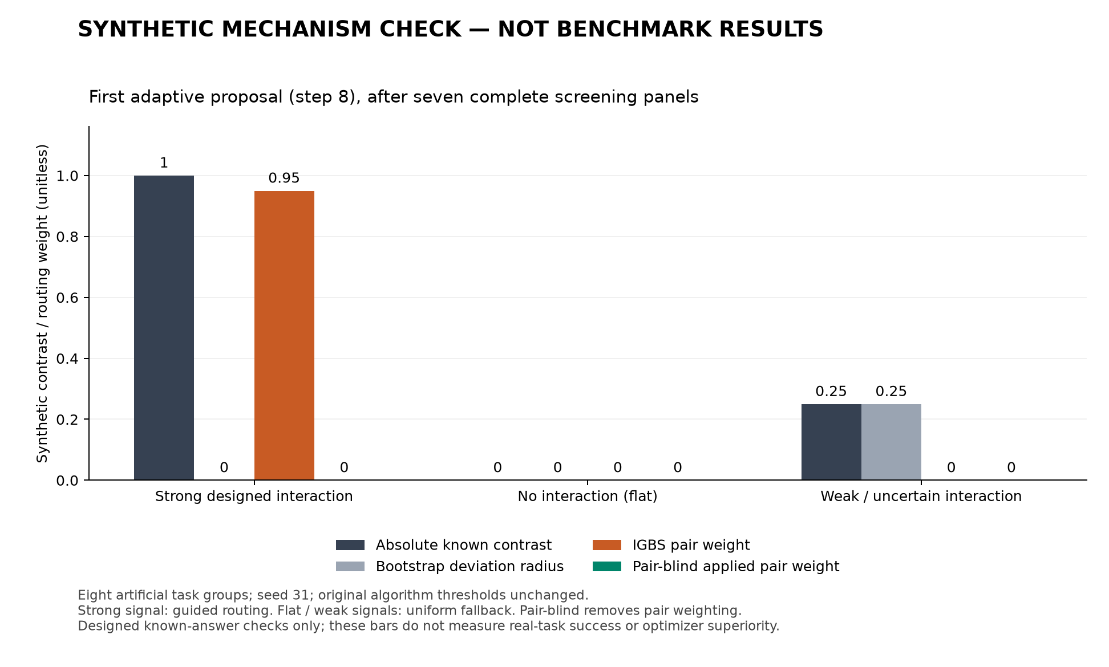
Figure 3. Controlled synthetic mechanism check. Artificial groups are not independent empirical replicates; bootstrap radii are algorithm outputs on the constructed inputs, not confidence bounds for real-task improvement.
All six trace hash chains and completed ask/tell sequences passed verification, and 165 protected source files were unchanged. Network and subprocess execution were blocked. The protocol, per-round configurations, traces and checks are retained under results/igbs-synthetic-20261030. This validates implemented routing and ablation behavior only; it does not demonstrate SkillsBench gains, a compaction effect, generalization, or superiority over BO, Random or pair-blind.

