Factors Report 20100104-20161230

**1. yanYD_190923_Alpha_GT_71_1**

**截面指标累计曲线:**

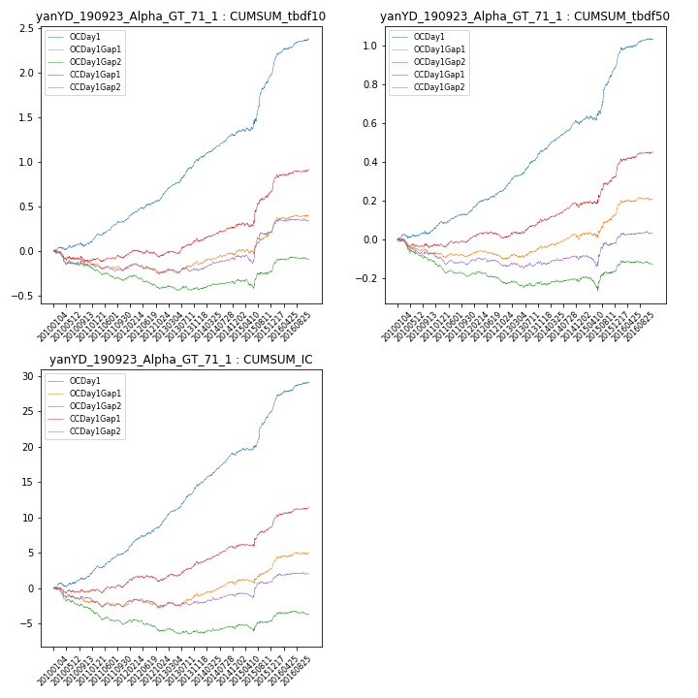

**因子换手率:** 49.72%

**截面指标_OCDay1:**

|  |  |  |  |  |  |  |  |  |
| --- | --- | --- | --- | --- | --- | --- | --- | --- |
| year | annret_tbdf10 | sharpe_tbdf10 | maxdd_tbdf10 | annret_tbdf50 | sharpe_tbdf50 | maxdd_tbdf50 | mean_IC | tstat_IC |
| 2010 | 0.09 | 1.51 | -0.05 | 0.05 | 1.8 | -0.02 | 0.01 | 2.63 |
| 2011 | 0.26 | 5.8 | -0.02 | 0.09 | 4.36 | -0.01 | 0.01 | 5.68 |
| 2012 | 0.29 | 5.73 | -0.02 | 0.14 | 5.84 | -0.01 | 0.02 | 6.19 |
| 2013 | 0.4 | 7.04 | -0.02 | 0.18 | 6.7 | -0.01 | 0.02 | 7.62 |
| 2014 | 0.27 | 5.84 | -0.02 | 0.14 | 6.04 | -0.02 | 0.02 | 7.33 |
| 2015 | 0.69 | 5.09 | -0.04 | 0.29 | 4.42 | -0.02 | 0.03 | 4.54 |
| 2016 | 0.39 | 6.16 | -0.01 | 0.14 | 4.68 | -0.01 | 0.02 | 5.68 |

**截面指标_CCDay1Gap1:**

|  |  |  |  |  |  |  |  |  |
| --- | --- | --- | --- | --- | --- | --- | --- | --- |
| year | annret_tbdf10 | sharpe_tbdf10 | maxdd_tbdf10 | annret_tbdf50 | sharpe_tbdf50 | maxdd_tbdf50 | mean_IC | tstat_IC |
| 2010 | -0.11 | -1.88 | -0.11 | -0.03 | -0.97 | -0.05 | -0.0 | -0.53 |
| 2011 | 0.06 | 1.33 | -0.04 | 0.03 | 1.38 | -0.02 | 0.0 | 1.67 |
| 2012 | 0.01 | 0.2 | -0.08 | 0.01 | 0.62 | -0.03 | 0.0 | 1.01 |
| 2013 | 0.16 | 2.74 | -0.03 | 0.08 | 2.99 | -0.01 | 0.01 | 3.53 |
| 2014 | 0.17 | 3.69 | -0.02 | 0.08 | 3.21 | -0.03 | 0.01 | 4.15 |
| 2015 | 0.4 | 3.58 | -0.05 | 0.16 | 3.15 | -0.02 | 0.01 | 3.0 |
| 2016 | 0.23 | 3.55 | -0.03 | 0.12 | 3.79 | -0.01 | 0.01 | 4.2 |

**风格暴露:**

|  |  |  |  |  |
| --- | --- | --- | --- | --- |
|  | long | short | corr_OCDay1 | corr_CCDay1Gap1 |
| momentum30 | 0.03 | -0.02 | -0.03 | -0.12 |
| logmktcap | -0.01 | 0.01 | -0.2 | -0.01 |
| liquidity10 | -0.04 | 0.04 | 0.12 | -0.03 |
| retvolatility30 | -0.04 | 0.04 | 0.11 | -0.01 |
| liquidity20 | -0.03 | 0.03 | 0.14 | -0.01 |
| momentum5 | 0.07 | -0.07 | -0.03 | -0.18 |
| momentum15 | 0.06 | -0.05 | -0.1 | -0.22 |
| liquidity5 | -0.03 | 0.04 | 0.11 | -0.08 |