Factors Report 20120104-20161230

**1. yanYD_0810_Alpha_test1**

**截面指标累计曲线:**

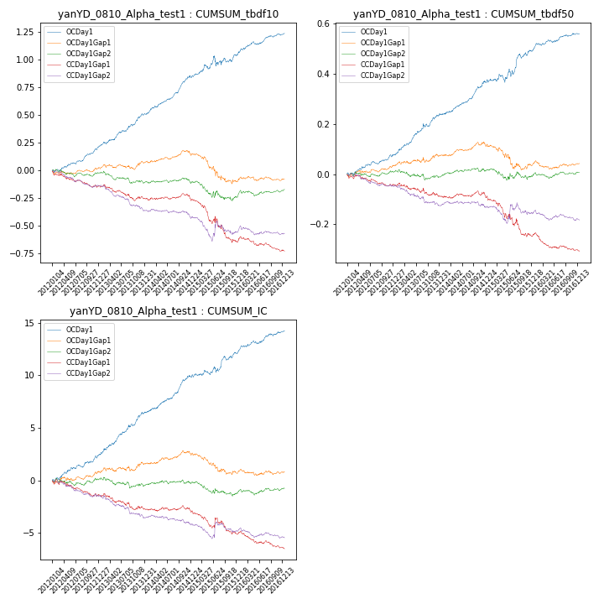

**因子换手率:** 57.91%

**截面指标_OCDay1:**

|  |  |  |  |  |  |  |  |  |
| --- | --- | --- | --- | --- | --- | --- | --- | --- |
| year | annret_tbdf10 | sharpe_tbdf10 | maxdd_tbdf10 | annret_tbdf50 | sharpe_tbdf50 | maxdd_tbdf50 | mean_IC | tstat_IC |
| 2012 | 0.22 | 4.14 | -0.03 | 0.08 | 3.02 | -0.01 | 0.01 | 3.42 |
| 2013 | 0.3 | 5.02 | -0.02 | 0.16 | 4.81 | -0.01 | 0.02 | 5.12 |
| 2014 | 0.33 | 5.86 | -0.02 | 0.13 | 4.95 | -0.01 | 0.01 | 5.23 |
| 2015 | 0.21 | 1.98 | -0.09 | 0.13 | 2.51 | -0.03 | 0.01 | 2.56 |
| 2016 | 0.19 | 3.71 | -0.03 | 0.07 | 2.97 | -0.01 | 0.01 | 3.41 |

**截面指标_CCDay1Gap1:**

|  |  |  |  |  |  |  |  |  |
| --- | --- | --- | --- | --- | --- | --- | --- | --- |
| year | annret_tbdf10 | sharpe_tbdf10 | maxdd_tbdf10 | annret_tbdf50 | sharpe_tbdf50 | maxdd_tbdf50 | mean_IC | tstat_IC |
| 2012 | -0.14 | -2.78 | -0.14 | -0.04 | -1.69 | -0.05 | -0.01 | -2.16 |
| 2013 | -0.12 | -1.99 | -0.14 | -0.05 | -1.5 | -0.05 | -0.01 | -1.87 |
| 2014 | -0.02 | -0.43 | -0.06 | -0.01 | -0.21 | -0.03 | -0.0 | -0.56 |
| 2015 | -0.37 | -3.3 | -0.33 | -0.15 | -2.9 | -0.15 | -0.01 | -2.11 |
| 2016 | -0.09 | -1.66 | -0.13 | -0.06 | -2.64 | -0.07 | -0.01 | -2.66 |

**风格暴露:**

|  |  |  |  |  |
| --- | --- | --- | --- | --- |
|  | long | short | corr_OCDay1 | corr_CCDay1Gap1 |
| momentum30 | -0.07 | 0.07 | 0.06 | 0.02 |
| logmktcap | 0.0 | 0.0 | 0.09 | 0.06 |
| liquidity10 | -0.02 | 0.02 | 0.01 | 0.03 |
| retvolatility30 | 0.0 | 0.0 | -0.03 | 0.02 |
| liquidity20 | 0.0 | 0.0 | -0.01 | 0.03 |
| momentum5 | -0.1 | 0.1 | 0.21 | 0.15 |
| momentum15 | -0.09 | 0.1 | 0.1 | 0.02 |
| liquidity5 | -0.04 | 0.04 | 0.04 | 0.03 |