Factors Report 20120104-20161230

**1. yanYD_0813_Alpha_GT_008_3**

**截面指标累计曲线:**

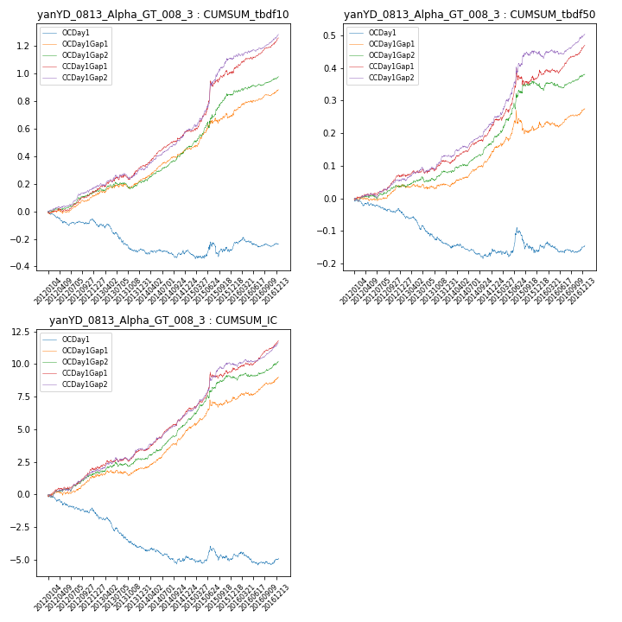

**因子换手率:** 59.1%

**截面指标_OCDay1:**

|  |  |  |  |  |  |  |  |  |
| --- | --- | --- | --- | --- | --- | --- | --- | --- |
| year | annret_tbdf10 | sharpe_tbdf10 | maxdd_tbdf10 | annret_tbdf50 | sharpe_tbdf50 | maxdd_tbdf50 | mean_IC | tstat_IC |
| 2012 | -0.07 | -1.58 | -0.1 | -0.04 | -1.71 | -0.04 | -0.01 | -2.14 |
| 2013 | -0.22 | -3.38 | -0.21 | -0.1 | -3.61 | -0.1 | -0.01 | -3.97 |
| 2014 | -0.0 | -0.08 | -0.07 | -0.02 | -0.79 | -0.05 | -0.0 | -1.24 |
| 2015 | 0.02 | 0.16 | -0.1 | -0.0 | -0.0 | -0.08 | -0.0 | -0.16 |
| 2016 | 0.04 | 0.72 | -0.07 | 0.01 | 0.51 | -0.03 | -0.0 | -0.01 |

**截面指标_CCDay1Gap1:**

|  |  |  |  |  |  |  |  |  |
| --- | --- | --- | --- | --- | --- | --- | --- | --- |
| year | annret_tbdf10 | sharpe_tbdf10 | maxdd_tbdf10 | annret_tbdf50 | sharpe_tbdf50 | maxdd_tbdf50 | mean_IC | tstat_IC |
| 2012 | 0.14 | 3.11 | -0.02 | 0.07 | 2.96 | -0.01 | 0.01 | 3.34 |
| 2013 | 0.18 | 2.83 | -0.04 | 0.05 | 1.78 | -0.01 | 0.01 | 2.32 |
| 2014 | 0.27 | 5.64 | -0.01 | 0.11 | 4.76 | -0.01 | 0.01 | 6.04 |
| 2015 | 0.42 | 3.9 | -0.04 | 0.15 | 2.36 | -0.05 | 0.01 | 3.49 |
| 2016 | 0.26 | 5.27 | -0.02 | 0.1 | 3.46 | -0.01 | 0.01 | 4.4 |

**风格暴露:**

|  |  |  |  |  |
| --- | --- | --- | --- | --- |
|  | long | short | corr_OCDay1 | corr_CCDay1Gap1 |
| momentum30 | 0.04 | -0.03 | -0.14 | -0.12 |
| logmktcap | -0.06 | 0.07 | 0.24 | 0.06 |
| liquidity10 | 0.11 | -0.11 | -0.28 | -0.19 |
| retvolatility30 | 0.1 | -0.1 | -0.28 | -0.24 |
| liquidity20 | 0.11 | -0.11 | -0.29 | -0.2 |
| momentum5 | 0.01 | -0.0 | -0.01 | -0.04 |
| momentum15 | 0.03 | -0.02 | -0.1 | -0.0 |
| liquidity5 | 0.11 | -0.1 | -0.3 | -0.25 |