Factors Report 20100104-20161230

**1. yanYD_0814_Alpha_GT_12_2**

**截面指标累计曲线:**

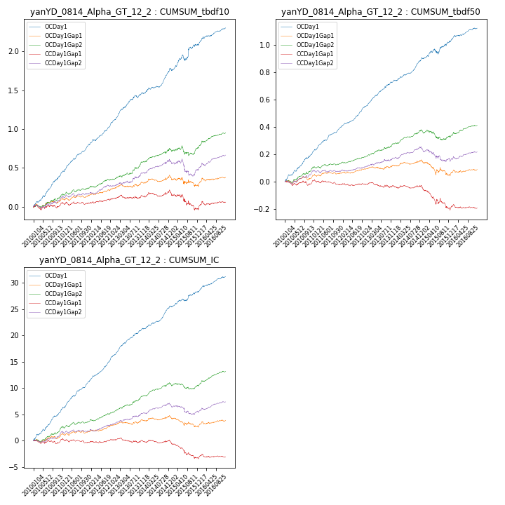

**因子换手率:** 55.95%

**截面指标_OCDay1:**

|  |  |  |  |  |  |  |  |  |
| --- | --- | --- | --- | --- | --- | --- | --- | --- |
| year | annret_tbdf10 | sharpe_tbdf10 | maxdd_tbdf10 | annret_tbdf50 | sharpe_tbdf50 | maxdd_tbdf50 | mean_IC | tstat_IC |
| 2010 | 0.42 | 7.03 | -0.02 | 0.21 | 6.75 | -0.01 | 0.02 | 7.49 |
| 2011 | 0.38 | 8.09 | -0.01 | 0.19 | 8.1 | -0.01 | 0.02 | 8.54 |
| 2012 | 0.34 | 7.26 | -0.02 | 0.16 | 7.97 | -0.0 | 0.02 | 8.77 |
| 2013 | 0.34 | 5.99 | -0.04 | 0.19 | 7.09 | -0.01 | 0.02 | 7.65 |
| 2014 | 0.32 | 6.11 | -0.02 | 0.16 | 6.69 | -0.01 | 0.02 | 6.84 |
| 2015 | 0.31 | 2.74 | -0.07 | 0.12 | 2.58 | -0.04 | 0.01 | 3.27 |
| 2016 | 0.21 | 4.47 | -0.02 | 0.1 | 4.04 | -0.01 | 0.01 | 4.72 |

**截面指标_CCDay1Gap1:**

|  |  |  |  |  |  |  |  |  |
| --- | --- | --- | --- | --- | --- | --- | --- | --- |
| year | annret_tbdf10 | sharpe_tbdf10 | maxdd_tbdf10 | annret_tbdf50 | sharpe_tbdf50 | maxdd_tbdf50 | mean_IC | tstat_IC |
| 2010 | 0.03 | 0.51 | -0.06 | -0.0 | -0.02 | -0.03 | 0.0 | 0.07 |
| 2011 | 0.01 | 0.26 | -0.04 | -0.02 | -0.93 | -0.04 | -0.0 | -0.58 |
| 2012 | 0.07 | 1.52 | -0.02 | 0.0 | 0.16 | -0.02 | 0.0 | 0.87 |
| 2013 | 0.03 | 0.48 | -0.05 | -0.02 | -0.68 | -0.04 | -0.0 | -0.36 |
| 2014 | 0.05 | 0.84 | -0.05 | -0.01 | -0.27 | -0.02 | -0.0 | -0.32 |
| 2015 | -0.2 | -1.9 | -0.21 | -0.15 | -2.76 | -0.15 | -0.01 | -3.37 |
| 2016 | 0.08 | 1.45 | -0.05 | 0.0 | 0.08 | -0.03 | 0.0 | 0.19 |

**风格暴露:**

|  |  |  |  |  |
| --- | --- | --- | --- | --- |
|  | long | short | corr_OCDay1 | corr_CCDay1Gap1 |
| momentum30 | -0.01 | 0.02 | 0.15 | 0.1 |
| logmktcap | 0.04 | -0.03 | -0.0 | -0.01 |
| liquidity10 | -0.01 | 0.02 | 0.1 | 0.05 |
| retvolatility30 | 0.01 | -0.01 | 0.02 | 0.04 |
| liquidity20 | -0.01 | 0.01 | 0.08 | 0.05 |
| momentum5 | -0.05 | 0.06 | -0.03 | -0.12 |
| momentum15 | -0.04 | 0.05 | 0.15 | 0.06 |
| liquidity5 | -0.02 | 0.03 | 0.1 | 0.05 |