Factors Report 20100104-20161230

**1. yanYD_0814_Alpha_GT_13_2**

**截面指标累计曲线:**

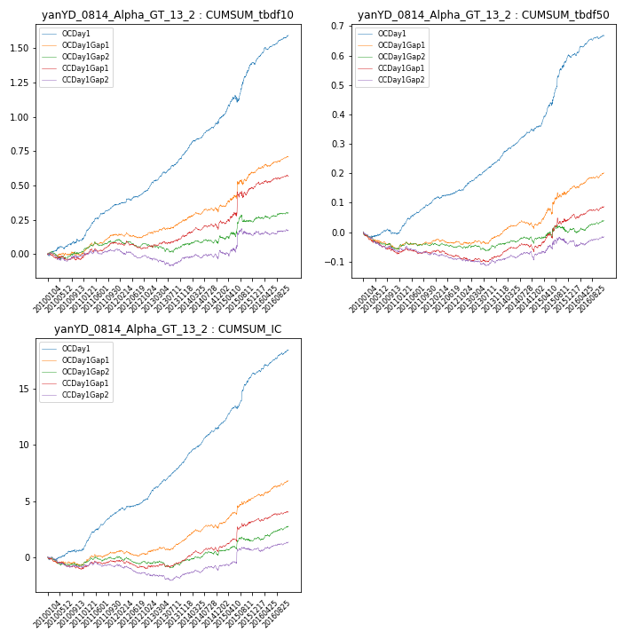

**因子换手率:** 58.08%

**截面指标_OCDay1:**

|  |  |  |  |  |  |  |  |  |
| --- | --- | --- | --- | --- | --- | --- | --- | --- |
| year | annret_tbdf10 | sharpe_tbdf10 | maxdd_tbdf10 | annret_tbdf50 | sharpe_tbdf50 | maxdd_tbdf50 | mean_IC | tstat_IC |
| 2010 | 0.1 | 2.11 | -0.02 | -0.01 | -0.31 | -0.02 | 0.0 | 1.25 |
| 2011 | 0.26 | 6.77 | -0.01 | 0.11 | 6.24 | -0.0 | 0.01 | 7.43 |
| 2012 | 0.15 | 4.3 | -0.01 | 0.06 | 3.62 | -0.01 | 0.01 | 4.22 |
| 2013 | 0.23 | 5.85 | -0.01 | 0.09 | 5.73 | -0.0 | 0.01 | 6.81 |
| 2014 | 0.25 | 5.76 | -0.02 | 0.1 | 5.92 | -0.01 | 0.01 | 7.06 |
| 2015 | 0.41 | 4.88 | -0.05 | 0.25 | 5.88 | -0.01 | 0.02 | 4.87 |
| 2016 | 0.2 | 5.22 | -0.02 | 0.07 | 3.71 | -0.01 | 0.01 | 4.82 |

**截面指标_CCDay1Gap1:**

|  |  |  |  |  |  |  |  |  |
| --- | --- | --- | --- | --- | --- | --- | --- | --- |
| year | annret_tbdf10 | sharpe_tbdf10 | maxdd_tbdf10 | annret_tbdf50 | sharpe_tbdf50 | maxdd_tbdf50 | mean_IC | tstat_IC |
| 2010 | -0.02 | -0.34 | -0.05 | -0.07 | -3.33 | -0.07 | -0.0 | -2.09 |
| 2011 | 0.1 | 2.64 | -0.02 | -0.0 | -0.01 | -0.02 | 0.0 | 1.43 |
| 2012 | -0.02 | -0.73 | -0.06 | -0.02 | -1.35 | -0.03 | -0.0 | -1.1 |
| 2013 | 0.08 | 1.83 | -0.02 | 0.01 | 0.47 | -0.01 | 0.0 | 1.31 |
| 2014 | 0.1 | 2.17 | -0.04 | 0.03 | 1.72 | -0.03 | 0.0 | 2.73 |
| 2015 | 0.26 | 2.23 | -0.05 | 0.1 | 2.49 | -0.02 | 0.01 | 2.48 |
| 2016 | 0.08 | 2.24 | -0.02 | 0.04 | 2.36 | -0.02 | 0.0 | 2.29 |

**风格暴露:**

|  |  |  |  |  |
| --- | --- | --- | --- | --- |
|  | long | short | corr_OCDay1 | corr_CCDay1Gap1 |
| momentum30 | 0.01 | -0.0 | 0.12 | 0.11 |
| logmktcap | -0.01 | 0.01 | -0.11 | 0.09 |
| liquidity10 | -0.01 | 0.01 | 0.08 | -0.01 |
| retvolatility30 | -0.01 | 0.02 | 0.13 | -0.02 |
| liquidity20 | -0.01 | 0.01 | 0.09 | -0.0 |
| momentum5 | -0.01 | 0.02 | 0.11 | 0.02 |
| momentum15 | 0.02 | -0.01 | 0.07 | 0.04 |
| liquidity5 | -0.01 | 0.02 | 0.09 | -0.01 |