Factors Report 20080102-20161230

**1. Alpha_7_12**

**截面指标累计曲线:**

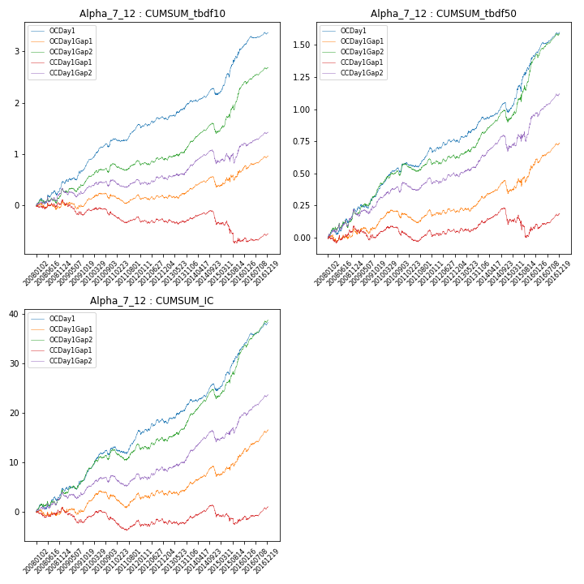

**因子换手率:** 48.04%

**截面指标_OCDay1:**

|  |  |  |  |  |  |  |  |  |
| --- | --- | --- | --- | --- | --- | --- | --- | --- |
| year | annret_tbdf10 | sharpe_tbdf10 | maxdd_tbdf10 | annret_tbdf50 | sharpe_tbdf50 | maxdd_tbdf50 | mean_IC | tstat_IC |
| 2008 | 0.46 | 3.15 | -0.1 | 0.22 | 3.15 | -0.04 | 0.02 | 3.16 |
| 2009 | 0.38 | 3.52 | -0.05 | 0.16 | 3.0 | -0.03 | 0.01 | 2.73 |
| 2010 | 0.45 | 4.48 | -0.07 | 0.2 | 3.93 | -0.04 | 0.02 | 3.93 |
| 2011 | 0.28 | 3.67 | -0.06 | 0.12 | 2.9 | -0.04 | 0.01 | 2.79 |
| 2012 | 0.1 | 1.27 | -0.07 | 0.06 | 1.36 | -0.03 | 0.01 | 1.41 |
| 2013 | 0.35 | 3.62 | -0.03 | 0.19 | 3.96 | -0.02 | 0.02 | 3.77 |
| 2014 | 0.13 | 1.43 | -0.13 | 0.04 | 0.9 | -0.08 | 0.01 | 1.81 |
| 2015 | 0.92 | 4.8 | -0.08 | 0.45 | 4.88 | -0.05 | 0.04 | 5.43 |
| 2016 | 0.3 | 4.46 | -0.04 | 0.18 | 5.79 | -0.02 | 0.02 | 6.16 |

**截面指标_CCDay1Gap1:**

|  |  |  |  |  |  |  |  |  |
| --- | --- | --- | --- | --- | --- | --- | --- | --- |
| year | annret_tbdf10 | sharpe_tbdf10 | maxdd_tbdf10 | annret_tbdf50 | sharpe_tbdf50 | maxdd_tbdf50 | mean_IC | tstat_IC |
| 2008 | 0.09 | 0.63 | -0.09 | 0.08 | 1.2 | -0.05 | 0.0 | 0.45 |
| 2009 | -0.18 | -1.62 | -0.26 | -0.05 | -0.83 | -0.11 | -0.01 | -1.39 |
| 2010 | -0.1 | -0.96 | -0.14 | -0.0 | -0.1 | -0.07 | -0.0 | -0.49 |
| 2011 | -0.08 | -1.09 | -0.14 | 0.01 | 0.16 | -0.06 | -0.0 | -0.6 |
| 2012 | -0.04 | -0.53 | -0.07 | 0.01 | 0.26 | -0.03 | 0.0 | 0.1 |
| 2013 | 0.08 | 0.78 | -0.09 | 0.09 | 1.95 | -0.03 | 0.01 | 1.17 |
| 2014 | -0.13 | -1.28 | -0.24 | -0.03 | -0.48 | -0.12 | -0.0 | -0.08 |
| 2015 | -0.31 | -1.58 | -0.36 | -0.03 | -0.28 | -0.17 | -0.0 | -0.33 |
| 2016 | 0.13 | 1.54 | -0.08 | 0.11 | 2.65 | -0.04 | 0.01 | 2.75 |

**风格暴露:**

|  |  |  |  |  |
| --- | --- | --- | --- | --- |
|  | long | short | corr_OCDay1 | corr_CCDay1Gap1 |
| momentum30 | 0.1 | -0.1 | -0.02 | 0.04 |
| logmktcap | 1.23 | -1.23 | -0.53 | -0.57 |
| liquidity10 | 0.11 | -0.1 | -0.04 | 0.07 |
| retvolatility30 | 0.3 | -0.29 | -0.04 | 0.07 |
| liquidity20 | 0.19 | -0.18 | -0.03 | 0.06 |
| momentum5 | -0.23 | 0.24 | 0.09 | 0.18 |
| momentum15 | -0.08 | 0.08 | -0.0 | 0.06 |
| liquidity5 | 0.07 | -0.07 | -0.03 | 0.07 |