Factors Report 20080102-20161230

**1. acd5mat**

**截面指标累计曲线:**

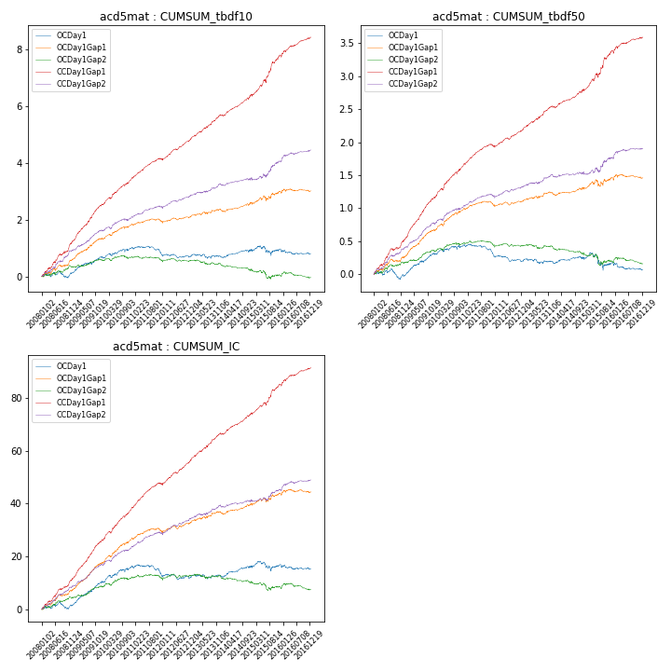

**因子换手率:** 51.33%

**截面指标_OCDay1:**

|  |  |  |  |  |  |  |  |  |
| --- | --- | --- | --- | --- | --- | --- | --- | --- |
| year | annret_tbdf10 | sharpe_tbdf10 | maxdd_tbdf10 | annret_tbdf50 | sharpe_tbdf50 | maxdd_tbdf50 | mean_IC | tstat_IC |
| 2008 | 0.12 | 0.58 | -0.22 | -0.03 | -0.27 | -0.15 | 0.01 | 0.7 |
| 2009 | 0.58 | 3.63 | -0.15 | 0.35 | 4.68 | -0.08 | 0.04 | 5.16 |
| 2010 | 0.32 | 1.88 | -0.47 | 0.12 | 1.45 | -0.31 | 0.02 | 2.71 |
| 2011 | -0.23 | -1.8 | -0.56 | -0.16 | -2.57 | -0.39 | -0.01 | -1.91 |
| 2012 | -0.04 | -0.34 | -0.51 | -0.07 | -1.3 | -0.36 | -0.0 | -0.24 |
| 2013 | -0.03 | -0.19 | -0.49 | -0.02 | -0.31 | -0.33 | 0.0 | 0.19 |
| 2014 | 0.19 | 1.48 | -0.47 | 0.05 | 0.78 | -0.31 | 0.01 | 2.06 |
| 2015 | 0.06 | 0.23 | -0.53 | -0.06 | -0.46 | -0.41 | 0.0 | 0.36 |
| 2016 | -0.15 | -1.06 | -0.53 | -0.1 | -1.42 | -0.37 | -0.01 | -0.86 |

**截面指标_CCDay1Gap1:**

|  |  |  |  |  |  |  |  |  |
| --- | --- | --- | --- | --- | --- | --- | --- | --- |
| year | annret_tbdf10 | sharpe_tbdf10 | maxdd_tbdf10 | annret_tbdf50 | sharpe_tbdf50 | maxdd_tbdf50 | mean_IC | tstat_IC |
| 2008 | 1.21 | 5.95 | -0.07 | 0.52 | 5.73 | -0.03 | 0.05 | 6.23 |
| 2009 | 1.33 | 8.44 | -0.69 | 0.65 | 8.74 | -0.4 | 0.06 | 8.9 |
| 2010 | 0.92 | 5.67 | -0.74 | 0.5 | 6.21 | -0.48 | 0.05 | 6.9 |
| 2011 | 0.67 | 5.43 | -0.73 | 0.27 | 4.88 | -0.47 | 0.04 | 5.87 |
| 2012 | 0.78 | 6.43 | -0.74 | 0.28 | 5.13 | -0.48 | 0.04 | 6.31 |
| 2013 | 0.83 | 5.57 | -0.73 | 0.34 | 5.06 | -0.47 | 0.04 | 5.78 |
| 2014 | 0.71 | 5.23 | -0.74 | 0.25 | 4.12 | -0.49 | 0.03 | 5.18 |
| 2015 | 1.39 | 5.24 | -0.74 | 0.59 | 4.51 | -0.49 | 0.05 | 4.82 |
| 2016 | 0.64 | 4.47 | -0.76 | 0.21 | 3.08 | -0.49 | 0.03 | 4.29 |

**风格暴露:**

|  |  |  |  |  |
| --- | --- | --- | --- | --- |
|  | long | short | corr_OCDay1 | corr_CCDay1Gap1 |
| liquidity10 | 0.18 | -0.17 | -0.06 | -0.07 |
| liquidity20 | 0.08 | -0.07 | 0.02 | -0.01 |
| liquidity5 | 0.39 | -0.39 | -0.14 | -0.15 |
| logmktcap | -0.08 | 0.08 | -0.19 | -0.09 |
| momentum15 | 1.03 | -1.02 | -0.67 | -0.64 |
| momentum30 | 0.68 | -0.67 | -0.54 | -0.5 |
| momentum5 | 2.1 | -2.09 | -0.96 | -0.96 |
| retvolatility30 | 0.05 | -0.04 | 0.09 | 0.07 |

**2. Alpha_76**

**截面指标累计曲线:**

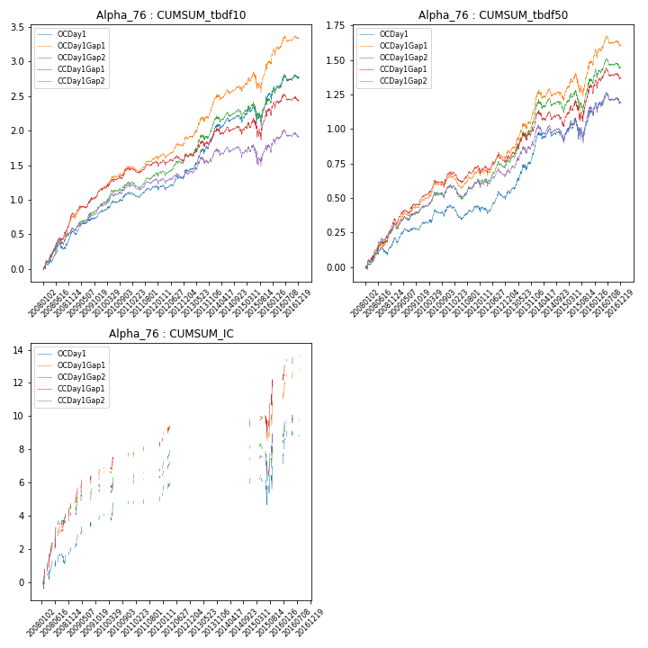

**因子换手率:** 30.84%

**截面指标_OCDay1:**

|  |  |  |  |  |  |  |  |
| --- | --- | --- | --- | --- | --- | --- | --- |
| annret_tbdf10 | sharpe_tbdf10 | maxdd_tbdf10 | annret_tbdf50 | sharpe_tbdf50 | maxdd_tbdf50 | mean_IC | tstat_IC |
| 0 | 3.87 | -0.09 | 0.2 | 3.05 | -0.06 | 0.03 | 1.97 |
| 0 | 3.16 | -0.43 | 0.12 | 2.26 | -0.2 | 0.05 | 3.36 |
| 0 | 2.86 | -0.41 | 0.13 | 2.21 | -0.18 | 0.04 | 1.59 |
| 0 | 1.0 | -0.45 | -0.03 | -0.52 | -0.26 | 0.03 | 0.77 |
| 0 | 2.27 | -0.43 | 0.11 | 1.7 | -0.21 | 0.05 | 1.74 |
| 0 | 3.6 | -0.41 | 0.37 | 3.93 | -0.18 | nan | nan |
| 0 | 1.24 | -0.4 | 0.02 | 0.23 | -0.29 | 0.08 | 2.62 |
| 0 | 1.48 | -0.46 | 0.21 | 1.48 | -0.31 | 0.01 | 0.28 |
| 0 | 1.73 | -0.43 | 0.08 | 0.89 | -0.31 | 0.09 | 2.51 |

**截面指标_CCDay1Gap1:**

|  |  |  |  |  |  |  |  |
| --- | --- | --- | --- | --- | --- | --- | --- |
| annret_tbdf10 | sharpe_tbdf10 | maxdd_tbdf10 | annret_tbdf50 | sharpe_tbdf50 | maxdd_tbdf50 | mean_IC | tstat_IC |
| 0 | 5.68 | -0.05 | 0.33 | 4.98 | -0.02 | 0.06 | 5.1 |
| 0 | 3.58 | -0.57 | 0.18 | 3.24 | -0.3 | 0.06 | 4.09 |
| 0 | 3.05 | -0.55 | 0.18 | 3.29 | -0.29 | 0.04 | 2.79 |
| 0 | 0.69 | -0.59 | 0.01 | 0.16 | -0.34 | 0.06 | 1.95 |
| 0 | 1.21 | -0.57 | 0.09 | 1.44 | -0.3 | 0.06 | 2.58 |
| 0 | 1.83 | -0.56 | 0.28 | 2.82 | -0.29 | nan | nan |
| 0 | 0.3 | -0.55 | -0.03 | -0.35 | -0.32 | 0.1 | 2.89 |
| 0 | 0.98 | -0.61 | 0.25 | 1.65 | -0.29 | 0.04 | 1.19 |
| 0 | 1.19 | -0.56 | 0.09 | 1.03 | -0.3 | 0.08 | 2.87 |

**风格暴露:**

|  |  |  |  |  |
| --- | --- | --- | --- | --- |
|  | long | short | corr_OCDay1 | corr_CCDay1Gap1 |
| liquidity10 | -0.67 | 0.67 | 0.55 | 0.58 |
| liquidity20 | -0.68 | 0.69 | 0.59 | 0.6 |
| liquidity5 | -0.64 | 0.64 | 0.52 | 0.55 |
| logmktcap | 0.38 | -0.37 | -0.46 | -0.5 |
| momentum15 | 0.13 | -0.12 | -0.11 | -0.11 |
| momentum30 | 0.01 | -0.0 | -0.0 | -0.01 |
| momentum5 | 0.34 | -0.33 | -0.28 | -0.19 |
| retvolatility30 | -0.65 | 0.66 | 0.68 | 0.71 |