Factors Report 20080102-20161230

**1. Alpha_76**

**截面指标累计曲线:**

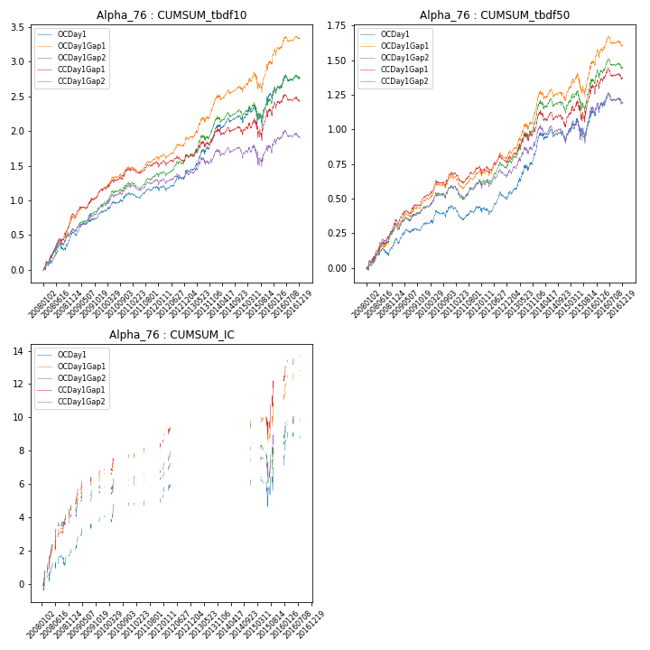

**因子换手率:** 30.84%

**截面指标_OCDay1:**

|  |  |  |  |  |  |  |  |
| --- | --- | --- | --- | --- | --- | --- | --- |
| annret_tbdf10 | sharpe_tbdf10 | maxdd_tbdf10 | annret_tbdf50 | sharpe_tbdf50 | maxdd_tbdf50 | mean_IC | tstat_IC |
| 0 | 3.87 | -0.09 | 0.2 | 3.05 | -0.06 | 0.03 | 1.97 |
| 0 | 3.16 | -0.43 | 0.12 | 2.26 | -0.2 | 0.05 | 3.36 |
| 0 | 2.86 | -0.41 | 0.13 | 2.21 | -0.18 | 0.04 | 1.59 |
| 0 | 1.0 | -0.45 | -0.03 | -0.52 | -0.26 | 0.03 | 0.77 |
| 0 | 2.27 | -0.43 | 0.11 | 1.7 | -0.21 | 0.05 | 1.74 |
| 0 | 3.6 | -0.41 | 0.37 | 3.93 | -0.18 | nan | nan |
| 0 | 1.24 | -0.4 | 0.02 | 0.23 | -0.29 | 0.08 | 2.62 |
| 0 | 1.48 | -0.46 | 0.21 | 1.48 | -0.31 | 0.01 | 0.28 |
| 0 | 1.73 | -0.43 | 0.08 | 0.89 | -0.31 | 0.09 | 2.51 |

**截面指标_CCDay1Gap1:**

|  |  |  |  |  |  |  |  |
| --- | --- | --- | --- | --- | --- | --- | --- |
| annret_tbdf10 | sharpe_tbdf10 | maxdd_tbdf10 | annret_tbdf50 | sharpe_tbdf50 | maxdd_tbdf50 | mean_IC | tstat_IC |
| 0 | 5.68 | -0.05 | 0.33 | 4.98 | -0.02 | 0.06 | 5.1 |
| 0 | 3.58 | -0.57 | 0.18 | 3.24 | -0.3 | 0.06 | 4.09 |
| 0 | 3.05 | -0.55 | 0.18 | 3.29 | -0.29 | 0.04 | 2.79 |
| 0 | 0.69 | -0.59 | 0.01 | 0.16 | -0.34 | 0.06 | 1.95 |
| 0 | 1.21 | -0.57 | 0.09 | 1.44 | -0.3 | 0.06 | 2.58 |
| 0 | 1.83 | -0.56 | 0.28 | 2.82 | -0.29 | nan | nan |
| 0 | 0.3 | -0.55 | -0.03 | -0.35 | -0.32 | 0.1 | 2.89 |
| 0 | 0.98 | -0.61 | 0.25 | 1.65 | -0.29 | 0.04 | 1.19 |
| 0 | 1.19 | -0.56 | 0.09 | 1.03 | -0.3 | 0.08 | 2.87 |

**风格暴露:**

|  |  |  |  |  |
| --- | --- | --- | --- | --- |
|  | long | short | corr_OCDay1 | corr_CCDay1Gap1 |
| liquidity10 | -0.67 | 0.67 | 0.55 | 0.58 |
| liquidity20 | -0.68 | 0.69 | 0.59 | 0.6 |
| liquidity5 | -0.64 | 0.64 | 0.52 | 0.55 |
| logmktcap | 0.38 | -0.37 | -0.46 | -0.5 |
| momentum15 | 0.13 | -0.12 | -0.11 | -0.11 |
| momentum30 | 0.01 | -0.0 | -0.0 | -0.01 |
| momentum5 | 0.34 | -0.33 | -0.28 | -0.19 |
| retvolatility30 | -0.65 | 0.66 | 0.68 | 0.71 |