Factors Report 20080102-20161230

**1. Alpha_8_9**

**截面指标累计曲线:**

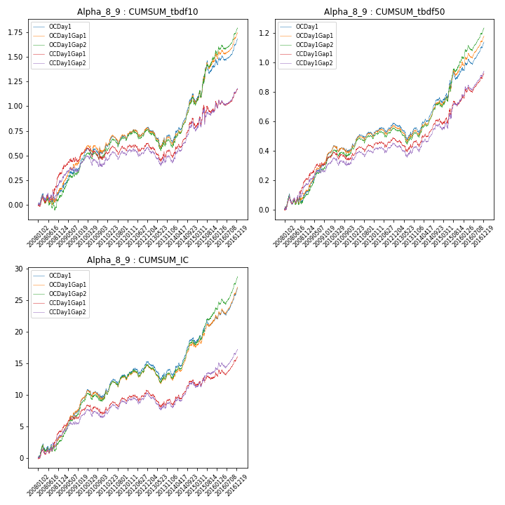

**因子换手率:** 15.57%

**截面指标_OCDay1:**

|  |  |  |  |  |  |  |  |  |
| --- | --- | --- | --- | --- | --- | --- | --- | --- |
| year | annret_tbdf10 | sharpe_tbdf10 | maxdd_tbdf10 | annret_tbdf50 | sharpe_tbdf50 | maxdd_tbdf50 | mean_IC | tstat_IC |
| 2008 | 0.13 | 1.05 | -0.09 | 0.12 | 1.63 | -0.07 | 0.01 | 2.22 |
| 2009 | 0.33 | 3.48 | -0.04 | 0.26 | 5.03 | -0.02 | 0.02 | 5.31 |
| 2010 | 0.08 | 0.89 | -0.07 | 0.02 | 0.48 | -0.05 | 0.0 | 0.41 |
| 2011 | 0.13 | 1.82 | -0.1 | 0.1 | 2.45 | -0.04 | 0.01 | 2.68 |
| 2012 | 0.1 | 1.41 | -0.08 | 0.07 | 1.96 | -0.04 | 0.01 | 2.18 |
| 2013 | -0.1 | -1.04 | -0.19 | -0.03 | -0.65 | -0.1 | -0.01 | -1.11 |
| 2014 | 0.45 | 4.89 | -0.05 | 0.22 | 4.78 | -0.03 | 0.02 | 4.57 |
| 2015 | 0.31 | 1.85 | -0.13 | 0.19 | 2.28 | -0.06 | 0.01 | 1.99 |
| 2016 | 0.25 | 3.3 | -0.06 | 0.19 | 4.02 | -0.04 | 0.02 | 4.31 |

**截面指标_CCDay1Gap1:**

|  |  |  |  |  |  |  |  |  |
| --- | --- | --- | --- | --- | --- | --- | --- | --- |
| year | annret_tbdf10 | sharpe_tbdf10 | maxdd_tbdf10 | annret_tbdf50 | sharpe_tbdf50 | maxdd_tbdf50 | mean_IC | tstat_IC |
| 2008 | 0.32 | 2.33 | -0.07 | 0.21 | 2.72 | -0.06 | 0.02 | 2.96 |
| 2009 | 0.21 | 2.13 | -0.05 | 0.15 | 2.74 | -0.02 | 0.01 | 3.19 |
| 2010 | -0.05 | -0.5 | -0.12 | -0.01 | -0.23 | -0.06 | -0.0 | -0.5 |
| 2011 | 0.08 | 1.22 | -0.09 | 0.08 | 2.04 | -0.04 | 0.01 | 2.1 |
| 2012 | 0.05 | 0.65 | -0.07 | 0.05 | 1.39 | -0.04 | 0.01 | 1.28 |
| 2013 | -0.09 | -0.95 | -0.16 | -0.02 | -0.43 | -0.08 | -0.01 | -1.27 |
| 2014 | 0.35 | 3.67 | -0.04 | 0.16 | 3.35 | -0.03 | 0.01 | 2.96 |
| 2015 | 0.13 | 0.74 | -0.16 | 0.15 | 1.77 | -0.05 | 0.0 | 0.59 |
| 2016 | 0.18 | 2.23 | -0.06 | 0.17 | 3.51 | -0.03 | 0.01 | 2.91 |

**风格暴露:**

|  |  |  |  |  |
| --- | --- | --- | --- | --- |
|  | long | short | corr_OCDay1 | corr_CCDay1Gap1 |
| momentum30 | 0.14 | -0.13 | -0.27 | -0.21 |
| logmktcap | 1.09 | -1.08 | -0.35 | -0.33 |
| liquidity10 | -0.14 | 0.14 | -0.17 | -0.12 |
| retvolatility30 | 0.23 | -0.23 | -0.31 | -0.27 |
| liquidity20 | -0.16 | 0.16 | -0.14 | -0.11 |
| momentum5 | -0.05 | 0.05 | -0.08 | 0.0 |
| momentum15 | 0.06 | -0.06 | -0.18 | -0.13 |
| liquidity5 | -0.13 | 0.14 | -0.19 | -0.13 |

**2. Alpha_8_8**

**截面指标累计曲线:**

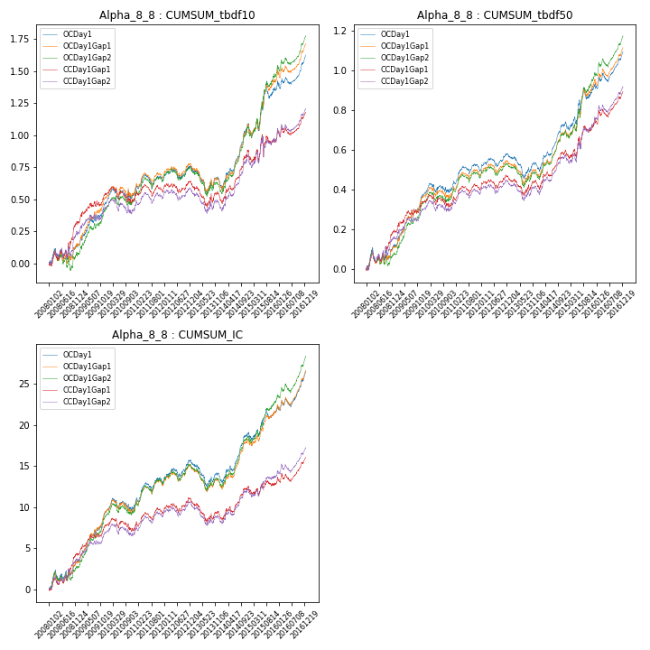

**因子换手率:** 15.66%

**截面指标_OCDay1:**

|  |  |  |  |  |  |  |  |  |
| --- | --- | --- | --- | --- | --- | --- | --- | --- |
| year | annret_tbdf10 | sharpe_tbdf10 | maxdd_tbdf10 | annret_tbdf50 | sharpe_tbdf50 | maxdd_tbdf50 | mean_IC | tstat_IC |
| 2008 | 0.13 | 1.05 | -0.09 | 0.12 | 1.57 | -0.07 | 0.01 | 2.15 |
| 2009 | 0.34 | 3.5 | -0.04 | 0.26 | 4.8 | -0.02 | 0.03 | 5.28 |
| 2010 | 0.07 | 0.69 | -0.08 | 0.03 | 0.48 | -0.05 | 0.0 | 0.36 |
| 2011 | 0.12 | 1.58 | -0.1 | 0.1 | 2.27 | -0.04 | 0.01 | 2.72 |
| 2012 | 0.09 | 1.32 | -0.08 | 0.07 | 1.81 | -0.04 | 0.01 | 2.15 |
| 2013 | -0.11 | -1.11 | -0.19 | -0.05 | -0.9 | -0.11 | -0.01 | -1.35 |
| 2014 | 0.46 | 4.76 | -0.05 | 0.22 | 4.55 | -0.03 | 0.02 | 4.38 |
| 2015 | 0.3 | 1.72 | -0.13 | 0.18 | 2.05 | -0.06 | 0.01 | 1.78 |
| 2016 | 0.24 | 3.01 | -0.06 | 0.17 | 3.58 | -0.04 | 0.02 | 3.91 |

**截面指标_CCDay1Gap1:**

|  |  |  |  |  |  |  |  |  |
| --- | --- | --- | --- | --- | --- | --- | --- | --- |
| year | annret_tbdf10 | sharpe_tbdf10 | maxdd_tbdf10 | annret_tbdf50 | sharpe_tbdf50 | maxdd_tbdf50 | mean_IC | tstat_IC |
| 2008 | 0.32 | 2.28 | -0.08 | 0.19 | 2.49 | -0.06 | 0.02 | 2.92 |
| 2009 | 0.22 | 2.25 | -0.04 | 0.15 | 2.63 | -0.02 | 0.01 | 3.21 |
| 2010 | -0.05 | -0.54 | -0.13 | -0.01 | -0.26 | -0.06 | -0.0 | -0.52 |
| 2011 | 0.08 | 1.16 | -0.09 | 0.08 | 1.98 | -0.04 | 0.01 | 2.15 |
| 2012 | 0.05 | 0.69 | -0.08 | 0.05 | 1.28 | -0.05 | 0.01 | 1.29 |
| 2013 | -0.11 | -1.1 | -0.17 | -0.03 | -0.52 | -0.08 | -0.01 | -1.41 |
| 2014 | 0.36 | 3.62 | -0.05 | 0.16 | 3.24 | -0.03 | 0.01 | 2.86 |
| 2015 | 0.12 | 0.68 | -0.17 | 0.14 | 1.68 | -0.05 | 0.0 | 0.53 |
| 2016 | 0.19 | 2.21 | -0.07 | 0.16 | 3.14 | -0.04 | 0.01 | 2.7 |

**风格暴露:**

|  |  |  |  |  |
| --- | --- | --- | --- | --- |
|  | long | short | corr_OCDay1 | corr_CCDay1Gap1 |
| momentum30 | 0.15 | -0.14 | -0.27 | -0.22 |
| logmktcap | 1.08 | -1.08 | -0.33 | -0.31 |
| liquidity10 | -0.12 | 0.12 | -0.18 | -0.14 |
| retvolatility30 | 0.25 | -0.24 | -0.32 | -0.28 |
| liquidity20 | -0.14 | 0.14 | -0.15 | -0.13 |
| momentum5 | -0.04 | 0.05 | -0.09 | -0.0 |
| momentum15 | 0.07 | -0.06 | -0.19 | -0.15 |
| liquidity5 | -0.11 | 0.11 | -0.2 | -0.14 |

**3. Alpha_8_14**

**截面指标累计曲线:**

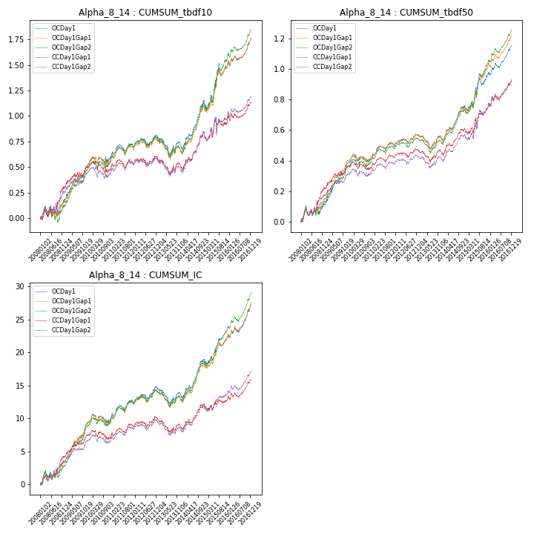

**因子换手率:** 15.48%

**截面指标_OCDay1:**

|  |  |  |  |  |  |  |  |  |
| --- | --- | --- | --- | --- | --- | --- | --- | --- |
| year | annret_tbdf10 | sharpe_tbdf10 | maxdd_tbdf10 | annret_tbdf50 | sharpe_tbdf50 | maxdd_tbdf50 | mean_IC | tstat_IC |
| 2008 | 0.16 | 1.33 | -0.09 | 0.13 | 1.79 | -0.07 | 0.01 | 2.29 |
| 2009 | 0.34 | 3.6 | -0.04 | 0.26 | 5.1 | -0.02 | 0.02 | 5.32 |
| 2010 | 0.08 | 0.89 | -0.07 | 0.02 | 0.5 | -0.05 | 0.0 | 0.47 |
| 2011 | 0.12 | 1.72 | -0.09 | 0.09 | 2.34 | -0.03 | 0.01 | 2.6 |
| 2012 | 0.1 | 1.46 | -0.07 | 0.07 | 2.08 | -0.03 | 0.01 | 2.19 |
| 2013 | -0.09 | -0.93 | -0.18 | -0.01 | -0.29 | -0.09 | -0.0 | -0.82 |
| 2014 | 0.44 | 4.95 | -0.05 | 0.21 | 4.85 | -0.03 | 0.02 | 4.77 |
| 2015 | 0.35 | 2.13 | -0.12 | 0.21 | 2.62 | -0.06 | 0.01 | 2.24 |
| 2016 | 0.26 | 3.57 | -0.05 | 0.19 | 4.33 | -0.03 | 0.02 | 4.74 |

**截面指标_CCDay1Gap1:**

|  |  |  |  |  |  |  |  |  |
| --- | --- | --- | --- | --- | --- | --- | --- | --- |
| year | annret_tbdf10 | sharpe_tbdf10 | maxdd_tbdf10 | annret_tbdf50 | sharpe_tbdf50 | maxdd_tbdf50 | mean_IC | tstat_IC |
| 2008 | 0.3 | 2.24 | -0.07 | 0.22 | 2.95 | -0.05 | 0.02 | 3.0 |
| 2009 | 0.2 | 2.08 | -0.05 | 0.14 | 2.76 | -0.02 | 0.01 | 3.15 |
| 2010 | -0.03 | -0.33 | -0.11 | -0.01 | -0.3 | -0.06 | -0.0 | -0.47 |
| 2011 | 0.07 | 1.06 | -0.09 | 0.07 | 1.97 | -0.03 | 0.01 | 2.03 |
| 2012 | 0.05 | 0.76 | -0.07 | 0.05 | 1.35 | -0.04 | 0.0 | 1.24 |
| 2013 | -0.09 | -0.92 | -0.16 | -0.01 | -0.22 | -0.08 | -0.0 | -1.08 |
| 2014 | 0.33 | 3.58 | -0.04 | 0.15 | 3.29 | -0.03 | 0.01 | 3.06 |
| 2015 | 0.13 | 0.74 | -0.17 | 0.15 | 1.93 | -0.05 | 0.0 | 0.66 |
| 2016 | 0.18 | 2.29 | -0.06 | 0.17 | 3.68 | -0.03 | 0.01 | 3.13 |

**风格暴露:**

|  |  |  |  |  |
| --- | --- | --- | --- | --- |
|  | long | short | corr_OCDay1 | corr_CCDay1Gap1 |
| momentum30 | 0.12 | -0.12 | -0.25 | -0.2 |
| logmktcap | 1.09 | -1.08 | -0.38 | -0.35 |
| liquidity10 | -0.16 | 0.17 | -0.14 | -0.1 |
| retvolatility30 | 0.22 | -0.21 | -0.29 | -0.26 |
| liquidity20 | -0.18 | 0.19 | -0.11 | -0.09 |
| momentum5 | -0.05 | 0.05 | -0.07 | 0.01 |
| momentum15 | 0.06 | -0.05 | -0.17 | -0.12 |
| liquidity5 | -0.15 | 0.16 | -0.16 | -0.1 |

**4. Alpha_8_13**

**截面指标累计曲线:**

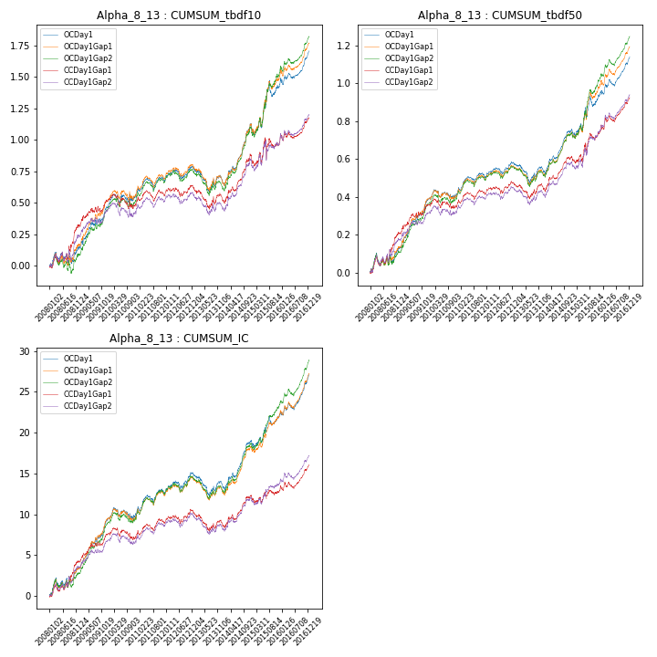

**因子换手率:** 15.54%

**截面指标_OCDay1:**

|  |  |  |  |  |  |  |  |  |
| --- | --- | --- | --- | --- | --- | --- | --- | --- |
| year | annret_tbdf10 | sharpe_tbdf10 | maxdd_tbdf10 | annret_tbdf50 | sharpe_tbdf50 | maxdd_tbdf50 | mean_IC | tstat_IC |
| 2008 | 0.14 | 1.09 | -0.09 | 0.13 | 1.76 | -0.07 | 0.01 | 2.25 |
| 2009 | 0.33 | 3.47 | -0.04 | 0.26 | 5.03 | -0.02 | 0.02 | 5.32 |
| 2010 | 0.08 | 0.91 | -0.07 | 0.02 | 0.49 | -0.05 | 0.0 | 0.43 |
| 2011 | 0.13 | 1.87 | -0.09 | 0.09 | 2.43 | -0.04 | 0.01 | 2.65 |
| 2012 | 0.1 | 1.43 | -0.07 | 0.07 | 1.94 | -0.04 | 0.01 | 2.19 |
| 2013 | -0.1 | -1.02 | -0.18 | -0.03 | -0.56 | -0.1 | -0.0 | -1.01 |
| 2014 | 0.45 | 4.96 | -0.05 | 0.21 | 4.74 | -0.03 | 0.02 | 4.64 |
| 2015 | 0.32 | 1.94 | -0.13 | 0.19 | 2.34 | -0.06 | 0.01 | 2.09 |
| 2016 | 0.26 | 3.42 | -0.05 | 0.19 | 4.21 | -0.03 | 0.02 | 4.47 |

**截面指标_CCDay1Gap1:**

|  |  |  |  |  |  |  |  |  |
| --- | --- | --- | --- | --- | --- | --- | --- | --- |
| year | annret_tbdf10 | sharpe_tbdf10 | maxdd_tbdf10 | annret_tbdf50 | sharpe_tbdf50 | maxdd_tbdf50 | mean_IC | tstat_IC |
| 2008 | 0.32 | 2.38 | -0.07 | 0.21 | 2.77 | -0.05 | 0.02 | 2.97 |
| 2009 | 0.2 | 2.03 | -0.05 | 0.15 | 2.76 | -0.02 | 0.01 | 3.17 |
| 2010 | -0.04 | -0.42 | -0.11 | -0.01 | -0.19 | -0.05 | -0.0 | -0.49 |
| 2011 | 0.09 | 1.34 | -0.08 | 0.07 | 1.88 | -0.04 | 0.01 | 2.08 |
| 2012 | 0.05 | 0.76 | -0.07 | 0.05 | 1.38 | -0.04 | 0.0 | 1.26 |
| 2013 | -0.09 | -0.95 | -0.16 | -0.01 | -0.29 | -0.08 | -0.01 | -1.2 |
| 2014 | 0.34 | 3.6 | -0.04 | 0.15 | 3.36 | -0.03 | 0.01 | 3.0 |
| 2015 | 0.13 | 0.75 | -0.16 | 0.15 | 1.82 | -0.05 | 0.0 | 0.61 |
| 2016 | 0.18 | 2.25 | -0.06 | 0.17 | 3.59 | -0.03 | 0.01 | 2.99 |

**风格暴露:**

|  |  |  |  |  |
| --- | --- | --- | --- | --- |
|  | long | short | corr_OCDay1 | corr_CCDay1Gap1 |
| momentum30 | 0.13 | -0.12 | -0.26 | -0.21 |
| logmktcap | 1.09 | -1.08 | -0.36 | -0.34 |
| liquidity10 | -0.15 | 0.15 | -0.16 | -0.11 |
| retvolatility30 | 0.23 | -0.22 | -0.31 | -0.27 |
| liquidity20 | -0.17 | 0.17 | -0.13 | -0.1 |
| momentum5 | -0.05 | 0.05 | -0.08 | 0.01 |
| momentum15 | 0.06 | -0.05 | -0.18 | -0.13 |
| liquidity5 | -0.14 | 0.15 | -0.18 | -0.12 |

**5. acd5mat**

**截面指标累计曲线:**

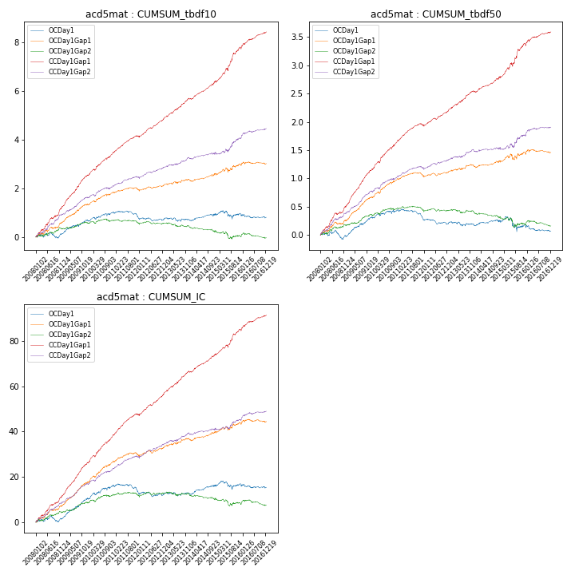

**因子换手率:** 51.33%

**截面指标_OCDay1:**

|  |  |  |  |  |  |  |  |  |
| --- | --- | --- | --- | --- | --- | --- | --- | --- |
| year | annret_tbdf10 | sharpe_tbdf10 | maxdd_tbdf10 | annret_tbdf50 | sharpe_tbdf50 | maxdd_tbdf50 | mean_IC | tstat_IC |
| 2008 | 0.12 | 0.58 | -0.22 | -0.03 | -0.27 | -0.15 | 0.01 | 0.7 |
| 2009 | 0.58 | 3.63 | -0.09 | 0.35 | 4.68 | -0.03 | 0.04 | 5.16 |
| 2010 | 0.32 | 1.88 | -0.1 | 0.12 | 1.45 | -0.05 | 0.02 | 2.71 |
| 2011 | -0.23 | -1.8 | -0.25 | -0.16 | -2.57 | -0.16 | -0.01 | -1.91 |
| 2012 | -0.04 | -0.34 | -0.13 | -0.07 | -1.3 | -0.09 | -0.0 | -0.24 |
| 2013 | -0.03 | -0.19 | -0.15 | -0.02 | -0.31 | -0.08 | 0.0 | 0.19 |
| 2014 | 0.19 | 1.48 | -0.07 | 0.05 | 0.78 | -0.04 | 0.01 | 2.06 |
| 2015 | 0.06 | 0.23 | -0.31 | -0.06 | -0.46 | -0.24 | 0.0 | 0.36 |
| 2016 | -0.15 | -1.06 | -0.18 | -0.1 | -1.42 | -0.11 | -0.01 | -0.86 |

**截面指标_CCDay1Gap1:**

|  |  |  |  |  |  |  |  |  |
| --- | --- | --- | --- | --- | --- | --- | --- | --- |
| year | annret_tbdf10 | sharpe_tbdf10 | maxdd_tbdf10 | annret_tbdf50 | sharpe_tbdf50 | maxdd_tbdf50 | mean_IC | tstat_IC |
| 2008 | 1.21 | 5.95 | -0.07 | 0.52 | 5.73 | -0.03 | 0.05 | 6.23 |
| 2009 | 1.33 | 8.44 | -0.03 | 0.65 | 8.74 | -0.01 | 0.06 | 8.9 |
| 2010 | 0.92 | 5.67 | -0.07 | 0.5 | 6.21 | -0.03 | 0.05 | 6.9 |
| 2011 | 0.67 | 5.43 | -0.05 | 0.27 | 4.88 | -0.04 | 0.04 | 5.87 |
| 2012 | 0.78 | 6.43 | -0.06 | 0.28 | 5.13 | -0.03 | 0.04 | 6.31 |
| 2013 | 0.83 | 5.57 | -0.04 | 0.34 | 5.06 | -0.02 | 0.04 | 5.78 |
| 2014 | 0.71 | 5.23 | -0.06 | 0.25 | 4.12 | -0.02 | 0.03 | 5.18 |
| 2015 | 1.39 | 5.24 | -0.1 | 0.59 | 4.51 | -0.06 | 0.05 | 4.82 |
| 2016 | 0.64 | 4.47 | -0.06 | 0.21 | 3.08 | -0.04 | 0.03 | 4.29 |

**风格暴露:**

|  |  |  |  |  |
| --- | --- | --- | --- | --- |
|  | long | short | corr_OCDay1 | corr_CCDay1Gap1 |
| momentum30 | 0.68 | -0.67 | -0.54 | -0.5 |
| logmktcap | -0.08 | 0.08 | -0.19 | -0.09 |
| liquidity10 | 0.18 | -0.17 | -0.06 | -0.07 |
| retvolatility30 | 0.05 | -0.04 | 0.09 | 0.07 |
| liquidity20 | 0.08 | -0.07 | 0.02 | -0.01 |
| momentum5 | 2.1 | -2.09 | -0.96 | -0.96 |
| momentum15 | 1.03 | -1.02 | -0.67 | -0.64 |
| liquidity5 | 0.39 | -0.39 | -0.14 | -0.15 |

**6. Alpha_8_15**

**截面指标累计曲线:**

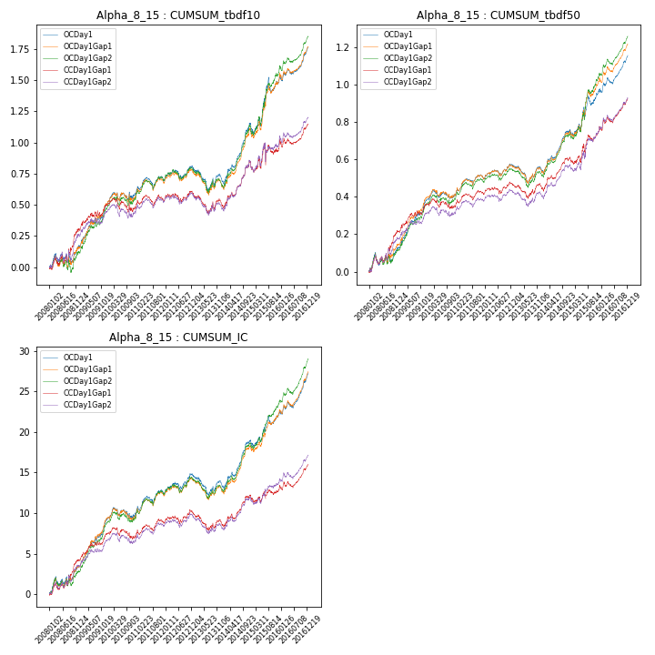

**因子换手率:** 15.49%

**截面指标_OCDay1:**

|  |  |  |  |  |  |  |  |  |
| --- | --- | --- | --- | --- | --- | --- | --- | --- |
| year | annret_tbdf10 | sharpe_tbdf10 | maxdd_tbdf10 | annret_tbdf50 | sharpe_tbdf50 | maxdd_tbdf50 | mean_IC | tstat_IC |
| 2008 | 0.15 | 1.25 | -0.09 | 0.13 | 1.74 | -0.07 | 0.01 | 2.28 |
| 2009 | 0.35 | 3.65 | -0.04 | 0.26 | 5.14 | -0.02 | 0.02 | 5.32 |
| 2010 | 0.08 | 0.92 | -0.07 | 0.02 | 0.49 | -0.05 | 0.0 | 0.46 |
| 2011 | 0.12 | 1.71 | -0.09 | 0.09 | 2.37 | -0.03 | 0.01 | 2.61 |
| 2012 | 0.1 | 1.45 | -0.07 | 0.07 | 2.03 | -0.03 | 0.01 | 2.19 |
| 2013 | -0.09 | -0.94 | -0.18 | -0.02 | -0.35 | -0.1 | -0.0 | -0.86 |
| 2014 | 0.44 | 4.99 | -0.05 | 0.21 | 4.81 | -0.03 | 0.02 | 4.74 |
| 2015 | 0.35 | 2.11 | -0.12 | 0.21 | 2.58 | -0.06 | 0.01 | 2.2 |
| 2016 | 0.26 | 3.55 | -0.05 | 0.19 | 4.3 | -0.03 | 0.02 | 4.68 |

**截面指标_CCDay1Gap1:**

|  |  |  |  |  |  |  |  |  |
| --- | --- | --- | --- | --- | --- | --- | --- | --- |
| year | annret_tbdf10 | sharpe_tbdf10 | maxdd_tbdf10 | annret_tbdf50 | sharpe_tbdf50 | maxdd_tbdf50 | mean_IC | tstat_IC |
| 2008 | 0.3 | 2.24 | -0.07 | 0.21 | 2.89 | -0.05 | 0.02 | 2.99 |
| 2009 | 0.2 | 2.09 | -0.05 | 0.15 | 2.75 | -0.02 | 0.01 | 3.15 |
| 2010 | -0.03 | -0.34 | -0.11 | -0.01 | -0.29 | -0.05 | -0.0 | -0.48 |
| 2011 | 0.07 | 1.08 | -0.09 | 0.07 | 1.93 | -0.03 | 0.01 | 2.04 |
| 2012 | 0.05 | 0.75 | -0.07 | 0.05 | 1.41 | -0.04 | 0.0 | 1.24 |
| 2013 | -0.09 | -0.93 | -0.16 | -0.01 | -0.21 | -0.07 | -0.01 | -1.11 |
| 2014 | 0.33 | 3.61 | -0.04 | 0.15 | 3.33 | -0.03 | 0.01 | 3.05 |
| 2015 | 0.13 | 0.76 | -0.16 | 0.15 | 1.87 | -0.05 | 0.0 | 0.65 |
| 2016 | 0.18 | 2.28 | -0.06 | 0.17 | 3.66 | -0.03 | 0.01 | 3.1 |

**风格暴露:**

|  |  |  |  |  |
| --- | --- | --- | --- | --- |
|  | long | short | corr_OCDay1 | corr_CCDay1Gap1 |
| momentum30 | 0.13 | -0.12 | -0.25 | -0.2 |
| logmktcap | 1.09 | -1.08 | -0.38 | -0.35 |
| liquidity10 | -0.16 | 0.16 | -0.14 | -0.1 |
| retvolatility30 | 0.22 | -0.21 | -0.29 | -0.26 |
| liquidity20 | -0.18 | 0.18 | -0.11 | -0.09 |
| momentum5 | -0.05 | 0.05 | -0.08 | 0.01 |
| momentum15 | 0.06 | -0.05 | -0.17 | -0.12 |
| liquidity5 | -0.15 | 0.16 | -0.17 | -0.11 |

**7. Alpha_8_6**

**截面指标累计曲线:**

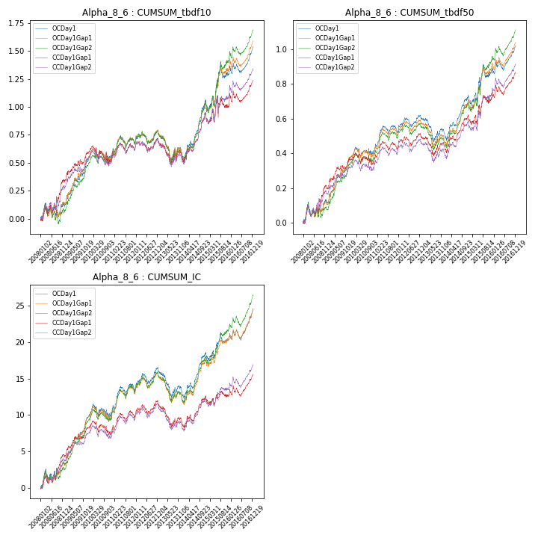

**因子换手率:** 15.84%

**截面指标_OCDay1:**

|  |  |  |  |  |  |  |  |  |
| --- | --- | --- | --- | --- | --- | --- | --- | --- |
| year | annret_tbdf10 | sharpe_tbdf10 | maxdd_tbdf10 | annret_tbdf50 | sharpe_tbdf50 | maxdd_tbdf50 | mean_IC | tstat_IC |
| 2008 | 0.11 | 0.8 | -0.12 | 0.12 | 1.4 | -0.08 | 0.01 | 1.93 |
| 2009 | 0.41 | 4.0 | -0.04 | 0.26 | 4.47 | -0.02 | 0.03 | 5.14 |
| 2010 | 0.03 | 0.3 | -0.11 | 0.03 | 0.45 | -0.06 | 0.0 | 0.19 |
| 2011 | 0.13 | 1.62 | -0.11 | 0.12 | 2.49 | -0.05 | 0.01 | 2.7 |
| 2012 | 0.09 | 1.13 | -0.1 | 0.08 | 1.76 | -0.05 | 0.01 | 2.0 |
| 2013 | -0.18 | -1.61 | -0.23 | -0.09 | -1.44 | -0.13 | -0.01 | -1.9 |
| 2014 | 0.48 | 4.55 | -0.06 | 0.22 | 3.92 | -0.04 | 0.02 | 3.85 |
| 2015 | 0.27 | 1.48 | -0.14 | 0.15 | 1.48 | -0.07 | 0.01 | 1.19 |
| 2016 | 0.21 | 2.33 | -0.09 | 0.14 | 2.56 | -0.06 | 0.02 | 2.9 |

**截面指标_CCDay1Gap1:**

|  |  |  |  |  |  |  |  |  |
| --- | --- | --- | --- | --- | --- | --- | --- | --- |
| year | annret_tbdf10 | sharpe_tbdf10 | maxdd_tbdf10 | annret_tbdf50 | sharpe_tbdf50 | maxdd_tbdf50 | mean_IC | tstat_IC |
| 2008 | 0.34 | 2.31 | -0.08 | 0.2 | 2.38 | -0.06 | 0.02 | 2.78 |
| 2009 | 0.25 | 2.39 | -0.04 | 0.16 | 2.73 | -0.03 | 0.02 | 3.22 |
| 2010 | -0.07 | -0.69 | -0.16 | -0.02 | -0.31 | -0.07 | -0.0 | -0.61 |
| 2011 | 0.12 | 1.51 | -0.09 | 0.09 | 1.91 | -0.05 | 0.01 | 2.15 |
| 2012 | 0.06 | 0.76 | -0.09 | 0.06 | 1.38 | -0.05 | 0.01 | 1.29 |
| 2013 | -0.15 | -1.26 | -0.19 | -0.06 | -0.97 | -0.11 | -0.01 | -1.74 |
| 2014 | 0.39 | 3.58 | -0.05 | 0.18 | 3.01 | -0.03 | 0.01 | 2.58 |
| 2015 | 0.12 | 0.62 | -0.17 | 0.11 | 1.2 | -0.06 | 0.0 | 0.33 |
| 2016 | 0.18 | 1.91 | -0.1 | 0.14 | 2.49 | -0.06 | 0.01 | 2.15 |

**风格暴露:**

|  |  |  |  |  |
| --- | --- | --- | --- | --- |
|  | long | short | corr_OCDay1 | corr_CCDay1Gap1 |
| momentum30 | 0.17 | -0.16 | -0.29 | -0.24 |
| logmktcap | 1.05 | -1.04 | -0.27 | -0.26 |
| liquidity10 | -0.05 | 0.05 | -0.21 | -0.17 |
| retvolatility30 | 0.29 | -0.28 | -0.34 | -0.3 |
| liquidity20 | -0.07 | 0.07 | -0.19 | -0.16 |
| momentum5 | -0.04 | 0.05 | -0.09 | -0.02 |
| momentum15 | 0.08 | -0.08 | -0.2 | -0.16 |
| liquidity5 | -0.04 | 0.05 | -0.23 | -0.18 |

**8. Alpha_8_7**

**截面指标累计曲线:**

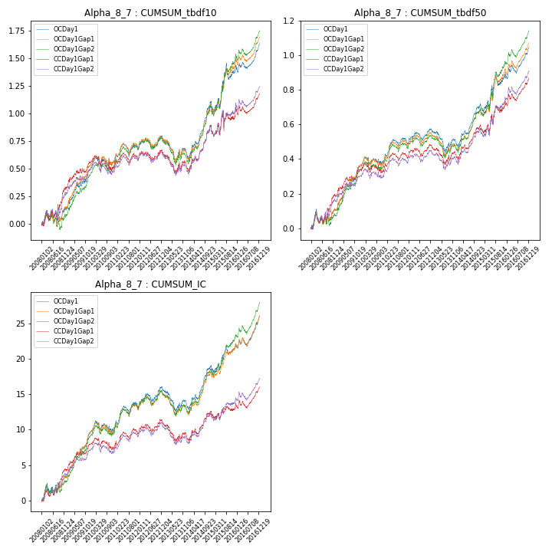

**因子换手率:** 15.72%

**截面指标_OCDay1:**

|  |  |  |  |  |  |  |  |  |
| --- | --- | --- | --- | --- | --- | --- | --- | --- |
| year | annret_tbdf10 | sharpe_tbdf10 | maxdd_tbdf10 | annret_tbdf50 | sharpe_tbdf50 | maxdd_tbdf50 | mean_IC | tstat_IC |
| 2008 | 0.13 | 0.98 | -0.1 | 0.11 | 1.36 | -0.08 | 0.01 | 2.09 |
| 2009 | 0.36 | 3.72 | -0.04 | 0.25 | 4.52 | -0.02 | 0.03 | 5.25 |
| 2010 | 0.07 | 0.7 | -0.08 | 0.03 | 0.5 | -0.05 | 0.0 | 0.32 |
| 2011 | 0.13 | 1.68 | -0.1 | 0.11 | 2.36 | -0.04 | 0.01 | 2.73 |
| 2012 | 0.09 | 1.21 | -0.09 | 0.07 | 1.74 | -0.05 | 0.01 | 2.11 |
| 2013 | -0.13 | -1.24 | -0.2 | -0.06 | -1.16 | -0.12 | -0.01 | -1.53 |
| 2014 | 0.47 | 4.73 | -0.06 | 0.22 | 4.37 | -0.03 | 0.02 | 4.21 |
| 2015 | 0.29 | 1.67 | -0.14 | 0.16 | 1.78 | -0.06 | 0.01 | 1.6 |
| 2016 | 0.23 | 2.81 | -0.06 | 0.17 | 3.28 | -0.05 | 0.02 | 3.59 |

**截面指标_CCDay1Gap1:**

|  |  |  |  |  |  |  |  |  |
| --- | --- | --- | --- | --- | --- | --- | --- | --- |
| year | annret_tbdf10 | sharpe_tbdf10 | maxdd_tbdf10 | annret_tbdf50 | sharpe_tbdf50 | maxdd_tbdf50 | mean_IC | tstat_IC |
| 2008 | 0.32 | 2.37 | -0.07 | 0.19 | 2.41 | -0.06 | 0.02 | 2.88 |
| 2009 | 0.23 | 2.29 | -0.04 | 0.15 | 2.6 | -0.02 | 0.01 | 3.22 |
| 2010 | -0.06 | -0.55 | -0.14 | -0.01 | -0.14 | -0.06 | -0.0 | -0.55 |
| 2011 | 0.1 | 1.35 | -0.09 | 0.08 | 1.92 | -0.04 | 0.01 | 2.16 |
| 2012 | 0.05 | 0.63 | -0.08 | 0.05 | 1.3 | -0.05 | 0.01 | 1.3 |
| 2013 | -0.13 | -1.21 | -0.18 | -0.05 | -0.8 | -0.1 | -0.01 | -1.52 |
| 2014 | 0.36 | 3.54 | -0.05 | 0.17 | 3.16 | -0.03 | 0.01 | 2.78 |
| 2015 | 0.11 | 0.63 | -0.17 | 0.12 | 1.38 | -0.06 | 0.0 | 0.48 |
| 2016 | 0.18 | 2.11 | -0.08 | 0.16 | 2.97 | -0.04 | 0.01 | 2.53 |

**风格暴露:**

|  |  |  |  |  |
| --- | --- | --- | --- | --- |
|  | long | short | corr_OCDay1 | corr_CCDay1Gap1 |
| momentum30 | 0.15 | -0.15 | -0.28 | -0.23 |
| logmktcap | 1.07 | -1.07 | -0.31 | -0.29 |
| liquidity10 | -0.1 | 0.1 | -0.19 | -0.15 |
| retvolatility30 | 0.26 | -0.26 | -0.33 | -0.29 |
| liquidity20 | -0.11 | 0.12 | -0.16 | -0.14 |
| momentum5 | -0.04 | 0.05 | -0.09 | -0.01 |
| momentum15 | 0.07 | -0.07 | -0.19 | -0.15 |
| liquidity5 | -0.09 | 0.09 | -0.21 | -0.16 |

**9. Alpha_8_10**

**截面指标累计曲线:**

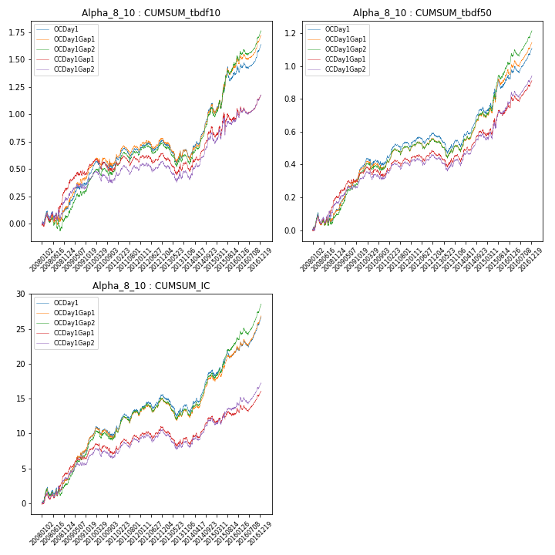

**因子换手率:** 15.63%

**截面指标_OCDay1:**

|  |  |  |  |  |  |  |  |  |
| --- | --- | --- | --- | --- | --- | --- | --- | --- |
| year | annret_tbdf10 | sharpe_tbdf10 | maxdd_tbdf10 | annret_tbdf50 | sharpe_tbdf50 | maxdd_tbdf50 | mean_IC | tstat_IC |
| 2008 | 0.13 | 1.04 | -0.09 | 0.12 | 1.65 | -0.07 | 0.01 | 2.18 |
| 2009 | 0.33 | 3.45 | -0.04 | 0.26 | 4.89 | -0.02 | 0.03 | 5.3 |
| 2010 | 0.07 | 0.79 | -0.07 | 0.03 | 0.57 | -0.05 | 0.0 | 0.38 |
| 2011 | 0.12 | 1.68 | -0.1 | 0.1 | 2.35 | -0.04 | 0.01 | 2.71 |
| 2012 | 0.09 | 1.31 | -0.08 | 0.07 | 1.82 | -0.04 | 0.01 | 2.17 |
| 2013 | -0.11 | -1.11 | -0.19 | -0.05 | -0.87 | -0.11 | -0.01 | -1.27 |
| 2014 | 0.46 | 4.86 | -0.05 | 0.22 | 4.55 | -0.03 | 0.02 | 4.45 |
| 2015 | 0.3 | 1.77 | -0.13 | 0.18 | 2.11 | -0.06 | 0.01 | 1.86 |
| 2016 | 0.24 | 3.08 | -0.06 | 0.18 | 3.75 | -0.04 | 0.02 | 4.06 |

**截面指标_CCDay1Gap1:**

|  |  |  |  |  |  |  |  |  |
| --- | --- | --- | --- | --- | --- | --- | --- | --- |
| year | annret_tbdf10 | sharpe_tbdf10 | maxdd_tbdf10 | annret_tbdf50 | sharpe_tbdf50 | maxdd_tbdf50 | mean_IC | tstat_IC |
| 2008 | 0.32 | 2.3 | -0.07 | 0.2 | 2.59 | -0.06 | 0.02 | 2.94 |
| 2009 | 0.22 | 2.22 | -0.05 | 0.15 | 2.65 | -0.02 | 0.01 | 3.2 |
| 2010 | -0.04 | -0.44 | -0.12 | -0.01 | -0.21 | -0.06 | -0.0 | -0.51 |
| 2011 | 0.08 | 1.15 | -0.09 | 0.08 | 2.0 | -0.04 | 0.01 | 2.13 |
| 2012 | 0.05 | 0.68 | -0.08 | 0.05 | 1.34 | -0.04 | 0.01 | 1.29 |
| 2013 | -0.11 | -1.07 | -0.17 | -0.03 | -0.49 | -0.08 | -0.01 | -1.36 |
| 2014 | 0.35 | 3.61 | -0.05 | 0.16 | 3.31 | -0.03 | 0.01 | 2.9 |
| 2015 | 0.12 | 0.7 | -0.16 | 0.14 | 1.71 | -0.05 | 0.0 | 0.56 |
| 2016 | 0.18 | 2.19 | -0.07 | 0.16 | 3.25 | -0.04 | 0.01 | 2.78 |

**风格暴露:**

|  |  |  |  |  |
| --- | --- | --- | --- | --- |
|  | long | short | corr_OCDay1 | corr_CCDay1Gap1 |
| momentum30 | 0.14 | -0.14 | -0.27 | -0.22 |
| logmktcap | 1.08 | -1.08 | -0.34 | -0.31 |
| liquidity10 | -0.12 | 0.13 | -0.18 | -0.13 |
| retvolatility30 | 0.24 | -0.24 | -0.32 | -0.28 |
| liquidity20 | -0.14 | 0.15 | -0.15 | -0.12 |
| momentum5 | -0.05 | 0.05 | -0.09 | 0.0 |
| momentum15 | 0.07 | -0.06 | -0.19 | -0.14 |
| liquidity5 | -0.12 | 0.12 | -0.2 | -0.14 |

**10. Alpha_8_16**

**截面指标累计曲线:**

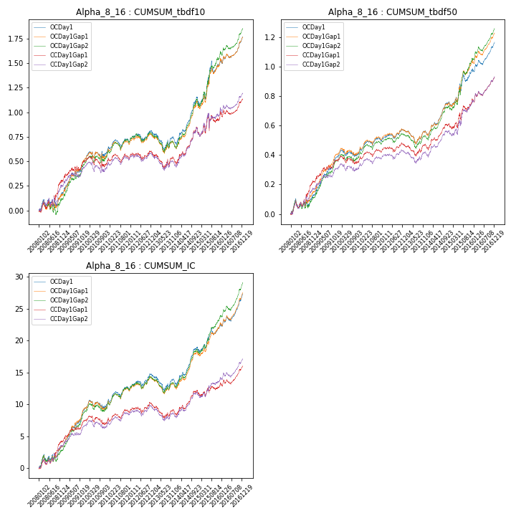

**因子换手率:** 15.48%

**截面指标_OCDay1:**

|  |  |  |  |  |  |  |  |  |
| --- | --- | --- | --- | --- | --- | --- | --- | --- |
| year | annret_tbdf10 | sharpe_tbdf10 | maxdd_tbdf10 | annret_tbdf50 | sharpe_tbdf50 | maxdd_tbdf50 | mean_IC | tstat_IC |
| 2008 | 0.16 | 1.33 | -0.09 | 0.13 | 1.79 | -0.07 | 0.01 | 2.29 |
| 2009 | 0.34 | 3.58 | -0.04 | 0.26 | 5.12 | -0.02 | 0.02 | 5.32 |
| 2010 | 0.08 | 0.9 | -0.07 | 0.02 | 0.5 | -0.05 | 0.0 | 0.47 |
| 2011 | 0.12 | 1.76 | -0.09 | 0.09 | 2.34 | -0.03 | 0.01 | 2.59 |
| 2012 | 0.1 | 1.44 | -0.07 | 0.07 | 2.07 | -0.03 | 0.01 | 2.19 |
| 2013 | -0.09 | -0.92 | -0.18 | -0.01 | -0.29 | -0.09 | -0.0 | -0.81 |
| 2014 | 0.44 | 4.96 | -0.05 | 0.21 | 4.85 | -0.03 | 0.02 | 4.78 |
| 2015 | 0.35 | 2.14 | -0.12 | 0.21 | 2.64 | -0.06 | 0.01 | 2.24 |
| 2016 | 0.26 | 3.61 | -0.05 | 0.19 | 4.36 | -0.03 | 0.02 | 4.75 |

**截面指标_CCDay1Gap1:**

|  |  |  |  |  |  |  |  |  |
| --- | --- | --- | --- | --- | --- | --- | --- | --- |
| year | annret_tbdf10 | sharpe_tbdf10 | maxdd_tbdf10 | annret_tbdf50 | sharpe_tbdf50 | maxdd_tbdf50 | mean_IC | tstat_IC |
| 2008 | 0.3 | 2.25 | -0.07 | 0.22 | 2.97 | -0.05 | 0.02 | 3.0 |
| 2009 | 0.2 | 2.07 | -0.05 | 0.15 | 2.77 | -0.02 | 0.01 | 3.15 |
| 2010 | -0.03 | -0.35 | -0.11 | -0.01 | -0.29 | -0.06 | -0.0 | -0.47 |
| 2011 | 0.07 | 1.1 | -0.09 | 0.07 | 1.95 | -0.03 | 0.01 | 2.02 |
| 2012 | 0.05 | 0.73 | -0.07 | 0.05 | 1.36 | -0.04 | 0.0 | 1.24 |
| 2013 | -0.09 | -0.92 | -0.16 | -0.01 | -0.22 | -0.08 | -0.0 | -1.08 |
| 2014 | 0.33 | 3.58 | -0.04 | 0.15 | 3.31 | -0.03 | 0.01 | 3.07 |
| 2015 | 0.12 | 0.73 | -0.17 | 0.15 | 1.94 | -0.05 | 0.0 | 0.66 |
| 2016 | 0.18 | 2.31 | -0.06 | 0.17 | 3.68 | -0.03 | 0.01 | 3.14 |

**风格暴露:**

|  |  |  |  |  |
| --- | --- | --- | --- | --- |
|  | long | short | corr_OCDay1 | corr_CCDay1Gap1 |
| momentum30 | 0.12 | -0.12 | -0.25 | -0.2 |
| logmktcap | 1.09 | -1.08 | -0.39 | -0.35 |
| liquidity10 | -0.16 | 0.17 | -0.14 | -0.1 |
| retvolatility30 | 0.21 | -0.21 | -0.29 | -0.26 |
| liquidity20 | -0.18 | 0.19 | -0.11 | -0.09 |
| momentum5 | -0.05 | 0.05 | -0.07 | 0.01 |
| momentum15 | 0.06 | -0.05 | -0.17 | -0.12 |
| liquidity5 | -0.15 | 0.16 | -0.16 | -0.1 |

**11. Alpha_8_17**

**截面指标累计曲线:**

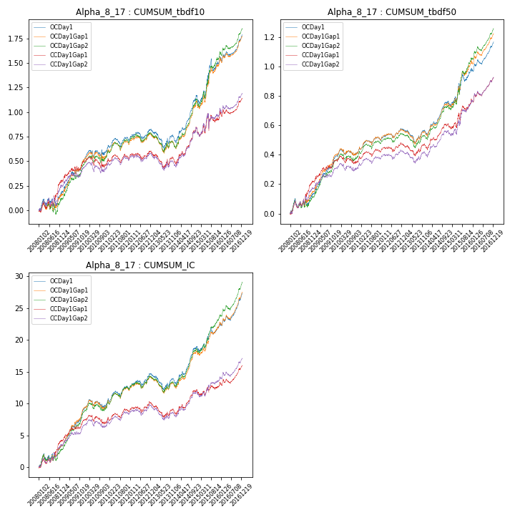

**因子换手率:** 15.47%

**截面指标_OCDay1:**

|  |  |  |  |  |  |  |  |  |
| --- | --- | --- | --- | --- | --- | --- | --- | --- |
| year | annret_tbdf10 | sharpe_tbdf10 | maxdd_tbdf10 | annret_tbdf50 | sharpe_tbdf50 | maxdd_tbdf50 | mean_IC | tstat_IC |
| 2008 | 0.17 | 1.42 | -0.09 | 0.13 | 1.86 | -0.06 | 0.01 | 2.3 |
| 2009 | 0.34 | 3.59 | -0.04 | 0.26 | 5.09 | -0.02 | 0.02 | 5.32 |
| 2010 | 0.09 | 0.96 | -0.07 | 0.03 | 0.53 | -0.04 | 0.0 | 0.47 |
| 2011 | 0.12 | 1.76 | -0.09 | 0.09 | 2.31 | -0.03 | 0.01 | 2.58 |
| 2012 | 0.1 | 1.46 | -0.07 | 0.07 | 2.07 | -0.03 | 0.01 | 2.19 |
| 2013 | -0.09 | -0.91 | -0.18 | -0.01 | -0.31 | -0.09 | -0.0 | -0.79 |
| 2014 | 0.44 | 4.98 | -0.04 | 0.21 | 4.9 | -0.03 | 0.02 | 4.79 |
| 2015 | 0.36 | 2.17 | -0.12 | 0.21 | 2.64 | -0.06 | 0.01 | 2.26 |
| 2016 | 0.26 | 3.61 | -0.05 | 0.19 | 4.39 | -0.03 | 0.02 | 4.78 |

**截面指标_CCDay1Gap1:**

|  |  |  |  |  |  |  |  |  |
| --- | --- | --- | --- | --- | --- | --- | --- | --- |
| year | annret_tbdf10 | sharpe_tbdf10 | maxdd_tbdf10 | annret_tbdf50 | sharpe_tbdf50 | maxdd_tbdf50 | mean_IC | tstat_IC |
| 2008 | 0.3 | 2.23 | -0.07 | 0.22 | 2.97 | -0.05 | 0.02 | 3.0 |
| 2009 | 0.2 | 2.04 | -0.05 | 0.15 | 2.78 | -0.02 | 0.01 | 3.15 |
| 2010 | -0.04 | -0.38 | -0.11 | -0.01 | -0.25 | -0.05 | -0.0 | -0.47 |
| 2011 | 0.08 | 1.15 | -0.08 | 0.07 | 1.95 | -0.03 | 0.01 | 2.01 |
| 2012 | 0.05 | 0.77 | -0.07 | 0.05 | 1.36 | -0.04 | 0.0 | 1.23 |
| 2013 | -0.09 | -0.92 | -0.16 | -0.01 | -0.2 | -0.07 | -0.0 | -1.07 |
| 2014 | 0.33 | 3.59 | -0.04 | 0.15 | 3.32 | -0.03 | 0.01 | 3.07 |
| 2015 | 0.13 | 0.75 | -0.16 | 0.15 | 1.92 | -0.05 | 0.0 | 0.66 |
| 2016 | 0.18 | 2.33 | -0.06 | 0.17 | 3.71 | -0.03 | 0.01 | 3.16 |

**风格暴露:**

|  |  |  |  |  |
| --- | --- | --- | --- | --- |
|  | long | short | corr_OCDay1 | corr_CCDay1Gap1 |
| momentum30 | 0.12 | -0.12 | -0.25 | -0.2 |
| logmktcap | 1.09 | -1.08 | -0.39 | -0.36 |
| liquidity10 | -0.16 | 0.17 | -0.14 | -0.09 |
| retvolatility30 | 0.21 | -0.21 | -0.29 | -0.25 |
| liquidity20 | -0.18 | 0.19 | -0.11 | -0.08 |
| momentum5 | -0.05 | 0.05 | -0.07 | 0.01 |
| momentum15 | 0.06 | -0.05 | -0.17 | -0.12 |
| liquidity5 | -0.15 | 0.16 | -0.16 | -0.1 |

**12. Alpha_8_12**

**截面指标累计曲线:**

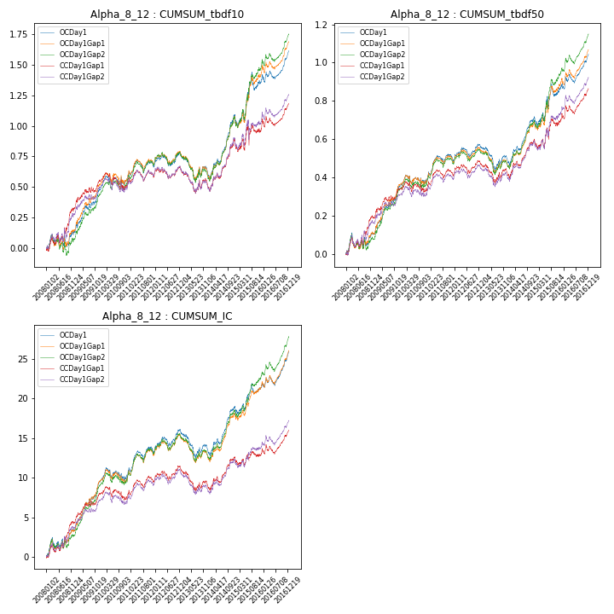

**因子换手率:** 15.73%

**截面指标_OCDay1:**

|  |  |  |  |  |  |  |  |  |
| --- | --- | --- | --- | --- | --- | --- | --- | --- |
| year | annret_tbdf10 | sharpe_tbdf10 | maxdd_tbdf10 | annret_tbdf50 | sharpe_tbdf50 | maxdd_tbdf50 | mean_IC | tstat_IC |
| 2008 | 0.12 | 0.92 | -0.1 | 0.11 | 1.35 | -0.08 | 0.01 | 2.07 |
| 2009 | 0.36 | 3.7 | -0.04 | 0.25 | 4.52 | -0.02 | 0.03 | 5.24 |
| 2010 | 0.07 | 0.73 | -0.08 | 0.03 | 0.48 | -0.05 | 0.0 | 0.3 |
| 2011 | 0.13 | 1.64 | -0.1 | 0.11 | 2.36 | -0.04 | 0.01 | 2.73 |
| 2012 | 0.08 | 1.15 | -0.09 | 0.07 | 1.72 | -0.05 | 0.01 | 2.11 |
| 2013 | -0.14 | -1.3 | -0.2 | -0.06 | -1.15 | -0.12 | -0.01 | -1.57 |
| 2014 | 0.47 | 4.73 | -0.06 | 0.22 | 4.33 | -0.03 | 0.02 | 4.18 |
| 2015 | 0.29 | 1.66 | -0.14 | 0.16 | 1.76 | -0.06 | 0.01 | 1.57 |
| 2016 | 0.23 | 2.77 | -0.06 | 0.17 | 3.26 | -0.05 | 0.02 | 3.53 |

**截面指标_CCDay1Gap1:**

|  |  |  |  |  |  |  |  |  |
| --- | --- | --- | --- | --- | --- | --- | --- | --- |
| year | annret_tbdf10 | sharpe_tbdf10 | maxdd_tbdf10 | annret_tbdf50 | sharpe_tbdf50 | maxdd_tbdf50 | mean_IC | tstat_IC |
| 2008 | 0.32 | 2.34 | -0.07 | 0.19 | 2.43 | -0.06 | 0.02 | 2.87 |
| 2009 | 0.23 | 2.28 | -0.04 | 0.15 | 2.59 | -0.02 | 0.01 | 3.22 |
| 2010 | -0.05 | -0.53 | -0.14 | -0.01 | -0.13 | -0.06 | -0.0 | -0.55 |
| 2011 | 0.1 | 1.33 | -0.09 | 0.09 | 1.94 | -0.04 | 0.01 | 2.16 |
| 2012 | 0.05 | 0.62 | -0.08 | 0.05 | 1.29 | -0.05 | 0.01 | 1.3 |
| 2013 | -0.13 | -1.2 | -0.18 | -0.05 | -0.82 | -0.1 | -0.01 | -1.54 |
| 2014 | 0.36 | 3.53 | -0.05 | 0.17 | 3.12 | -0.03 | 0.01 | 2.76 |
| 2015 | 0.12 | 0.66 | -0.16 | 0.12 | 1.33 | -0.06 | 0.0 | 0.47 |
| 2016 | 0.18 | 2.1 | -0.08 | 0.15 | 2.91 | -0.04 | 0.01 | 2.5 |

**风格暴露:**

|  |  |  |  |  |
| --- | --- | --- | --- | --- |
|  | long | short | corr_OCDay1 | corr_CCDay1Gap1 |
| momentum30 | 0.15 | -0.15 | -0.28 | -0.23 |
| logmktcap | 1.07 | -1.07 | -0.31 | -0.29 |
| liquidity10 | -0.09 | 0.1 | -0.19 | -0.15 |
| retvolatility30 | 0.27 | -0.26 | -0.33 | -0.29 |
| liquidity20 | -0.11 | 0.12 | -0.17 | -0.14 |
| momentum5 | -0.04 | 0.05 | -0.09 | -0.01 |
| momentum15 | 0.07 | -0.07 | -0.2 | -0.15 |
| liquidity5 | -0.08 | 0.09 | -0.21 | -0.16 |

**13. Alpha_8_11**

**截面指标累计曲线:**

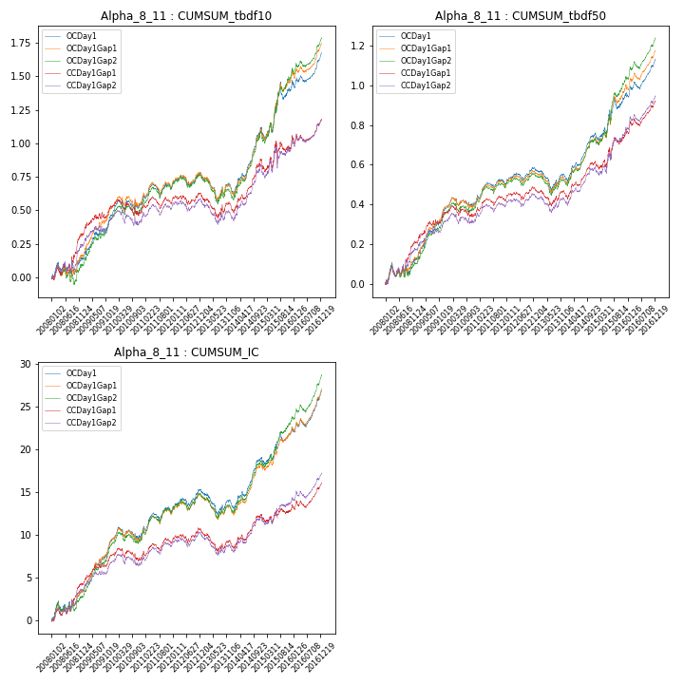

**因子换手率:** 15.58%

**截面指标_OCDay1:**

|  |  |  |  |  |  |  |  |  |
| --- | --- | --- | --- | --- | --- | --- | --- | --- |
| year | annret_tbdf10 | sharpe_tbdf10 | maxdd_tbdf10 | annret_tbdf50 | sharpe_tbdf50 | maxdd_tbdf50 | mean_IC | tstat_IC |
| 2008 | 0.13 | 1.05 | -0.09 | 0.12 | 1.64 | -0.07 | 0.01 | 2.22 |
| 2009 | 0.33 | 3.48 | -0.04 | 0.26 | 4.98 | -0.02 | 0.02 | 5.31 |
| 2010 | 0.08 | 0.88 | -0.07 | 0.03 | 0.49 | -0.05 | 0.0 | 0.41 |
| 2011 | 0.13 | 1.78 | -0.1 | 0.1 | 2.44 | -0.04 | 0.01 | 2.68 |
| 2012 | 0.09 | 1.32 | -0.08 | 0.07 | 1.92 | -0.04 | 0.01 | 2.18 |
| 2013 | -0.1 | -1.03 | -0.18 | -0.03 | -0.68 | -0.1 | -0.01 | -1.13 |
| 2014 | 0.46 | 4.9 | -0.05 | 0.22 | 4.79 | -0.03 | 0.02 | 4.55 |
| 2015 | 0.31 | 1.86 | -0.13 | 0.19 | 2.26 | -0.06 | 0.01 | 1.98 |
| 2016 | 0.25 | 3.3 | -0.06 | 0.18 | 3.97 | -0.04 | 0.02 | 4.28 |

**截面指标_CCDay1Gap1:**

|  |  |  |  |  |  |  |  |  |
| --- | --- | --- | --- | --- | --- | --- | --- | --- |
| year | annret_tbdf10 | sharpe_tbdf10 | maxdd_tbdf10 | annret_tbdf50 | sharpe_tbdf50 | maxdd_tbdf50 | mean_IC | tstat_IC |
| 2008 | 0.32 | 2.34 | -0.07 | 0.21 | 2.73 | -0.06 | 0.02 | 2.96 |
| 2009 | 0.21 | 2.16 | -0.05 | 0.15 | 2.76 | -0.02 | 0.01 | 3.19 |
| 2010 | -0.05 | -0.5 | -0.12 | -0.01 | -0.25 | -0.06 | -0.0 | -0.5 |
| 2011 | 0.08 | 1.2 | -0.09 | 0.08 | 2.0 | -0.04 | 0.01 | 2.11 |
| 2012 | 0.05 | 0.69 | -0.07 | 0.05 | 1.38 | -0.04 | 0.01 | 1.28 |
| 2013 | -0.09 | -0.96 | -0.16 | -0.02 | -0.42 | -0.08 | -0.01 | -1.28 |
| 2014 | 0.35 | 3.66 | -0.04 | 0.16 | 3.32 | -0.03 | 0.01 | 2.96 |
| 2015 | 0.13 | 0.75 | -0.16 | 0.15 | 1.77 | -0.05 | 0.0 | 0.59 |
| 2016 | 0.18 | 2.2 | -0.06 | 0.17 | 3.45 | -0.04 | 0.01 | 2.89 |

**风格暴露:**

|  |  |  |  |  |
| --- | --- | --- | --- | --- |
|  | long | short | corr_OCDay1 | corr_CCDay1Gap1 |
| momentum30 | 0.14 | -0.13 | -0.27 | -0.22 |
| logmktcap | 1.09 | -1.08 | -0.35 | -0.33 |
| liquidity10 | -0.14 | 0.14 | -0.17 | -0.12 |
| retvolatility30 | 0.23 | -0.23 | -0.31 | -0.28 |
| liquidity20 | -0.16 | 0.16 | -0.14 | -0.11 |
| momentum5 | -0.05 | 0.05 | -0.08 | 0.0 |
| momentum15 | 0.06 | -0.06 | -0.18 | -0.14 |
| liquidity5 | -0.13 | 0.13 | -0.19 | -0.13 |

**14. Alpha_8_5**

**截面指标累计曲线:**

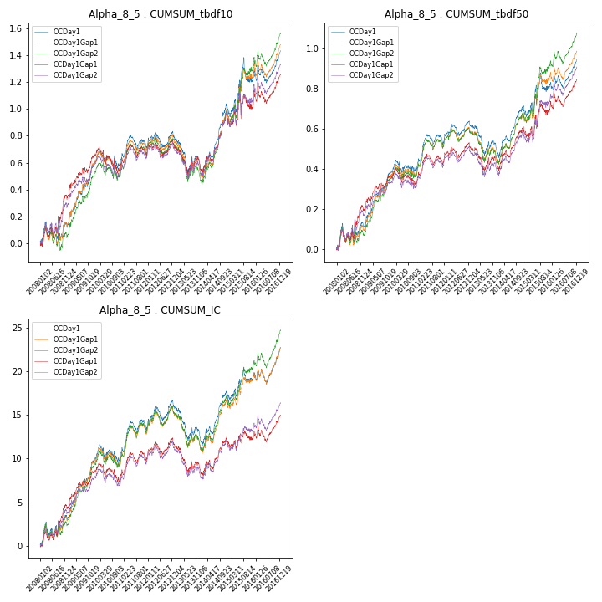

**因子换手率:** 15.94%

**截面指标_OCDay1:**

|  |  |  |  |  |  |  |  |  |
| --- | --- | --- | --- | --- | --- | --- | --- | --- |
| year | annret_tbdf10 | sharpe_tbdf10 | maxdd_tbdf10 | annret_tbdf50 | sharpe_tbdf50 | maxdd_tbdf50 | mean_IC | tstat_IC |
| 2008 | 0.12 | 0.83 | -0.13 | 0.11 | 1.29 | -0.08 | 0.01 | 1.77 |
| 2009 | 0.45 | 4.29 | -0.04 | 0.27 | 4.38 | -0.02 | 0.03 | 5.02 |
| 2010 | 0.0 | 0.01 | -0.13 | 0.02 | 0.3 | -0.06 | 0.0 | 0.07 |
| 2011 | 0.15 | 1.66 | -0.11 | 0.13 | 2.56 | -0.05 | 0.02 | 2.62 |
| 2012 | 0.08 | 0.96 | -0.11 | 0.08 | 1.75 | -0.06 | 0.01 | 1.86 |
| 2013 | -0.22 | -1.81 | -0.25 | -0.12 | -1.7 | -0.14 | -0.01 | -2.18 |
| 2014 | 0.47 | 4.15 | -0.07 | 0.22 | 3.56 | -0.04 | 0.02 | 3.53 |
| 2015 | 0.2 | 1.03 | -0.17 | 0.1 | 0.96 | -0.09 | 0.01 | 0.84 |
| 2016 | 0.19 | 1.84 | -0.12 | 0.12 | 2.11 | -0.06 | 0.01 | 2.32 |

**截面指标_CCDay1Gap1:**

|  |  |  |  |  |  |  |  |  |
| --- | --- | --- | --- | --- | --- | --- | --- | --- |
| year | annret_tbdf10 | sharpe_tbdf10 | maxdd_tbdf10 | annret_tbdf50 | sharpe_tbdf50 | maxdd_tbdf50 | mean_IC | tstat_IC |
| 2008 | 0.34 | 2.25 | -0.09 | 0.2 | 2.21 | -0.07 | 0.02 | 2.67 |
| 2009 | 0.3 | 2.77 | -0.04 | 0.16 | 2.57 | -0.03 | 0.02 | 3.22 |
| 2010 | -0.1 | -0.89 | -0.18 | -0.03 | -0.42 | -0.08 | -0.0 | -0.67 |
| 2011 | 0.14 | 1.61 | -0.1 | 0.11 | 2.09 | -0.05 | 0.01 | 2.1 |
| 2012 | 0.06 | 0.72 | -0.1 | 0.07 | 1.45 | -0.06 | 0.01 | 1.26 |
| 2013 | -0.17 | -1.34 | -0.21 | -0.08 | -1.16 | -0.12 | -0.01 | -1.89 |
| 2014 | 0.39 | 3.32 | -0.06 | 0.18 | 2.75 | -0.04 | 0.01 | 2.42 |
| 2015 | 0.1 | 0.52 | -0.17 | 0.1 | 0.97 | -0.06 | 0.0 | 0.18 |
| 2016 | 0.19 | 1.75 | -0.12 | 0.14 | 2.32 | -0.07 | 0.01 | 1.83 |

**风格暴露:**

|  |  |  |  |  |
| --- | --- | --- | --- | --- |
|  | long | short | corr_OCDay1 | corr_CCDay1Gap1 |
| momentum30 | 0.18 | -0.18 | -0.3 | -0.25 |
| logmktcap | 1.01 | -1.0 | -0.24 | -0.22 |
| liquidity10 | -0.0 | 0.01 | -0.23 | -0.19 |
| retvolatility30 | 0.31 | -0.3 | -0.36 | -0.32 |
| liquidity20 | -0.02 | 0.02 | -0.21 | -0.18 |
| momentum5 | -0.04 | 0.04 | -0.1 | -0.03 |
| momentum15 | 0.09 | -0.09 | -0.21 | -0.16 |
| liquidity5 | 0.0 | 0.01 | -0.25 | -0.19 |