Factors Report 20100104-20161230

**1. yanYD_190902_Alpha_GT_39_3**

**截面指标累计曲线:**

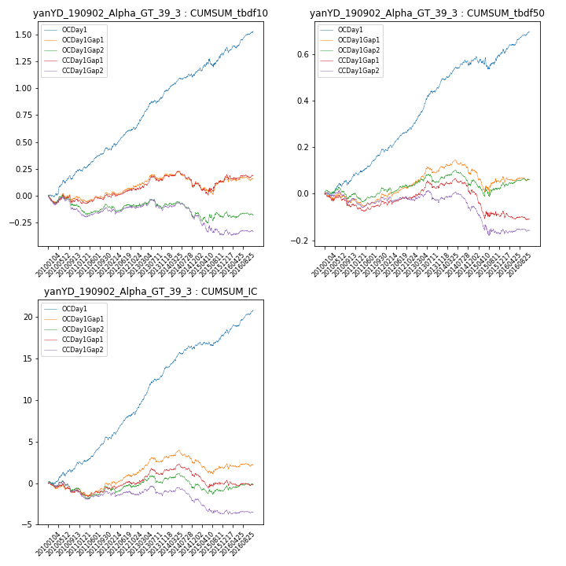

**因子换手率:** 43.43%

**截面指标_OCDay1:**

|  |  |  |  |  |  |  |  |  |
| --- | --- | --- | --- | --- | --- | --- | --- | --- |
| year | annret_tbdf10 | sharpe_tbdf10 | maxdd_tbdf10 | annret_tbdf50 | sharpe_tbdf50 | maxdd_tbdf50 | mean_IC | tstat_IC |
| 2010 | 0.24 | 3.54 | -0.04 | 0.08 | 2.78 | -0.02 | 0.01 | 3.2 |
| 2011 | 0.21 | 4.71 | -0.02 | 0.11 | 5.1 | -0.01 | 0.01 | 5.19 |
| 2012 | 0.18 | 3.48 | -0.03 | 0.1 | 4.38 | -0.01 | 0.01 | 4.44 |
| 2013 | 0.35 | 6.01 | -0.03 | 0.2 | 7.47 | -0.01 | 0.02 | 7.74 |
| 2014 | 0.15 | 2.96 | -0.03 | 0.07 | 2.73 | -0.03 | 0.01 | 3.84 |
| 2015 | 0.21 | 2.47 | -0.07 | 0.04 | 0.94 | -0.05 | 0.01 | 2.29 |
| 2016 | 0.2 | 4.05 | -0.05 | 0.1 | 4.64 | -0.02 | 0.01 | 5.02 |

**截面指标_CCDay1Gap1:**

|  |  |  |  |  |  |  |  |  |
| --- | --- | --- | --- | --- | --- | --- | --- | --- |
| year | annret_tbdf10 | sharpe_tbdf10 | maxdd_tbdf10 | annret_tbdf50 | sharpe_tbdf50 | maxdd_tbdf50 | mean_IC | tstat_IC |
| 2010 | -0.04 | -0.57 | -0.08 | -0.05 | -1.45 | -0.06 | -0.0 | -1.41 |
| 2011 | 0.05 | 1.11 | -0.03 | 0.01 | 0.54 | -0.03 | 0.0 | 0.76 |
| 2012 | 0.05 | 0.88 | -0.03 | 0.02 | 0.85 | -0.02 | 0.0 | 0.75 |
| 2013 | 0.13 | 2.26 | -0.05 | 0.06 | 2.09 | -0.03 | 0.01 | 2.46 |
| 2014 | -0.09 | -1.68 | -0.14 | -0.04 | -1.64 | -0.07 | -0.0 | -1.19 |
| 2015 | 0.05 | 0.48 | -0.12 | -0.1 | -2.04 | -0.12 | -0.0 | -1.21 |
| 2016 | 0.04 | 0.84 | -0.05 | -0.01 | -0.42 | -0.04 | -0.0 | -0.04 |

**风格暴露:**

|  |  |  |  |  |
| --- | --- | --- | --- | --- |
|  | long | short | corr_OCDay1 | corr_CCDay1Gap1 |
| momentum30 | -0.03 | 0.03 | 0.01 | -0.05 |
| logmktcap | 0.02 | -0.01 | 0.05 | -0.08 |
| liquidity10 | -0.07 | 0.08 | 0.03 | 0.06 |
| retvolatility30 | -0.06 | 0.06 | 0.07 | 0.14 |
| liquidity20 | -0.07 | 0.07 | 0.02 | 0.06 |
| momentum5 | 0.03 | -0.03 | -0.02 | -0.09 |
| momentum15 | -0.02 | 0.03 | 0.02 | -0.04 |
| liquidity5 | -0.07 | 0.08 | 0.03 | 0.02 |