Factors Report 20100104-20161230

**1. yanYD_190902_Alpha_GT_43_3**

**截面指标累计曲线:**

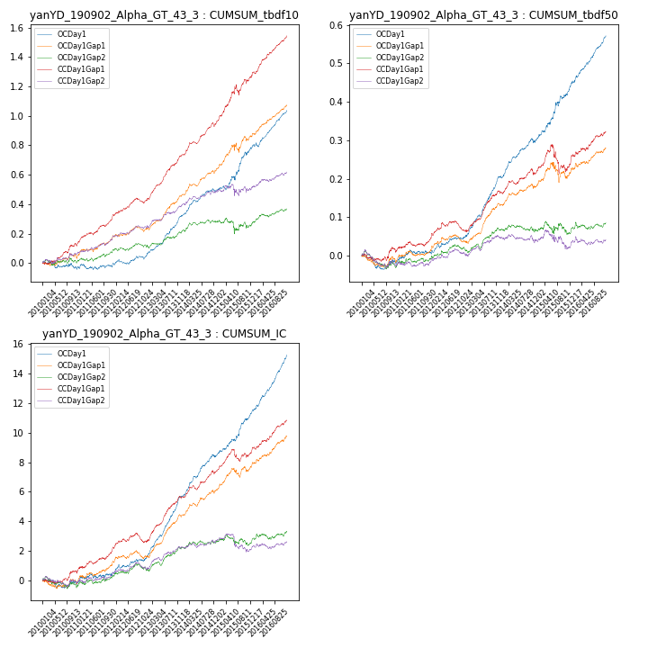

**因子换手率:** 48.11%

**截面指标_OCDay1:**

|  |  |  |  |  |  |  |  |  |
| --- | --- | --- | --- | --- | --- | --- | --- | --- |
| year | annret_tbdf10 | sharpe_tbdf10 | maxdd_tbdf10 | annret_tbdf50 | sharpe_tbdf50 | maxdd_tbdf50 | mean_IC | tstat_IC |
| 2010 | -0.03 | -0.66 | -0.06 | -0.02 | -0.76 | -0.04 | -0.0 | -0.36 |
| 2011 | 0.01 | 0.33 | -0.04 | 0.03 | 1.31 | -0.01 | 0.0 | 1.1 |
| 2012 | 0.09 | 2.32 | -0.03 | 0.05 | 2.51 | -0.01 | 0.01 | 2.7 |
| 2013 | 0.27 | 6.82 | -0.01 | 0.16 | 7.72 | -0.0 | 0.02 | 8.47 |
| 2014 | 0.17 | 4.55 | -0.02 | 0.09 | 4.75 | -0.01 | 0.01 | 5.88 |
| 2015 | 0.29 | 3.71 | -0.03 | 0.14 | 4.18 | -0.01 | 0.01 | 4.75 |
| 2016 | 0.26 | 6.73 | -0.03 | 0.13 | 6.88 | -0.01 | 0.02 | 8.48 |

**截面指标_CCDay1Gap1:**

|  |  |  |  |  |  |  |  |  |
| --- | --- | --- | --- | --- | --- | --- | --- | --- |
| year | annret_tbdf10 | sharpe_tbdf10 | maxdd_tbdf10 | annret_tbdf50 | sharpe_tbdf50 | maxdd_tbdf50 | mean_IC | tstat_IC |
| 2010 | 0.13 | 2.72 | -0.02 | 0.02 | 0.6 | -0.02 | 0.0 | 1.33 |
| 2011 | 0.18 | 4.45 | -0.02 | 0.04 | 2.06 | -0.01 | 0.01 | 3.13 |
| 2012 | 0.13 | 3.35 | -0.04 | 0.01 | 0.6 | -0.03 | 0.0 | 1.36 |
| 2013 | 0.3 | 7.17 | -0.01 | 0.1 | 4.78 | -0.01 | 0.01 | 6.15 |
| 2014 | 0.23 | 5.9 | -0.03 | 0.05 | 2.6 | -0.02 | 0.01 | 4.24 |
| 2015 | 0.32 | 3.66 | -0.07 | 0.03 | 0.71 | -0.07 | 0.01 | 2.24 |
| 2016 | 0.27 | 6.41 | -0.01 | 0.08 | 3.53 | -0.01 | 0.01 | 4.83 |

**风格暴露:**

|  |  |  |  |  |
| --- | --- | --- | --- | --- |
|  | long | short | corr_OCDay1 | corr_CCDay1Gap1 |
| momentum30 | -0.08 | 0.09 | 0.16 | 0.23 |
| logmktcap | 0.02 | -0.02 | -0.02 | 0.04 |
| liquidity10 | 0.01 | -0.01 | 0.08 | 0.05 |
| retvolatility30 | 0.03 | -0.02 | 0.04 | 0.0 |
| liquidity20 | 0.02 | -0.01 | 0.07 | 0.04 |
| momentum5 | -0.14 | 0.14 | 0.13 | 0.18 |
| momentum15 | -0.11 | 0.12 | 0.17 | 0.24 |
| liquidity5 | 0.0 | 0.0 | 0.09 | 0.08 |