Factors Report 20100104-20161230

**1. yanYD_190904_Alpha_GT_47_2**

**截面指标累计曲线:**

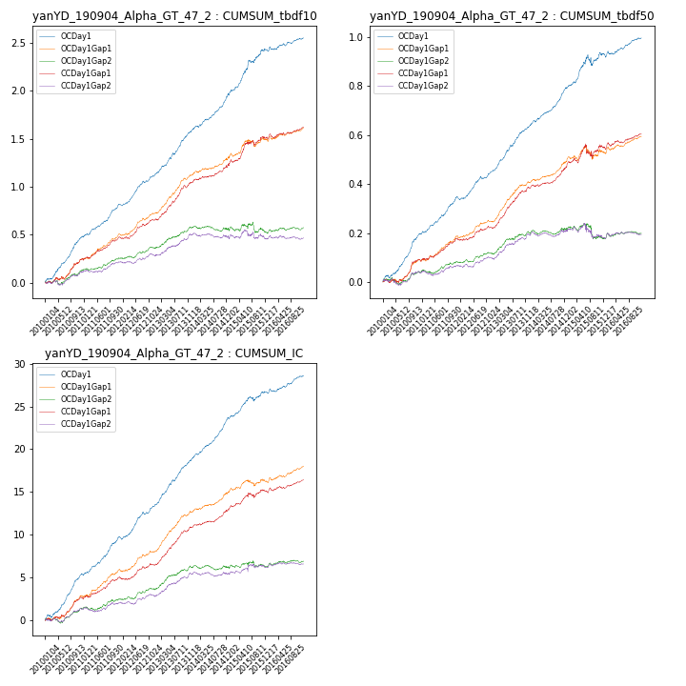

**因子换手率:** 49.16%

**截面指标_OCDay1:**

|  |  |  |  |  |  |  |  |  |
| --- | --- | --- | --- | --- | --- | --- | --- | --- |
| year | annret_tbdf10 | sharpe_tbdf10 | maxdd_tbdf10 | annret_tbdf50 | sharpe_tbdf50 | maxdd_tbdf50 | mean_IC | tstat_IC |
| 2010 | 0.48 | 7.66 | -0.01 | 0.2 | 7.1 | -0.01 | 0.02 | 7.69 |
| 2011 | 0.34 | 6.8 | -0.01 | 0.15 | 6.88 | -0.01 | 0.02 | 7.02 |
| 2012 | 0.32 | 7.08 | -0.02 | 0.11 | 5.31 | -0.01 | 0.02 | 6.32 |
| 2013 | 0.47 | 7.84 | -0.02 | 0.19 | 8.09 | -0.01 | 0.02 | 8.76 |
| 2014 | 0.39 | 6.85 | -0.02 | 0.16 | 7.42 | -0.01 | 0.02 | 8.43 |
| 2015 | 0.45 | 5.2 | -0.03 | 0.14 | 2.64 | -0.04 | 0.01 | 3.86 |
| 2016 | 0.13 | 2.52 | -0.03 | 0.07 | 3.15 | -0.01 | 0.01 | 3.62 |

**截面指标_CCDay1Gap1:**

|  |  |  |  |  |  |  |  |  |
| --- | --- | --- | --- | --- | --- | --- | --- | --- |
| year | annret_tbdf10 | sharpe_tbdf10 | maxdd_tbdf10 | annret_tbdf50 | sharpe_tbdf50 | maxdd_tbdf50 | mean_IC | tstat_IC |
| 2010 | 0.25 | 3.81 | -0.03 | 0.09 | 3.35 | -0.01 | 0.01 | 4.34 |
| 2011 | 0.23 | 4.9 | -0.02 | 0.09 | 3.99 | -0.01 | 0.01 | 4.2 |
| 2012 | 0.19 | 3.94 | -0.02 | 0.05 | 2.45 | -0.01 | 0.01 | 2.85 |
| 2013 | 0.39 | 6.59 | -0.03 | 0.16 | 6.63 | -0.01 | 0.02 | 7.06 |
| 2014 | 0.2 | 3.29 | -0.03 | 0.1 | 4.27 | -0.01 | 0.01 | 4.11 |
| 2015 | 0.27 | 3.04 | -0.05 | 0.07 | 1.26 | -0.06 | 0.01 | 2.5 |
| 2016 | 0.11 | 2.06 | -0.04 | 0.05 | 2.46 | -0.01 | 0.01 | 2.72 |

**风格暴露:**

|  |  |  |  |  |
| --- | --- | --- | --- | --- |
|  | long | short | corr_OCDay1 | corr_CCDay1Gap1 |
| momentum30 | 0.0 | -0.01 | -0.02 | -0.02 |
| logmktcap | 0.02 | -0.01 | -0.02 | -0.17 |
| liquidity10 | -0.02 | -0.01 | 0.02 | 0.11 |
| retvolatility30 | -0.03 | 0.0 | 0.06 | 0.15 |
| liquidity20 | -0.03 | 0.01 | -0.01 | 0.11 |
| momentum5 | -0.02 | 0.03 | 0.06 | 0.05 |
| momentum15 | 0.02 | -0.03 | 0.04 | -0.06 |
| liquidity5 | -0.02 | -0.02 | 0.03 | 0.11 |