Factors Report 20100104-20161230

**1. yanYD_190903_Alpha_GT_45_1**

**截面指标累计曲线:**

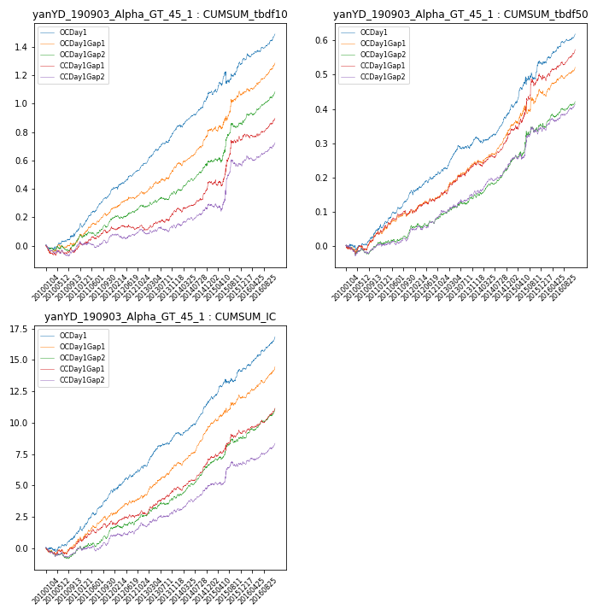

**因子换手率:** 56.97%

**截面指标_OCDay1:**

|  |  |  |  |  |  |  |  |  |
| --- | --- | --- | --- | --- | --- | --- | --- | --- |
| year | annret_tbdf10 | sharpe_tbdf10 | maxdd_tbdf10 | annret_tbdf50 | sharpe_tbdf50 | maxdd_tbdf50 | mean_IC | tstat_IC |
| 2010 | 0.11 | 2.09 | -0.03 | 0.05 | 1.89 | -0.02 | 0.01 | 2.21 |
| 2011 | 0.28 | 6.36 | -0.03 | 0.11 | 5.38 | -0.01 | 0.01 | 6.02 |
| 2012 | 0.19 | 4.6 | -0.02 | 0.07 | 2.95 | -0.01 | 0.01 | 3.37 |
| 2013 | 0.25 | 5.73 | -0.01 | 0.09 | 3.85 | -0.01 | 0.01 | 4.76 |
| 2014 | 0.27 | 5.26 | -0.02 | 0.07 | 3.38 | -0.02 | 0.01 | 4.97 |
| 2015 | 0.2 | 2.0 | -0.08 | 0.14 | 2.97 | -0.02 | 0.01 | 3.19 |
| 2016 | 0.21 | 4.48 | -0.02 | 0.09 | 3.94 | -0.01 | 0.01 | 5.1 |

**截面指标_CCDay1Gap1:**

|  |  |  |  |  |  |  |  |  |
| --- | --- | --- | --- | --- | --- | --- | --- | --- |
| year | annret_tbdf10 | sharpe_tbdf10 | maxdd_tbdf10 | annret_tbdf50 | sharpe_tbdf50 | maxdd_tbdf50 | mean_IC | tstat_IC |
| 2010 | -0.01 | -0.25 | -0.07 | 0.04 | 1.51 | -0.03 | 0.0 | 0.96 |
| 2011 | 0.14 | 3.14 | -0.02 | 0.07 | 3.24 | -0.01 | 0.01 | 3.14 |
| 2012 | -0.01 | -0.31 | -0.03 | 0.05 | 2.22 | -0.01 | 0.0 | 1.11 |
| 2013 | 0.12 | 2.67 | -0.02 | 0.08 | 3.31 | -0.01 | 0.01 | 3.53 |
| 2014 | 0.21 | 4.15 | -0.03 | 0.09 | 4.26 | -0.01 | 0.01 | 5.1 |
| 2015 | 0.3 | 2.74 | -0.04 | 0.16 | 2.66 | -0.02 | 0.01 | 2.46 |
| 2016 | 0.15 | 3.18 | -0.03 | 0.09 | 4.0 | -0.02 | 0.01 | 4.31 |

**风格暴露:**

|  |  |  |  |  |
| --- | --- | --- | --- | --- |
|  | long | short | corr_OCDay1 | corr_CCDay1Gap1 |
| momentum30 | 0.04 | -0.04 | -0.08 | -0.12 |
| logmktcap | -0.02 | 0.02 | 0.21 | 0.2 |
| liquidity10 | 0.06 | -0.06 | -0.27 | -0.26 |
| retvolatility30 | 0.02 | -0.01 | -0.27 | -0.26 |
| liquidity20 | 0.05 | -0.05 | -0.25 | -0.25 |
| momentum5 | 0.07 | -0.06 | 0.03 | -0.04 |
| momentum15 | 0.07 | -0.06 | -0.09 | -0.15 |
| liquidity5 | 0.07 | -0.07 | -0.28 | -0.3 |