Factors Report 20100104-20161230

**1. yanYD_190905_Alpha_GT_16_continue_1**

**截面指标累计曲线:**

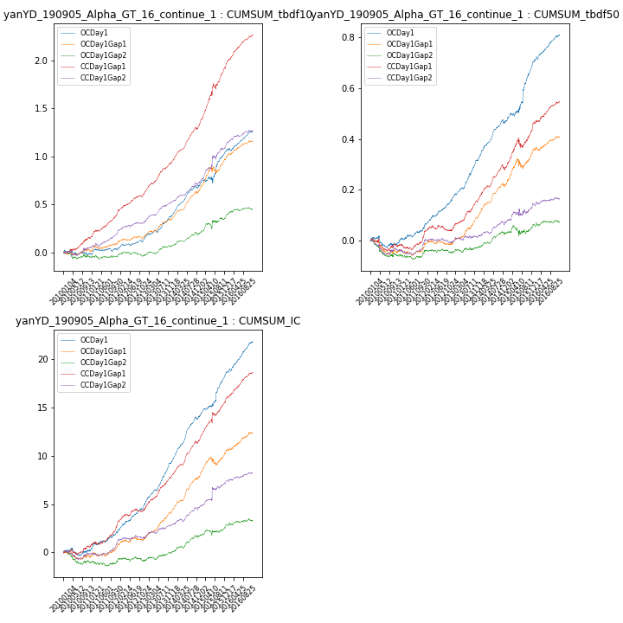

**因子换手率:** 53.9%

**截面指标_OCDay1:**

|  |  |  |  |  |  |  |  |  |
| --- | --- | --- | --- | --- | --- | --- | --- | --- |
| year | annret_tbdf10 | sharpe_tbdf10 | maxdd_tbdf10 | annret_tbdf50 | sharpe_tbdf50 | maxdd_tbdf50 | mean_IC | tstat_IC |
| 2010 | -0.01 | -0.19 | -0.05 | -0.01 | -0.41 | -0.05 | 0.0 | 0.32 |
| 2011 | 0.04 | 0.95 | -0.04 | 0.07 | 2.9 | -0.01 | 0.01 | 3.27 |
| 2012 | 0.12 | 3.28 | -0.02 | 0.11 | 5.24 | -0.01 | 0.01 | 5.73 |
| 2013 | 0.23 | 5.14 | -0.03 | 0.16 | 7.17 | -0.01 | 0.02 | 8.51 |
| 2014 | 0.31 | 7.76 | -0.03 | 0.15 | 6.92 | -0.02 | 0.02 | 9.48 |
| 2015 | 0.36 | 3.3 | -0.07 | 0.23 | 4.34 | -0.01 | 0.02 | 4.89 |
| 2016 | 0.21 | 5.24 | -0.03 | 0.12 | 5.7 | -0.01 | 0.01 | 6.63 |

**截面指标_CCDay1Gap1:**

|  |  |  |  |  |  |  |  |  |
| --- | --- | --- | --- | --- | --- | --- | --- | --- |
| year | annret_tbdf10 | sharpe_tbdf10 | maxdd_tbdf10 | annret_tbdf50 | sharpe_tbdf50 | maxdd_tbdf50 | mean_IC | tstat_IC |
| 2010 | 0.16 | 2.95 | -0.02 | -0.02 | -0.67 | -0.05 | 0.0 | 1.2 |
| 2011 | 0.26 | 5.93 | -0.02 | 0.05 | 2.16 | -0.02 | 0.01 | 4.2 |
| 2012 | 0.22 | 5.38 | -0.01 | 0.01 | 0.4 | -0.02 | 0.01 | 3.15 |
| 2013 | 0.31 | 7.65 | -0.01 | 0.12 | 5.24 | -0.01 | 0.01 | 6.7 |
| 2014 | 0.38 | 9.7 | -0.03 | 0.13 | 5.96 | -0.02 | 0.02 | 8.5 |
| 2015 | 0.61 | 6.11 | -0.06 | 0.16 | 3.72 | -0.04 | 0.02 | 3.93 |
| 2016 | 0.34 | 8.12 | -0.01 | 0.1 | 4.65 | -0.01 | 0.01 | 6.56 |

**风格暴露:**

|  |  |  |  |  |
| --- | --- | --- | --- | --- |
|  | long | short | corr_OCDay1 | corr_CCDay1Gap1 |
| momentum30 | -0.13 | 0.13 | 0.32 | 0.24 |
| logmktcap | 0.03 | -0.02 | -0.2 | -0.04 |
| liquidity10 | 0.0 | 0.0 | 0.24 | 0.09 |
| retvolatility30 | 0.05 | -0.05 | 0.15 | 0.0 |
| liquidity20 | 0.02 | -0.01 | 0.23 | 0.07 |
| momentum5 | -0.23 | 0.23 | 0.23 | 0.23 |
| momentum15 | -0.18 | 0.18 | 0.29 | 0.2 |
| liquidity5 | -0.01 | 0.02 | 0.25 | 0.09 |