Factors Report 20100104-20161230

**1. yanYD_190910_Alpha_GT_57_3**

**截面指标累计曲线:**

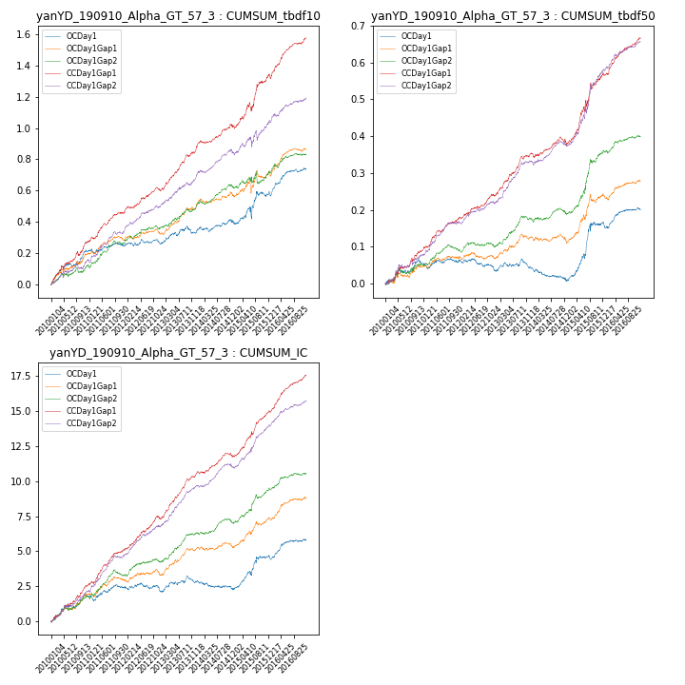

**因子换手率:** 42.96%

**截面指标_OCDay1:**

|  |  |  |  |  |  |  |  |  |
| --- | --- | --- | --- | --- | --- | --- | --- | --- |
| year | annret_tbdf10 | sharpe_tbdf10 | maxdd_tbdf10 | annret_tbdf50 | sharpe_tbdf50 | maxdd_tbdf50 | mean_IC | tstat_IC |
| 2010 | 0.21 | 3.94 | -0.02 | 0.06 | 2.24 | -0.01 | 0.01 | 2.98 |
| 2011 | 0.04 | 0.8 | -0.03 | 0.0 | 0.09 | -0.02 | 0.0 | 1.14 |
| 2012 | 0.01 | 0.37 | -0.03 | -0.02 | -1.18 | -0.03 | -0.0 | -0.51 |
| 2013 | 0.07 | 1.4 | -0.05 | 0.01 | 0.5 | -0.03 | 0.0 | 1.49 |
| 2014 | 0.08 | 1.69 | -0.04 | -0.04 | -1.9 | -0.04 | -0.0 | -1.19 |
| 2015 | 0.19 | 1.9 | -0.08 | 0.16 | 3.49 | -0.02 | 0.01 | 3.24 |
| 2016 | 0.14 | 3.28 | -0.03 | 0.04 | 1.91 | -0.01 | 0.0 | 2.45 |

**截面指标_CCDay1Gap1:**

|  |  |  |  |  |  |  |  |  |
| --- | --- | --- | --- | --- | --- | --- | --- | --- |
| year | annret_tbdf10 | sharpe_tbdf10 | maxdd_tbdf10 | annret_tbdf50 | sharpe_tbdf50 | maxdd_tbdf50 | mean_IC | tstat_IC |
| 2010 | 0.27 | 4.69 | -0.03 | 0.09 | 3.5 | -0.01 | 0.01 | 4.74 |
| 2011 | 0.19 | 4.25 | -0.01 | 0.09 | 4.47 | -0.01 | 0.01 | 5.16 |
| 2012 | 0.15 | 3.73 | -0.02 | 0.06 | 3.57 | -0.01 | 0.01 | 4.87 |
| 2013 | 0.27 | 6.06 | -0.01 | 0.12 | 5.54 | -0.01 | 0.01 | 7.04 |
| 2014 | 0.15 | 3.39 | -0.02 | 0.03 | 1.43 | -0.02 | 0.01 | 3.25 |
| 2015 | 0.33 | 3.73 | -0.06 | 0.18 | 4.38 | -0.02 | 0.01 | 5.72 |
| 2016 | 0.24 | 5.38 | -0.03 | 0.1 | 4.97 | -0.0 | 0.01 | 6.53 |

**风格暴露:**

|  |  |  |  |  |
| --- | --- | --- | --- | --- |
|  | long | short | corr_OCDay1 | corr_CCDay1Gap1 |
| momentum30 | 0.05 | -0.05 | -0.17 | -0.1 |
| logmktcap | -0.02 | 0.02 | -0.08 | -0.02 |
| liquidity10 | 0.06 | -0.06 | -0.09 | -0.06 |
| retvolatility30 | 0.02 | -0.02 | -0.04 | 0.01 |
| liquidity20 | 0.05 | -0.04 | -0.05 | -0.03 |
| momentum5 | 0.03 | -0.02 | -0.14 | -0.02 |
| momentum15 | 0.08 | -0.07 | -0.19 | -0.06 |
| liquidity5 | 0.06 | -0.05 | -0.1 | -0.03 |