Factors Report 20100104-20161230

**1. yanYD_190910_Alpha_GT_59_2**

**截面指标累计曲线:**

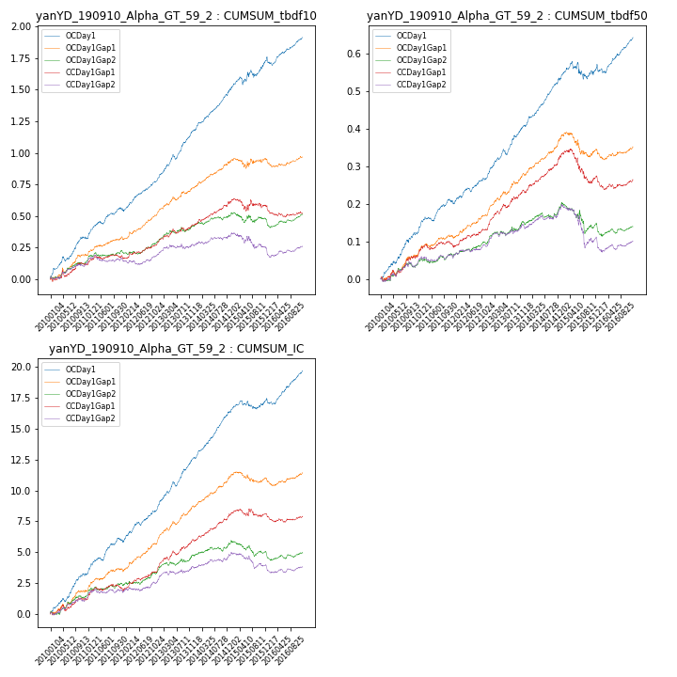

**因子换手率:** 55.36%

**截面指标_OCDay1:**

|  |  |  |  |  |  |  |  |  |
| --- | --- | --- | --- | --- | --- | --- | --- | --- |
| year | annret_tbdf10 | sharpe_tbdf10 | maxdd_tbdf10 | annret_tbdf50 | sharpe_tbdf50 | maxdd_tbdf50 | mean_IC | tstat_IC |
| 2010 | 0.33 | 5.29 | -0.04 | 0.12 | 4.68 | -0.01 | 0.01 | 5.1 |
| 2011 | 0.24 | 4.78 | -0.02 | 0.09 | 4.35 | -0.01 | 0.01 | 4.82 |
| 2012 | 0.24 | 5.36 | -0.02 | 0.08 | 3.79 | -0.01 | 0.01 | 5.02 |
| 2013 | 0.39 | 6.5 | -0.04 | 0.13 | 5.78 | -0.01 | 0.02 | 6.61 |
| 2014 | 0.33 | 6.85 | -0.01 | 0.12 | 6.59 | -0.01 | 0.02 | 7.68 |
| 2015 | 0.23 | 2.49 | -0.06 | 0.03 | 0.72 | -0.05 | 0.0 | 1.45 |
| 2016 | 0.18 | 3.43 | -0.07 | 0.08 | 3.54 | -0.02 | 0.01 | 4.58 |

**截面指标_CCDay1Gap1:**

|  |  |  |  |  |  |  |  |  |
| --- | --- | --- | --- | --- | --- | --- | --- | --- |
| year | annret_tbdf10 | sharpe_tbdf10 | maxdd_tbdf10 | annret_tbdf50 | sharpe_tbdf50 | maxdd_tbdf50 | mean_IC | tstat_IC |
| 2010 | 0.11 | 1.8 | -0.05 | 0.06 | 2.32 | -0.02 | 0.0 | 1.92 |
| 2011 | 0.06 | 1.41 | -0.02 | 0.03 | 1.56 | -0.01 | 0.0 | 1.76 |
| 2012 | 0.12 | 2.74 | -0.02 | 0.06 | 3.1 | -0.01 | 0.01 | 3.58 |
| 2013 | 0.14 | 2.68 | -0.03 | 0.09 | 4.09 | -0.01 | 0.01 | 4.07 |
| 2014 | 0.18 | 3.49 | -0.02 | 0.09 | 4.46 | -0.0 | 0.01 | 4.39 |
| 2015 | -0.03 | -0.29 | -0.1 | -0.05 | -1.42 | -0.09 | 0.0 | 0.14 |
| 2016 | -0.06 | -1.22 | -0.09 | -0.01 | -0.5 | -0.03 | -0.0 | -0.52 |

**风格暴露:**

|  |  |  |  |  |
| --- | --- | --- | --- | --- |
|  | long | short | corr_OCDay1 | corr_CCDay1Gap1 |
| momentum30 | 0.04 | -0.04 | -0.07 | 0.04 |
| logmktcap | -0.0 | 0.01 | -0.04 | -0.06 |
| liquidity10 | 0.01 | -0.03 | -0.05 | 0.04 |
| retvolatility30 | -0.02 | -0.0 | -0.03 | 0.03 |
| liquidity20 | -0.01 | -0.0 | -0.05 | 0.03 |
| momentum5 | 0.1 | -0.1 | -0.07 | -0.03 |
| momentum15 | 0.08 | -0.08 | -0.05 | 0.04 |
| liquidity5 | 0.03 | -0.06 | -0.04 | 0.04 |