Factors Report 20100104-20161230

**1. yanYD_190916_Alpha_GT_63_2**

**截面指标累计曲线:**

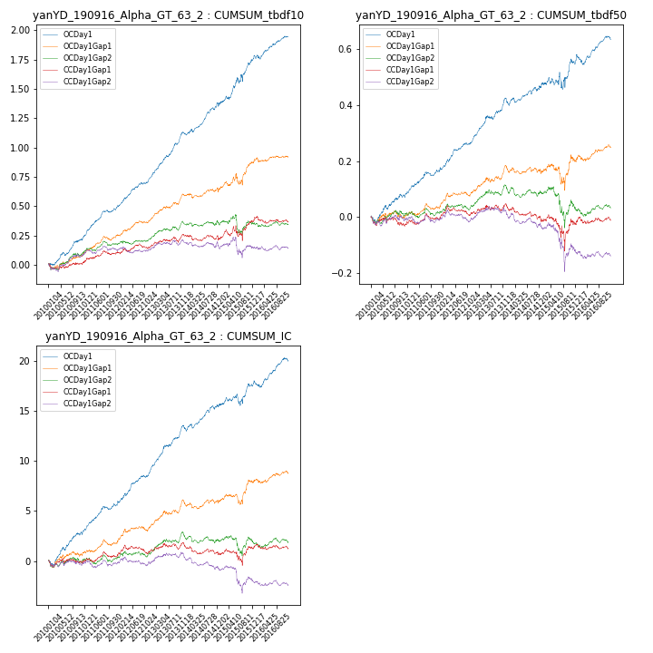

**因子换手率:** 52.12%

**截面指标_OCDay1:**

|  |  |  |  |  |  |  |  |  |
| --- | --- | --- | --- | --- | --- | --- | --- | --- |
| year | annret_tbdf10 | sharpe_tbdf10 | maxdd_tbdf10 | annret_tbdf50 | sharpe_tbdf50 | maxdd_tbdf50 | mean_IC | tstat_IC |
| 2010 | 0.22 | 3.51 | -0.03 | 0.07 | 2.21 | -0.02 | 0.01 | 3.38 |
| 2011 | 0.27 | 5.63 | -0.02 | 0.09 | 3.69 | -0.01 | 0.01 | 4.33 |
| 2012 | 0.26 | 5.63 | -0.02 | 0.12 | 4.69 | -0.01 | 0.02 | 5.14 |
| 2013 | 0.38 | 6.84 | -0.02 | 0.13 | 3.97 | -0.02 | 0.02 | 5.42 |
| 2014 | 0.26 | 4.48 | -0.03 | 0.07 | 2.34 | -0.02 | 0.01 | 3.42 |
| 2015 | 0.38 | 3.4 | -0.06 | 0.08 | 1.15 | -0.06 | 0.01 | 1.86 |
| 2016 | 0.18 | 3.29 | -0.04 | 0.07 | 2.28 | -0.04 | 0.01 | 3.06 |

**截面指标_CCDay1Gap1:**

|  |  |  |  |  |  |  |  |  |
| --- | --- | --- | --- | --- | --- | --- | --- | --- |
| year | annret_tbdf10 | sharpe_tbdf10 | maxdd_tbdf10 | annret_tbdf50 | sharpe_tbdf50 | maxdd_tbdf50 | mean_IC | tstat_IC |
| 2010 | 0.01 | 0.14 | -0.05 | -0.03 | -0.83 | -0.04 | -0.0 | -0.18 |
| 2011 | 0.09 | 1.78 | -0.04 | 0.02 | 0.67 | -0.02 | 0.0 | 0.8 |
| 2012 | 0.06 | 1.22 | -0.04 | 0.03 | 1.11 | -0.04 | 0.0 | 1.07 |
| 2013 | 0.09 | 1.72 | -0.05 | 0.02 | 0.53 | -0.02 | 0.0 | 0.57 |
| 2014 | -0.03 | -0.49 | -0.05 | -0.05 | -1.63 | -0.05 | -0.0 | -1.3 |
| 2015 | 0.15 | 1.33 | -0.12 | -0.01 | -0.14 | -0.12 | 0.0 | 0.52 |
| 2016 | -0.01 | -0.15 | -0.06 | 0.01 | 0.47 | -0.02 | -0.0 | -0.02 |

**风格暴露:**

|  |  |  |  |  |
| --- | --- | --- | --- | --- |
|  | long | short | corr_OCDay1 | corr_CCDay1Gap1 |
| momentum30 | -0.11 | 0.12 | 0.12 | 0.2 |
| logmktcap | -0.0 | 0.01 | 0.01 | -0.08 |
| liquidity10 | -0.06 | 0.07 | 0.04 | 0.12 |
| retvolatility30 | -0.12 | 0.12 | 0.01 | 0.13 |
| liquidity20 | -0.11 | 0.11 | 0.05 | 0.13 |
| momentum5 | -0.02 | 0.03 | 0.07 | -0.0 |
| momentum15 | 0.01 | -0.01 | 0.07 | 0.08 |
| liquidity5 | 0.01 | -0.01 | 0.04 | 0.11 |