Factors Report 20100104-20161230

**1. Alpha_10_new_56**

**截面指标累计曲线:**

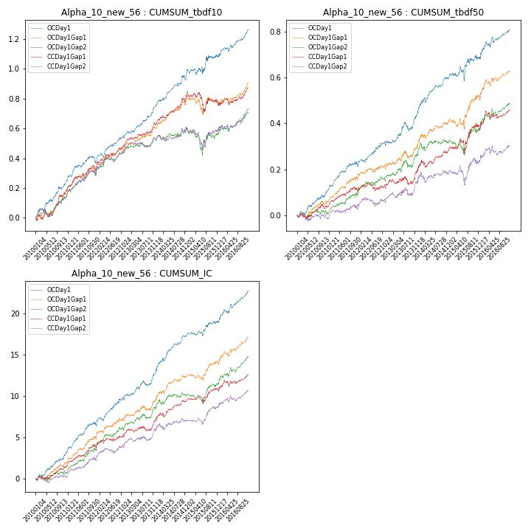

**因子换手率:** 48.44%

**截面指标_OCDay1:**

|  |  |  |  |  |  |  |  |  |
| --- | --- | --- | --- | --- | --- | --- | --- | --- |
| year | annret_tbdf10 | sharpe_tbdf10 | maxdd_tbdf10 | annret_tbdf50 | sharpe_tbdf50 | maxdd_tbdf50 | mean_IC | tstat_IC |
| 2010 | 0.24 | 4.04 | -0.04 | 0.11 | 3.03 | -0.01 | 0.01 | 3.71 |
| 2011 | 0.13 | 2.46 | -0.05 | 0.11 | 3.48 | -0.02 | 0.01 | 4.1 |
| 2012 | 0.2 | 4.52 | -0.03 | 0.11 | 2.92 | -0.02 | 0.02 | 3.96 |
| 2013 | 0.19 | 4.27 | -0.02 | 0.14 | 2.95 | -0.04 | 0.01 | 3.33 |
| 2014 | 0.24 | 4.37 | -0.03 | 0.14 | 3.72 | -0.02 | 0.02 | 4.9 |
| 2015 | 0.09 | 1.01 | -0.05 | 0.09 | 1.35 | -0.06 | 0.01 | 1.78 |
| 2016 | 0.18 | 3.52 | -0.03 | 0.13 | 2.84 | -0.03 | 0.02 | 4.03 |

**截面指标_CCDay1Gap1:**

|  |  |  |  |  |  |  |  |  |
| --- | --- | --- | --- | --- | --- | --- | --- | --- |
| year | annret_tbdf10 | sharpe_tbdf10 | maxdd_tbdf10 | annret_tbdf50 | sharpe_tbdf50 | maxdd_tbdf50 | mean_IC | tstat_IC |
| 2010 | 0.18 | 2.94 | -0.04 | 0.04 | 1.19 | -0.02 | 0.01 | 2.01 |
| 2011 | 0.15 | 2.83 | -0.04 | 0.06 | 1.83 | -0.03 | 0.01 | 2.81 |
| 2012 | 0.2 | 4.05 | -0.02 | 0.04 | 1.08 | -0.03 | 0.01 | 2.26 |
| 2013 | 0.12 | 2.56 | -0.02 | 0.07 | 1.3 | -0.04 | 0.01 | 1.68 |
| 2014 | 0.21 | 3.73 | -0.03 | 0.08 | 2.0 | -0.03 | 0.01 | 2.82 |
| 2015 | -0.07 | -0.71 | -0.13 | 0.1 | 1.51 | -0.07 | 0.01 | 1.42 |
| 2016 | 0.09 | 1.58 | -0.04 | 0.07 | 1.43 | -0.04 | 0.01 | 1.9 |

**风格暴露:**

|  |  |  |  |  |
| --- | --- | --- | --- | --- |
|  | long | short | corr_OCDay1 | corr_CCDay1Gap1 |
| momentum30 | 0.09 | -0.08 | -0.17 | -0.09 |
| logmktcap | 0.28 | -0.28 | -0.31 | -0.29 |
| liquidity10 | -0.3 | 0.3 | 0.27 | 0.28 |
| retvolatility30 | -0.36 | 0.37 | 0.35 | 0.33 |
| liquidity20 | -0.32 | 0.33 | 0.29 | 0.29 |
| momentum5 | -0.04 | 0.04 | -0.1 | -0.1 |
| momentum15 | 0.23 | -0.23 | -0.24 | -0.21 |
| liquidity5 | -0.3 | 0.31 | 0.27 | 0.28 |