Factors Report 20100104-20161230

**1. Alpha_10_new_55**

**截面指标累计曲线:**

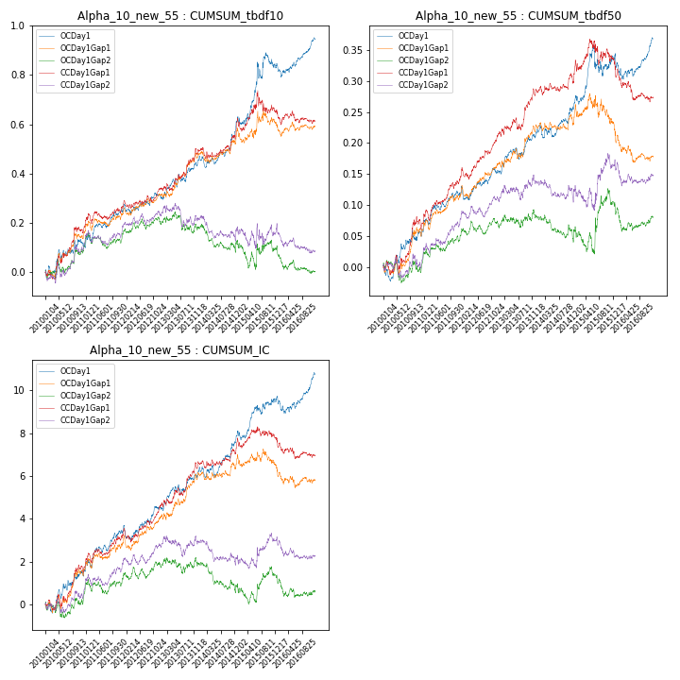

**因子换手率:** 76.8%

**截面指标_OCDay1:**

|  |  |  |  |  |  |  |  |  |
| --- | --- | --- | --- | --- | --- | --- | --- | --- |
| year | annret_tbdf10 | sharpe_tbdf10 | maxdd_tbdf10 | annret_tbdf50 | sharpe_tbdf50 | maxdd_tbdf50 | mean_IC | tstat_IC |
| 2010 | 0.11 | 1.37 | -0.04 | 0.05 | 1.56 | -0.03 | 0.01 | 1.67 |
| 2011 | 0.13 | 2.52 | -0.03 | 0.06 | 2.5 | -0.01 | 0.01 | 2.8 |
| 2012 | 0.06 | 1.16 | -0.04 | 0.04 | 1.58 | -0.02 | 0.0 | 1.68 |
| 2013 | 0.16 | 2.49 | -0.03 | 0.07 | 2.66 | -0.02 | 0.01 | 2.67 |
| 2014 | 0.18 | 2.99 | -0.05 | 0.06 | 2.24 | -0.02 | 0.01 | 2.74 |
| 2015 | 0.21 | 1.79 | -0.07 | 0.06 | 1.26 | -0.05 | 0.01 | 1.83 |
| 2016 | 0.11 | 2.05 | -0.05 | 0.03 | 0.99 | -0.04 | 0.0 | 1.66 |

**截面指标_CCDay1Gap1:**

|  |  |  |  |  |  |  |  |  |
| --- | --- | --- | --- | --- | --- | --- | --- | --- |
| year | annret_tbdf10 | sharpe_tbdf10 | maxdd_tbdf10 | annret_tbdf50 | sharpe_tbdf50 | maxdd_tbdf50 | mean_IC | tstat_IC |
| 2010 | 0.17 | 2.27 | -0.04 | 0.07 | 1.86 | -0.02 | 0.01 | 2.06 |
| 2011 | 0.1 | 1.71 | -0.04 | 0.08 | 3.1 | -0.02 | 0.01 | 2.4 |
| 2012 | 0.08 | 1.7 | -0.03 | 0.07 | 3.24 | -0.02 | 0.01 | 2.42 |
| 2013 | 0.15 | 2.36 | -0.03 | 0.07 | 2.28 | -0.02 | 0.01 | 2.63 |
| 2014 | 0.13 | 2.02 | -0.04 | 0.05 | 1.68 | -0.02 | 0.0 | 1.74 |
| 2015 | 0.04 | 0.36 | -0.09 | -0.0 | -0.0 | -0.04 | 0.0 | 0.07 |
| 2016 | -0.04 | -0.79 | -0.06 | -0.06 | -1.87 | -0.06 | -0.0 | -1.3 |

**风格暴露:**

|  |  |  |  |  |
| --- | --- | --- | --- | --- |
|  | long | short | corr_OCDay1 | corr_CCDay1Gap1 |
| momentum30 | -0.01 | 0.01 | 0.14 | 0.12 |
| logmktcap | 0.02 | -0.01 | 0.02 | 0.01 |
| liquidity10 | 0.02 | -0.02 | -0.03 | -0.0 |
| retvolatility30 | 0.02 | -0.02 | -0.08 | -0.05 |
| liquidity20 | 0.02 | -0.01 | -0.04 | -0.03 |
| momentum5 | 0.03 | -0.02 | 0.1 | 0.1 |
| momentum15 | -0.01 | 0.02 | 0.21 | 0.21 |
| liquidity5 | 0.03 | -0.02 | -0.03 | -0.01 |

**2. Alpha_10_new_54**

**截面指标累计曲线:**

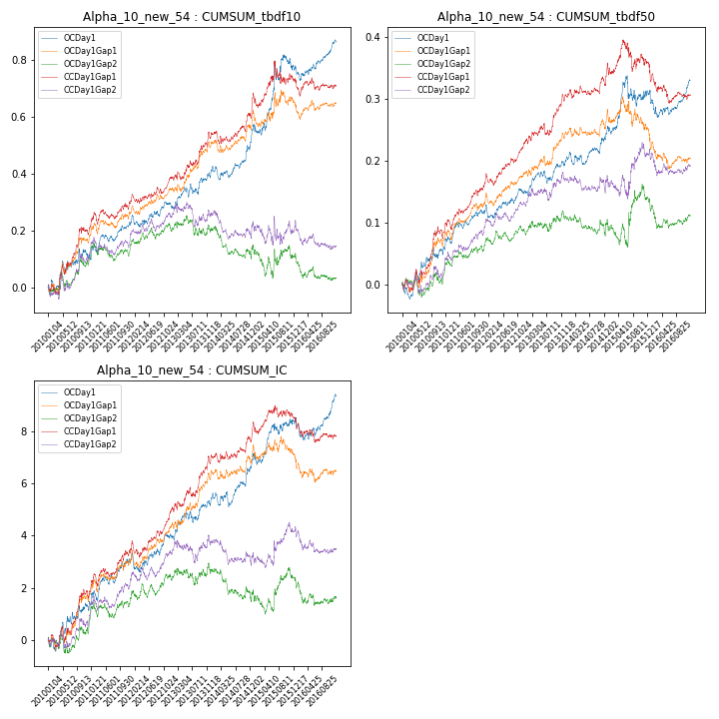

**因子换手率:** 73.77%

**截面指标_OCDay1:**

|  |  |  |  |  |  |  |  |  |
| --- | --- | --- | --- | --- | --- | --- | --- | --- |
| year | annret_tbdf10 | sharpe_tbdf10 | maxdd_tbdf10 | annret_tbdf50 | sharpe_tbdf50 | maxdd_tbdf50 | mean_IC | tstat_IC |
| 2010 | 0.11 | 1.31 | -0.04 | 0.05 | 1.55 | -0.03 | 0.01 | 1.44 |
| 2011 | 0.11 | 2.09 | -0.03 | 0.06 | 2.52 | -0.01 | 0.01 | 2.52 |
| 2012 | 0.06 | 1.26 | -0.04 | 0.03 | 1.41 | -0.02 | 0.0 | 1.4 |
| 2013 | 0.13 | 2.11 | -0.04 | 0.05 | 2.14 | -0.02 | 0.01 | 2.28 |
| 2014 | 0.16 | 2.77 | -0.05 | 0.06 | 2.11 | -0.02 | 0.01 | 2.49 |
| 2015 | 0.2 | 1.83 | -0.06 | 0.05 | 1.09 | -0.05 | 0.01 | 1.58 |
| 2016 | 0.09 | 1.74 | -0.05 | 0.02 | 0.65 | -0.04 | 0.0 | 1.35 |

**截面指标_CCDay1Gap1:**

|  |  |  |  |  |  |  |  |  |
| --- | --- | --- | --- | --- | --- | --- | --- | --- |
| year | annret_tbdf10 | sharpe_tbdf10 | maxdd_tbdf10 | annret_tbdf50 | sharpe_tbdf50 | maxdd_tbdf50 | mean_IC | tstat_IC |
| 2010 | 0.19 | 2.58 | -0.03 | 0.08 | 2.27 | -0.02 | 0.01 | 2.19 |
| 2011 | 0.11 | 1.92 | -0.04 | 0.08 | 3.24 | -0.02 | 0.01 | 2.53 |
| 2012 | 0.09 | 1.93 | -0.03 | 0.07 | 3.16 | -0.02 | 0.01 | 2.57 |
| 2013 | 0.15 | 2.35 | -0.03 | 0.08 | 2.46 | -0.02 | 0.01 | 2.75 |
| 2014 | 0.14 | 2.17 | -0.05 | 0.05 | 1.79 | -0.01 | 0.01 | 1.97 |
| 2015 | 0.05 | 0.52 | -0.08 | -0.0 | -0.0 | -0.05 | 0.0 | 0.28 |
| 2016 | -0.02 | -0.43 | -0.06 | -0.05 | -1.56 | -0.06 | -0.0 | -1.11 |

**风格暴露:**

|  |  |  |  |  |
| --- | --- | --- | --- | --- |
|  | long | short | corr_OCDay1 | corr_CCDay1Gap1 |
| momentum30 | -0.01 | 0.01 | 0.15 | 0.12 |
| logmktcap | 0.01 | -0.01 | 0.02 | 0.01 |
| liquidity10 | 0.02 | -0.02 | -0.03 | 0.0 |
| retvolatility30 | 0.02 | -0.02 | -0.07 | -0.05 |
| liquidity20 | 0.02 | -0.01 | -0.04 | -0.02 |
| momentum5 | 0.03 | -0.02 | 0.11 | 0.11 |
| momentum15 | -0.02 | 0.02 | 0.22 | 0.21 |
| liquidity5 | 0.03 | -0.02 | -0.02 | -0.01 |

**3. Alpha_10_new_53**

**截面指标累计曲线:**

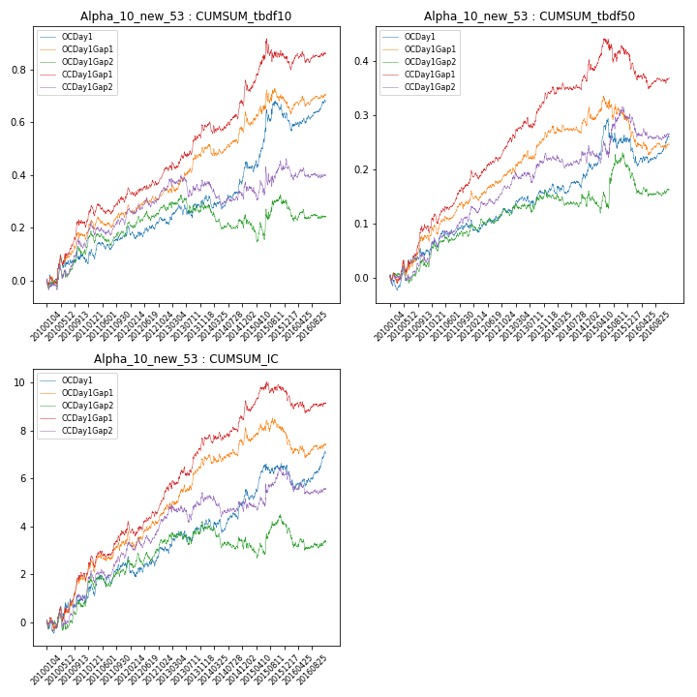

**因子换手率:** 68.59%

**截面指标_OCDay1:**

|  |  |  |  |  |  |  |  |  |
| --- | --- | --- | --- | --- | --- | --- | --- | --- |
| year | annret_tbdf10 | sharpe_tbdf10 | maxdd_tbdf10 | annret_tbdf50 | sharpe_tbdf50 | maxdd_tbdf50 | mean_IC | tstat_IC |
| 2010 | 0.08 | 0.95 | -0.05 | 0.04 | 1.3 | -0.03 | 0.0 | 1.05 |
| 2011 | 0.09 | 1.72 | -0.04 | 0.05 | 1.85 | -0.01 | 0.01 | 2.03 |
| 2012 | 0.05 | 0.97 | -0.05 | 0.03 | 1.25 | -0.02 | 0.0 | 0.93 |
| 2013 | 0.09 | 1.5 | -0.05 | 0.04 | 1.46 | -0.02 | 0.0 | 1.64 |
| 2014 | 0.14 | 2.38 | -0.05 | 0.05 | 1.96 | -0.02 | 0.01 | 2.09 |
| 2015 | 0.18 | 1.65 | -0.06 | 0.04 | 0.87 | -0.06 | 0.0 | 1.17 |
| 2016 | 0.05 | 0.99 | -0.07 | 0.0 | 0.14 | -0.05 | 0.0 | 0.84 |

**截面指标_CCDay1Gap1:**

|  |  |  |  |  |  |  |  |  |
| --- | --- | --- | --- | --- | --- | --- | --- | --- |
| year | annret_tbdf10 | sharpe_tbdf10 | maxdd_tbdf10 | annret_tbdf50 | sharpe_tbdf50 | maxdd_tbdf50 | mean_IC | tstat_IC |
| 2010 | 0.21 | 2.77 | -0.04 | 0.09 | 2.43 | -0.02 | 0.01 | 2.38 |
| 2011 | 0.11 | 2.0 | -0.04 | 0.09 | 3.52 | -0.02 | 0.01 | 2.77 |
| 2012 | 0.11 | 2.34 | -0.03 | 0.08 | 3.35 | -0.02 | 0.01 | 2.78 |
| 2013 | 0.16 | 2.39 | -0.03 | 0.09 | 2.87 | -0.02 | 0.01 | 2.87 |
| 2014 | 0.17 | 2.63 | -0.04 | 0.06 | 2.05 | -0.01 | 0.01 | 2.31 |
| 2015 | 0.09 | 0.85 | -0.09 | 0.01 | 0.23 | -0.04 | 0.0 | 0.6 |
| 2016 | 0.02 | 0.3 | -0.05 | -0.04 | -1.37 | -0.06 | -0.0 | -0.81 |

**风格暴露:**

|  |  |  |  |  |
| --- | --- | --- | --- | --- |
|  | long | short | corr_OCDay1 | corr_CCDay1Gap1 |
| momentum30 | -0.01 | 0.02 | 0.17 | 0.15 |
| logmktcap | 0.01 | -0.0 | 0.05 | 0.01 |
| liquidity10 | 0.02 | -0.02 | -0.03 | 0.01 |
| retvolatility30 | 0.02 | -0.01 | -0.08 | -0.05 |
| liquidity20 | 0.02 | -0.01 | -0.05 | -0.02 |
| momentum5 | 0.03 | -0.02 | 0.12 | 0.11 |
| momentum15 | -0.02 | 0.03 | 0.23 | 0.25 |
| liquidity5 | 0.03 | -0.02 | -0.03 | -0.0 |

**4. Alpha_10_new_57**

**截面指标累计曲线:**

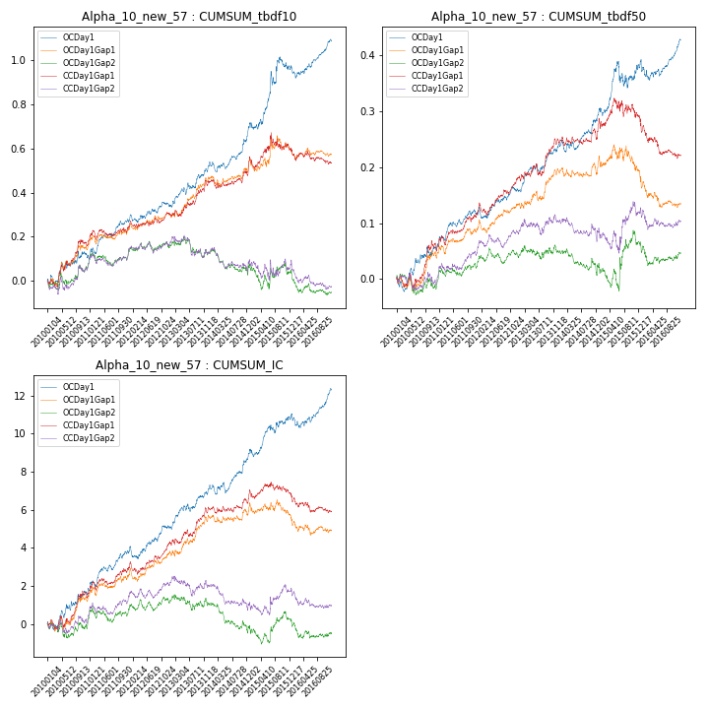

**因子换手率:** 80.17%

**截面指标_OCDay1:**

|  |  |  |  |  |  |  |  |  |
| --- | --- | --- | --- | --- | --- | --- | --- | --- |
| year | annret_tbdf10 | sharpe_tbdf10 | maxdd_tbdf10 | annret_tbdf50 | sharpe_tbdf50 | maxdd_tbdf50 | mean_IC | tstat_IC |
| 2010 | 0.11 | 1.37 | -0.04 | 0.05 | 1.58 | -0.03 | 0.01 | 1.93 |
| 2011 | 0.16 | 2.97 | -0.03 | 0.06 | 2.46 | -0.01 | 0.01 | 3.11 |
| 2012 | 0.07 | 1.48 | -0.04 | 0.04 | 1.85 | -0.02 | 0.01 | 2.0 |
| 2013 | 0.18 | 2.91 | -0.03 | 0.08 | 3.27 | -0.02 | 0.01 | 3.11 |
| 2014 | 0.2 | 3.37 | -0.05 | 0.07 | 2.55 | -0.02 | 0.01 | 3.04 |
| 2015 | 0.26 | 2.0 | -0.06 | 0.08 | 1.58 | -0.05 | 0.01 | 2.04 |
| 2016 | 0.12 | 2.22 | -0.06 | 0.04 | 1.48 | -0.04 | 0.01 | 2.02 |

**截面指标_CCDay1Gap1:**

|  |  |  |  |  |  |  |  |  |
| --- | --- | --- | --- | --- | --- | --- | --- | --- |
| year | annret_tbdf10 | sharpe_tbdf10 | maxdd_tbdf10 | annret_tbdf50 | sharpe_tbdf50 | maxdd_tbdf50 | mean_IC | tstat_IC |
| 2010 | 0.16 | 2.23 | -0.03 | 0.05 | 1.55 | -0.03 | 0.01 | 1.89 |
| 2011 | 0.08 | 1.43 | -0.04 | 0.07 | 2.72 | -0.02 | 0.01 | 2.24 |
| 2012 | 0.07 | 1.39 | -0.03 | 0.06 | 2.83 | -0.02 | 0.01 | 2.21 |
| 2013 | 0.14 | 2.17 | -0.03 | 0.07 | 2.16 | -0.02 | 0.01 | 2.45 |
| 2014 | 0.11 | 1.76 | -0.04 | 0.04 | 1.28 | -0.02 | 0.0 | 1.47 |
| 2015 | 0.04 | 0.43 | -0.08 | 0.0 | 0.03 | -0.04 | -0.0 | -0.19 |
| 2016 | -0.07 | -1.22 | -0.07 | -0.07 | -2.09 | -0.07 | -0.0 | -1.52 |

**风格暴露:**

|  |  |  |  |  |
| --- | --- | --- | --- | --- |
|  | long | short | corr_OCDay1 | corr_CCDay1Gap1 |
| momentum30 | -0.0 | 0.01 | 0.13 | 0.12 |
| logmktcap | 0.03 | -0.02 | 0.02 | 0.02 |
| liquidity10 | 0.02 | -0.02 | -0.04 | -0.01 |
| retvolatility30 | 0.02 | -0.02 | -0.09 | -0.07 |
| liquidity20 | 0.02 | -0.01 | -0.05 | -0.03 |
| momentum5 | 0.03 | -0.03 | 0.1 | 0.1 |
| momentum15 | -0.01 | 0.02 | 0.2 | 0.22 |
| liquidity5 | 0.03 | -0.02 | -0.03 | -0.01 |

**5. Alpha_10_new_56**

**截面指标累计曲线:**

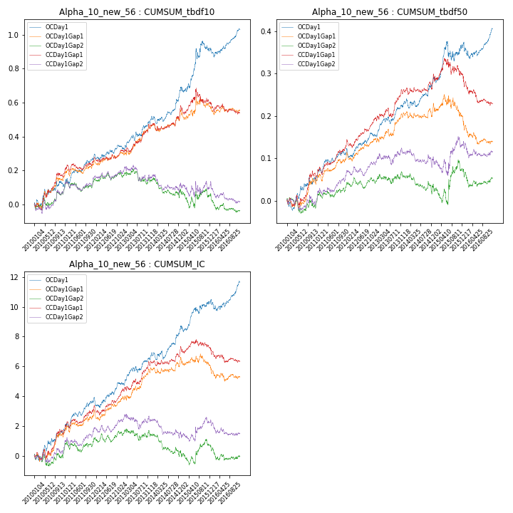

**因子换手率:** 78.78%

**截面指标_OCDay1:**

|  |  |  |  |  |  |  |  |  |
| --- | --- | --- | --- | --- | --- | --- | --- | --- |
| year | annret_tbdf10 | sharpe_tbdf10 | maxdd_tbdf10 | annret_tbdf50 | sharpe_tbdf50 | maxdd_tbdf50 | mean_IC | tstat_IC |
| 2010 | 0.11 | 1.37 | -0.04 | 0.05 | 1.48 | -0.02 | 0.01 | 1.83 |
| 2011 | 0.15 | 2.86 | -0.03 | 0.06 | 2.33 | -0.01 | 0.01 | 2.98 |
| 2012 | 0.07 | 1.36 | -0.04 | 0.04 | 1.92 | -0.02 | 0.01 | 1.86 |
| 2013 | 0.17 | 2.76 | -0.03 | 0.08 | 3.18 | -0.02 | 0.01 | 2.93 |
| 2014 | 0.19 | 3.27 | -0.04 | 0.06 | 2.3 | -0.02 | 0.01 | 2.91 |
| 2015 | 0.23 | 1.95 | -0.06 | 0.08 | 1.53 | -0.05 | 0.01 | 1.96 |
| 2016 | 0.11 | 2.18 | -0.05 | 0.04 | 1.29 | -0.04 | 0.01 | 1.87 |

**截面指标_CCDay1Gap1:**

|  |  |  |  |  |  |  |  |  |
| --- | --- | --- | --- | --- | --- | --- | --- | --- |
| year | annret_tbdf10 | sharpe_tbdf10 | maxdd_tbdf10 | annret_tbdf50 | sharpe_tbdf50 | maxdd_tbdf50 | mean_IC | tstat_IC |
| 2010 | 0.17 | 2.27 | -0.04 | 0.06 | 1.58 | -0.02 | 0.01 | 1.96 |
| 2011 | 0.09 | 1.53 | -0.04 | 0.07 | 2.96 | -0.02 | 0.01 | 2.3 |
| 2012 | 0.07 | 1.49 | -0.03 | 0.07 | 3.03 | -0.02 | 0.01 | 2.3 |
| 2013 | 0.15 | 2.22 | -0.03 | 0.07 | 2.17 | -0.02 | 0.01 | 2.53 |
| 2014 | 0.11 | 1.81 | -0.04 | 0.04 | 1.3 | -0.02 | 0.0 | 1.58 |
| 2015 | 0.02 | 0.22 | -0.09 | -0.0 | -0.06 | -0.04 | -0.0 | -0.07 |
| 2016 | -0.06 | -1.14 | -0.07 | -0.07 | -2.06 | -0.07 | -0.0 | -1.43 |

**风格暴露:**

|  |  |  |  |  |
| --- | --- | --- | --- | --- |
|  | long | short | corr_OCDay1 | corr_CCDay1Gap1 |
| momentum30 | -0.01 | 0.01 | 0.14 | 0.11 |
| logmktcap | 0.02 | -0.02 | 0.02 | 0.01 |
| liquidity10 | 0.02 | -0.02 | -0.03 | 0.0 |
| retvolatility30 | 0.02 | -0.02 | -0.08 | -0.05 |
| liquidity20 | 0.02 | -0.01 | -0.04 | -0.03 |
| momentum5 | 0.03 | -0.03 | 0.1 | 0.1 |
| momentum15 | -0.01 | 0.02 | 0.21 | 0.21 |
| liquidity5 | 0.03 | -0.02 | -0.03 | -0.01 |

**6. Alpha_10_new_515**

**截面指标累计曲线:**

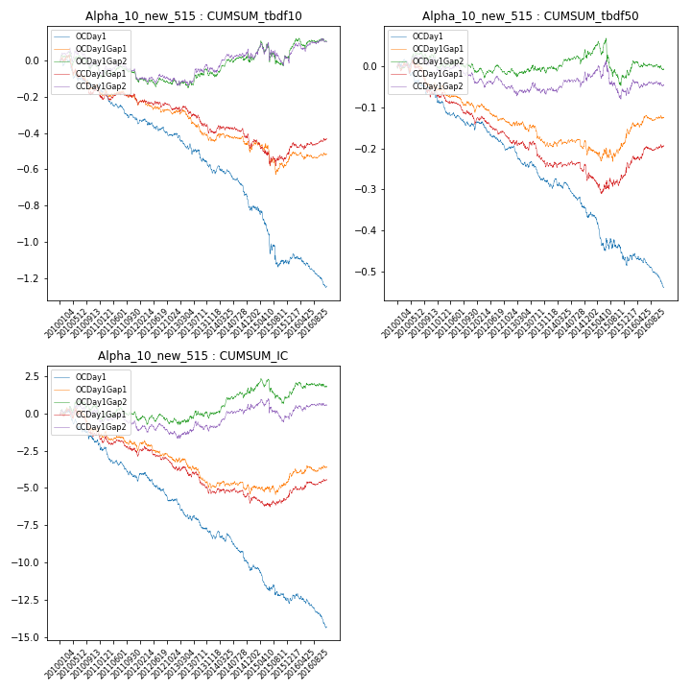

**因子换手率:** 84.54%

**截面指标_OCDay1:**

|  |  |  |  |  |  |  |  |  |
| --- | --- | --- | --- | --- | --- | --- | --- | --- |
| year | annret_tbdf10 | sharpe_tbdf10 | maxdd_tbdf10 | annret_tbdf50 | sharpe_tbdf50 | maxdd_tbdf50 | mean_IC | tstat_IC |
| 2010 | -0.14 | -1.71 | -0.16 | -0.07 | -1.95 | -0.08 | -0.01 | -2.25 |
| 2011 | -0.18 | -3.37 | -0.18 | -0.07 | -3.03 | -0.08 | -0.01 | -3.49 |
| 2012 | -0.09 | -1.85 | -0.1 | -0.06 | -2.44 | -0.07 | -0.01 | -2.43 |
| 2013 | -0.2 | -3.05 | -0.19 | -0.09 | -3.57 | -0.09 | -0.01 | -3.65 |
| 2014 | -0.23 | -3.9 | -0.22 | -0.08 | -2.93 | -0.09 | -0.01 | -3.43 |
| 2015 | -0.3 | -2.29 | -0.29 | -0.11 | -2.14 | -0.11 | -0.01 | -2.3 |
| 2016 | -0.12 | -2.31 | -0.17 | -0.06 | -2.17 | -0.08 | -0.01 | -2.5 |

**截面指标_CCDay1Gap1:**

|  |  |  |  |  |  |  |  |  |
| --- | --- | --- | --- | --- | --- | --- | --- | --- |
| year | annret_tbdf10 | sharpe_tbdf10 | maxdd_tbdf10 | annret_tbdf50 | sharpe_tbdf50 | maxdd_tbdf50 | mean_IC | tstat_IC |
| 2010 | -0.15 | -2.07 | -0.2 | -0.06 | -1.57 | -0.08 | -0.01 | -1.64 |
| 2011 | -0.06 | -1.08 | -0.06 | -0.07 | -2.92 | -0.07 | -0.01 | -2.04 |
| 2012 | -0.06 | -1.16 | -0.06 | -0.06 | -2.87 | -0.06 | -0.0 | -1.92 |
| 2013 | -0.12 | -1.88 | -0.14 | -0.06 | -1.75 | -0.06 | -0.01 | -2.17 |
| 2014 | -0.09 | -1.46 | -0.12 | -0.03 | -1.19 | -0.05 | -0.0 | -1.08 |
| 2015 | -0.04 | -0.36 | -0.14 | 0.02 | 0.33 | -0.05 | 0.0 | 0.51 |
| 2016 | 0.09 | 1.53 | -0.04 | 0.07 | 2.06 | -0.01 | 0.0 | 1.83 |

**风格暴露:**

|  |  |  |  |  |
| --- | --- | --- | --- | --- |
|  | long | short | corr_OCDay1 | corr_CCDay1Gap1 |
| momentum30 | 0.01 | 0.0 | -0.12 | -0.1 |
| logmktcap | -0.03 | 0.03 | 0.02 | 0.0 |
| liquidity10 | -0.02 | 0.02 | 0.02 | 0.0 |
| retvolatility30 | -0.02 | 0.02 | 0.08 | 0.06 |
| liquidity20 | -0.01 | 0.02 | 0.03 | 0.03 |
| momentum5 | -0.03 | 0.03 | -0.08 | -0.08 |
| momentum15 | 0.01 | -0.01 | -0.18 | -0.19 |
| liquidity5 | -0.02 | 0.03 | 0.02 | 0.02 |

**7. Alpha_10_new_58**

**截面指标累计曲线:**

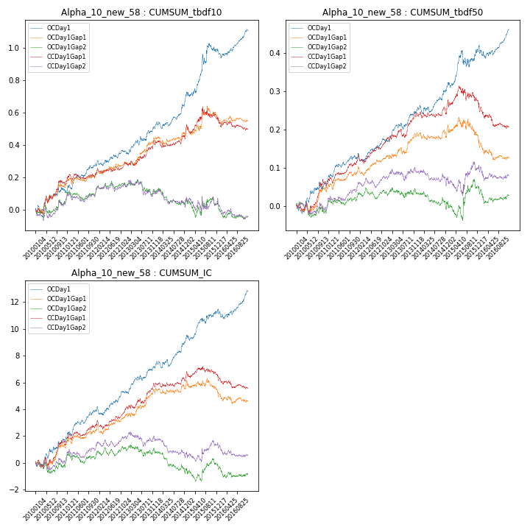

**因子换手率:** 81.21%

**截面指标_OCDay1:**

|  |  |  |  |  |  |  |  |  |
| --- | --- | --- | --- | --- | --- | --- | --- | --- |
| year | annret_tbdf10 | sharpe_tbdf10 | maxdd_tbdf10 | annret_tbdf50 | sharpe_tbdf50 | maxdd_tbdf50 | mean_IC | tstat_IC |
| 2010 | 0.11 | 1.38 | -0.04 | 0.06 | 1.65 | -0.02 | 0.01 | 2.01 |
| 2011 | 0.16 | 3.06 | -0.03 | 0.07 | 2.66 | -0.01 | 0.01 | 3.21 |
| 2012 | 0.08 | 1.6 | -0.03 | 0.05 | 2.0 | -0.02 | 0.01 | 2.11 |
| 2013 | 0.18 | 2.81 | -0.03 | 0.08 | 3.41 | -0.02 | 0.01 | 3.24 |
| 2014 | 0.2 | 3.44 | -0.04 | 0.07 | 2.64 | -0.02 | 0.01 | 3.13 |
| 2015 | 0.27 | 2.09 | -0.06 | 0.09 | 1.77 | -0.04 | 0.01 | 2.11 |
| 2016 | 0.12 | 2.25 | -0.06 | 0.05 | 1.68 | -0.03 | 0.01 | 2.13 |

**截面指标_CCDay1Gap1:**

|  |  |  |  |  |  |  |  |  |
| --- | --- | --- | --- | --- | --- | --- | --- | --- |
| year | annret_tbdf10 | sharpe_tbdf10 | maxdd_tbdf10 | annret_tbdf50 | sharpe_tbdf50 | maxdd_tbdf50 | mean_IC | tstat_IC |
| 2010 | 0.16 | 2.14 | -0.03 | 0.05 | 1.49 | -0.03 | 0.01 | 1.84 |
| 2011 | 0.07 | 1.2 | -0.04 | 0.07 | 2.71 | -0.02 | 0.01 | 2.19 |
| 2012 | 0.06 | 1.33 | -0.03 | 0.06 | 2.72 | -0.02 | 0.01 | 2.15 |
| 2013 | 0.13 | 2.0 | -0.03 | 0.06 | 2.05 | -0.02 | 0.01 | 2.39 |
| 2014 | 0.11 | 1.68 | -0.04 | 0.04 | 1.21 | -0.02 | 0.0 | 1.38 |
| 2015 | 0.05 | 0.49 | -0.08 | -0.01 | -0.11 | -0.04 | -0.0 | -0.26 |
| 2016 | -0.07 | -1.33 | -0.08 | -0.06 | -2.0 | -0.07 | -0.0 | -1.59 |

**风格暴露:**

|  |  |  |  |  |
| --- | --- | --- | --- | --- |
|  | long | short | corr_OCDay1 | corr_CCDay1Gap1 |
| momentum30 | -0.0 | 0.01 | 0.13 | 0.12 |
| logmktcap | 0.03 | -0.02 | 0.02 | 0.01 |
| liquidity10 | 0.02 | -0.02 | -0.04 | -0.01 |
| retvolatility30 | 0.02 | -0.02 | -0.09 | -0.06 |
| liquidity20 | 0.02 | -0.01 | -0.05 | -0.03 |
| momentum5 | 0.03 | -0.03 | 0.1 | 0.1 |
| momentum15 | -0.01 | 0.02 | 0.2 | 0.21 |
| liquidity5 | 0.03 | -0.02 | -0.03 | -0.01 |