**因子定义及优化结果**

1. **Alpha_13**
2. **因子定义**

$$(((HIGH * LOW)^0.5) - VWAP)$$

|  |  |  |  |  |  |  |  |  |
| --- | --- | --- | --- | --- | --- | --- | --- | --- |
| year | annret_tbdf10 | sharpe_tbdf10 | maxdd_tbdf10 | annret_tbdf50 | sharpe_tbdf50 | maxdd_tbdf50 | mean_IC | tstat_IC |
| 2010 | 0.21 | 1.77 | -0.11 | 0.13 | 1.94 | -0.05 | 0.02 | 2.71 |
| 2011 | 0.04 | 0.42 | -0.08 | 0.07 | 1.49 | -0.04 | 0.01 | 1.81 |
| 2012 | 0.15 | 1.43 | -0.09 | 0.11 | 2.04 | -0.06 | 0.02 | 2.7 |
| 2013 | 0.23 | 2.08 | -0.08 | 0.18 | 2.76 | -0.03 | 0.02 | 2.99 |
| 2014 | 0.03 | 0.42 | -0.09 | 0.07 | 1.38 | -0.04 | 0.01 | 1.97 |
| 2015 | 0.23 | 1.53 | -0.19 | 0.18 | 2.32 | -0.07 | 0.01 | 2.04 |
| 2016 | 0.24 | 2.41 | -0.07 | 0.18 | 3.39 | -0.03 | 0.02 | 3.63 |

因子分析：该因子值刻画的是最高价与最低价、均价之间的关系。

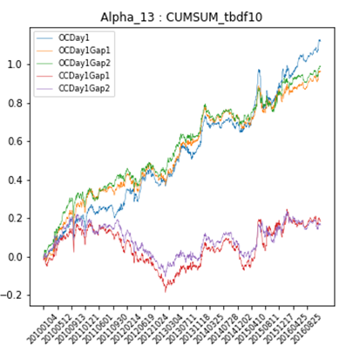

1. **因子优化**
$$Alpha_13(m,n)=(((HIGH * LOW)^m) - n*VWAP)$$

2. 遍历参数

* $m=range(0.1,2,0.2)$；
* **增加一个额外的参数n, $n=range(0.1,1.5,0.3)$**；

1. 改变因子指标：

* High换成Close，Low换成Open
* High和 Low 不变，将VWAP改为DEALAY(VWAP,X) ,X=range(1,10,1)

1. 最后因子的定义：
$${SMA(-\left(Open*Close\right)}^{0.5}+Vwap,12,2)/STD(Close,12)$$

2. **优化结果**

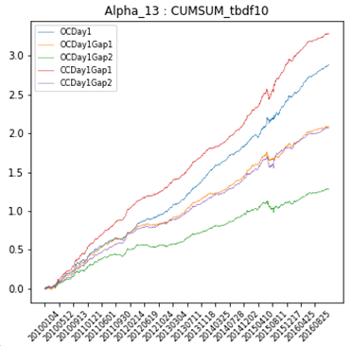

|  |  |  |  |  |  |  |  |  |
| --- | --- | --- | --- | --- | --- | --- | --- | --- |
| year | annret_tbdf10 | sharpe_tbdf10 | maxdd_tbdf10 | annret_tbdf50 | sharpe_tbdf50 | maxdd_tbdf50 | mean_IC | tstat_IC |
| 2010 | 0.35 | 4.21 | -0.03 | 0.16 | 4.9 | -0.01 | 0.02 | 5.08 |
| 2011 | 0.33 | 5.24 | -0.02 | 0.11 | 4.41 | -0.01 | 0.02 | 5.19 |
| 2012 | 0.33 | 5.82 | -0.02 | 0.15 | 6.42 | -0.01 | 0.02 | 6.81 |
| 2013 | 0.47 | 7.8 | -0.01 | 0.18 | 6.61 | -0.01 | 0.02 | 7.91 |
| 2014 | 0.43 | 7.48 | -0.02 | 0.2 | 8.01 | -0.01 | 0.02 | 8.85 |
| 2015 | 0.55 | 3.75 | -0.07 | 0.26 | 4.45 | -0.03 | 0.02 | 5.16 |
| 2016 | 0.45 | 6.4 | -0.02 | 0.18 | 6.18 | -0.02 | 0.02 | 7.38 |