Factors Report 20100104-20161230

**1. Alpha_13**

**截面指标累计曲线:**

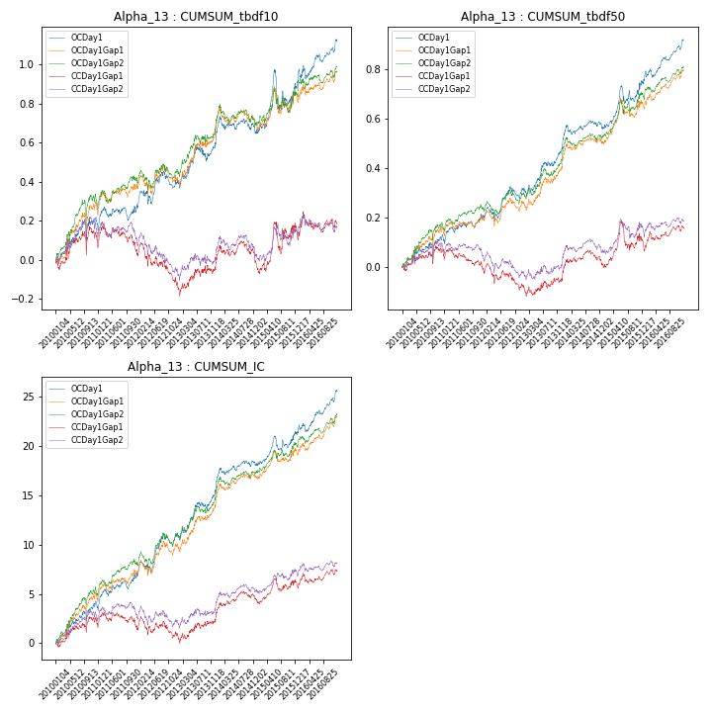

**因子换手率:** 35.12%

**截面指标_OCDay1:**

|  |  |  |  |  |  |  |  |  |
| --- | --- | --- | --- | --- | --- | --- | --- | --- |
| year | annret_tbdf10 | sharpe_tbdf10 | maxdd_tbdf10 | annret_tbdf50 | sharpe_tbdf50 | maxdd_tbdf50 | mean_IC | tstat_IC |
| 2010 | 0.21 | 1.77 | -0.11 | 0.13 | 1.94 | -0.05 | 0.02 | 2.71 |
| 2011 | 0.04 | 0.42 | -0.08 | 0.07 | 1.49 | -0.04 | 0.01 | 1.81 |
| 2012 | 0.15 | 1.43 | -0.09 | 0.11 | 2.04 | -0.06 | 0.02 | 2.7 |
| 2013 | 0.23 | 2.08 | -0.08 | 0.18 | 2.76 | -0.03 | 0.02 | 2.99 |
| 2014 | 0.03 | 0.42 | -0.09 | 0.07 | 1.38 | -0.04 | 0.01 | 1.97 |
| 2015 | 0.23 | 1.53 | -0.19 | 0.18 | 2.32 | -0.07 | 0.01 | 2.04 |
| 2016 | 0.24 | 2.41 | -0.07 | 0.18 | 3.39 | -0.03 | 0.02 | 3.63 |

**截面指标_CCDay1Gap1:**

|  |  |  |  |  |  |  |  |  |
| --- | --- | --- | --- | --- | --- | --- | --- | --- |
| year | annret_tbdf10 | sharpe_tbdf10 | maxdd_tbdf10 | annret_tbdf50 | sharpe_tbdf50 | maxdd_tbdf50 | mean_IC | tstat_IC |
| 2010 | 0.14 | 1.14 | -0.12 | 0.08 | 1.19 | -0.05 | 0.01 | 1.87 |
| 2011 | -0.1 | -1.08 | -0.13 | -0.09 | -1.72 | -0.08 | -0.0 | -0.75 |
| 2012 | -0.16 | -1.54 | -0.19 | -0.06 | -1.11 | -0.1 | -0.0 | -0.42 |
| 2013 | 0.1 | 0.91 | -0.07 | 0.04 | 0.57 | -0.04 | 0.01 | 1.09 |
| 2014 | -0.0 | -0.05 | -0.11 | 0.05 | 0.92 | -0.06 | 0.01 | 1.63 |
| 2015 | 0.16 | 1.02 | -0.15 | 0.07 | 0.88 | -0.11 | 0.01 | 1.1 |
| 2016 | 0.04 | 0.45 | -0.09 | 0.07 | 1.58 | -0.04 | 0.01 | 1.31 |

**风格暴露:**

|  |  |  |  |  |
| --- | --- | --- | --- | --- |
|  | long | short | corr_OCDay1 | corr_CCDay1Gap1 |
| momentum30 | -0.16 | 0.16 | 0.22 | 0.19 |
| logmktcap | 0.67 | -0.66 | -0.44 | -0.44 |
| liquidity10 | -0.89 | 0.89 | 0.56 | 0.53 |
| retvolatility30 | -0.43 | 0.44 | 0.47 | 0.42 |
| liquidity20 | -0.9 | 0.91 | 0.56 | 0.54 |
| momentum5 | -0.07 | 0.08 | 0.02 | 0.06 |
| momentum15 | -0.11 | 0.12 | 0.14 | 0.14 |
| liquidity5 | -0.87 | 0.87 | 0.56 | 0.52 |