Factors Report 20120104-20161230

**1. Alpha_17**

**截面指标累计曲线:**

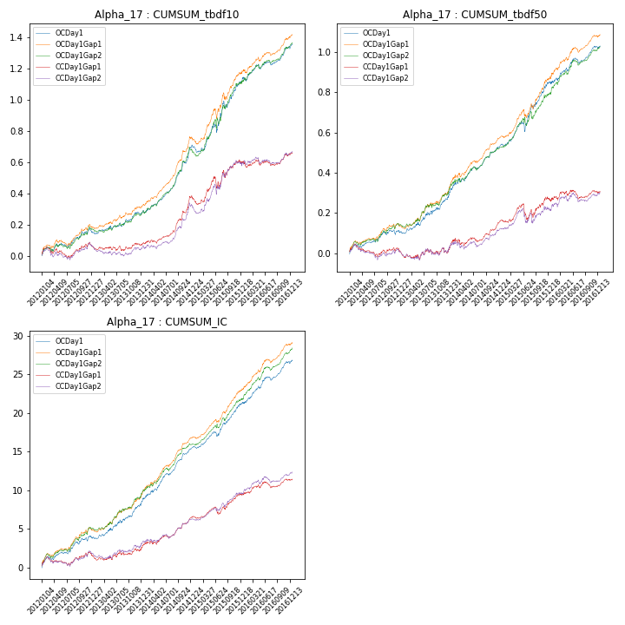

**因子换手率:** 23.81%

**截面指标_OCDay1:**

|  |  |  |  |  |  |  |  |  |
| --- | --- | --- | --- | --- | --- | --- | --- | --- |
| year | annret_tbdf10 | sharpe_tbdf10 | maxdd_tbdf10 | annret_tbdf50 | sharpe_tbdf50 | maxdd_tbdf50 | mean_IC | tstat_IC |
| 2012 | 0.16 | 2.79 | -0.03 | 0.11 | 2.53 | -0.02 | 0.02 | 3.6 |
| 2013 | 0.11 | 2.25 | -0.02 | 0.19 | 3.22 | -0.02 | 0.02 | 3.7 |
| 2014 | 0.44 | 7.08 | -0.02 | 0.24 | 5.01 | -0.02 | 0.03 | 6.93 |
| 2015 | 0.41 | 3.91 | -0.06 | 0.32 | 4.66 | -0.05 | 0.02 | 5.59 |
| 2016 | 0.24 | 3.85 | -0.03 | 0.19 | 3.72 | -0.03 | 0.02 | 5.32 |

**截面指标_CCDay1Gap1:**

|  |  |  |  |  |  |  |  |  |
| --- | --- | --- | --- | --- | --- | --- | --- | --- |
| year | annret_tbdf10 | sharpe_tbdf10 | maxdd_tbdf10 | annret_tbdf50 | sharpe_tbdf50 | maxdd_tbdf50 | mean_IC | tstat_IC |
| 2012 | 0.07 | 1.2 | -0.07 | 0.01 | 0.29 | -0.06 | 0.01 | 1.55 |
| 2013 | 0.0 | 0.04 | -0.04 | 0.01 | 0.12 | -0.04 | 0.0 | 0.7 |
| 2014 | 0.31 | 4.83 | -0.02 | 0.14 | 2.62 | -0.04 | 0.02 | 3.99 |
| 2015 | 0.2 | 1.81 | -0.07 | 0.11 | 1.46 | -0.08 | 0.01 | 2.82 |
| 2016 | 0.08 | 1.19 | -0.04 | 0.05 | 0.89 | -0.04 | 0.01 | 2.13 |

**风格暴露:**

|  |  |  |  |  |
| --- | --- | --- | --- | --- |
|  | long | short | corr_OCDay1 | corr_CCDay1Gap1 |
| momentum30 | -0.2 | 0.2 | 0.16 | 0.22 |
| logmktcap | 0.62 | -0.61 | -0.56 | -0.53 |
| liquidity10 | -0.8 | 0.8 | 0.72 | 0.74 |
| retvolatility30 | -0.92 | 0.93 | 0.73 | 0.72 |
| liquidity20 | -0.8 | 0.81 | 0.74 | 0.75 |
| momentum5 | -0.07 | 0.08 | -0.1 | -0.04 |
| momentum15 | -0.13 | 0.13 | 0.08 | 0.15 |
| liquidity5 | -0.81 | 0.81 | 0.71 | 0.72 |