Factors Report 20120104-20161230

**1. Alpha_22_3**

**截面指标累计曲线:**

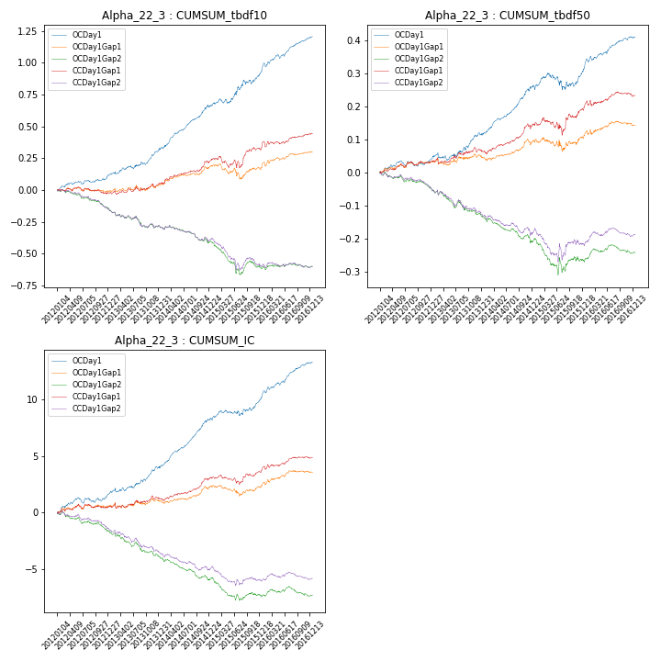

**因子换手率:** 60.0%

**截面指标_OCDay1:**

|  |  |  |  |  |  |  |  |  |
| --- | --- | --- | --- | --- | --- | --- | --- | --- |
| year | annret_tbdf10 | sharpe_tbdf10 | maxdd_tbdf10 | annret_tbdf50 | sharpe_tbdf50 | maxdd_tbdf50 | mean_IC | tstat_IC |
| 2012 | 0.12 | 2.55 | -0.02 | 0.04 | 1.81 | -0.02 | 0.01 | 2.57 |
| 2013 | 0.2 | 3.45 | -0.02 | 0.08 | 2.67 | -0.02 | 0.01 | 3.44 |
| 2014 | 0.35 | 6.21 | -0.02 | 0.14 | 6.35 | -0.01 | 0.02 | 7.61 |
| 2015 | 0.27 | 3.11 | -0.04 | 0.05 | 1.2 | -0.05 | 0.01 | 2.43 |
| 2016 | 0.28 | 5.23 | -0.03 | 0.1 | 4.09 | -0.01 | 0.01 | 5.41 |

**截面指标_CCDay1Gap1:**

|  |  |  |  |  |  |  |  |  |
| --- | --- | --- | --- | --- | --- | --- | --- | --- |
| year | annret_tbdf10 | sharpe_tbdf10 | maxdd_tbdf10 | annret_tbdf50 | sharpe_tbdf50 | maxdd_tbdf50 | mean_IC | tstat_IC |
| 2012 | -0.02 | -0.49 | -0.05 | 0.03 | 1.59 | -0.01 | 0.0 | 0.92 |
| 2013 | 0.07 | 1.2 | -0.04 | 0.04 | 1.2 | -0.02 | 0.0 | 1.18 |
| 2014 | 0.18 | 3.62 | -0.02 | 0.08 | 3.18 | -0.02 | 0.01 | 3.42 |
| 2015 | 0.1 | 1.1 | -0.09 | 0.05 | 0.96 | -0.05 | 0.0 | 0.88 |
| 2016 | 0.12 | 2.08 | -0.04 | 0.04 | 1.53 | -0.02 | 0.01 | 2.28 |

**风格暴露:**

|  |  |  |  |  |
| --- | --- | --- | --- | --- |
|  | long | short | corr_OCDay1 | corr_CCDay1Gap1 |
| momentum30 | 0.12 | -0.11 | -0.2 | -0.25 |
| logmktcap | 0.03 | -0.03 | -0.14 | -0.1 |
| liquidity10 | 0.02 | -0.01 | 0.0 | -0.03 |
| retvolatility30 | 0.0 | 0.01 | 0.04 | 0.0 |
| liquidity20 | 0.01 | -0.01 | 0.03 | -0.01 |
| momentum5 | 0.21 | -0.21 | -0.22 | -0.22 |
| momentum15 | 0.12 | -0.11 | -0.22 | -0.23 |
| liquidity5 | 0.04 | -0.04 | 0.0 | -0.05 |