Factors Report 20100104-20161230

**1. Alpha_9**

**截面指标累计曲线:**

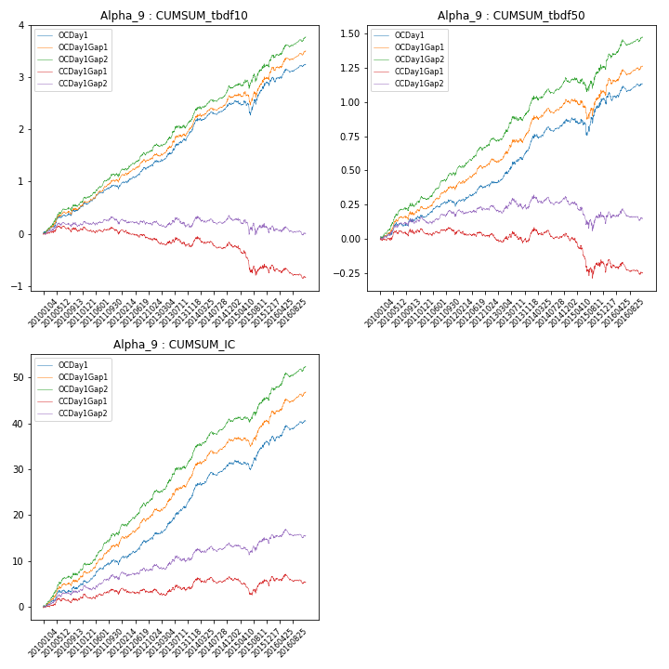

**因子换手率:** 35.72%

**截面指标_OCDay1:**

|  |  |  |  |  |  |  |  |  |
| --- | --- | --- | --- | --- | --- | --- | --- | --- |
| year | annret_tbdf10 | sharpe_tbdf10 | maxdd_tbdf10 | annret_tbdf50 | sharpe_tbdf50 | maxdd_tbdf50 | mean_IC | tstat_IC |
| 2010 | 0.53 | 3.39 | -0.05 | 0.17 | 2.2 | -0.03 | 0.02 | 2.7 |
| 2011 | 0.36 | 3.07 | -0.05 | 0.09 | 1.59 | -0.04 | 0.02 | 2.67 |
| 2012 | 0.51 | 3.79 | -0.04 | 0.17 | 2.82 | -0.02 | 0.03 | 3.72 |
| 2013 | 0.64 | 3.7 | -0.05 | 0.26 | 3.24 | -0.02 | 0.04 | 4.03 |
| 2014 | 0.47 | 3.32 | -0.06 | 0.19 | 2.62 | -0.03 | 0.03 | 3.83 |
| 2015 | 0.4 | 1.5 | -0.26 | 0.15 | 1.14 | -0.13 | 0.02 | 1.94 |
| 2016 | 0.37 | 2.22 | -0.09 | 0.12 | 1.5 | -0.06 | 0.02 | 2.43 |

**截面指标_CCDay1Gap1:**

|  |  |  |  |  |  |  |  |  |
| --- | --- | --- | --- | --- | --- | --- | --- | --- |
| year | annret_tbdf10 | sharpe_tbdf10 | maxdd_tbdf10 | annret_tbdf50 | sharpe_tbdf50 | maxdd_tbdf50 | mean_IC | tstat_IC |
| 2010 | 0.1 | 0.66 | -0.12 | 0.07 | 0.95 | -0.04 | 0.01 | 1.39 |
| 2011 | -0.11 | -0.87 | -0.14 | -0.04 | -0.71 | -0.05 | 0.0 | 0.31 |
| 2012 | -0.1 | -0.72 | -0.2 | 0.0 | 0.01 | -0.05 | 0.0 | 0.58 |
| 2013 | -0.1 | -0.51 | -0.18 | -0.02 | -0.28 | -0.08 | 0.0 | 0.48 |
| 2014 | -0.01 | -0.09 | -0.22 | 0.01 | 0.17 | -0.08 | 0.01 | 0.9 |
| 2015 | -0.48 | -1.72 | -0.46 | -0.23 | -1.68 | -0.27 | -0.0 | -0.43 |
| 2016 | -0.15 | -0.84 | -0.24 | -0.04 | -0.45 | -0.11 | 0.0 | 0.09 |

**风格暴露:**

|  |  |  |  |  |
| --- | --- | --- | --- | --- |
|  | long | short | corr_OCDay1 | corr_CCDay1Gap1 |
| momentum30 | -0.55 | 0.55 | 0.32 | 0.3 |
| logmktcap | 0.32 | -0.32 | -0.4 | -0.45 |
| liquidity10 | -1.29 | 1.3 | 0.76 | 0.79 |
| retvolatility30 | -1.31 | 1.32 | 0.8 | 0.82 |
| liquidity20 | -1.16 | 1.16 | 0.74 | 0.76 |
| momentum5 | -0.22 | 0.23 | 0.08 | 0.07 |
| momentum15 | -0.49 | 0.5 | 0.28 | 0.25 |
| liquidity5 | -1.41 | 1.41 | 0.78 | 0.79 |