Factors Report 20120104-20161230

**1. Alpha_34_2**

**截面指标累计曲线:**

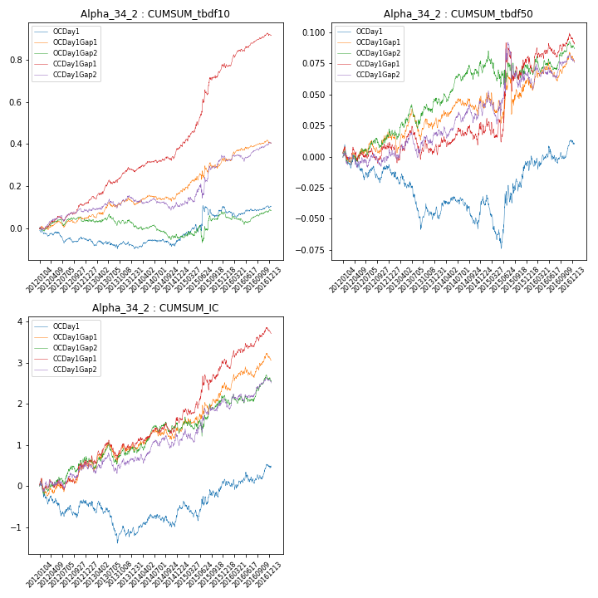

**因子换手率:** 45.04%

**截面指标_OCDay1:**

|  |  |  |  |  |  |  |  |  |
| --- | --- | --- | --- | --- | --- | --- | --- | --- |
| year | annret_tbdf10 | sharpe_tbdf10 | maxdd_tbdf10 | annret_tbdf50 | sharpe_tbdf50 | maxdd_tbdf50 | mean_IC | tstat_IC |
| 2012 | -0.05 | -1.24 | -0.07 | -0.01 | -0.43 | -0.03 | -0.0 | -0.74 |
| 2013 | -0.03 | -0.6 | -0.05 | -0.04 | -1.77 | -0.05 | -0.0 | -1.45 |
| 2014 | 0.02 | 0.47 | -0.03 | 0.01 | 0.48 | -0.03 | 0.0 | 1.28 |
| 2015 | 0.16 | 1.68 | -0.06 | 0.03 | 0.92 | -0.04 | 0.0 | 1.3 |
| 2016 | 0.0 | 0.09 | -0.05 | 0.02 | 0.79 | -0.01 | 0.0 | 0.75 |

**截面指标_CCDay1Gap1:**

|  |  |  |  |  |  |  |  |  |
| --- | --- | --- | --- | --- | --- | --- | --- | --- |
| year | annret_tbdf10 | sharpe_tbdf10 | maxdd_tbdf10 | annret_tbdf50 | sharpe_tbdf50 | maxdd_tbdf50 | mean_IC | tstat_IC |
| 2012 | 0.12 | 3.18 | -0.02 | 0.01 | 0.47 | -0.01 | 0.0 | 1.27 |
| 2013 | 0.17 | 3.52 | -0.02 | -0.0 | -0.15 | -0.03 | 0.0 | 0.86 |
| 2014 | 0.1 | 2.3 | -0.02 | 0.02 | 0.81 | -0.02 | 0.0 | 1.45 |
| 2015 | 0.4 | 4.9 | -0.02 | 0.06 | 1.09 | -0.04 | 0.01 | 2.58 |
| 2016 | 0.14 | 3.5 | -0.02 | 0.01 | 0.55 | -0.01 | 0.0 | 1.67 |

**风格暴露:**

|  |  |  |  |  |
| --- | --- | --- | --- | --- |
|  | long | short | corr_OCDay1 | corr_CCDay1Gap1 |
| momentum30 | -0.05 | 0.05 | 0.18 | 0.18 |
| logmktcap | -0.0 | 0.01 | 0.05 | 0.09 |
| liquidity10 | -0.02 | 0.03 | 0.12 | 0.02 |
| retvolatility30 | -0.01 | 0.02 | 0.06 | -0.03 |
| liquidity20 | -0.01 | 0.01 | 0.09 | 0.01 |
| momentum5 | -0.11 | 0.11 | 0.21 | 0.1 |
| momentum15 | -0.08 | 0.08 | 0.19 | 0.25 |
| liquidity5 | -0.04 | 0.04 | 0.13 | 0.03 |