Factors Report 20120104-20161230

**1. Alpha101_37**

**截面指标累计曲线:**

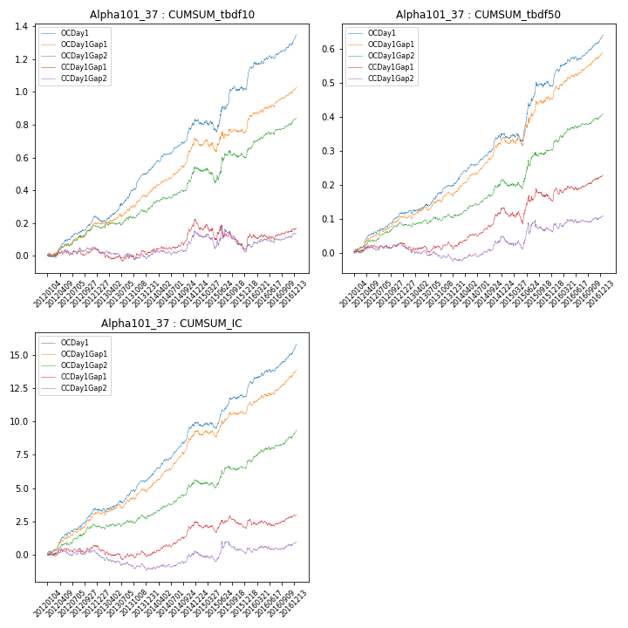

**因子换手率:** 38.07%

**截面指标_OCDay1:**

|  |  |  |  |  |  |  |  |  |
| --- | --- | --- | --- | --- | --- | --- | --- | --- |
| year | annret_tbdf10 | sharpe_tbdf10 | maxdd_tbdf10 | annret_tbdf50 | sharpe_tbdf50 | maxdd_tbdf50 | mean_IC | tstat_IC |
| 2012 | 0.23 | 5.23 | -0.02 | 0.12 | 5.86 | -0.01 | 0.01 | 5.8 |
| 2013 | 0.27 | 4.94 | -0.03 | 0.08 | 3.65 | -0.01 | 0.01 | 3.84 |
| 2014 | 0.33 | 5.92 | -0.02 | 0.15 | 6.46 | -0.01 | 0.02 | 7.32 |
| 2015 | 0.2 | 2.07 | -0.08 | 0.14 | 3.01 | -0.02 | 0.01 | 2.75 |
| 2016 | 0.33 | 5.45 | -0.02 | 0.15 | 5.56 | -0.01 | 0.02 | 5.89 |

**截面指标_CCDay1Gap1:**

|  |  |  |  |  |  |  |  |  |
| --- | --- | --- | --- | --- | --- | --- | --- | --- |
| year | annret_tbdf10 | sharpe_tbdf10 | maxdd_tbdf10 | annret_tbdf50 | sharpe_tbdf50 | maxdd_tbdf50 | mean_IC | tstat_IC |
| 2012 | 0.03 | 0.75 | -0.03 | 0.02 | 1.19 | -0.01 | 0.0 | 1.01 |
| 2013 | -0.03 | -0.49 | -0.07 | -0.01 | -0.42 | -0.03 | -0.0 | -1.24 |
| 2014 | 0.2 | 3.38 | -0.02 | 0.12 | 4.57 | -0.01 | 0.01 | 4.44 |
| 2015 | -0.16 | -1.7 | -0.16 | 0.02 | 0.48 | -0.05 | -0.0 | -0.66 |
| 2016 | 0.13 | 2.09 | -0.03 | 0.07 | 2.59 | -0.02 | 0.0 | 1.66 |

**风格暴露:**

|  |  |  |  |  |
| --- | --- | --- | --- | --- |
|  | long | short | corr_OCDay1 | corr_CCDay1Gap1 |
| momentum30 | 0.01 | -0.01 | 0.03 | -0.07 |
| logmktcap | 0.01 | -0.01 | 0.2 | 0.17 |
| liquidity10 | 0.02 | -0.01 | -0.1 | -0.1 |
| retvolatility30 | 0.02 | -0.01 | -0.23 | -0.17 |
| liquidity20 | 0.02 | -0.01 | -0.14 | -0.13 |
| momentum5 | 0.01 | -0.01 | 0.19 | 0.03 |
| momentum15 | 0.02 | -0.01 | 0.12 | -0.01 |
| liquidity5 | 0.02 | -0.01 | -0.07 | -0.12 |