Factors Report 20120104-20161230

**1. Alpha101_38**

**截面指标累计曲线:**

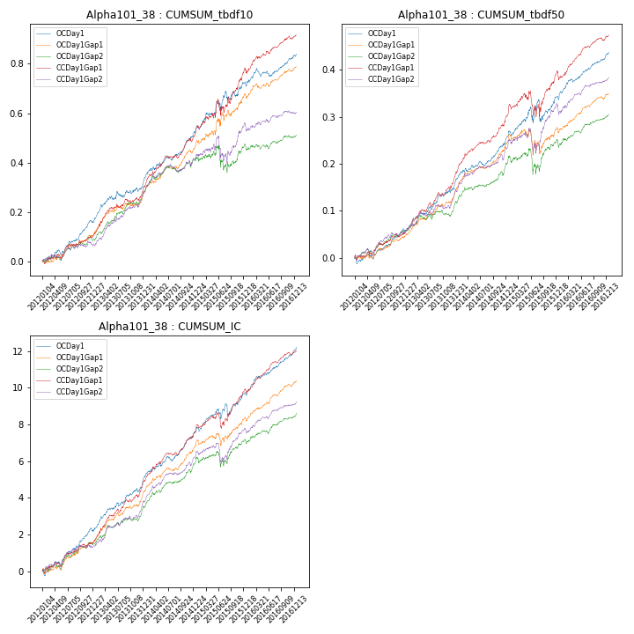

**因子换手率:** 44.06%

**截面指标_OCDay1:**

|  |  |  |  |  |  |  |  |  |
| --- | --- | --- | --- | --- | --- | --- | --- | --- |
| year | annret_tbdf10 | sharpe_tbdf10 | maxdd_tbdf10 | annret_tbdf50 | sharpe_tbdf50 | maxdd_tbdf50 | mean_IC | tstat_IC |
| 2012 | 0.16 | 4.5 | -0.02 | 0.06 | 3.17 | -0.01 | 0.01 | 4.38 |
| 2013 | 0.16 | 3.37 | -0.03 | 0.1 | 4.91 | -0.01 | 0.01 | 5.18 |
| 2014 | 0.21 | 5.21 | -0.01 | 0.1 | 4.73 | -0.01 | 0.01 | 5.3 |
| 2015 | 0.2 | 2.6 | -0.04 | 0.09 | 1.63 | -0.05 | 0.01 | 2.63 |
| 2016 | 0.12 | 2.95 | -0.03 | 0.09 | 5.04 | -0.01 | 0.01 | 5.85 |

**截面指标_CCDay1Gap1:**

|  |  |  |  |  |  |  |  |  |
| --- | --- | --- | --- | --- | --- | --- | --- | --- |
| year | annret_tbdf10 | sharpe_tbdf10 | maxdd_tbdf10 | annret_tbdf50 | sharpe_tbdf50 | maxdd_tbdf50 | mean_IC | tstat_IC |
| 2012 | 0.1 | 2.74 | -0.02 | 0.06 | 2.83 | -0.01 | 0.01 | 3.17 |
| 2013 | 0.19 | 4.61 | -0.02 | 0.12 | 5.62 | -0.01 | 0.01 | 6.28 |
| 2014 | 0.22 | 5.65 | -0.01 | 0.13 | 6.29 | -0.01 | 0.01 | 6.42 |
| 2015 | 0.27 | 3.04 | -0.06 | 0.09 | 1.82 | -0.05 | 0.01 | 3.17 |
| 2016 | 0.14 | 3.5 | -0.02 | 0.08 | 4.15 | -0.02 | 0.01 | 5.76 |

**风格暴露:**

|  |  |  |  |  |
| --- | --- | --- | --- | --- |
|  | long | short | corr_OCDay1 | corr_CCDay1Gap1 |
| momentum30 | -0.0 | 0.01 | -0.22 | -0.13 |
| logmktcap | 0.01 | -0.0 | -0.05 | -0.25 |
| liquidity10 | 0.01 | -0.0 | 0.1 | 0.26 |
| retvolatility30 | 0.0 | 0.0 | 0.13 | 0.26 |
| liquidity20 | 0.0 | 0.0 | 0.07 | 0.24 |
| momentum5 | -0.03 | 0.04 | -0.11 | -0.03 |
| momentum15 | 0.0 | 0.01 | -0.16 | -0.01 |
| liquidity5 | 0.0 | 0.0 | 0.11 | 0.29 |