Factors Report 20120104-20161230

**1. Alpha101_40_2**

**截面指标累计曲线:**

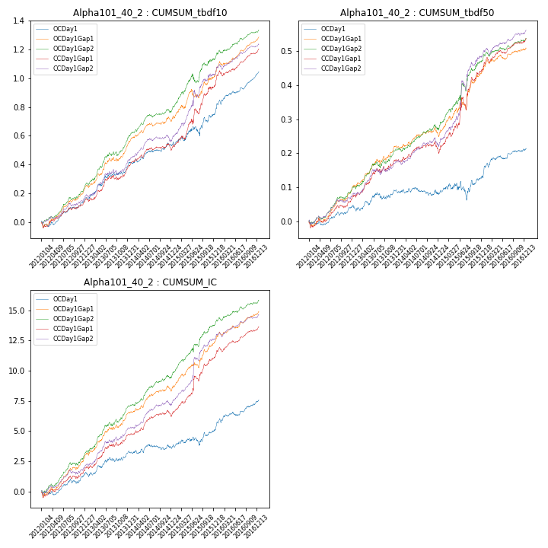

**因子换手率:** 43.95%

**截面指标_OCDay1:**

|  |  |  |  |  |  |  |  |  |
| --- | --- | --- | --- | --- | --- | --- | --- | --- |
| year | annret_tbdf10 | sharpe_tbdf10 | maxdd_tbdf10 | annret_tbdf50 | sharpe_tbdf50 | maxdd_tbdf50 | mean_IC | tstat_IC |
| 2012 | 0.16 | 3.07 | -0.04 | 0.04 | 2.01 | -0.01 | 0.01 | 2.28 |
| 2013 | 0.24 | 3.62 | -0.02 | 0.05 | 1.54 | -0.02 | 0.01 | 2.4 |
| 2014 | 0.15 | 3.05 | -0.02 | -0.01 | -0.43 | -0.02 | 0.0 | 0.63 |
| 2015 | 0.23 | 2.34 | -0.07 | 0.06 | 1.15 | -0.05 | 0.01 | 1.93 |
| 2016 | 0.29 | 5.48 | -0.03 | 0.08 | 3.09 | -0.01 | 0.01 | 4.06 |

**截面指标_CCDay1Gap1:**

|  |  |  |  |  |  |  |  |  |
| --- | --- | --- | --- | --- | --- | --- | --- | --- |
| year | annret_tbdf10 | sharpe_tbdf10 | maxdd_tbdf10 | annret_tbdf50 | sharpe_tbdf50 | maxdd_tbdf50 | mean_IC | tstat_IC |
| 2012 | 0.14 | 3.12 | -0.04 | 0.07 | 2.87 | -0.02 | 0.01 | 2.93 |
| 2013 | 0.24 | 3.64 | -0.03 | 0.11 | 3.65 | -0.01 | 0.01 | 4.14 |
| 2014 | 0.13 | 2.72 | -0.05 | 0.03 | 0.96 | -0.04 | 0.01 | 2.93 |
| 2015 | 0.45 | 4.36 | -0.04 | 0.24 | 4.06 | -0.04 | 0.02 | 4.78 |
| 2016 | 0.26 | 4.87 | -0.04 | 0.09 | 3.82 | -0.02 | 0.01 | 5.11 |

**风格暴露:**

|  |  |  |  |  |
| --- | --- | --- | --- | --- |
|  | long | short | corr_OCDay1 | corr_CCDay1Gap1 |
| momentum30 | 0.0 | 0.0 | 0.11 | -0.01 |
| logmktcap | 0.04 | -0.03 | 0.09 | 0.13 |
| liquidity10 | 0.01 | -0.0 | -0.04 | -0.11 |
| retvolatility30 | 0.03 | -0.03 | 0.08 | -0.03 |
| liquidity20 | 0.0 | 0.01 | -0.04 | -0.11 |
| momentum5 | -0.03 | 0.03 | 0.06 | 0.06 |
| momentum15 | -0.02 | 0.02 | 0.04 | 0.01 |
| liquidity5 | 0.03 | -0.02 | -0.02 | -0.08 |