Factors Report 20120104-20161230

**1. Alpha_27_1**

**截面指标累计曲线:**

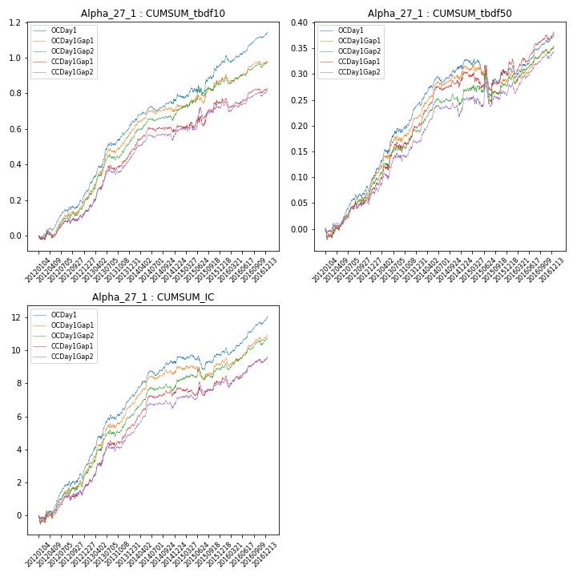

**因子换手率:** 27.74%

**截面指标_OCDay1:**

|  |  |  |  |  |  |  |  |  |
| --- | --- | --- | --- | --- | --- | --- | --- | --- |
| year | annret_tbdf10 | sharpe_tbdf10 | maxdd_tbdf10 | annret_tbdf50 | sharpe_tbdf50 | maxdd_tbdf50 | mean_IC | tstat_IC |
| 2012 | 0.23 | 4.3 | -0.02 | 0.09 | 3.36 | -0.02 | 0.01 | 3.64 |
| 2013 | 0.39 | 6.11 | -0.02 | 0.15 | 4.96 | -0.01 | 0.02 | 5.76 |
| 2014 | 0.15 | 3.07 | -0.03 | 0.07 | 3.19 | -0.01 | 0.01 | 3.8 |
| 2015 | 0.21 | 2.39 | -0.05 | -0.01 | -0.18 | -0.07 | 0.0 | 0.87 |
| 2016 | 0.18 | 3.99 | -0.04 | 0.08 | 3.37 | -0.02 | 0.01 | 4.41 |

**截面指标_CCDay1Gap1:**

|  |  |  |  |  |  |  |  |  |
| --- | --- | --- | --- | --- | --- | --- | --- | --- |
| year | annret_tbdf10 | sharpe_tbdf10 | maxdd_tbdf10 | annret_tbdf50 | sharpe_tbdf50 | maxdd_tbdf50 | mean_IC | tstat_IC |
| 2012 | 0.12 | 2.22 | -0.03 | 0.07 | 2.64 | -0.02 | 0.01 | 2.23 |
| 2013 | 0.35 | 5.38 | -0.03 | 0.13 | 4.04 | -0.02 | 0.02 | 4.95 |
| 2014 | 0.14 | 2.76 | -0.03 | 0.1 | 3.97 | -0.01 | 0.01 | 4.14 |
| 2015 | 0.16 | 1.68 | -0.05 | 0.02 | 0.32 | -0.05 | 0.0 | 0.9 |
| 2016 | 0.07 | 1.59 | -0.05 | 0.07 | 3.02 | -0.03 | 0.01 | 2.9 |

**风格暴露:**

|  |  |  |  |  |
| --- | --- | --- | --- | --- |
|  | long | short | corr_OCDay1 | corr_CCDay1Gap1 |
| momentum30 | -0.01 | 0.01 | 0.17 | 0.11 |
| logmktcap | 0.04 | -0.03 | 0.15 | 0.09 |
| liquidity10 | 0.02 | -0.03 | -0.02 | 0.02 |
| retvolatility30 | 0.04 | -0.04 | 0.01 | 0.05 |
| liquidity20 | 0.01 | -0.01 | -0.03 | 0.01 |
| momentum5 | 0.0 | 0.0 | 0.11 | 0.14 |
| momentum15 | -0.02 | 0.02 | 0.14 | 0.15 |
| liquidity5 | 0.02 | -0.02 | -0.01 | 0.01 |