Factors Report 20120104-20161230

**1. Alpha101_43_1**

**截面指标累计曲线:**

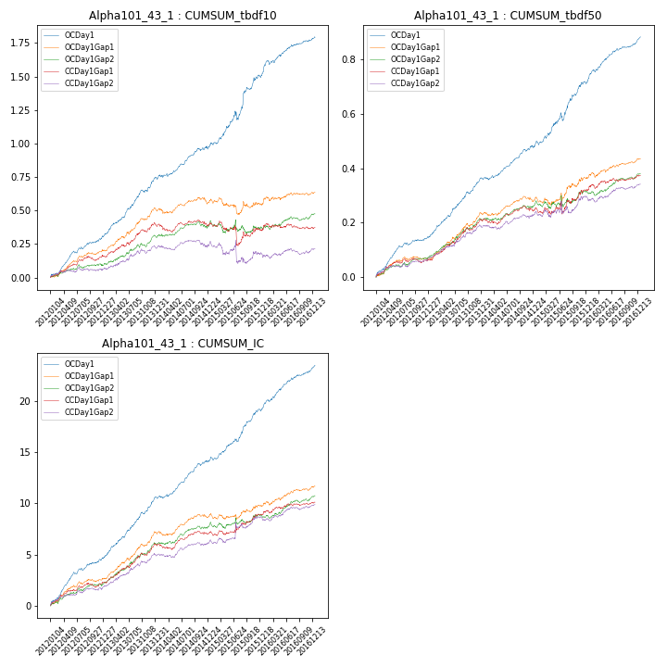

**因子换手率:** 49.45%

**截面指标_OCDay1:**

|  |  |  |  |  |  |  |  |  |
| --- | --- | --- | --- | --- | --- | --- | --- | --- |
| year | annret_tbdf10 | sharpe_tbdf10 | maxdd_tbdf10 | annret_tbdf50 | sharpe_tbdf50 | maxdd_tbdf50 | mean_IC | tstat_IC |
| 2012 | 0.31 | 5.96 | -0.01 | 0.15 | 6.2 | -0.01 | 0.02 | 6.63 |
| 2013 | 0.45 | 7.2 | -0.02 | 0.22 | 7.95 | -0.01 | 0.02 | 8.25 |
| 2014 | 0.23 | 4.08 | -0.02 | 0.12 | 4.69 | -0.01 | 0.01 | 5.58 |
| 2015 | 0.54 | 4.43 | -0.06 | 0.24 | 4.9 | -0.03 | 0.02 | 5.81 |
| 2016 | 0.29 | 4.7 | -0.03 | 0.17 | 6.53 | -0.01 | 0.02 | 6.42 |

**截面指标_CCDay1Gap1:**

|  |  |  |  |  |  |  |  |  |
| --- | --- | --- | --- | --- | --- | --- | --- | --- |
| year | annret_tbdf10 | sharpe_tbdf10 | maxdd_tbdf10 | annret_tbdf50 | sharpe_tbdf50 | maxdd_tbdf50 | mean_IC | tstat_IC |
| 2012 | 0.16 | 3.36 | -0.03 | 0.06 | 2.77 | -0.02 | 0.01 | 3.56 |
| 2013 | 0.25 | 3.87 | -0.02 | 0.15 | 4.93 | -0.01 | 0.02 | 5.14 |
| 2014 | -0.01 | -0.16 | -0.06 | 0.04 | 1.36 | -0.02 | 0.0 | 1.69 |
| 2015 | -0.04 | -0.35 | -0.17 | 0.07 | 1.27 | -0.05 | 0.01 | 1.64 |
| 2016 | 0.02 | 0.38 | -0.04 | 0.06 | 2.02 | -0.02 | 0.01 | 1.98 |

**风格暴露:**

|  |  |  |  |  |
| --- | --- | --- | --- | --- |
|  | long | short | corr_OCDay1 | corr_CCDay1Gap1 |
| momentum30 | 0.03 | -0.03 | 0.19 | 0.11 |
| logmktcap | 0.01 | -0.0 | -0.07 | -0.17 |
| liquidity10 | 0.05 | -0.05 | 0.29 | 0.32 |
| retvolatility30 | 0.01 | -0.01 | 0.29 | 0.38 |
| liquidity20 | 0.04 | -0.04 | 0.26 | 0.33 |
| momentum5 | -0.01 | 0.02 | 0.21 | 0.22 |
| momentum15 | 0.03 | -0.03 | 0.24 | 0.16 |
| liquidity5 | 0.03 | -0.03 | 0.31 | 0.35 |