Factors Report 20120104-20161230

**1. Alpha101_45_1**

**截面指标累计曲线:**

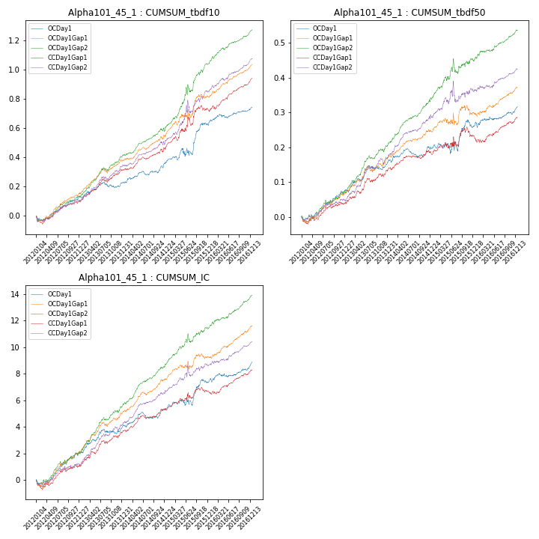

**因子换手率:** 48.49%

**截面指标_OCDay1:**

|  |  |  |  |  |  |  |  |  |
| --- | --- | --- | --- | --- | --- | --- | --- | --- |
| year | annret_tbdf10 | sharpe_tbdf10 | maxdd_tbdf10 | annret_tbdf50 | sharpe_tbdf50 | maxdd_tbdf50 | mean_IC | tstat_IC |
| 2012 | 0.13 | 3.49 | -0.04 | 0.08 | 3.42 | -0.02 | 0.01 | 3.75 |
| 2013 | 0.09 | 2.03 | -0.04 | 0.08 | 2.77 | -0.01 | 0.01 | 2.88 |
| 2014 | 0.14 | 3.04 | -0.03 | 0.05 | 2.18 | -0.02 | 0.01 | 3.02 |
| 2015 | 0.26 | 2.76 | -0.05 | 0.06 | 1.27 | -0.03 | 0.01 | 2.56 |
| 2016 | 0.12 | 2.81 | -0.03 | 0.06 | 2.4 | -0.02 | 0.01 | 2.87 |

**截面指标_CCDay1Gap1:**

|  |  |  |  |  |  |  |  |  |
| --- | --- | --- | --- | --- | --- | --- | --- | --- |
| year | annret_tbdf10 | sharpe_tbdf10 | maxdd_tbdf10 | annret_tbdf50 | sharpe_tbdf50 | maxdd_tbdf50 | mean_IC | tstat_IC |
| 2012 | 0.1 | 2.24 | -0.06 | 0.04 | 1.62 | -0.02 | 0.0 | 1.77 |
| 2013 | 0.22 | 4.68 | -0.03 | 0.1 | 3.56 | -0.01 | 0.01 | 4.4 |
| 2014 | 0.15 | 3.14 | -0.02 | 0.05 | 2.45 | -0.01 | 0.01 | 3.63 |
| 2015 | 0.26 | 2.49 | -0.06 | 0.05 | 0.94 | -0.03 | 0.01 | 1.8 |
| 2016 | 0.22 | 5.01 | -0.02 | 0.05 | 2.17 | -0.02 | 0.01 | 3.28 |

**风格暴露:**

|  |  |  |  |  |
| --- | --- | --- | --- | --- |
|  | long | short | corr_OCDay1 | corr_CCDay1Gap1 |
| momentum30 | 0.0 | 0.0 | 0.17 | 0.08 |
| logmktcap | -0.02 | 0.02 | 0.21 | 0.25 |
| liquidity10 | 0.05 | -0.05 | -0.07 | -0.12 |
| retvolatility30 | 0.11 | -0.1 | -0.06 | -0.14 |
| liquidity20 | 0.05 | -0.05 | -0.08 | -0.13 |
| momentum5 | -0.06 | 0.06 | 0.07 | 0.02 |
| momentum15 | -0.01 | 0.01 | 0.14 | 0.13 |
| liquidity5 | 0.05 | -0.05 | -0.05 | -0.08 |