Factors Report 20120104-20161230

**1. Alpha101_48_2**

**截面指标累计曲线:**

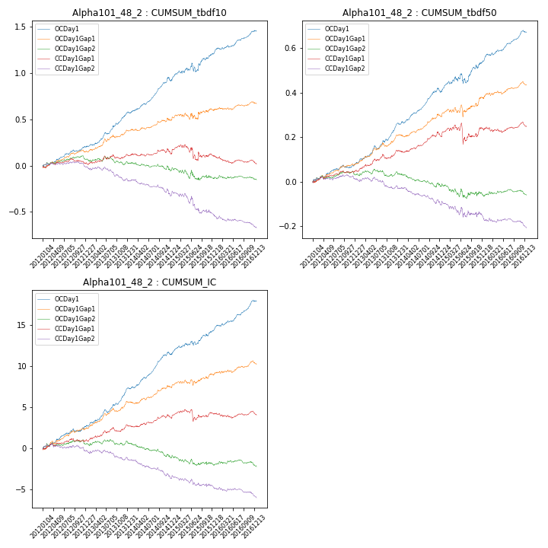

**因子换手率:** 57.02%

**截面指标_OCDay1:**

|  |  |  |  |  |  |  |  |  |
| --- | --- | --- | --- | --- | --- | --- | --- | --- |
| year | annret_tbdf10 | sharpe_tbdf10 | maxdd_tbdf10 | annret_tbdf50 | sharpe_tbdf50 | maxdd_tbdf50 | mean_IC | tstat_IC |
| 2012 | 0.21 | 3.84 | -0.02 | 0.08 | 3.12 | -0.01 | 0.01 | 3.41 |
| 2013 | 0.38 | 5.61 | -0.02 | 0.18 | 6.11 | -0.02 | 0.02 | 6.12 |
| 2014 | 0.34 | 5.25 | -0.04 | 0.14 | 5.02 | -0.02 | 0.02 | 5.76 |
| 2015 | 0.3 | 2.72 | -0.09 | 0.14 | 2.62 | -0.04 | 0.01 | 3.27 |
| 2016 | 0.25 | 4.45 | -0.02 | 0.13 | 5.07 | -0.01 | 0.01 | 5.46 |

**截面指标_CCDay1Gap1:**

|  |  |  |  |  |  |  |  |  |
| --- | --- | --- | --- | --- | --- | --- | --- | --- |
| year | annret_tbdf10 | sharpe_tbdf10 | maxdd_tbdf10 | annret_tbdf50 | sharpe_tbdf50 | maxdd_tbdf50 | mean_IC | tstat_IC |
| 2012 | 0.03 | 0.48 | -0.05 | 0.05 | 1.93 | -0.01 | 0.0 | 1.28 |
| 2013 | 0.09 | 1.35 | -0.05 | 0.09 | 3.1 | -0.02 | 0.01 | 2.57 |
| 2014 | 0.01 | 0.19 | -0.06 | 0.07 | 2.36 | -0.02 | 0.0 | 1.43 |
| 2015 | -0.02 | -0.13 | -0.16 | 0.03 | 0.49 | -0.09 | 0.0 | 0.5 |
| 2016 | -0.09 | -1.74 | -0.09 | 0.01 | 0.45 | -0.02 | -0.0 | -0.32 |

**风格暴露:**

|  |  |  |  |  |
| --- | --- | --- | --- | --- |
|  | long | short | corr_OCDay1 | corr_CCDay1Gap1 |
| momentum30 | 0.04 | -0.03 | -0.07 | -0.09 |
| logmktcap | 0.01 | -0.01 | 0.02 | 0.01 |
| liquidity10 | 0.1 | -0.09 | -0.07 | -0.1 |
| retvolatility30 | 0.07 | -0.06 | -0.06 | -0.03 |
| liquidity20 | 0.06 | -0.06 | -0.07 | -0.09 |
| momentum5 | 0.07 | -0.07 | 0.03 | 0.07 |
| momentum15 | 0.05 | -0.05 | -0.05 | -0.09 |
| liquidity5 | 0.12 | -0.11 | -0.04 | -0.02 |