Factors Report 20120104-20161230

**1. Alpha101_50_3**

**截面指标累计曲线:**

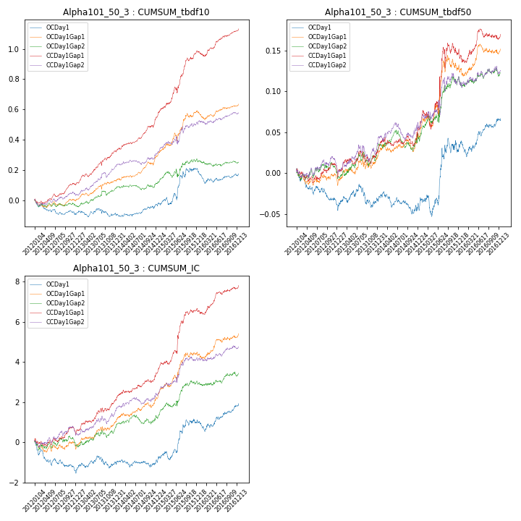

**因子换手率:** 49.54%

**截面指标_OCDay1:**

|  |  |  |  |  |  |  |  |  |
| --- | --- | --- | --- | --- | --- | --- | --- | --- |
| year | annret_tbdf10 | sharpe_tbdf10 | maxdd_tbdf10 | annret_tbdf50 | sharpe_tbdf50 | maxdd_tbdf50 | mean_IC | tstat_IC |
| 2012 | -0.09 | -2.22 | -0.1 | -0.04 | -2.16 | -0.04 | -0.01 | -2.78 |
| 2013 | 0.01 | 0.1 | -0.05 | 0.01 | 0.32 | -0.03 | 0.0 | 0.77 |
| 2014 | 0.06 | 1.4 | -0.02 | -0.01 | -0.32 | -0.03 | 0.0 | 0.23 |
| 2015 | 0.24 | 2.48 | -0.05 | 0.07 | 1.69 | -0.03 | 0.01 | 2.61 |
| 2016 | -0.03 | -0.63 | -0.09 | 0.03 | 1.84 | -0.02 | 0.0 | 1.81 |

**截面指标_CCDay1Gap1:**

|  |  |  |  |  |  |  |  |  |
| --- | --- | --- | --- | --- | --- | --- | --- | --- |
| year | annret_tbdf10 | sharpe_tbdf10 | maxdd_tbdf10 | annret_tbdf50 | sharpe_tbdf50 | maxdd_tbdf50 | mean_IC | tstat_IC |
| 2012 | 0.11 | 2.71 | -0.03 | 0.0 | 0.04 | -0.02 | 0.0 | 1.04 |
| 2013 | 0.23 | 4.41 | -0.03 | 0.03 | 1.13 | -0.02 | 0.01 | 3.06 |
| 2014 | 0.22 | 4.93 | -0.01 | 0.03 | 1.41 | -0.01 | 0.01 | 3.06 |
| 2015 | 0.43 | 5.34 | -0.04 | 0.09 | 1.68 | -0.03 | 0.01 | 3.95 |
| 2016 | 0.15 | 3.23 | -0.03 | 0.03 | 1.29 | -0.01 | 0.01 | 2.78 |

**风格暴露:**

|  |  |  |  |  |
| --- | --- | --- | --- | --- |
|  | long | short | corr_OCDay1 | corr_CCDay1Gap1 |
| momentum30 | -0.03 | 0.03 | 0.12 | 0.03 |
| logmktcap | -0.0 | 0.01 | -0.18 | -0.21 |
| liquidity10 | -0.01 | 0.02 | 0.23 | 0.23 |
| retvolatility30 | -0.03 | 0.03 | 0.26 | 0.26 |
| liquidity20 | -0.02 | 0.02 | 0.21 | 0.22 |
| momentum5 | -0.22 | 0.22 | 0.12 | 0.09 |
| momentum15 | -0.05 | 0.05 | 0.14 | 0.06 |
| liquidity5 | -0.05 | 0.05 | 0.24 | 0.19 |