Factors Report 20120104-20161230

**1. Alpha101_53_2**

**截面指标累计曲线:**

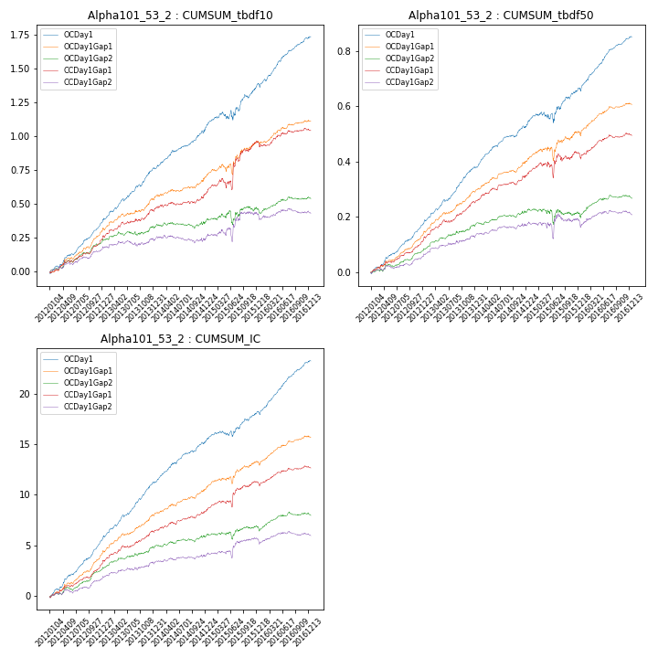

**因子换手率:** 47.36%

**截面指标_OCDay1:**

|  |  |  |  |  |  |  |  |  |
| --- | --- | --- | --- | --- | --- | --- | --- | --- |
| year | annret_tbdf10 | sharpe_tbdf10 | maxdd_tbdf10 | annret_tbdf50 | sharpe_tbdf50 | maxdd_tbdf50 | mean_IC | tstat_IC |
| 2012 | 0.36 | 7.87 | -0.02 | 0.17 | 8.04 | -0.01 | 0.02 | 8.75 |
| 2013 | 0.41 | 7.26 | -0.02 | 0.21 | 8.49 | -0.01 | 0.02 | 8.94 |
| 2014 | 0.3 | 5.64 | -0.02 | 0.15 | 6.6 | -0.01 | 0.02 | 6.64 |
| 2015 | 0.32 | 3.17 | -0.07 | 0.13 | 2.69 | -0.04 | 0.01 | 3.43 |
| 2016 | 0.35 | 6.44 | -0.03 | 0.19 | 7.67 | -0.01 | 0.02 | 8.33 |

**截面指标_CCDay1Gap1:**

|  |  |  |  |  |  |  |  |  |
| --- | --- | --- | --- | --- | --- | --- | --- | --- |
| year | annret_tbdf10 | sharpe_tbdf10 | maxdd_tbdf10 | annret_tbdf50 | sharpe_tbdf50 | maxdd_tbdf50 | mean_IC | tstat_IC |
| 2012 | 0.23 | 4.64 | -0.02 | 0.11 | 5.0 | -0.01 | 0.01 | 5.17 |
| 2013 | 0.23 | 3.69 | -0.02 | 0.15 | 5.29 | -0.01 | 0.01 | 4.84 |
| 2014 | 0.12 | 2.19 | -0.02 | 0.09 | 3.79 | -0.01 | 0.01 | 3.32 |
| 2015 | 0.39 | 2.9 | -0.08 | 0.08 | 1.41 | -0.06 | 0.01 | 2.85 |
| 2016 | 0.08 | 1.53 | -0.04 | 0.06 | 2.45 | -0.02 | 0.01 | 2.62 |

**风格暴露:**

|  |  |  |  |  |
| --- | --- | --- | --- | --- |
|  | long | short | corr_OCDay1 | corr_CCDay1Gap1 |
| momentum30 | -0.02 | 0.03 | 0.08 | 0.11 |
| logmktcap | 0.01 | -0.0 | -0.14 | -0.17 |
| liquidity10 | -0.08 | 0.08 | 0.15 | 0.21 |
| retvolatility30 | -0.07 | 0.07 | 0.17 | 0.16 |
| liquidity20 | -0.05 | 0.06 | 0.13 | 0.17 |
| momentum5 | -0.01 | 0.01 | 0.06 | -0.01 |
| momentum15 | -0.02 | 0.02 | 0.12 | 0.14 |
| liquidity5 | -0.08 | 0.09 | 0.16 | 0.19 |