Factors Report 20120104-20161230

**1. Alpha101_57_2**

**截面指标累计曲线:**

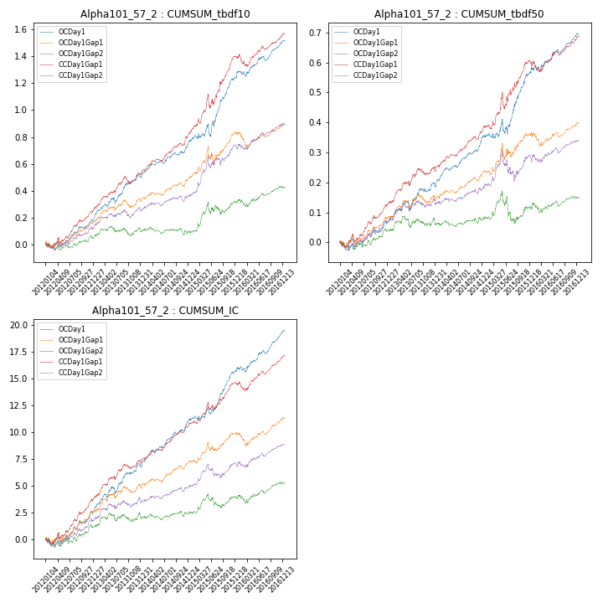

**因子换手率:** 49.74%

**截面指标_OCDay1:**

|  |  |  |  |  |  |  |  |  |
| --- | --- | --- | --- | --- | --- | --- | --- | --- |
| year | annret_tbdf10 | sharpe_tbdf10 | maxdd_tbdf10 | annret_tbdf50 | sharpe_tbdf50 | maxdd_tbdf50 | mean_IC | tstat_IC |
| 2012 | 0.19 | 2.66 | -0.05 | 0.07 | 1.72 | -0.03 | 0.01 | 2.32 |
| 2013 | 0.32 | 4.39 | -0.04 | 0.13 | 2.96 | -0.03 | 0.02 | 4.14 |
| 2014 | 0.26 | 4.6 | -0.02 | 0.16 | 5.21 | -0.01 | 0.02 | 5.46 |
| 2015 | 0.49 | 4.28 | -0.09 | 0.21 | 3.29 | -0.05 | 0.02 | 4.45 |
| 2016 | 0.27 | 3.88 | -0.04 | 0.13 | 3.51 | -0.02 | 0.02 | 4.24 |

**截面指标_CCDay1Gap1:**

|  |  |  |  |  |  |  |  |  |
| --- | --- | --- | --- | --- | --- | --- | --- | --- |
| year | annret_tbdf10 | sharpe_tbdf10 | maxdd_tbdf10 | annret_tbdf50 | sharpe_tbdf50 | maxdd_tbdf50 | mean_IC | tstat_IC |
| 2012 | 0.26 | 3.77 | -0.05 | 0.13 | 3.31 | -0.03 | 0.02 | 3.71 |
| 2013 | 0.27 | 3.77 | -0.05 | 0.12 | 2.85 | -0.02 | 0.01 | 3.59 |
| 2014 | 0.3 | 5.32 | -0.02 | 0.14 | 4.83 | -0.01 | 0.01 | 5.38 |
| 2015 | 0.57 | 4.42 | -0.1 | 0.22 | 3.03 | -0.05 | 0.02 | 3.76 |
| 2016 | 0.17 | 2.35 | -0.09 | 0.09 | 2.54 | -0.04 | 0.01 | 3.27 |

**风格暴露:**

|  |  |  |  |  |
| --- | --- | --- | --- | --- |
|  | long | short | corr_OCDay1 | corr_CCDay1Gap1 |
| momentum30 | 0.01 | -0.0 | 0.08 | 0.08 |
| logmktcap | -0.02 | 0.02 | -0.14 | 0.04 |
| liquidity10 | 0.01 | -0.01 | 0.13 | 0.05 |
| retvolatility30 | -0.05 | 0.05 | 0.15 | 0.04 |
| liquidity20 | -0.02 | 0.02 | 0.14 | 0.06 |
| momentum5 | 0.13 | -0.12 | 0.01 | -0.0 |
| momentum15 | 0.02 | -0.02 | 0.07 | 0.14 |
| liquidity5 | 0.05 | -0.05 | 0.13 | 0.06 |