Factors Report 20120104-20161230

**1. Alpha101_56_1**

**截面指标累计曲线:**

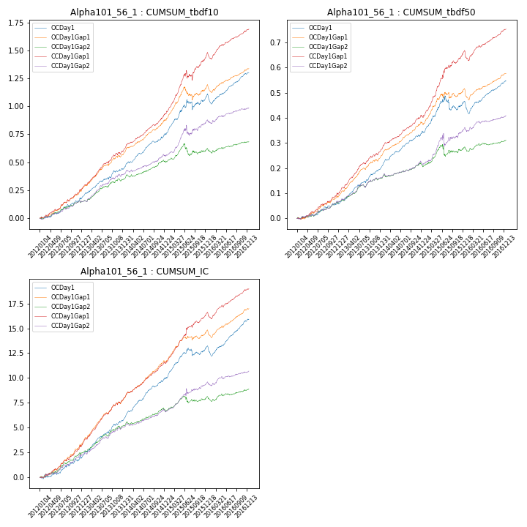

**因子换手率:** 42.09%

**截面指标_OCDay1:**

|  |  |  |  |  |  |  |  |  |
| --- | --- | --- | --- | --- | --- | --- | --- | --- |
| year | annret_tbdf10 | sharpe_tbdf10 | maxdd_tbdf10 | annret_tbdf50 | sharpe_tbdf50 | maxdd_tbdf50 | mean_IC | tstat_IC |
| 2012 | 0.18 | 3.99 | -0.02 | 0.06 | 2.96 | -0.01 | 0.01 | 3.25 |
| 2013 | 0.27 | 5.82 | -0.02 | 0.14 | 6.17 | -0.01 | 0.02 | 6.72 |
| 2014 | 0.3 | 6.95 | -0.01 | 0.15 | 7.27 | -0.01 | 0.02 | 8.47 |
| 2015 | 0.35 | 3.35 | -0.09 | 0.12 | 2.47 | -0.06 | 0.01 | 3.94 |
| 2016 | 0.2 | 4.29 | -0.09 | 0.08 | 3.21 | -0.05 | 0.01 | 4.86 |

**截面指标_CCDay1Gap1:**

|  |  |  |  |  |  |  |  |  |
| --- | --- | --- | --- | --- | --- | --- | --- | --- |
| year | annret_tbdf10 | sharpe_tbdf10 | maxdd_tbdf10 | annret_tbdf50 | sharpe_tbdf50 | maxdd_tbdf50 | mean_IC | tstat_IC |
| 2012 | 0.26 | 6.04 | -0.01 | 0.1 | 4.88 | -0.01 | 0.01 | 5.73 |
| 2013 | 0.35 | 6.92 | -0.02 | 0.17 | 7.28 | -0.01 | 0.02 | 8.31 |
| 2014 | 0.34 | 8.09 | -0.01 | 0.14 | 7.19 | -0.0 | 0.02 | 8.59 |
| 2015 | 0.53 | 4.96 | -0.09 | 0.26 | 6.47 | -0.01 | 0.02 | 6.49 |
| 2016 | 0.22 | 4.88 | -0.06 | 0.09 | 3.53 | -0.04 | 0.01 | 4.8 |

**风格暴露:**

|  |  |  |  |  |
| --- | --- | --- | --- | --- |
|  | long | short | corr_OCDay1 | corr_CCDay1Gap1 |
| momentum30 | 0.02 | -0.02 | -0.09 | -0.01 |
| logmktcap | 0.01 | -0.01 | 0.06 | -0.08 |
| liquidity10 | 0.02 | -0.02 | -0.06 | 0.02 |
| retvolatility30 | 0.02 | -0.02 | -0.08 | 0.03 |
| liquidity20 | 0.02 | -0.01 | -0.07 | -0.0 |
| momentum5 | 0.02 | -0.02 | -0.16 | 0.01 |
| momentum15 | 0.02 | -0.02 | -0.01 | 0.06 |
| liquidity5 | 0.03 | -0.02 | -0.06 | 0.03 |