Factors Report 20120104-20161230

**1. Alpha101_58_2**

**截面指标累计曲线:**

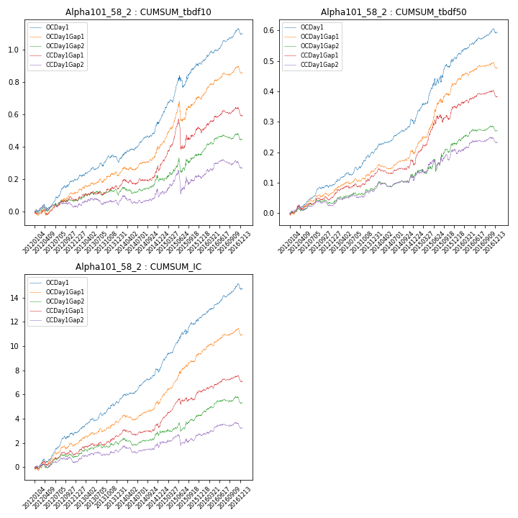

**因子换手率:** 42.88%

**截面指标_OCDay1:**

|  |  |  |  |  |  |  |  |  |
| --- | --- | --- | --- | --- | --- | --- | --- | --- |
| year | annret_tbdf10 | sharpe_tbdf10 | maxdd_tbdf10 | annret_tbdf50 | sharpe_tbdf50 | maxdd_tbdf50 | mean_IC | tstat_IC |
| 2012 | 0.2 | 4.29 | -0.03 | 0.09 | 4.61 | -0.01 | 0.01 | 4.69 |
| 2013 | 0.14 | 3.18 | -0.02 | 0.11 | 4.72 | -0.01 | 0.01 | 4.52 |
| 2014 | 0.21 | 3.94 | -0.03 | 0.09 | 4.03 | -0.02 | 0.01 | 4.33 |
| 2015 | 0.37 | 4.26 | -0.07 | 0.22 | 4.21 | -0.02 | 0.02 | 5.33 |
| 2016 | 0.18 | 4.08 | -0.04 | 0.08 | 3.79 | -0.02 | 0.01 | 4.29 |

**截面指标_CCDay1Gap1:**

|  |  |  |  |  |  |  |  |  |
| --- | --- | --- | --- | --- | --- | --- | --- | --- |
| year | annret_tbdf10 | sharpe_tbdf10 | maxdd_tbdf10 | annret_tbdf50 | sharpe_tbdf50 | maxdd_tbdf50 | mean_IC | tstat_IC |
| 2012 | 0.08 | 1.81 | -0.03 | 0.05 | 2.4 | -0.01 | 0.0 | 2.05 |
| 2013 | 0.08 | 1.58 | -0.02 | 0.08 | 3.14 | -0.01 | 0.01 | 2.61 |
| 2014 | 0.1 | 1.8 | -0.03 | 0.04 | 1.62 | -0.02 | 0.0 | 1.41 |
| 2015 | 0.25 | 2.23 | -0.17 | 0.19 | 4.14 | -0.03 | 0.01 | 3.98 |
| 2016 | 0.09 | 1.75 | -0.05 | 0.04 | 1.45 | -0.02 | 0.0 | 1.63 |

**风格暴露:**

|  |  |  |  |  |
| --- | --- | --- | --- | --- |
|  | long | short | corr_OCDay1 | corr_CCDay1Gap1 |
| momentum30 | 0.01 | -0.01 | -0.02 | -0.02 |
| logmktcap | 0.05 | -0.04 | 0.09 | -0.04 |
| liquidity10 | 0.02 | -0.01 | -0.07 | 0.01 |
| retvolatility30 | 0.02 | -0.02 | -0.03 | 0.03 |
| liquidity20 | 0.03 | -0.02 | -0.12 | -0.03 |
| momentum5 | -0.06 | 0.06 | 0.12 | 0.22 |
| momentum15 | -0.02 | 0.03 | 0.07 | 0.13 |
| liquidity5 | 0.0 | 0.0 | -0.03 | 0.06 |