Factors Report 20120104-20161230

**1. Alpha_volume_price_2**

**截面指标累计曲线:**

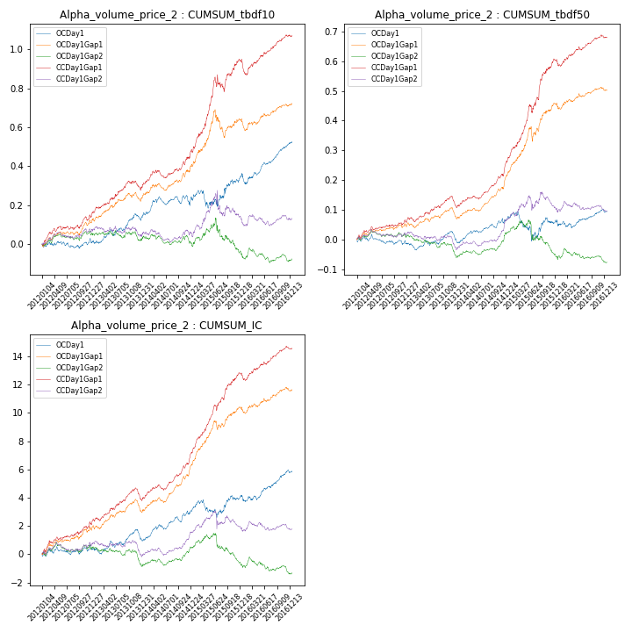

**因子换手率:** 49.92%

**截面指标_OCDay1:**

|  |  |  |  |  |  |  |  |  |
| --- | --- | --- | --- | --- | --- | --- | --- | --- |
| year | annret_tbdf10 | sharpe_tbdf10 | maxdd_tbdf10 | annret_tbdf50 | sharpe_tbdf50 | maxdd_tbdf50 | mean_IC | tstat_IC |
| 2012 | 0.01 | 0.28 | -0.04 | -0.01 | -0.43 | -0.03 | 0.0 | 0.58 |
| 2013 | 0.12 | 2.32 | -0.03 | 0.02 | 0.58 | -0.03 | 0.0 | 1.16 |
| 2014 | 0.11 | 1.77 | -0.05 | 0.06 | 2.26 | -0.02 | 0.01 | 3.01 |
| 2015 | 0.11 | 1.02 | -0.09 | -0.0 | -0.07 | -0.1 | 0.0 | 1.04 |
| 2016 | 0.17 | 3.38 | -0.05 | 0.04 | 1.2 | -0.03 | 0.01 | 2.7 |

**截面指标_CCDay1Gap1:**

|  |  |  |  |  |  |  |  |  |
| --- | --- | --- | --- | --- | --- | --- | --- | --- |
| year | annret_tbdf10 | sharpe_tbdf10 | maxdd_tbdf10 | annret_tbdf50 | sharpe_tbdf50 | maxdd_tbdf50 | mean_IC | tstat_IC |
| 2012 | 0.16 | 3.1 | -0.02 | 0.06 | 2.51 | -0.01 | 0.01 | 3.33 |
| 2013 | 0.14 | 2.58 | -0.05 | 0.05 | 1.87 | -0.03 | 0.01 | 2.69 |
| 2014 | 0.19 | 3.47 | -0.04 | 0.15 | 5.59 | -0.01 | 0.01 | 5.81 |
| 2015 | 0.47 | 4.5 | -0.09 | 0.34 | 5.75 | -0.03 | 0.02 | 6.42 |
| 2016 | 0.12 | 2.28 | -0.08 | 0.07 | 2.58 | -0.02 | 0.01 | 3.02 |

**风格暴露:**

|  |  |  |  |  |
| --- | --- | --- | --- | --- |
|  | long | short | corr_OCDay1 | corr_CCDay1Gap1 |
| momentum30 | 0.01 | -0.01 | -0.0 | -0.14 |
| logmktcap | 0.01 | -0.01 | -0.3 | -0.06 |
| liquidity10 | -0.03 | 0.04 | 0.23 | 0.07 |
| retvolatility30 | 0.01 | -0.0 | 0.28 | 0.06 |
| liquidity20 | -0.02 | 0.03 | 0.23 | 0.05 |
| momentum5 | 0.06 | -0.05 | -0.12 | -0.19 |
| momentum15 | 0.01 | -0.0 | 0.02 | -0.07 |
| liquidity5 | -0.03 | 0.04 | 0.23 | 0.07 |