Factors Report 20120104-20161230

**1. yanYD_190808_Alpha_test_5**

**截面指标累计曲线:**

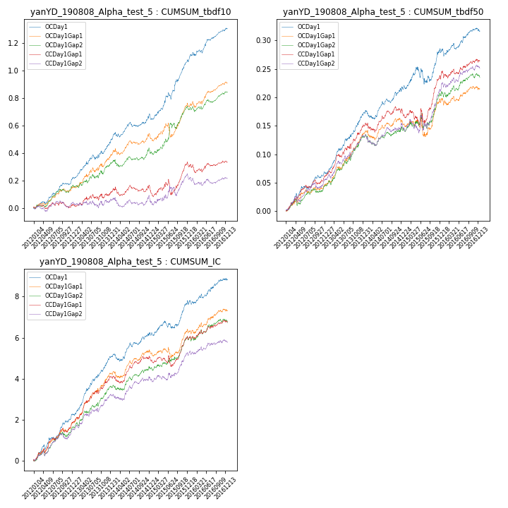

**因子换手率:** 35.42%

**截面指标_OCDay1:**

|  |  |  |  |  |  |  |  |  |
| --- | --- | --- | --- | --- | --- | --- | --- | --- |
| year | annret_tbdf10 | sharpe_tbdf10 | maxdd_tbdf10 | annret_tbdf50 | sharpe_tbdf50 | maxdd_tbdf50 | mean_IC | tstat_IC |
| 2012 | 0.22 | 4.71 | -0.02 | 0.07 | 4.45 | -0.01 | 0.01 | 5.3 |
| 2013 | 0.28 | 4.02 | -0.04 | 0.1 | 5.69 | -0.0 | 0.01 | 6.0 |
| 2014 | 0.2 | 3.38 | -0.03 | 0.05 | 2.5 | -0.02 | 0.0 | 2.52 |
| 2015 | 0.38 | 4.3 | -0.05 | 0.06 | 1.95 | -0.03 | 0.01 | 2.88 |
| 2016 | 0.24 | 4.16 | -0.02 | 0.04 | 2.07 | -0.01 | 0.0 | 2.73 |

**截面指标_CCDay1Gap1:**

|  |  |  |  |  |  |  |  |  |
| --- | --- | --- | --- | --- | --- | --- | --- | --- |
| year | annret_tbdf10 | sharpe_tbdf10 | maxdd_tbdf10 | annret_tbdf50 | sharpe_tbdf50 | maxdd_tbdf50 | mean_IC | tstat_IC |
| 2012 | 0.03 | 0.58 | -0.04 | 0.06 | 3.99 | -0.01 | 0.01 | 4.68 |
| 2013 | 0.09 | 1.24 | -0.04 | 0.09 | 4.51 | -0.01 | 0.01 | 4.81 |
| 2014 | 0.05 | 0.8 | -0.06 | 0.03 | 1.65 | -0.02 | 0.0 | 2.37 |
| 2015 | 0.15 | 1.58 | -0.11 | 0.06 | 1.48 | -0.03 | 0.0 | 1.57 |
| 2016 | 0.03 | 0.54 | -0.06 | 0.03 | 1.5 | -0.01 | 0.0 | 2.19 |

**风格暴露:**

|  |  |  |  |  |
| --- | --- | --- | --- | --- |
|  | long | short | corr_OCDay1 | corr_CCDay1Gap1 |
| momentum30 | 0.03 | -0.02 | 0.08 | 0.08 |
| logmktcap | -0.02 | 0.03 | 0.12 | 0.16 |
| liquidity10 | 0.04 | -0.04 | -0.02 | -0.05 |
| retvolatility30 | 0.03 | -0.03 | -0.03 | -0.01 |
| liquidity20 | 0.04 | -0.04 | -0.0 | -0.03 |
| momentum5 | -0.0 | 0.01 | -0.03 | -0.03 |
| momentum15 | 0.03 | -0.02 | -0.01 | 0.02 |
| liquidity5 | 0.04 | -0.03 | -0.03 | -0.02 |