Factors Report 20120104-20161230

**1. yanYD_190809_Alpha101_62_2**

**截面指标累计曲线:**

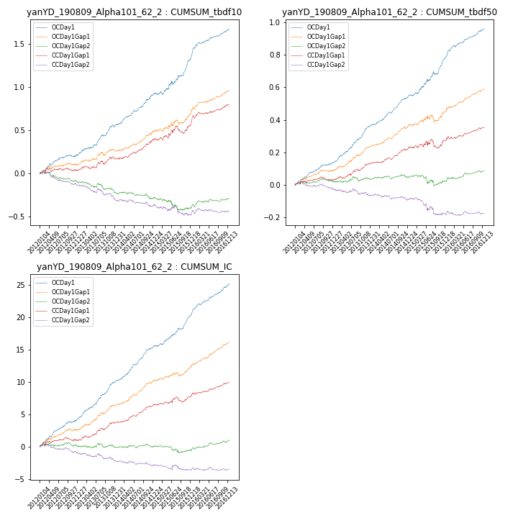

**因子换手率:** 49.59%

**截面指标_OCDay1:**

|  |  |  |  |  |  |  |  |  |
| --- | --- | --- | --- | --- | --- | --- | --- | --- |
| year | annret_tbdf10 | sharpe_tbdf10 | maxdd_tbdf10 | annret_tbdf50 | sharpe_tbdf50 | maxdd_tbdf50 | mean_IC | tstat_IC |
| 2012 | 0.22 | 3.83 | -0.03 | 0.14 | 5.71 | -0.01 | 0.02 | 5.85 |
| 2013 | 0.34 | 5.58 | -0.03 | 0.23 | 7.97 | -0.01 | 0.02 | 7.86 |
| 2014 | 0.36 | 6.63 | -0.02 | 0.18 | 7.61 | -0.01 | 0.02 | 8.7 |
| 2015 | 0.43 | 4.7 | -0.04 | 0.24 | 5.53 | -0.02 | 0.02 | 6.48 |
| 2016 | 0.34 | 6.22 | -0.02 | 0.18 | 6.85 | -0.01 | 0.02 | 7.86 |

**截面指标_CCDay1Gap1:**

|  |  |  |  |  |  |  |  |  |
| --- | --- | --- | --- | --- | --- | --- | --- | --- |
| year | annret_tbdf10 | sharpe_tbdf10 | maxdd_tbdf10 | annret_tbdf50 | sharpe_tbdf50 | maxdd_tbdf50 | mean_IC | tstat_IC |
| 2012 | 0.04 | 0.64 | -0.04 | 0.03 | 1.26 | -0.02 | 0.0 | 1.41 |
| 2013 | 0.14 | 2.16 | -0.04 | 0.1 | 3.25 | -0.01 | 0.01 | 3.68 |
| 2014 | 0.22 | 3.98 | -0.02 | 0.1 | 3.94 | -0.01 | 0.01 | 4.81 |
| 2015 | 0.19 | 1.94 | -0.09 | 0.05 | 0.92 | -0.06 | 0.01 | 1.53 |
| 2016 | 0.21 | 3.57 | -0.03 | 0.08 | 2.83 | -0.01 | 0.01 | 3.59 |

**风格暴露:**

|  |  |  |  |  |
| --- | --- | --- | --- | --- |
|  | long | short | corr_OCDay1 | corr_CCDay1Gap1 |
| momentum30 | -0.12 | 0.12 | 0.15 | 0.14 |
| logmktcap | 0.28 | -0.27 | -0.2 | -0.2 |
| liquidity10 | -0.27 | 0.26 | 0.25 | 0.24 |
| retvolatility30 | -0.22 | 0.22 | 0.2 | 0.16 |
| liquidity20 | -0.25 | 0.24 | 0.25 | 0.25 |
| momentum5 | -0.03 | 0.04 | 0.1 | 0.09 |
| momentum15 | -0.16 | 0.16 | 0.1 | 0.03 |
| liquidity5 | -0.26 | 0.25 | 0.25 | 0.2 |