Factors Report 20120104-20161230

**1. yanYD_190807_Alpha_test_4**

**截面指标累计曲线:**

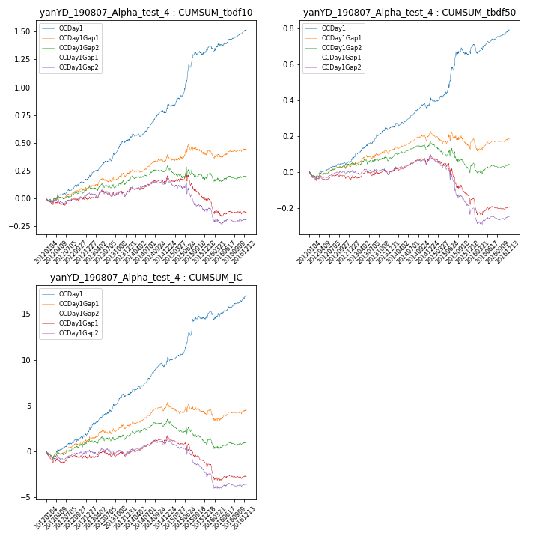

**因子换手率:** 46.88%

**截面指标_OCDay1:**

|  |  |  |  |  |  |  |  |  |
| --- | --- | --- | --- | --- | --- | --- | --- | --- |
| year | annret_tbdf10 | sharpe_tbdf10 | maxdd_tbdf10 | annret_tbdf50 | sharpe_tbdf50 | maxdd_tbdf50 | mean_IC | tstat_IC |
| 2012 | 0.17 | 2.69 | -0.03 | 0.05 | 1.83 | -0.03 | 0.01 | 2.26 |
| 2013 | 0.35 | 4.8 | -0.02 | 0.19 | 4.35 | -0.02 | 0.02 | 4.67 |
| 2014 | 0.27 | 4.06 | -0.03 | 0.14 | 3.84 | -0.03 | 0.01 | 4.57 |
| 2015 | 0.55 | 4.53 | -0.03 | 0.28 | 3.41 | -0.04 | 0.02 | 3.67 |
| 2016 | 0.2 | 2.75 | -0.06 | 0.13 | 2.67 | -0.05 | 0.01 | 2.66 |

**截面指标_CCDay1Gap1:**

|  |  |  |  |  |  |  |  |  |
| --- | --- | --- | --- | --- | --- | --- | --- | --- |
| year | annret_tbdf10 | sharpe_tbdf10 | maxdd_tbdf10 | annret_tbdf50 | sharpe_tbdf50 | maxdd_tbdf50 | mean_IC | tstat_IC |
| 2012 | -0.0 | -0.06 | -0.06 | -0.03 | -1.14 | -0.05 | -0.0 | -0.9 |
| 2013 | 0.04 | 0.49 | -0.05 | 0.02 | 0.48 | -0.03 | 0.0 | 0.21 |
| 2014 | 0.12 | 2.04 | -0.03 | 0.09 | 2.37 | -0.03 | 0.01 | 2.53 |
| 2015 | -0.16 | -1.4 | -0.22 | -0.21 | -3.02 | -0.21 | -0.01 | -2.32 |
| 2016 | -0.12 | -1.61 | -0.15 | -0.05 | -1.09 | -0.09 | -0.01 | -1.58 |

**风格暴露:**

|  |  |  |  |  |
| --- | --- | --- | --- | --- |
|  | long | short | corr_OCDay1 | corr_CCDay1Gap1 |
| momentum30 | 0.26 | -0.25 | 0.01 | -0.06 |
| logmktcap | 0.01 | -0.0 | -0.15 | -0.16 |
| liquidity10 | -0.03 | 0.04 | 0.16 | 0.17 |
| retvolatility30 | 0.05 | -0.04 | 0.16 | 0.15 |
| liquidity20 | 0.13 | -0.12 | 0.13 | 0.12 |
| momentum5 | -0.19 | 0.19 | 0.26 | 0.22 |
| momentum15 | -0.03 | 0.04 | 0.09 | 0.12 |
| liquidity5 | -0.22 | 0.22 | 0.21 | 0.2 |