Factors Report 20120104-20161230

**1. Alpha_0801_2**

**截面指标累计曲线:**

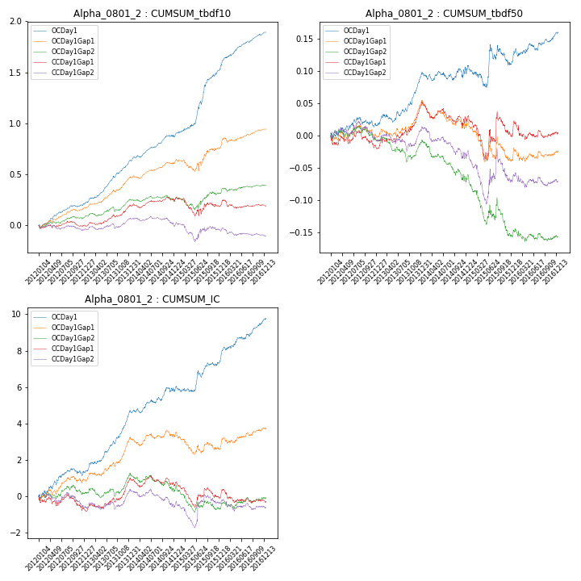

**因子换手率:** 37.2%

**截面指标_OCDay1:**

|  |  |  |  |  |  |  |  |  |
| --- | --- | --- | --- | --- | --- | --- | --- | --- |
| year | annret_tbdf10 | sharpe_tbdf10 | maxdd_tbdf10 | annret_tbdf50 | sharpe_tbdf50 | maxdd_tbdf50 | mean_IC | tstat_IC |
| 2012 | 0.21 | 4.06 | -0.03 | 0.02 | 0.64 | -0.02 | 0.01 | 2.0 |
| 2013 | 0.42 | 8.0 | -0.02 | 0.08 | 3.87 | -0.01 | 0.01 | 6.33 |
| 2014 | 0.25 | 4.93 | -0.02 | 0.01 | 0.37 | -0.01 | 0.01 | 2.36 |
| 2015 | 0.67 | 5.97 | -0.03 | 0.02 | 0.43 | -0.03 | 0.01 | 2.62 |
| 2016 | 0.36 | 6.09 | -0.01 | 0.04 | 2.21 | -0.01 | 0.01 | 4.33 |

**截面指标_CCDay1Gap1:**

|  |  |  |  |  |  |  |  |  |
| --- | --- | --- | --- | --- | --- | --- | --- | --- |
| year | annret_tbdf10 | sharpe_tbdf10 | maxdd_tbdf10 | annret_tbdf50 | sharpe_tbdf50 | maxdd_tbdf50 | mean_IC | tstat_IC |
| 2012 | -0.0 | -0.03 | -0.05 | -0.02 | -0.75 | -0.03 | -0.0 | -1.11 |
| 2013 | 0.19 | 3.47 | -0.03 | 0.06 | 3.15 | -0.01 | 0.01 | 2.99 |
| 2014 | 0.07 | 1.32 | -0.04 | -0.02 | -0.81 | -0.04 | -0.0 | -0.38 |
| 2015 | -0.06 | -0.5 | -0.17 | -0.02 | -0.46 | -0.07 | -0.0 | -1.04 |
| 2016 | -0.0 | -0.03 | -0.08 | 0.0 | 0.02 | -0.03 | -0.0 | -0.56 |

**风格暴露:**

|  |  |  |  |  |
| --- | --- | --- | --- | --- |
|  | long | short | corr_OCDay1 | corr_CCDay1Gap1 |
| momentum30 | 0.03 | -0.02 | -0.01 | -0.07 |
| logmktcap | -0.1 | 0.1 | 0.27 | 0.27 |
| liquidity10 | 0.1 | -0.1 | -0.17 | -0.19 |
| retvolatility30 | 0.13 | -0.13 | -0.23 | -0.21 |
| liquidity20 | 0.1 | -0.09 | -0.18 | -0.19 |
| momentum5 | 0.04 | -0.03 | 0.16 | 0.09 |
| momentum15 | 0.03 | -0.03 | 0.03 | -0.05 |
| liquidity5 | 0.11 | -0.1 | -0.16 | -0.18 |